# Shape From Silhouette Project

By: Nicholas Luis (NML5604@psu.edu)

For: Dr. Eapen, Aersp 497: Signal Processing & Computer Vision

## Introduction

The purpose of this project is to learn how to generate a 3D model of an object using pictures of it from different angles. Specifically, it employs a shape-from-silhouette (SFS) method, which only requires the silhouette of the object from different angles. This project generated a 3D model of a statue using 18 images, where the statue was rotated between each image.

## Procedure

The SFS process can be broken down into 5 main steps, which are described below:

### Step 1: Silhouette Intensity Thresholding

* Discuss threshold value
* Show thresholded Figures

The 5 steps in this project are as follows:

1. Silhouette Intensity Thresholding
2. Defining the Bounding Box and Voxels
3. Coordinate Transformations and Projections
4. Visual Hull
5. Image Generation

## Results

## Future Work and Improvements

## Conclusion

In short, this project demonstrated how to extract a shape from a silhouette.

The first step was to extract the silhouette of the object. This was done by trial and error of the *silhouetteThreshold* variable until the statue appeared with little noise around it. This trial and error process can be seen in figures __ through __.

* The next step was to determine the minimum and maximum values of *bbox* to capture the entire statue. Figure __ shows a very skewed rectangular prism. This was done in order to determine what are the x, y, and z directions in the image before adjusting the bounds of the box. The bounds of the box were also adjusted using trial and error to get a box that seemed to encompass the entire statue from all angles.

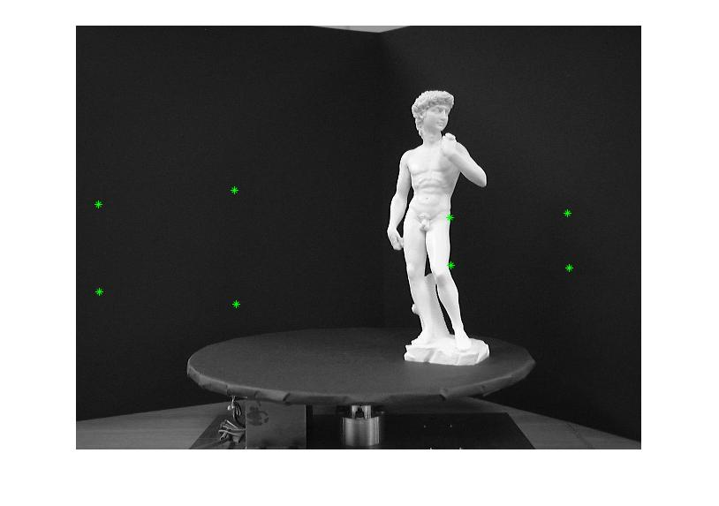

+x

+z

+y

* Figures __ to __ shows the locations of the centers of each voxel, viewed from a few different angles. This is just for demonstration purposes so that you can see the statue still. In the actual program, I used a very high number of voxels (4,760,000) to generate an accurate 3D map. When plotting the centers of the voxels, it appears to be a solid block, as is seen in Figure __. This used 50, 150, and 70 voxels in the x, y, and z directions, respectively.
* The next step was to determine which voxel contained the statue. This was done by getting the individual pixel coordinates of each of the centers and seeing if they lie on a white pixel from the intensity-thresholded image.
* A high-resolution (many voxels) model was used to accurately extract the edges, as is seen in Figure __.