**Week 7 Homework: A Day in the Life of a Windows Sysadmin**

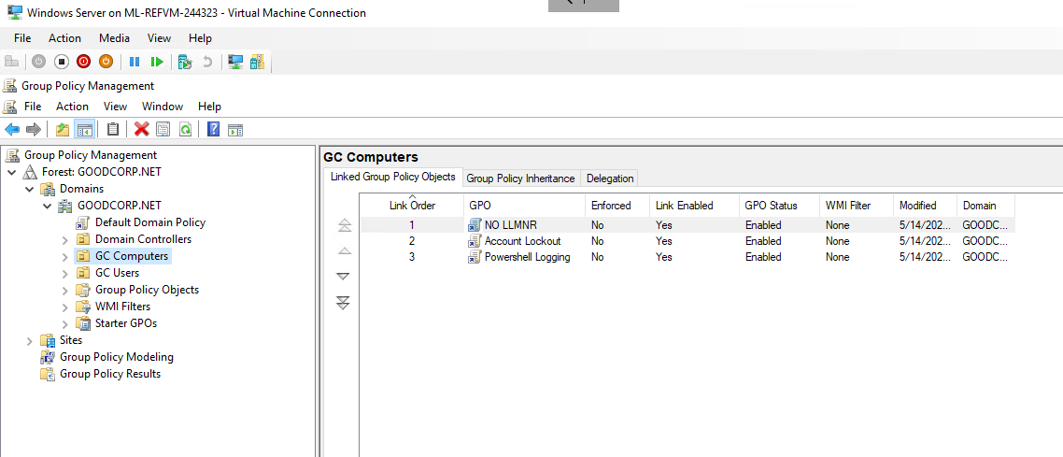**Deliverable for Task 1:** Take a screenshot of all the GPOs created for this homework assignment. To find these, launch the Group Policy Management tool, select **Group Policy Objects**, and take a screenshot of the GPOs you've created.

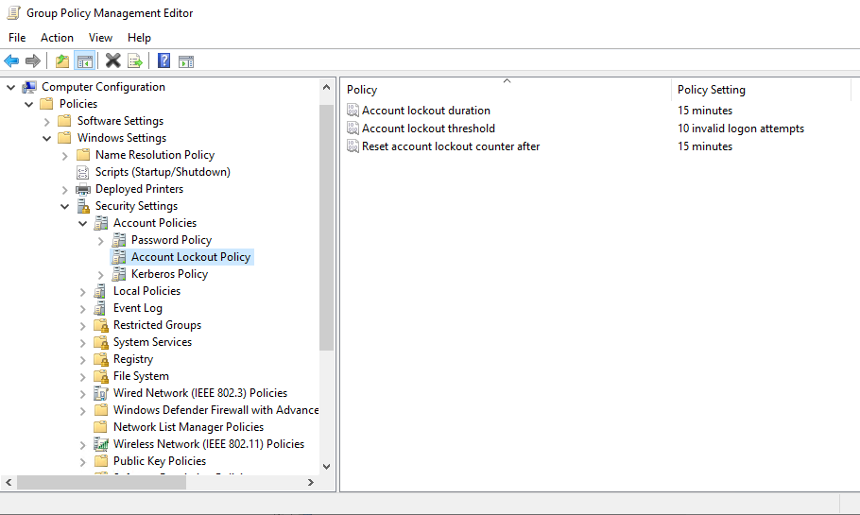**Deliverable for Task 2:** Submit a screenshot of the different Account Lockout policies in Group Policy Management Editor. It should show the three values you set under the Policy and Policy Setting columns.

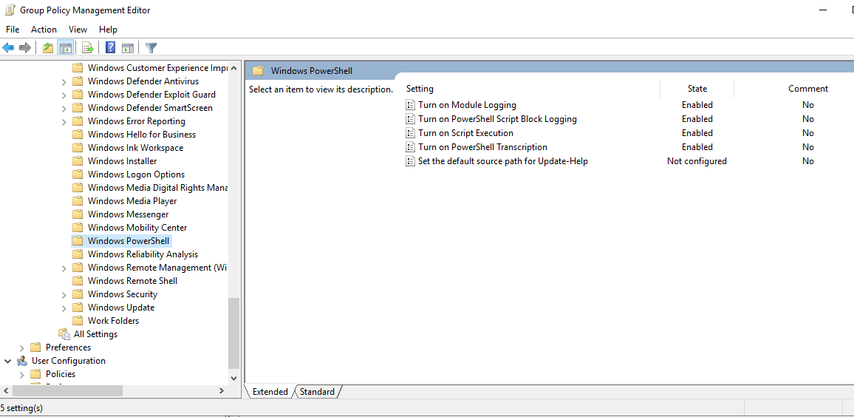**Deliverable for Task 3:** Submit a screenshot of the different Windows PowerShell policies within the Group Policy Management Editor. Four of these should be enabled.

**Deliverable for Task 4:** Submit a copy of your enum_acls.ps1 script.

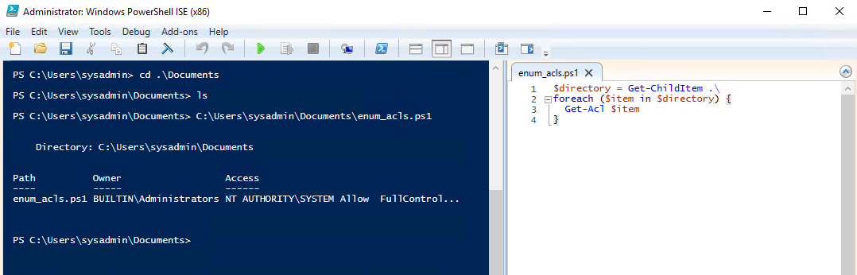

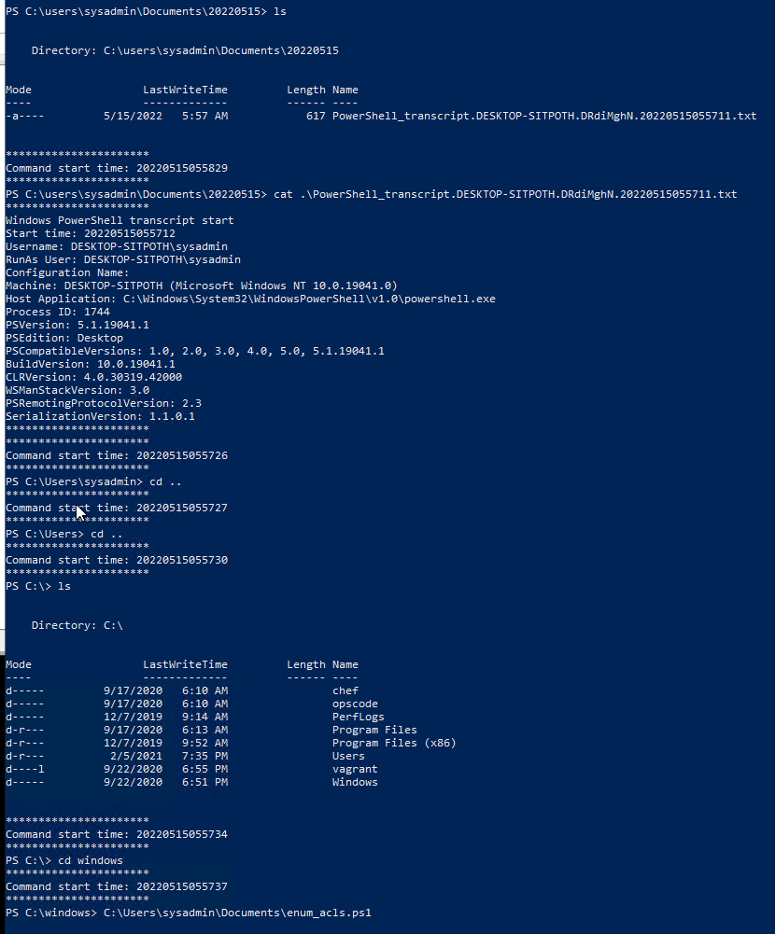**Deliverable for Bonus Task 5:** Submit a screenshot of the contents of one of your transcribed PowerShell logs or a copy of one of the logs.