AE 308 01DB Nicholas Ngo Syuan Yaw

1. Pointwise

* NACA 2412
* α = 5°
* Normal-to-wall spacing growth rate = 100

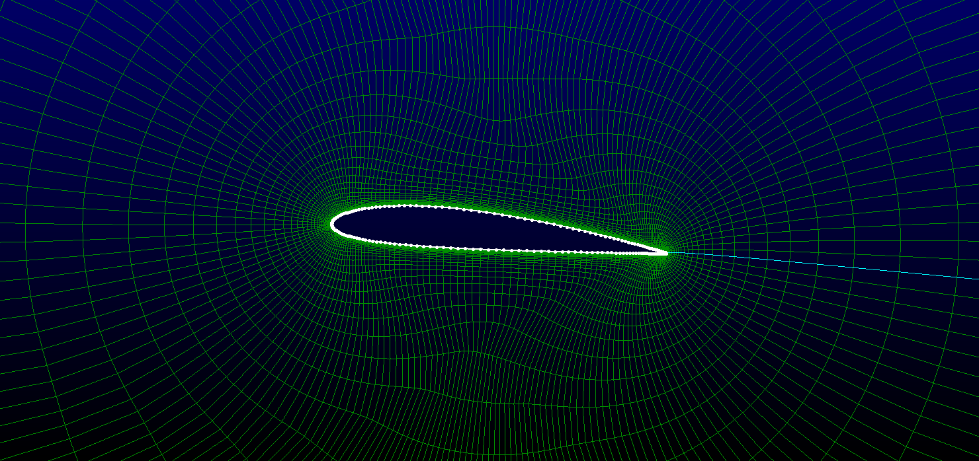

1. Overall Domain

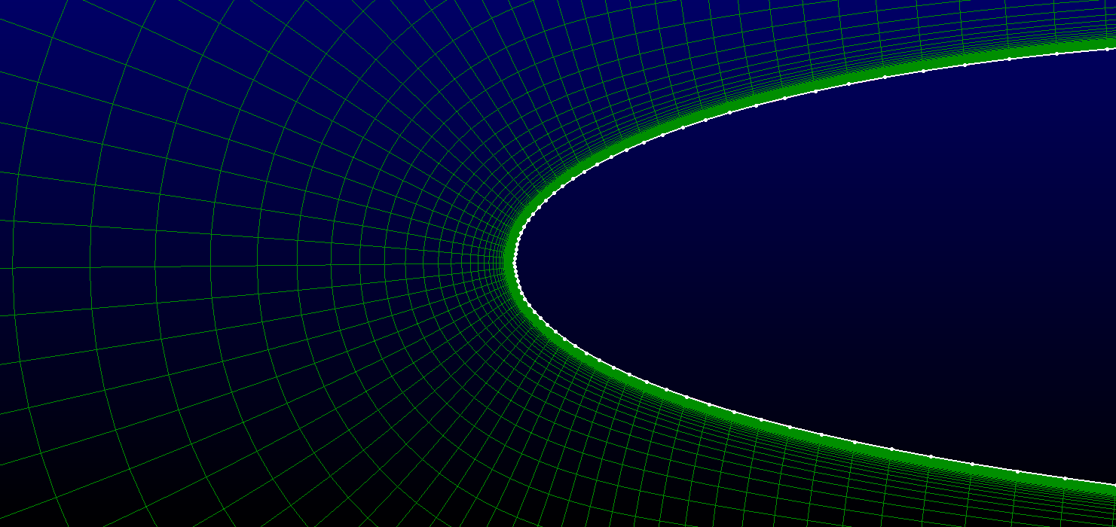

1. Close-Up of Leading Edge

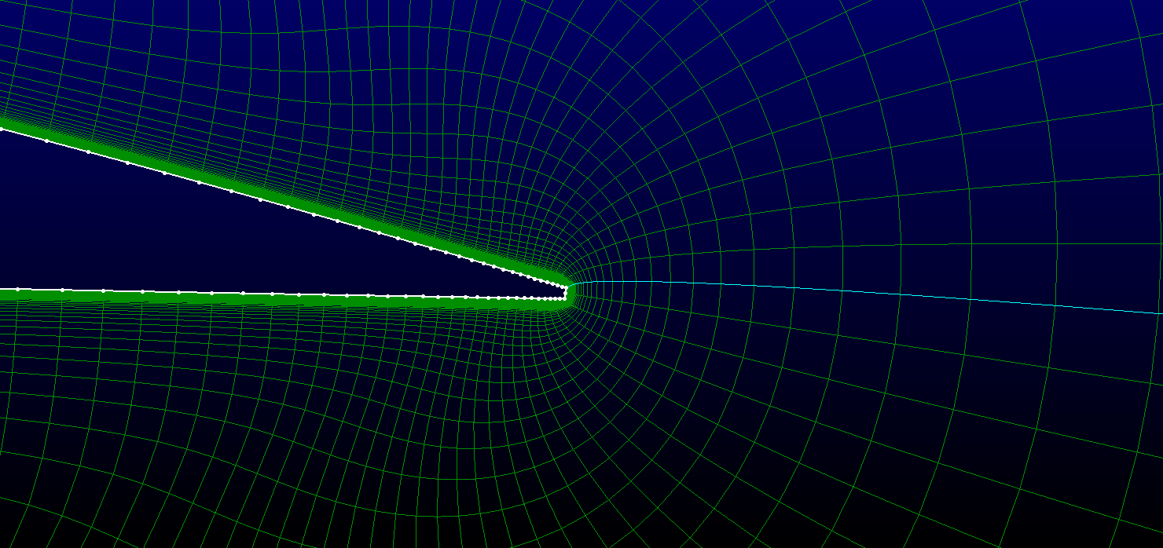

1. Close-Up of Trailing Edge
2. Ansys Fluent

* For Mach 3.0, 1.0, 0.8 (Solver Type = Density-Based)
* For Mach 0.3 (Solver Type = Pressure-Based)
* Viscous Model = Laminar (Solver Type = Density-Based)
* Viscous Model = k-omega (Solver Type = Pressure-Based)
* Air Density = Ideal Gas
* Flux Type = AUSM (Solver Type = Density-Based)
* Pressure-Velocity Coupling = SIMPLE (Solver Type = Pressure-Based)
* Courant Number = 0.5

|  |  |  |  |
| --- | --- | --- | --- |
| Mach | Cl | Cd | L/D |
| 3 | 0.089406 | 0.094133 | 0.949775 |
| 1 | 0.361067 | 0.143821 | 2.510527 |
| 0.8 | 0.459726 | 0.145521 | 3.159181 |
| 0.3 | 0.553984 | 0.128546 | 4.309607 |



1. Tecplot

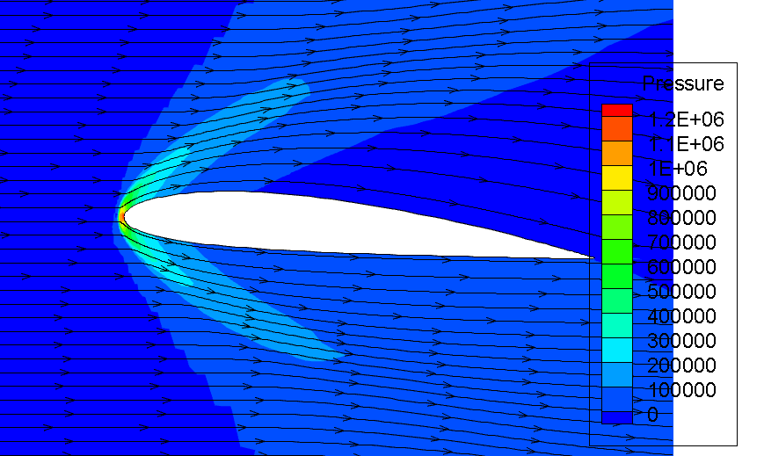

1. Mach = 3.0

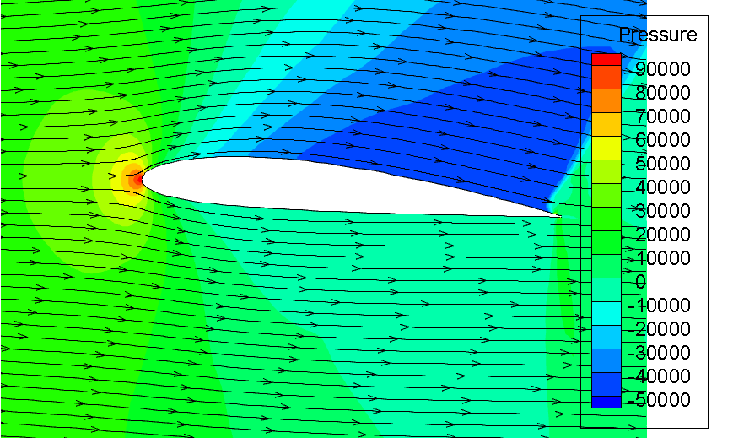

1. Mach = 1.0

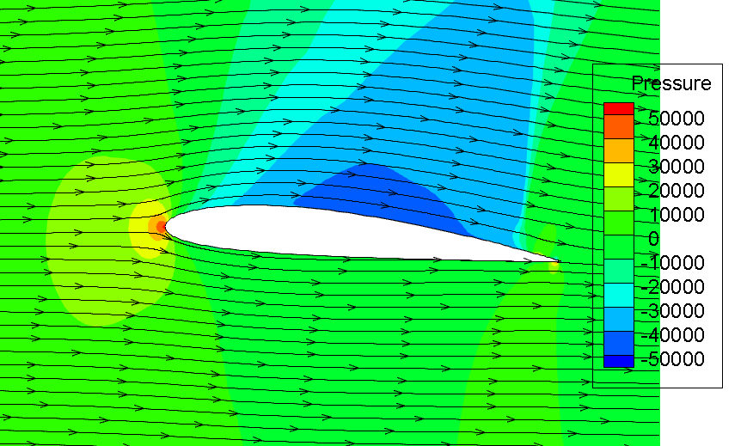

1. Mach = 0.8

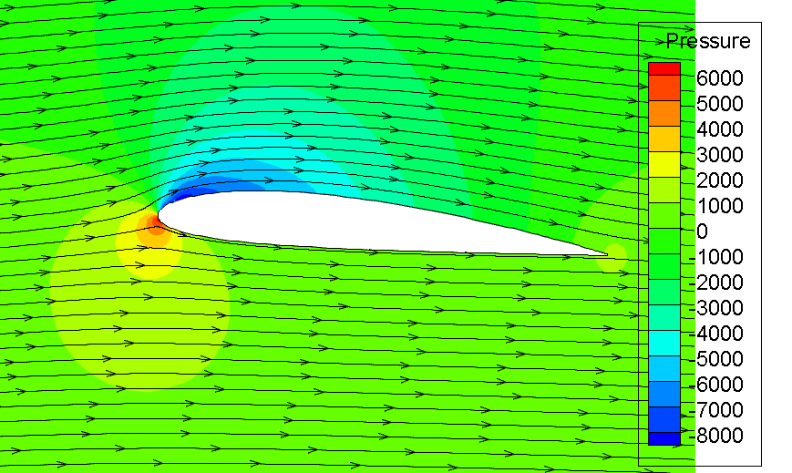

1. Mach = 0.3