**University of Waterloo**

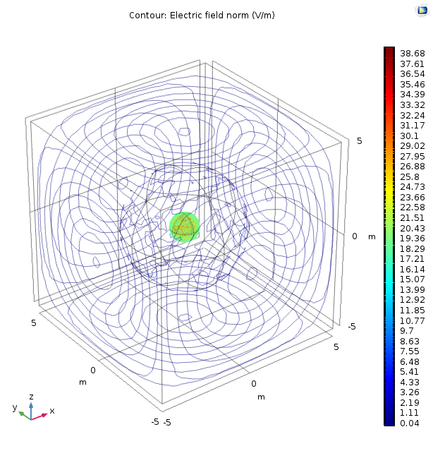

**Electrical and Computer Engineering Department**

**Electricity and Magnetism**

**ECE-106 Lab Report**

**LAB 1: Application of COMSOL Software in Electromagnetic Fields Simulation: Gauss Law**

**Winter 2019**

|  |  |  |  |
| --- | --- | --- | --- |
|  | Lab Section: 201 | Group:4 |  |
| **Partner 1** | Name: Nicholas Paquin | | ID:20761205 |
| **Partner 2** | Name: Kunal Chandan | | ID:20778788 |

This one template should be used to submit your prelab, data, and report.

After you have added your prelab answers, rename it (prelab1.docx), and upload it.

After you fill in your experiment observations, rename it (data1.docx), and upload it.

Finally, when you have added your report answers, rename it (report1.docx), and upload it.

Important Note: Feel free to edit the template to fit all your answers or make your report neater but please do not change the headings and figure numbers. This will help us with the marking. Thanks!

|  |
| --- |
| **Legend** |
| Prelab work |
| In-Lab work |
| Report work |

# Pre-Lab

## Gauss Law (enclosed distributed charge – centered)

Four solid concentric spheres (r=0.5m, r=0.6m, r=0.7m & r=3m) are located at the center of a cube (a=10m). The smallest sphere (r=0.5m) has a charge density of 2nc/m3.

* Find the electric flux flowing through each of the spheres and the cube. Fill Table 1.
* Calculate the Gaussian surface and the electric field at the surface for each of the spheres? Fill Table 1.
* Can we calculate the electric field at the surface of the cube using? Why?

No, we can not preform electric field calculations using a gaussian surface on a cube. Since the electric flux does not leave the cube evenly at all points, it cannot have a gaussian surface generated such that the field leaving the surface will be even.

|  |  |  |  |  |  |
| --- | --- | --- | --- | --- | --- |
|  | Sphere r=0.5m | Sphere r=0.6m | Sphere r=0.7m | Sphere r=3m | Cube |
|  |  |  |  |  |  |
|  |  |  |  |  | No |
|  |  |  |  |  | No |

Table 1

## Gauss Law (enclosed distributed charge – not centered)

A sphere (r=3m) centered at (0, 0, 0) encloses a smaller sphere (r=0.5) with a charge density of 2nc/m3. Find the electric flux through the surface of the sphere (r=3m) if (Fill Table 2):

* Smaller sphere (charge) is centered at (0, 0.25, 0.15)
* Smaller sphere (charge) is centered at (0, -0.35, -0.25)
* Smaller sphere (charge) is centered at (-0.15, -0.35, 0)
* Can we calculate the electric field at the surface of the sphere (r=3m) using? Why?
* No, we cannot as it is not a symmetrical system and therefore gauss’ law cannot be used to calculate the e-field. Since the flux leaving at different locations will have different concentrations, the e-field will be different at different points around the gaussian surface.

|  |  |  |  |
| --- | --- | --- | --- |
|  | Charge is centered at (0, 0.25, 0.15) | Charge is centered at (0, -0.35, -0.25) | Charge is centered at (-0.15, -0.35, 0) |
|  |  |  |  |

Table 2

## Gauss Law (within a distributed charge)

A sphere (r=8cm) holds a charge density of 2μC/m3.

* Calculate the flux through the gaussian surfaces of these spheres: r=2cm, r=4cm & r=8cm and fill Table 3.
* Calculate the Gaussian surface and electric field at the surface for each of the spheres and fill Table 3.

|  |  |  |  |
| --- | --- | --- | --- |
|  | Gaussian Surface:  r=2cm | Gaussian Surface:  r=4cm | Gaussian Surface:  R=8cm |
|  |  |  |  |
|  |  |  |  |
|  |  |  |  |

Table 3

## Gauss Law (Different configurations)

* What should be the value of the flux through the surface (surface=A) of a closed object if the charge Q is… (write the equations of the flux as a function of the variables A & Q)
  1. Inside the object?

I don’t believe it makes sense to represent flux in terms of surface area as it has nothing to do with flux that flows trough a surface as if it is a closed surface, all flux produced by a source will flow through a surface regardless of its surface. Further if it is represented in terms of the surface area as an integral, the expression will simplify to this.

Using Q, A:

* 1. Outside the object?

If the charge is located outside of the object Q is 0 as there is no charge located within the closed object. So, the net flux flowing through the surface is 0 as any flux that flows in flows out.

* What should be the value of the flux through the surface (surface=A) of a closed object if the charges Q & -2Q are both… (write the equations of the flux as a function of the variables A & Q)
  1. Inside the object?

The net charge enclosed within the object, using superposition is -Q, so we can represent

* 1. Outside the object?

If the charge is located outside of the object Q is 0 as there is no charge located within the closed object. So the net flux flowing through the surface is 0 as any flux that flows in flows out.

## Gauss Law (non-uniform distributed charge)

A solid sphere (r=0.5m) with a space charge density of 2μC/m3 has a spherical hole (r=0.1m) within it.

* Can we calculate the electric field at the surface of the sphere (r=0.5m) using? Why?

The only case in which the e-field can be calculated if the hole is in the center of the sphere. Otherwise, no the e-field cannot be calculated as the charge will not be uniformly distributed in the gaussian surface, since flux will be leaving in different densities, it cannot be calculated using a gaussian surface..

# In-Lab Procedure

## Gauss Law (enclosed distributed charge – centered)

|  |
| --- |
|  |

Figure 1 – [insert your title]

* Figure 1: Does the Electric Field appear to be constant at the surface of each sphere? Is it conform to theory? Explain your answers.

The electric field is constant on all the spheres. This confirms Gauss’ law as it is predicted that since charge is evenly distributed over a volume that the flux density and electric field leaving an enclosed Gaussian surface should be even at all points along that surface.

|  |
| --- |
|  |

Figure 2 – r=0.6m streamline plot

|  |
| --- |
|  |

Figure 3- [insert your title]

* Figure 2 &3: do you see any significant changes in the streamlines when changing boundaries? If yes, explain what you see. If no, explain why you don’t see any significant changes. Is it conform to theory? Why?

No we do not see any significant changes. This is as since the lines represent the flux leaving the surface. Flux is given by the flux leaving the surfaces will be the same, regardless of the surface area of the Gaussian surface.

This confirms theory as it is predicted that the flux leaving all surface areas with same enclosed charge will be equivalent.

|  |  |  |  |  |  |
| --- | --- | --- | --- | --- | --- |
|  | Sphere r=0.5m | Sphere r=0.6m | Sphere r=0.7m | Sphere r=3m | Cube |
|  |  | =118.85 | =117.75 | =116.85 | =117.54 |

Table 4

* Are these integral values (Table 4) in compliance with theory (Table 1)? Explain.
* For these two spheres (r=3m & r=0.5m), compare the ratio Er=3m/Er=0.5m and Gaussian Surfacer=3m/Gaussian Surfacer=0.5m and explain whether or not both spheres should have the same flux through their surfaces.
* If the block were replaced by a closed cone (enclosing the charge), would the flux be the same or not? Why?

## Gauss Law (enclosed distributed charge – not centered)

|  |  |  |  |
| --- | --- | --- | --- |
|  | Charge is centered at (0, 0.25, 0.15) | Charge is centered at (0, -0.35, -0.25) | Charge is centered at (-0.15, -0.35, 0) |
|  | =116.85 | =116.85 |  |

Table 5

* Are these integral values (Table 5) in compliance with theory (Table 2)? Explain.

## Gauss Law (within a distributed charge)

|  |
| --- |
|  |

Figure 4 – 3 small spheres

|  |  |  |  |
| --- | --- | --- | --- |
|  | Gaussian Surface:  r=2cm | Gaussian Surface:  r=4cm | Gaussian Surface:  R=8cm |
|  | 7.4130 | 59.441 | 482.85 |
|  | 7.4996 | 59.998 | 483.57 |

Table 6

* Are these integral values (Table 6) in compliance with theory (Table 3)? Explain.
* Do you get better results when increasing the number elements in the mesh?
* For these two spheres (r=2cm & r=4cm), compare the ratio Er=4cm/Er=2cm and Gaussian Surfacer=4cm/Gaussian Surfacer=2cm and explain whether or not both spheres should have the same flux through their surface.

## Gauss Law (Different configurations)

### *Scenario I (Positive Charge inside and outside)*

|  |  |  |  |  |
| --- | --- | --- | --- | --- |
|  | Sphere A | Sphere B | Sphere C | Sphere Ground |
|  | 2.2643 | 0.059269 | 0.54041 | 2.3184 |
|  | 0.035698 | 1.3639 | 0.32549 | 1.3963 |
|  | 2.2644 | 1.3646 | 0.65924 | 1.7010 |

Table 7

* Are these integral values (Table 7) in compliance with theory? Explain.
* From your results in Scenario I, II and III demonstrate the principle of superposition of the electrical flux through the Sphere Ground.

|  |
| --- |
|  |

Figure 5 - [insert your title]

|  |
| --- |
|  |

Figure 6 - [insert your title]

|  |
| --- |
|  |

Figure 7- [insert your title]

|  |
| --- |
|  |

Figure 8 – [insert your title]

Referring to Figure 5, 6, 7 & 8 of your lab report, which one(s) of the four spheres A, B, C and Ground has (have) the sum of its (their) entering streamlines equals the sum of its (their) leaving streamlines?

## Gauss Law (non-uniform distributed charge)

|  |
| --- |
|  |

Figure 9 – [insert your title]

|  |
| --- |
|  |

Figure 10 - [insert your title]

|  |
| --- |
|  |

Figure 11 - [insert your title]

* Figure 9: what is approximately the range (minimum value to maximum value) of the electric field within “Sphere r=0.5m”?
* Figure 10: what is approximately the range (minimum value to maximum value) of the electric field within “Sphere r=0.1m”?
* Figure 11: Except for the size and color, what is the difference between the arrows on “Sphere r=0.5m” and on “Sphere r=0.1m”?
* From the previous two questions, conclude whether the electric field within “Sphere r=0.1m” is constant or variable.

## General Questions

* In your lab report enter a title for each of your figures.
* Why is it important to have a ground in each of the simulations?
* Name a discrepancy that you have met when comparing your simulated values with your calculated value. What can be the cause of this discrepancy?