**University of Waterloo**

**Electrical and Computer Engineering Department**

**Electricity and Magnetism**

**ECE-106 Lab Report**

**LAB 2: Application of COMSOL Software in Electromagnetic Fields Simulation: Electric Potential**

**Winter 2019**

|  |  |  |  |
| --- | --- | --- | --- |
|  | Lab Section:201 | Group:4 |  |
| **Partner 1** | Name: Nicholas Paquin | | ID: 20761205 |
| **Partner 2** | Name: Kunal Chandan | | ID: 20778788 |

This one template should be used to submit your prelab, data, and report.

After you have added your prelab answers, rename it (prelab2.docx), and upload it.

After you fill in your experiment observations, rename it (data2.docx), and upload it.

Finally, when you have added your report answers, rename it (report2.docx), and upload it.

Important Note: Feel free to edit the template to fit all your answers or make your report neater but please do not change the headings and figure numbers. This will help us with the marking. Thanks!

|  |
| --- |
| **Legend** |
| Prelab work |
| In-Lab work |
| Report work |

# Pre-Lab

## ***Point charges***

All units of (x, y) stated below are in meters and z = 0 for all points.

* + 1. A point charge of +1 μC is placed at (x, y) = (-0.2, 0). Calculate the Electric Field vectors (indicate the direction for each of them) and the Electric Potentials at (x, y) = (-0.1, 0), (-0.2, 0.1), (-0.3, 0) and (-0.2, -0.1).

At the point ,

The direction vector is:

Thus

Thus:

At the point ,

The direction vector is:

Thus

Thus:

At the point ,

The direction vector is:

Thus

Thus:

At the point ,

The direction vector is:

Thus

Thus:

* + 2. A point charge of -1 μC is placed at (x, y) = (-0.2, 0) and a second point charge of 1 μC is placed at (x, y) = (0.2, 0). Calculate the Electric Field vectors (indicate the direction for each of them) and the Electric Potentials at (x, y) = (-0.1, 0) and (-0.3, 0).

Point charges:

Find E field:

Thus:

Point charges:

Find E field:

Thus:

* + 1. Four point charges of +1 μC are located at a distance of 0.1m from (0, 0). Their coordinates can be found on the figure below. Calculate the Electric Field vector (indicate the direction) and the Electric Potential at (x, y) = (0, 0).

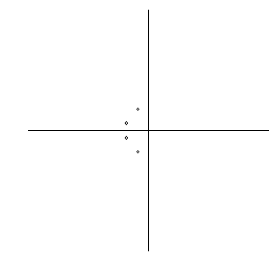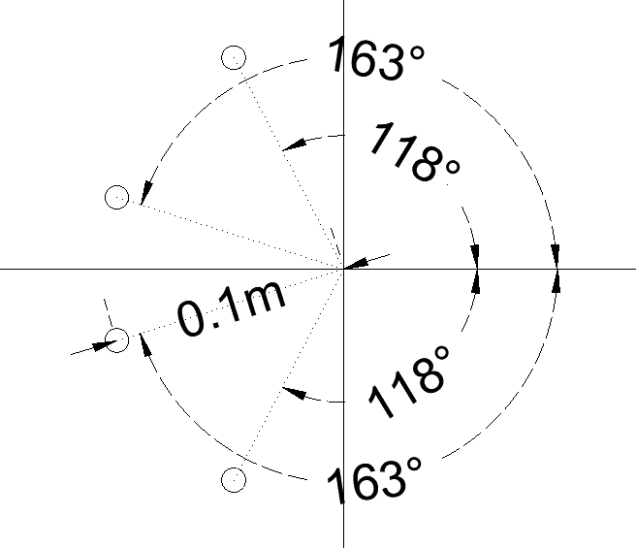

Figure 1 – Problem 3.1.3 and Location of the point charges (right)

Using symmetry, we know that only the component of in the direction of will be generating an electric field at point .

Thus:

***Charge Density***

* + 1. Two infinite plates are charged with uniform charge density of -8.85pC/m2 and 8.85pC/m2. The distance between the plates is one cm (1 cm). What is the Electric field between the plates?

# In-Lab Procedure

## Point Charges

* + 1. One Point Charge

|  |
| --- |
|  |

Figure 1 – Electric potential heat map point charge on rectangle

|  |
| --- |
|  |

Figure 2 – Electric potential contour map with electric field vector arrows

|  |
| --- |
|  |

Figure 3 – Electric potential contour map with electric field vector arrows using negative charge

* What was the main feature that has changed between the two cases (+1e-6C vs -1e-6C)?
  + 1. Two Point Charges
       1. Two point charges that are a dipole

|  |
| --- |
|  |

Figure 4 – Dipole Heat-Map

|  |
| --- |
|  |

Figure 5 – Di-pole contour plot, with e-field vector arrows

* Comment on these images: (Compare the Electric Field and Electric Potential of the dipole versus the Electric Field and Electric Potential of a single point charge).

|  |
| --- |
|  |

Figure 6 – Silicon dipole contour map with e-field vector arrows

* By how much the Electric Field / Electric Potential values are different when switching from Air to Silicon? Comment.
  + - 1. Two point charges that are not a dipole

|  |
| --- |
|  |

Figure 7 – Dipole heat map with 2x positive charge

|  |
| --- |
|  |

Figure 8 – Dipole contour map with e-field vector arrows and 2x positive charge

* Comment on these images: (Compare with the dipole).
  + 1. Multiple Point Charges

|  |
| --- |
|  |

Figure 9 – 4 point charge heat map

|  |  |  |  |
| --- | --- | --- | --- |
| Q1V=0 | Q2V=0 | Q1E=0 | Q2E=0 |
|  |  |  |  |

Table 1

|  |
| --- |
|  |

Figure 10 – Q1 v=0 for 5point 2-d system heat map

|  |
| --- |
|  |

Figure 11 – Q2 v=0 for 5point 2-d system heat map

|  |
| --- |
|  |

Figure 12 -4 point charge heat map with for e-field arrow for e-field vector

|  |
| --- |
|  |

Figure 13 – Q1 E=0 5 point charge heat map with for e-field arrow for e-field vector

|  |
| --- |
|  |

Figure 14 – Q2 E=0 5 point charge heat map with for e-field arrow for e-field vector

* In this problem, we created charges at distances D1=0.1m and D2=0.2m to cancel the Electric Potential or Electric Field at (0, 0). Now let’s compare the ratio of these charges knowing that the ratio D2/D1 = 2. Explain why the ratio of Q2V=0/Q1V=0 is different from the ratio Q2E=0/Q1E=0.

The ratio will be a difference of squares as for V is inversely proportional to the distance R. However, for the E-field, it is inversely proportional to R^2. So where as the difference between and will be . However, for the charges to set the e-field to equal 0,

## Charge distribution

* + 1. Plates

|  |
| --- |
|  |

Figure 15 – E-field heat map between 2 plates

|  |  |
| --- | --- |
| Electric Field Between the plates | 0.98860 |

Table 2

|  |
| --- |
|  |

Figure 16 –Electric potential contour map

* Figure 16: In relation with the two plates, where is the equipotential line of 0 V located (exclude the boundaries)?

It is located at the center of the space between the two plates. However, travelling parallel to the two plates, in between them will always result in there being no change in potential.

* Figure 15 and Table 2: Is the value of the Electric Field between the plates in compliance with theory (use your result from prelab 3.2.1)? If no, explain what causes the discrepancy?

|  |
| --- |
|  |

Figure 17 –E-field streamline plot

* Figure 17: Electric field lines (streamlines) are always directed normal to the equipotential lines. Is it the case for this figure? Explain what happens to the field lines at the ends of the plates.

|  |  |  |  |  |
| --- | --- | --- | --- | --- |
|  | Two points with the same y-coordinate | | Two points with the same x-coordinate | |
| Coordinates: | -6.4501E-4,  -0.0070888 | -2.5044E-4,  -0.0070888 | -2.2008E-5,  -0.0061751 | -2.2008E-5,  -0.0058636 |
| Electric Potential | -6.3768E-4 | -2.4760E-4 | -2.1758E-5 | -2.1758E-5 |

Table 3

* From Table 3, calculate and find the Electric Field based on the formula: .

* + 1. Hollow Circle

|  |
| --- |
|  |

Figure 18 –Electric Potential Solid circle (r=0.5m) inside air

|  |
| --- |
|  |

Figure 19 – Electric field norm around solid circle (r=0.5m) in air

* Figure 18: In relation with the circle, where is the Electric Field at its minimum and maximum?
* Is the Electric Field in compliance with theory? If no, explain what causes the discrepancy?
* Figure 19: In relation with the circle, where is the Electric Potential at its minimum and maximum?
* Is the Electric Potential in compliance with theory? If no, explain what causes the discrepancy?

## Application

* + 1. Corona Effect
       1. Shape of the object

|  |
| --- |
|  |

Figure 20 – Electric Potential as a result of Charged Connector with various corners

* Figure 20: Which one of these four corners would be the best to reduce the corona effect?
* Figure 20: Which one of these four corners would be the worst to reduce the corona effect?
  + - 1. Corona Ring

|  |
| --- |
|  |

Figure 21 – Corona Effect with Ring

|  |
| --- |
|  |

Figure 21 – Corona effect with Ring with Electric field vectors

* Figures 21 & 22: Based on these two figures explain how the corona ring reduces the corona effect on the connector?
* Do you see any drawbacks with the fact of adding corona rings?

## General Questions

* Don’t forget to enter a title for each of your figures.