**Partise problem 1.1**

1. T(new) = 20h

It is 1.2x

**Practice 2.29**

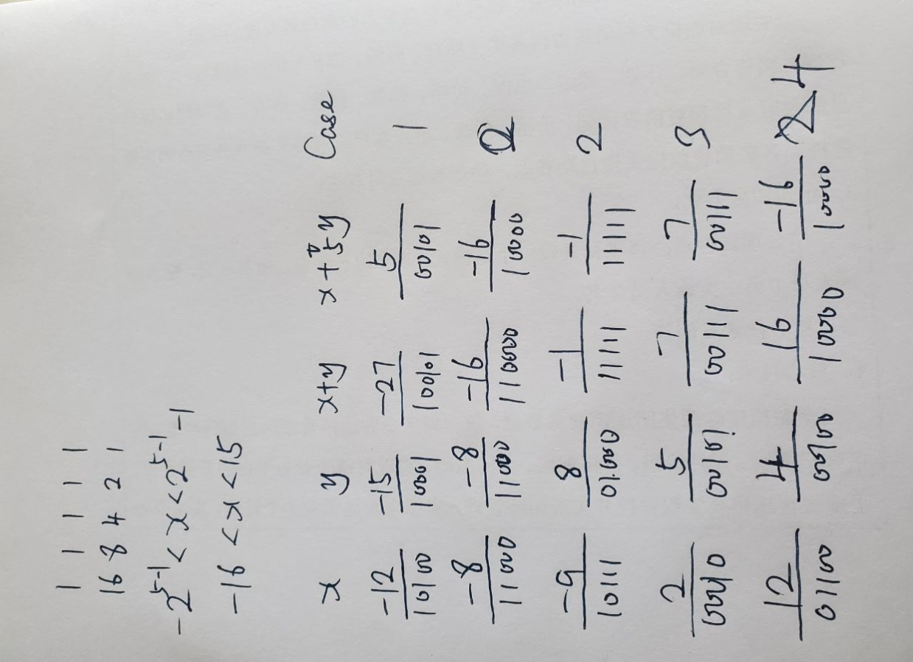

**Practice 2.34**

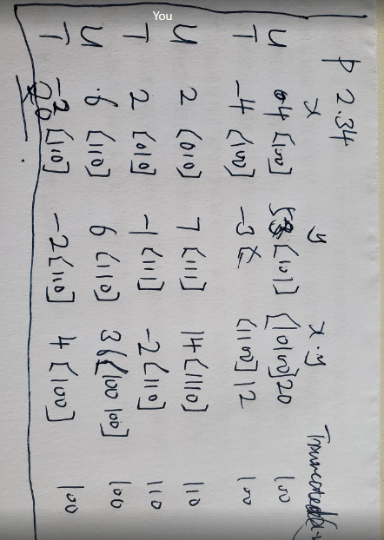

**P2.35**

I don’t understand problem 2.35 and find the solution later.

**P2.38**