**0, The organs of speech.**

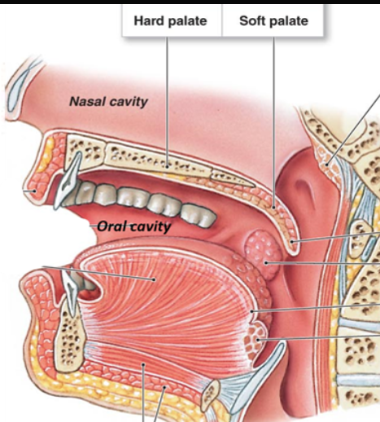

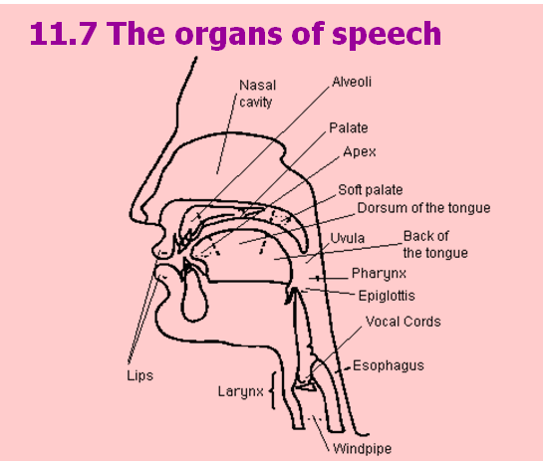

palate: 上颚

**Punctuation**

' : apostrophe 0027 + Alt_x

**Hotkeys of phonetic aphabet**

ʊ: “028a” and “Alt+x”. Firstly, input 028A and then press Alt+x.

ʌ : “028c” + “Alt + x”

ɔ : “0254” + “Alt + x”

ᴂ : “1d02” + “Alt + x”

ɑ : 0251 + Alt_x

ɒ : 0252 + Alt_x

ɪ : 026a + Alt_x

ə : 0259 + Alt_x

ɜ : 025c + Alt_x

**N.B. The following notes are specified on the pronunciation of British English.**

**1, /s/ and /z/**

/s/   
**Tongue Position:**

The tip of blage of your tongue is close to(but not touching) the alveolar ridge.

Air Flow

You force air through the narrow space between the tongue and the bridge.

For /s/ Only air flow. No voice.

/z/

For /z/ Air flows and your vocal cords vibrate.

**2. /i:/, /i/ and /I/**

   
To articulate //It is a long vowel. Your mouth is streched to each side as you are smiling. That’s many people say cheese when they are taken photographs.

fee, bee, tea

// is the shorter vowel of /i:/.

// Note that // is not the shorter sound of //; your tongue is slightly lower than that of // and /i/. It is a short and tense sound. Your mouth is not streched and just open naturally.

bit, fit, fish.

**3. /u:/, /u/ and /ʊ/**

/u:/ Your tongue is back and high in your mounth and your lips are round when articulating the long sound /u:/. It sounds like “tu(兔)” in Chinese, but in modern English the tongue moves slightly forward so it is not as same as “tu(兔)” any more.

For example, screw, pool.

/u/ It is the short vowel of /u:/.

/ʊ/ Note that /ʊ/ is not the short vowel of /u:/. Your tongue is slightly lower and more forward than that of /u:/ and /u/. Your mouth is also round but you should relax and it is not so round. Don’t move your lips too forward. There is not any equivalent sound in Chinese.

For instance, book, look, good, took, bush, would.

Compare, pool /pu:l/ and pull /pʊl/.

**4. /e/ and /ᴂ/**

/e/ is a short vowel. Your tongue is higher than when you pronounce /ᴂ/.

/ᴂ/ is also a short vowel. When articulating it, your tongue shoule be higher than // but lower than /e/.

**5. /ə:/ /ɜ:/ and /ə/**

/ə:/ is in IPA63 and /ɜ:/ is in IPA88; they are the same.

1. /ɜ:/ is a central vowel. It is not like the Chinese ‘e’; the position of it is more forward and lower than the Chinese ‘e’. ;

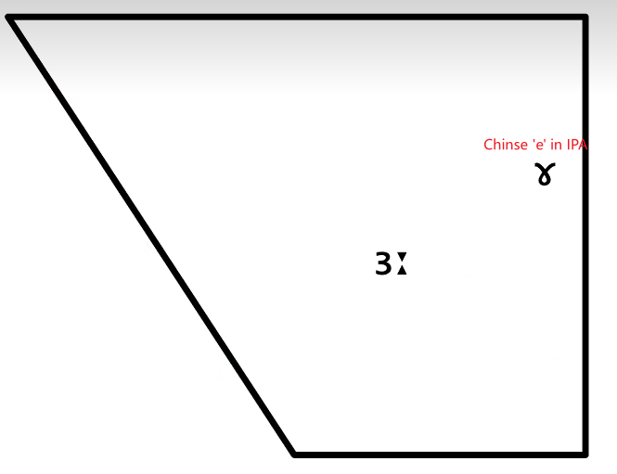

In American English, to articulate the coloured vowel needs you to wrap the tip of your tongue, which is like the Chinese “er”.

(2) /ə/ is schwa. You should NOT wrap your tongue when you’re articulating itRealx and don’t round your lips; your tongue is vertically and horizontally in the middle of your tongue.

**6. /ʌ/**

When you articulate // your tongue is slightly higher than when you articulate Chinese “a”.

**7 /ɔ:/**

To articulate /ɔ:/ you should put your tongue backward and rise it high but not too high. Its short vowel is /ɔ/, but NOT /ɒ/. It is higher than when you articulate /ɒ/.

For instance, caught /kɔ:/, bought /bɔ:/, law /lɔ:/, saw /sɔ:/, door /ɔ:/

**7 /ɑ:/**

It is actually the Latin α (alpha). Your tongue is more backward than when you articulate the Chinese “a”.

car /kɑ:/

**8 /ɒ/**

ɒ is the ɑ rotated by 180 degrees.

Note that it is not the /ɔ/, which is the short version of /ɔ:/. Your tongue is lower than /ɔ:/.

For example, top /ɒ/.

**9 /aɪ/**

1. Note that /a/ is the printing “a” not ɑ and “a” can not be used as a single vowel; it is only appears in double vowels with another vowel, such as /aɪ/ and /aʊ/.
2. When you articulate /a/, your tongue is the front and bottom of your mouth and is more forward than when you articulate /ɑ:/. Whereas, when articulate /aɪ/, your tongue should be put backward than /a/(like the Chinese “ɑ”) and then pronounce from /a/ to /ɪ/ seamlessly.
3. The sound of /aɪ/ is richer or resonant than the Chinese /ɑɪ/ so you should open your mouth more widely.

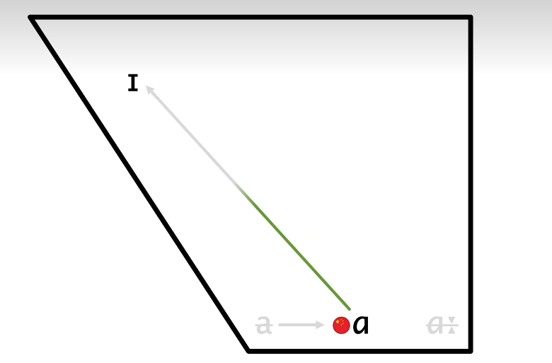

**10 /aʊ/**

It is like /aɪ/ except that /ɪ/ is replaced by /ʊ/.

**11 /ʊə/**

In /ʊə/ the stress falls on /ʊ/. It is the same when it is articulated with constants. For instance, in “lure /lʊə/” the stress falls on /lʊ/.

**12 /ɪə/**

The stress also falls on the first vowel /ɪ/ while the /ə/ is pronounced more slightly.

**Wrong Pronunciation:**  
Note that Chinese speakers always wrongly articulate “yi e”, or many people wrap their tongues to pronounce “er” as in Chinese.

Whereas /ɪ/ is a short vowel and /ə/ is schwa not Chinese “e”. See the notes of /ə/.