Saturday 20 December 2024

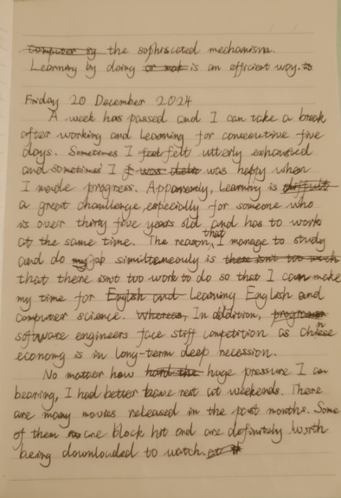

Today is Friday again and a week has passed so I can take a break after working and learning for consecutive five days.

***Improved by Adele***

A week had passed and I can take a break after working and learning for five consecutive days. Sometimes I feel utterly exhausted and sometimes I am happy when I made progress. Apparently learning is a great challenge especially for someone who is over thirty five years old and has to work at the same time. *The reason that I managed to study and do job simultaneously was that there wasn't too much work to do so that I can make my time for learning English and Computer Science. In addition, software engineers face stiff competition as Chinese economy is in a long-term deep recession.

*No matter how huge the pressure is, I can bear it. But I’d better have rest at weekends. There are many movies released in the past months. Some of them are blockbusters/box-office hit and are definitely worth being downloaded to be watched.