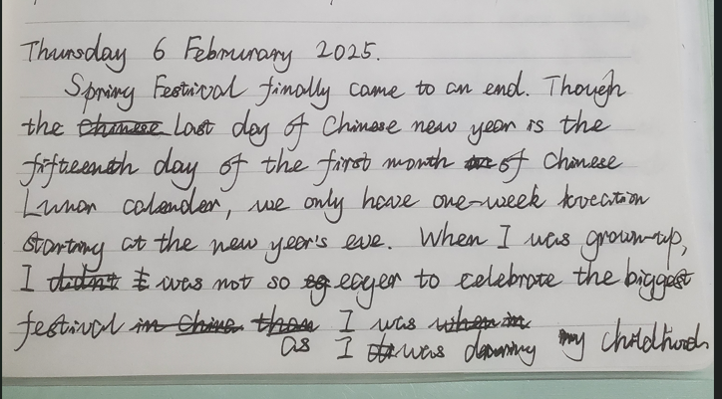

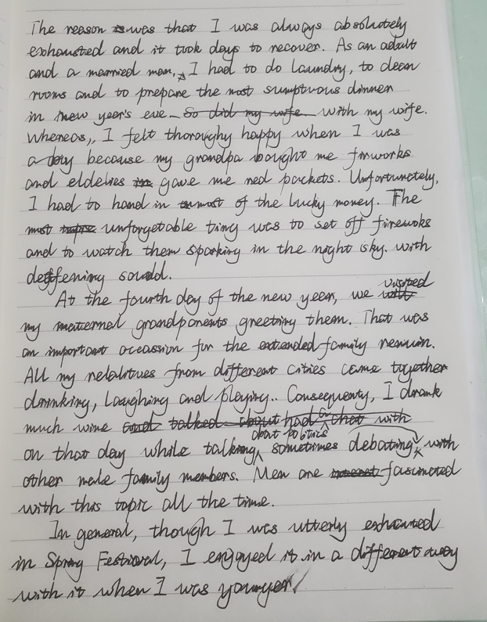

***A Revised Edition***

Thursday 6 February 2025

Chinese Spring Festival finally came to an end and I started working after a ten-day holiday. Although the Chinese New year tranditionally ends on the fifteenth day of the first month of Lunar Calendar in China, we have to start work one week earlier than it by the notorious labour law which is widely condemed around considerable number of employees. Advisers in the central government of China still satisfied with their clever arrangement by forcing workers to work at weekends to get a longer vocation. Many are absolutely exhausted after constantly working for seven days or even nine days before or after holiday.

On the other hand, since I was grown-up, I was not so eager to celegrate this most popular holiday as when I was a child. If my memory serves me right, my paternal grandfather always bought fireworks for me and my younger brother. I felt a pang of nostalgia when I was writing something about him. In addition, children could receive read packets, in which money is put, from their elderlies; that was a substantial amount for us in the 1990s. Unfortunately, we had to hand it over to our parents and only could keep a little of it. Whereas, we still felt thoroughly exhilariting not only because we could buy candies, biscuits and firecrackers, but also we could play on crowded streets or on secluded wild land without worrying all the miserable obstacles in the world of adults.