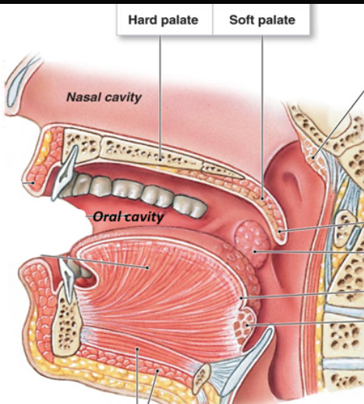
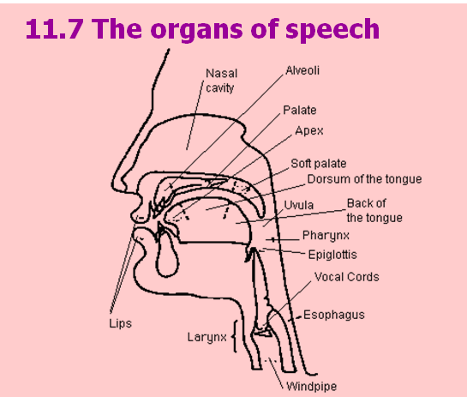
palate: 上颚
ʊ: The hotkey of ‘ʊ’ is “028A” and “Alt+x”. Firstly, input 028A and then press Alt+x.

1, /s/ and /z/
/s/
Tongue Position:
The tip of blage of your tongue is close to(but not touching) the alveolar ridge.
Air Flow
You force air through the narrow space between the tongue and the bridge.
For /s/ Only air flow. No voice.
/z/
For /z/ Air flows and your vocal cords vibrate.

2. /i:/, /i/ and /I/
 
To articulate //It is a long vowel. Your mouth is streched to each side as you are smiling. That’s many people say cheese when they are taken photographs.
fee, bee, tea
// is the shorter vowel of /i:/.
// Note that // is not the shorter sound of //; your tongue is slightly lower than that of // and /i/. It is a short and tense sound. Your mouth is not streched and just open naturally.
bit, fit, fish.

3. /u:/, /u/ and /ʊ/
/u:/ Your tongue is back and high in your mounth and your lips are round when articulating the long sound /u:/. It sounds like “tu(兔)” in Chiese, but in modern English the tongue moves slightly forward so it is not as same as “tu(兔)” any more.
For example, screw, pool.
/u/ It is the short vowel of /u:/.
/ʊ/ Note that /ʊ/ is not the short vowel of /u:/. Your tongue is slightly lower and more forward thant that of /u:/ and /u/. Your mouth is also round but you should relax and it is not so round. There is not any equivalent sound in Chinese.
For instance, book, look, good, took, bush, would.
Compare, pool /pu:l/ and pull /pʊl/.

