1. 首先把下载的证书文件放到resources目录下，项目打包后，没有把证书文件打包进去，因为maven把证书文件过滤了，需要在pom.xml文件里进行设置，在<build>标签中

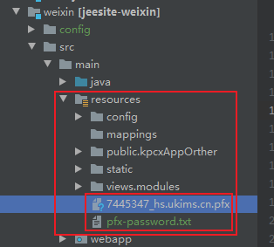

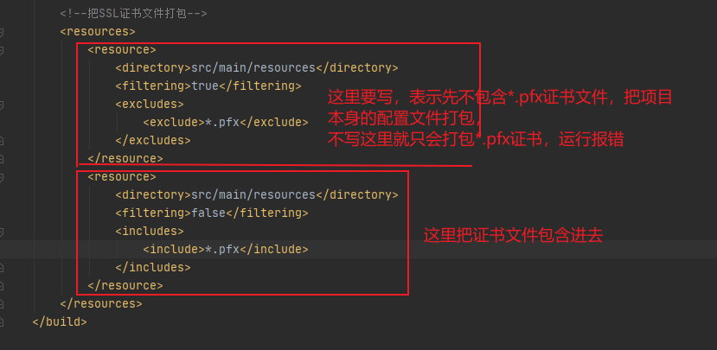

1. 在application.yml文件进行配置SSL，密码就是pfx-password.txt里的密码

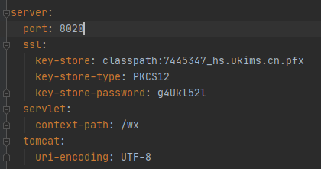

1. 配置：把http请求转向到https（本步骤可不配置）

|  |
| --- |
| @Bean  public EmbeddedServletContainerFactory servletContainer() {  TomcatEmbeddedServletContainerFactory tomcat = new TomcatEmbeddedServletContainerFactory() {  @Override  protected void postProcessContext(Context context) {  SecurityConstraint constraint = new SecurityConstraint();  constraint.setUserConstraint("CONFIDENTIAL");  SecurityCollection collection = new SecurityCollection();  collection.addPattern("/*");  constraint.addCollection(collection);  context.addConstraint(constraint);  }  };  tomcat.addAdditionalTomcatConnectors(httpConnector());  return tomcat;  }  @Bean  public Connector httpConnector() {  Connector connector = new Connector("org.apache.coyote.http11.Http11NioProtocol");  connector.setScheme("http");  //Connector监听的http的端口号  connector.setPort(8080);  connector.setSecure(false);  //监听到http的端口号后转向到的https的端口号  connector.setRedirectPort(8020);  return connector;  }  目端口  return connector;  } |

参考链接

https://www.jianshu.com/p/eb52e0f5ee85