**Kathyleen Beveridge:**

* Her career & Journey
  + Wells Fargo, Nikko Securities, 1995 - 1996, investment advisor
    - Stock broker
    - Went back to school and switched careers
  + First high tech job at HP
    - Loved to surf there
  + Qualcomm - Senior Manager Sales Operations and Director of Global Sales
  + ThermoFischer - senior director of marketing
    - Biotech
* Education
  + MBA, University of South California
  + BS Finance, Santa Clara University
  + Studied abroad in Spain
* Quote she lives by: Maya angelou: “my mission in life is not merely to survive, but to thrive; and to do so with passion, some compassion, some humor, and style”
* 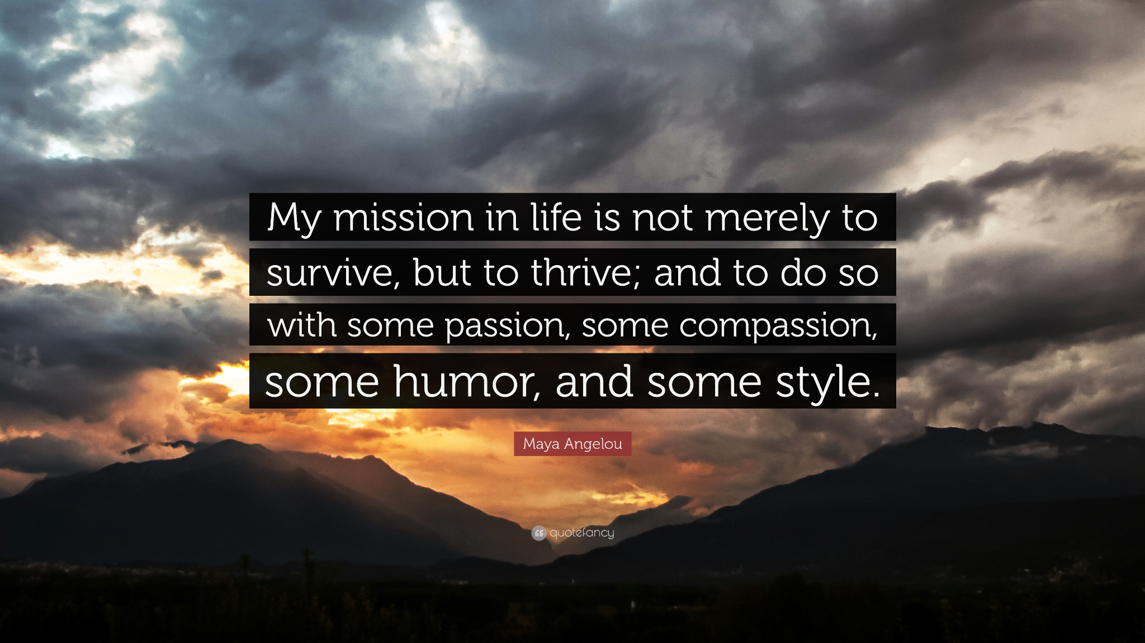
* Words to live by:
  + SURFING DOESN’T PAY THE BILLS
  + 
  + Investment banking is only one to one impact
  + Grateful that she works for company which makes a big impact on people

Company Mission Statements:

* HP: Create technology that makes life better for everyone, everywhere
* Qualcomm: Inventing the tech everyone loves
* Thermo Fisher Scientific: Enable our customers to make the world healthier, cleaner, and safer
  + Similarities: Using tech for the good of the people, main idea is to help people, doing something that people want

Every tech company that she worked in, it had a macro, global impact on the people of the world

* The product or service is life changing or generation changing
* Qualcomm chips were in 99% of cell phones in the world
  + Everyday a billion peoples lives are impacted by Qualcomm technology!

Thermo Fisher:

* > 100,000 colleagues
* 7,000 R&D scientists/engineers
* 1.5 Billion invested in R&D
* > 40B in revenue
* Note: R&D = Research and development

She:

* senior director of marketing and commercial sales
* Voice of sales, voice of customers
* People work really closely with scrum master to commercialize the product
* No matter what you are doing, she enjoys working with all the folks. She can't do what others do. You can take a concept and build it and make it happen

She has data scientist in her team

* Join massive fragment data bases outside the company to predict customer demand and where the sales will be
* They sell freezers okay (very important, remember this)
  + Databases predicted where the demand will be BEFORE customers place orders

**Kris Porter:**

Him:

* Software developer - SRE, DevOPs engineer, Infrastructure engineer
* There were no CS classes when he started -
* First cs class was second quarter of some year in college
* Graduated in 2008

Bachelors and Masters degree

* UCLA
  + Failed his first CS class; stopped after failure (thats pretty bad )

Words to live by:

It doesn't matter what you like at this age, you can have a tech career later on

* Marketable skill
  + Research project: internet of things
  + Robot that deployed somewhere in world
    - Costa rica: swings in the trees and gives biological readings (THATS SO COOL)

Career:

* NBC Universal, Streaming media infrastructure
* Twitter (does he know elon musk?) you should ask
* NOT a security engineer
* Now works at Twitter (HE GOT FIRED)
  + Very interesting, most of his team was laid off (thanks elon musty)
  + Requirement to go work in the office in SF
  + Remote workers got kicked out
    - When you see companies shuffle, you have to go (don’t wait)
* Mysten labs??

Learning Highlights

* Continuous learning
* CCNA training
* Machine learning and Deep Learning
* Python
* Data Structures, Algorithms, Systems
* Rest APIs in his job at twitter
* Slowly movies to graph UL

Agile Methodology

* Technical perspective, different companies have their own version of agile, they use it depending on what they need
  + Qualcomm, - 150 engineers, interacted with each other, planned all of the work for the quarter in a big meeting that last 2 day (good way to coordinate)
* Agile is important

Business landscape can change: Use Sprints

* Gone are the days where projects take 6 months
* What can we do in shorter time periods?
* That skillset is highly regarding

Machine Learning

* Learn how to use python libraries
* Use information on when to archive and delete repositories
* To cut costs

**Questions:**

Most important skill to have in the tech industry:

* Continuous learning
  + Not just learning a particular programming language, but to learn everything
  + Different companies have different stacks, everytime he moved companies he had to learn new programming languages
  + Everyone has different ways of doing things
* Don't be super concerned about things you read on the news
  + In learning the skill to work with computers, that is self fulfilling
  + Start ups are a risk
    - Only risk is not learning (thats deep)
* Be adaptive
  + Career path is zigzaggy
  + Dated herself for 35 years
  + Never thought she’d be doing what she’s doing
  + Best technical people
    - Listen to requirements
    - Translate it in terms of how the technology can solve the requirements
    - Help speak it to her

Biggest Challenges faced in the tech industry:

* She spent 14 years in qualcomm (semiconductor industry)
  + Acquisitions?? Buy other companies
  + The big fish in the pond (acquiring companies)
  + Serial killers (but not quite)
* Interviews are ridiculous
  + Interviews are a series of timed, random tests
    - Could be a problem to solve in 30-45 minutes
    - Code has to compile with no errors

How is your work-life balance:

* When you talk to a company, you're in a position to negotiate
  + You're the one with the skill
  + Some good companies, some bad
* You have to learn how to use services that are specific to certain companies

How does coding help in the business industry?

* Plenty of people were software developers academically, but moved into non-tech senior roles
* Coding is a way of thinking
  + A way of looking at a problem and dissecting it
  + Critical thinking, problem solving
  + Think methodically

* She interviews people on their ability to be a problem solver, and their ability to walk her through what you did what you did

One of her questions:

* You are in a room, not electronics, just whiteboard, pen, pencil
* How many cars were sold in the United States last year?
  + She wants to know your assumptions, how she derived her answer

What are you interested in exploring or learning right now?

* He is interested in learning about block chain technology
  + AWS and google cloud stuff at large companies

How would coding help with investment and finance?

* Understanding algorithms, patterns, and analytics