**PROJECT PROPOSAL**

*Arduino Weather Station*

Table of Contents

Project Abstract 3

Conceptual Design 3

Proof of Concept 3

Background 3

Required Resources 3

## Project Abstract

*This document proposes the creation of an IOT device that collects weather data and sends it to a web server where it can be monitored by the user. The data is collected on an Arduino with sensors attached to it and sent to a server to be display. The device will be modular to that users can easily add new sensors and track that information.*

## Conceptual Design

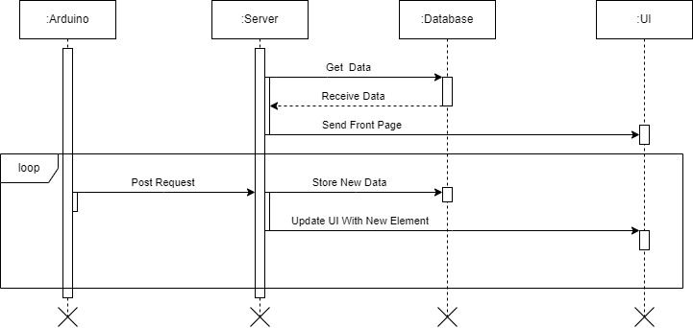

The sequence diagram above shows the main two actions in the app. The first is when the server starts. The server will get all the data from the database and combine it into the first page that is shown. From there any data that is received from the Arduino will be saved in the database and then added as an element to the UI.

## Proof of Concept

Git Repository:

<https://github.com/NickRucinski/CIS3296ProjectProposal.git>

This proof of concept uses the Arduino programming language, which is very similar to C++ but easier to use, to connect the sensors on the board. In the sample, one sensor is being used, the DHT22 which is used to detect temperature and humidity. This is currently being printed to the standard output but in the future, it will be displayed on the website. The website is using HTMX on the front end and Go on the back end. These could be switched out in the future. For testing there is a form on the website for manually adding data entries but this will be deleted when the Arduino can connect directly to the server. Also, there is no data persistence since there is not database so that will also have to be added.

## Background

The project I am proposing will be creating an IOT weather device. It will be similar to other smart weather devices that give users a dashboard for monitoring certain conditions. Using an Arduino with various weather detecting sensors connected to it the device. These sensors will collect the data and send it to a website where the it can be stored and displayed in a UI. Some hopes for this project would be for it to be modular and local. With it being modular more sensors and hardware could be added easily. I would also want it to be local so that even if the user is disconnected for the outside internet, they could still access everything. This would require more hardware so it would be easier to have everything connect to a hosted server.

## Required Resources

The required resources would be

Hardware

Arduino Uno (or Uno WIFI)

Temperature Sensor (DHT22 or BME280)

Humidity Sensory (DHT22 or BME280)

Barometer (or BME280)

WIFI Module (if using the Uno)

Software

Arduino Language and IDE

Database

Back End Language (Go or JavaScript)

Front End Languages (HTML, CSS, HTMX)

Background Information

How the Arduino works and integrates with sensors

Web Technologies