Efficient Attendance Monitoring Using

AI-Based Face Detection

Nicholas Marshall,

Nivedita Prabhu,

Frank Diabour,

Matthew Willingham,

Ayodeji Adeogun

Computer Science Students    
Texas Tech University    
Lubbock, United States

**Abstract -** **This paper presents an AI-powered attendance monitoring system that leverages face detection and recognition technologies to automate attendance tracking. The system employs the YOLOv8 deep learning model for real-time face detection and a secondary recognition model to accurately identify individuals. The system ensures efficiency, accuracy, and integrity in attendance recording by utilizing live video feeds and pre-registered facial databases. Key challenges, such as facial occlusion, lighting variations, and privacy concerns, are addressed through data augmentation techniques, encryption, and consent-based data storage. The proposed solution is designed for scalability and can be deployed in educational institutions and other environments requiring seamless attendance management.**

**Keywords—** AI, face detection, attendance monitoring, YOLOv8, machine learning.

# Introduction

In recent years, the integration of Artificial Intelligence (AI) into everyday tasks has revolutionized various domains, including education, workplace management, and security. One such application is the automation of attendance monitoring, which traditionally relies on manual processes that are time-consuming, error-prone, and inefficient. This paper proposes an efficient attendance monitoring system leveraging AI-based face detection technology. By utilizing computer vision and machine learning algorithms, the system can accurately detect and recognize faces in real time, automating the attendance process and reducing human intervention.

The proposed system employs a pre-trained deep learning model for face detection and recognition, ensuring high accuracy and robustness. The system captures live video feeds, detects faces, matches them against a pre-registered database, and records attendance automatically. This approach not only enhances efficiency but also provides a scalable and contactless solution, which is particularly relevant in the post-pandemic era.

# Motivation

### **Overview**: Eliminates the need for manual roll calls or sign-in sheets. **Integrity & Accuracy**: Ensures only present students are marked, reducing attendance fraud. Saves class time, allowing professors to focus on teaching.

### **Obstacles**: Among the challenges of AI-based attendance systems is maintaining accuracy and not falling prey to misidentification due to low lighting, facial occlusion (e.g., glasses or masks), or lookalike students. These can be addressed by training the model with diverse datasets, multi-facial angles, and confidence levels to eliminate errors.

### The other concern is security and privacy as facial recognition can be an ethical concern and concern for data security. This can be resolved through encrypting data via the system, storing only those facial embeddings that are required, and seeking the consent of students. How well the system performs and whether it integrates nicely with the database and user interface is also significant. Optimizing the AI model, for example, with YOLOv8, using an optimized database, and conducting extensive testing will lead to smooth real-time performance.

### Uses: This AI-powered attendance system can be used in large classrooms, and any environment where accurate and efficient tracking of attendance is crucial, ensuring integrity and saving time for both instructors and participants. **Impacts**: Provides a seamless, real-time attendance system that benefits both educators and students. Reduces administrative workload and ensures fair attendance records.

# Research

### Overview: The implementation of this system will require the use of the necessary technology and the research of prior articles. We will research: Data Collection and help with UI, Model Training and Image Augmentation,Database System [Store Attendance], and System Integration [Model + Schema +UI]

## Model Training and Image Augmentation

The success of an AI-powered attendance system relies heavily on the robustness of the underlying face recognition model. To achieve high accuracy, various deep learning models were considered, including YOLO, ResNet, and SSD. After evaluation, YOLOv8 was selected due to its lightweight architecture, fast inference speed, and lower dataset requirements, making it ideal for real-time applications in attendance tracking.

1. **Model Training**: The model training process involves fine-tuning YOLOv8 for face detection while integrating a secondary model, such as FaceNet or a custom-trained neural network, for identity recognition. The training dataset consists of labeled facial images collected from multiple angles, ensuring diversity in the learning process. To optimize performance: Preprocessing techniques such as resizing, normalization, and contrast adjustments are applied to maintain consistency. The dataset is split into training, validation, and testing sets to prevent overfitting and improve generalization. Transfer learning is leveraged to adapt YOLOv8’s pre-trained weights to our attendance system, reducing training time and enhancing accuracy.

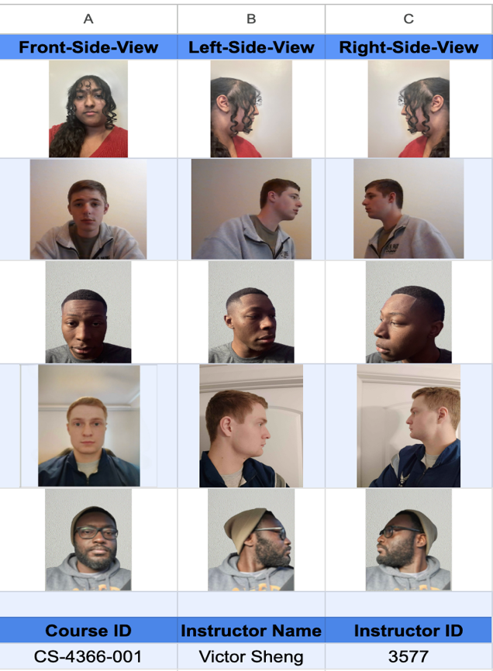

Image Augmentation

To further improve recognition performance, image augmentation techniques are employed to simulate real-world variations that may affect accuracy, such as Rotation & Tilt – Simulating different head angles. Brightness & Exposure Adjustments – Accounting for varying lighting conditions. Grain & Blur – Enhancing model robustness against image noise. Occlusion Simulation – Training the model to recognize partially covered faces(e.g., glasses, masks).

A custom augmentation script is deployed to generate these variations automatically, ensuring that the model is trained on a diverse dataset that enhances its ability to recognize faces under different conditions. By incorporating these augmentation techniques, the system aims to increase the confidence rate and reduce false positives in real-time attendance tracking

## Data Collection and help with UI

Data collection for the AI-powered auto attendance tracker involves systematically capturing and preparing images to ensure they are in the correct format for accurate processing. This process begins with collecting images from live video streams, such as classroom cameras, or from uploaded photos provided by students or administrators. To maintain compatibility across various devices, images may require format conversion, particularly when dealing with Apple’s HEIC format or other non-standard types, ensuring they are transformed into widely supported formats like JPEG or PNG. Standardizing the image format is crucial to streamline processing and analysis. Additionally, labeling images with relevant identifiers, such as Student IDs, names, or other metadata, helps in creating a structured and well-organized dataset. This labeled dataset is essential for training and improving the AI model’s accuracy in recognizing students and automating attendance tracking efficiently.

## Database System [Store Attendance]

1. The data will be stored in a database using **Yolov8**. Yolov8 is a state-of-the-art deep learning model for real-time object detection in computer vision. An alternative to this is **Roboflow**. Roboflow leverages the power of YOLOv8 within a comprehensive development pipeline, while YOLOv8 focuses on the core object detection algorithm. To make it easier and more focused -which may result in higher accuracy - we will use YOLOv8.

To use YOLOv8 for face recognition in an attendance system, first you would identify faces within a video stream using its object detection capabilities, then feed these detected facial regions to a face recognition model that identifies the person based on their identified identity (for example, **FaceNet** or a custom-trained model). As a result, YOLOv8 is essentially just used as the initial face detection step, while another model is used for comparing and recognizing facial features afterward.

Utilizing YOLOv8, we'll need data to base it on. As in the Data collection, the data will be stored in the database, we will need to take pictures of the **Front-Side-View, Left-Side-View,** and **Right-Side-View**. To respect privacy, we'll use our faces in our current research. To track this, our faces will be scanned on a map, matching our faces in the database. We also need to keep track of their **First Name, Middle Name, Last Name, Email,** and **R-Number**, but we don't need to scan for this. If the face matches a face in our database, it'll mark them for attendance. If not, it's possible that it's an error or they're not in that course.

This photo below is an example in the Software Excel; however, it will be migrated to MySQL. A CSV file can be exported from Excel to a MySQL database and then imported into your MySQL database using a tool such as MySQL Workbench. Connecting to your MySQL server, selecting the "Data Import" option, choosing your CSV file, selecting the target table, and initiating the import process is the first step.

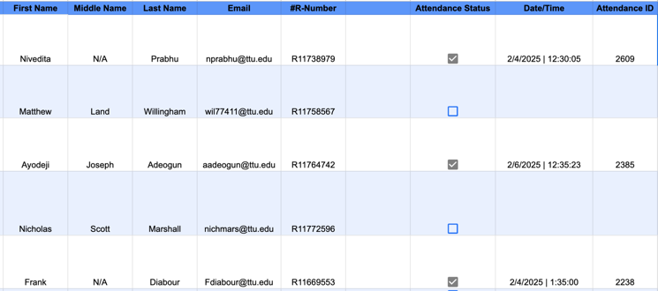

## System Integration [Model + Schema + UI]

### The proposed system is a web-based application designed to interact with attendance records and facilitate image uploads for verification purposes. The system integrates an Attendance Database, structured according to the provided ER diagram, to manage and store attendance records efficiently. Additionally, an AI Database is implemented to store trained data for facial recognition or other verification processes. To enhance model accuracy, Training Data will be collected and used for training the AI model; however, once training is complete, this data will be deleted to ensure data privacy and storage efficiency. The web interface will allow users to interact with attendance records, upload images for verification, and seamlessly integrate with the AI-driven recognition system.

The proposed website will serve as an attendance management system that tracks both past and current attendance records. It will allow users to upload or capture photos in real time, which will be processed using an AI-based verification system to mark attendance. The system will store attendance history, enabling administrators or instructors to review past records and monitor trends. Each student will have an individual profile where their attendance history can be accessed by clicking on their name, providing a detailed view of their participation over time. The platform will streamline attendance tracking by integrating image recognition technology with a structured database, ensuring accuracy and efficiency in monitoring student presence.

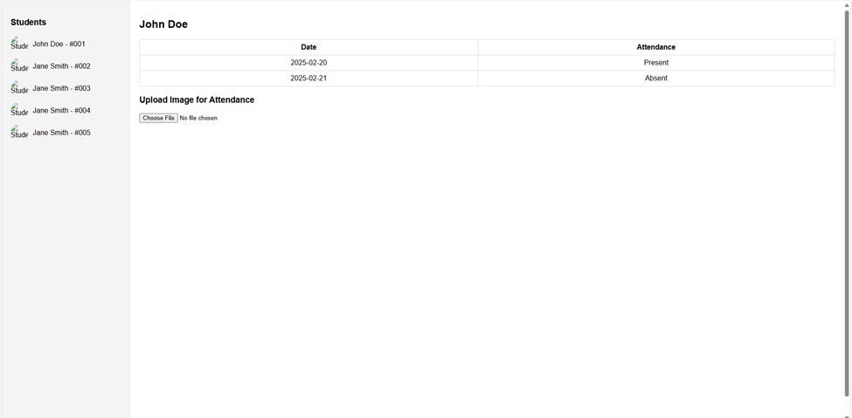

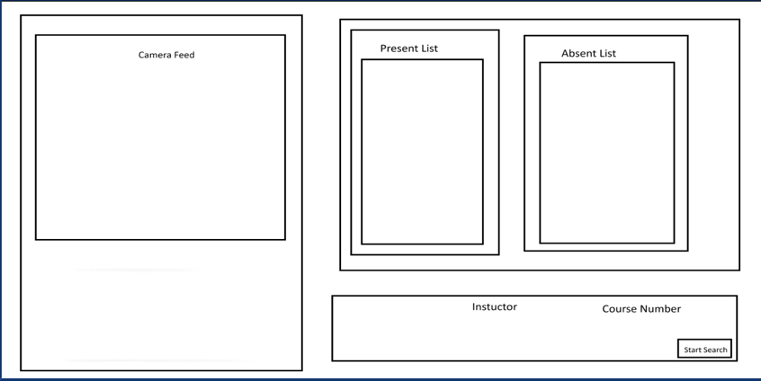

##### References

1. Ultralytics, “YoloV8 with Face Detection · Issue #4187 · ultralytics/ultralytics,” GitHub, 2024. https://github.com/ultralytics/ultralytics/issues/4187 (accessed Feb. 18, 2025).
2. Roboflow, “Difference Roboflow Model and Yolo8,” Roboflow, Nov. 21, 2023. <https://discuss.roboflow.com/t/difference-roboflow-model-and-yolo8/3785> (accessed Feb. 18, 2025)