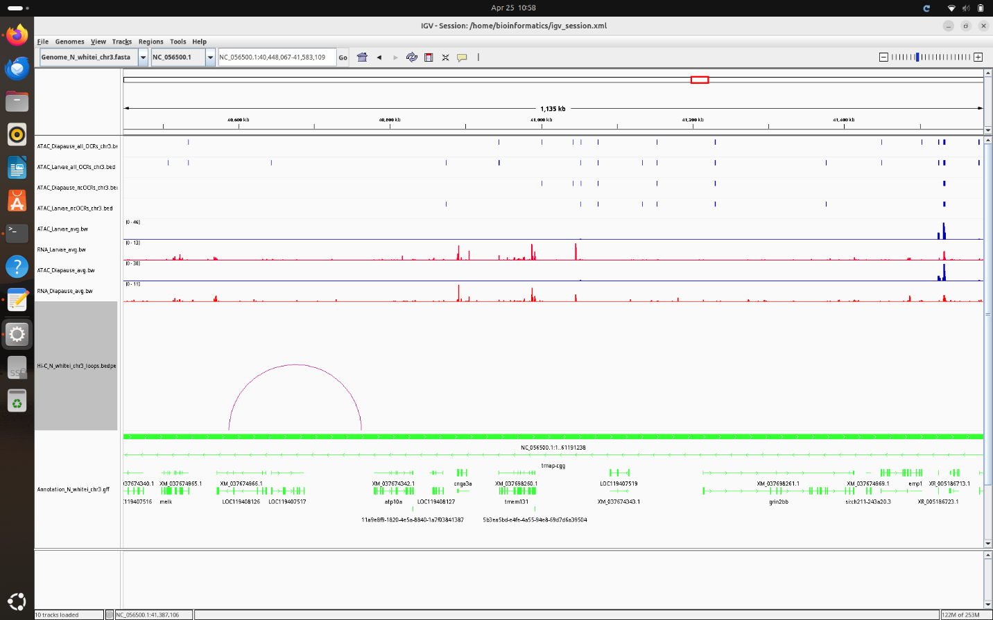

In the illustration shown above there are many different lines of information including ATAC peaks, gene expression data, and the Hi-C loops that correlate. The ACAC peak data that is focused on here is the non-coding OCR’s which indicate that the genomic information located in that position does not likely code for proteins. The gene expression data shows where coding for proteins does take place unlike the non-coding regions. And finally, the HI-C loops indicate the relationship between factors, especially when it comes to gene expression and where and how it occurs in a genome.