CSE6224 Software Requirements Engineering

Campus Wellness Portal with

Medical System and Fitness Center

Integration Project – Part 1

SRS Document

Tutorial Section: TT6L

Group 4

|  |  |
| --- | --- |
| Group member | Student ID |
| Nicholas Thong Meng Shui | 241UC2415Y |
| Muhammad Anas bin Khairul Azman | 241UC2401Z |
| Fikrul Amsyar Azmin | 241UC24167 |

**Table of Contents**

Changelog Table: 4

1. Introduction 7

1.1 Purpose 7

1.2 Scope 7

1.3 Product Overview 8

1.3.1 Product Perspective 8

1.3.2 Product functions 11

1.3.3 User Characteristics 12

1.3.4 Product Limitations 12

2.0 References 13

3.0 Requirements 13

3.1 Functional Requirement 13

3.1.1 Login 15

3.1.2 Book Fitness Class 16

3.1.3 Cancel Fitness Class 18

3.1.4 Schedule Health Centre Appointments 20

3.1.5 Cancel Health Centre Appointments 22

3.1.6 Track Wellness Goals 24

3.1.7 View Fitness Class Notifications 26

3.1.8 View Personalized Health Tips 28

3.1.9 Manage Health Centre Appointments 30

3.1.10 Manage Fitness Class Booking 32

3.1.11 Integrate Wellness Data Across Systems 34

3.2 Performance Requirements 40

3.3 Usability Requirements 40

3.4 Interface Requirements 40

3.4.1 Login Interface 40

3.4.2 Health Centre Appointment Interface 40

3.5 Logical Database Requirements 41

3.6 Design Constraints 41

3.7 Software System Attributes 42

3.7.1 Security 42

3.8 Supporting Information 43

4.0 Verification 43

5.0 Appendices 43

Pro



# Changelog Table:

|  |  |  |
| --- | --- | --- |
| Version | Author | Description |
| v1.0 | Nicholas Thong Meng Shui | * Created this document |
| V1.1 | Nicholas Thong Meng Shui | * Added information and content to 1.3.1 Product Perspective |
| V1.2 | Nicholas Thong Meng Shui | * Added information and content to 1.3.3 User Characteristics |
| V1.3 | Muhammad Anas bin Khairul Azman | * Added content to 1.3.2 Product Functions |
| V1.4 | Nicholas Thong Meng Shui | * Added Use Case Diagram to 3.1 Functions |
| V1.5 | Nicholas Thong Meng Shui | * Removed EHR System from 1.3.1 * Updated 1.3.2 Campus Recreation Facility Integration * Created and added content to table 3-1 in 3.1 functions * Added table labels to tables 1-1 and 3-1 |
| V1.5.1 | Muhammad Anas bin Khairul Azman | * Added Product Limitations in 1.3.4 * Added pretext for 3.1 Performance Requirements |
| V1.5.2 | Muhammad Anas bin Khairul Azman | * Added performance requirement and use case table for 3.1.5 |
| V1.5.3 | Muhammad Anas bin Khairul Azman | * Added functional requirement and use case table for 3.1.6, 3.1.7, 3.1.9 |
| V1.5.4 | Muhammad Anas bin Khairul Azman | * Added sequence diagrams for 3.1.5, 3.1.6, 3.1.7, 3.1.9 |
| V1.5.5 | Muhammad Anas bin Khairul Azman | * Fixed numbering for functional requirements |
| V.1.5.6 | Nicholas Thong Meng Shui | * Added Functional Requirements and use case table for 3.1.8, 3.1.10, 3.1.11 * Added Sequence Diagram for 3.1.8 |
| V1.5.7 | Muhammad Anas bin Khairul Azman | * Added cover page. * Added proper Table of Contents. * Added pre-text for upcoming chapters. * Added 3.2 Performance Requirements * Added 3.7 Security Requirements |
| V1.6 | Muhammad Anas bin Khairul Azman | * Added 3.4 Interface Requirements * Login interface and appointment interface |
| V1.6.1 | Nicholas Thong Meng Shui | * Updated figure 1.0 Use case diagram in 3.1 Functional Requirements * Updated table 3-1 Use case ID in 3.1 Functional Requirements * Updated use case table for 3.1.10, 3.1.11 * Added Sequence Diagrams for 3.1.10, 3.1.11 |
| V1.6.2 | Fikrul Amsyar Azmin | * Added functional requirements, use case table, and sequence diagram for 3.1.1, 3.1.2, 3.1.3, 3.1.4 * Added Project Purpose and Project Scope |
| V1.6.3 | Nicholas Thong Meng Shui | * Added functional requirements tables for 3.1.11 * Updated figure 1.0 Use case diagram in 3.1 Functional Requirements * Updated functional requirements and removed sequence diagram for 3.1.9 * Updated figure 1.0 Use case diagram in 3.1 Functional Requirements |

# Introduction

## Purpose

This project involves developing a wellness platform that integrates with the university health center's appointment system and campus recreation facility management software. The system will enable students to manage their holistic wellness by scheduling health center appointments, booking fitness classes, tracking personal wellness goals, and receiving tailored health resources.

## Scope

The system shall:

1. Make appointments, book fitness classes
2. Tracks health goals, receive tailored health resources

## 1.3 Product Overview

### 1.3.1 Product Perspective

The Wellness Platform is a system that integrates the university health centre’s appointment system and campus recreation facility management software. Its primary role is to support student wellness through personalized health resources and wellness goals, integration with university medical appointment records, and interaction with recreational facilities.

As such, this system communicates and interoperates with several other components of the university's infrastructure. These include the university authentication system, recreation portal, and health portal. The system utilizes these interfaces to authenticate users, retrieve health data, enable health appointment scheduling, enable fitness class scheduling, and provide wellness recommendations.

1. System Interfaces

* **Authentication System**: The system relies on the university's login infrastructure to authenticate student users securely.
* **Recreation Portal**: Interfaces with the university’s recreation facility management software to enable fitness class booking and data sharing.
* **Health Portal**: Interfaces with the university’s health centre’s appointment system to allow students to schedule health appointments.

1. User Interfaces
   1. Wellness Platform website shall make use of white (RGB Hex code: #FFFFFF) for its overall background and navigation bar font colour.
   2. Wellness Platform website shall always have a black (RGB Hex code: #000000) for non-navigation bar font colour.
   3. Wellness Platform website shall always have a blue (RGB Hex code: #000EBF) navigation bar present at the top of the page.
2. Hardware Interfaces

The system supports standard student devices such as personal computers and mobile phones. No specialized hardware is required.

1. Software Interfaces

|  |  |  |  |  |
| --- | --- | --- | --- | --- |
| **Name** | **Mnemonic** | **Specification Number** | **Version** | Reference |
| University Health Portal | UNIV_HEALTH_PORT | N/A | Current | [University Health Patient Portal](https://www.universityhealth.com/patient-visitor-resources/patients/patient-portal) |
| University Recreation Portal | UNIV_REC_PORTAL | N/A | Current | [Columbia University Recreation Portal](https://perec.columbia.edu/content/member-portal-resources) |
| OAuth 2.0 Authentication Framework | OAUTH2 | RFC 6749 | Latest | [OAuth 2.0 Specification](https://tools.ietf.org/html/rfc6749) |
| JSON Web Token Standard | JWT | RFC 7519 | Latest | [JWT Specification](https://tools.ietf.org/html/rfc7519) |
| RESTful API Interface | REST_API | OpenAPI 3.0 | Latest | [OpenAPI Specification](https://swagger.io/specification/) |

Interfaces:

* University Health Portal
  + **Purpose**: To allow students to manage medical appointments and view personal health records.
  + **Interface Definition**: Web-based interface; provides scheduling, messaging, and medical record access. Integration through RESTful API.
  + **Reference**: University Health Patient Portal
* University Recreation Portal
  + **Purpose**: To enable scheduling and tracking of fitness classes and recreational activities.
  + **Interface Definition**: Booking and facility access information exchanged over REST API. Includes user authentication via SSO.
  + **Reference**: Columbia University Recreation Portal
* OAuth 2.0 Authentication Framework
  + **Purpose**: To authenticate students securely across university systems.
  + **Interface Definition**: Standard OAuth 2.0 protocol to handle login tokens and authorization. Interfaces with the university’s identity provider.
  + **Reference**: OAuth 2.0 Specification
* JSON Web Token (JWT)
  + **Purpose**: To transmit session data securely between frontend and backend systems.
  + **Interface Definition**: Encodes claim-based tokens using standard JWT format (RFC 7519), embedded in HTTP headers.
  + **Reference**: JWT Specification
* RESTful API Interface
  + **Purpose**: To facilitate integration between the wellness platform and external systems such as EHR, health portal, and recreation systems.
  + **Interface Definition**: Uses HTTP(S) with standard methods (GET, POST, PUT, DELETE). Data formatted as JSON. Described using OpenAPI Specification.
  + **Reference**: OpenAPI Specification

1. Communication Interfaces

* HTTPS protocol is used for secure communication with internal university systems.
* Authentication via OAuth 2.0 and JWT for cross-system data sharing.

1. Memory Constraints

The system is lightweight and web-based, requiring minimal local memory. All user data is stored and processed in cloud/university-hosted servers.

1. Operations

The Wellness Platform is intended to function under both user-driven and automated operations. The following operational requirements are identified:

1) Modes of Operation

* **User-Initiated Mode**: Students interact with the web application to:
  + Set and view wellness goals.
  + Book or cancel health centre or fitness appointments.
  + View personalized health resources.
* **Admin Mode**: Authorized staff access logs or analytics reports through secure dashboards.

2) Periods of Interactive and Unattended Operations

* Interactive Operations:
  + Occur during active user sessions.
  + Includes booking appointments, viewing data, or modifying goals.
* Unattended Operations:
  + Background data syncing with Health Portal and Recreation Facility systems.
  + Periodic refresh of user statistics (e.g., wellness goals, appointment reminders).
  + Runs on a scheduled basis (e.g., nightly or hourly intervals).

3) Data Processing Support Functions

* **Data Aggregation**: Collects fitness and medical data from multiple systems and consolidates it in the student dashboard.
* **Data Validation**: Ensures data accuracy and compliance with privacy regulations (e.g., HIPAA).
* **Error Logging**: Logs failures during API communication or user actions for diagnostics.
* **Monitoring**: System health checks and logging for server uptime and performance metrics.

1. Site Adaptation Requirements

The system requires configuration of university-specific endpoints (e.g., Recreation API URLs, fitness class schedule formats) during deployment. It also requires institution-specific policy parameters (e.g., data retention limits, HIPAA compliance flags).

1. Interfaces with Services

Integrates with:

* University SaaS-based portals (e.g., health appointment scheduling)
* Cloud storage services (if enabled)

### 1.3.2 Product functions

Campus Recreation Facility Integration

* Search and filter classes by their type, date and location.
* Book fitness classes.
* Notification for open slots in fitness classes.
* Google/Outlook calendar integration which syncs any booked fitness classes.
* Email reminders of booked fitness classes

University Health Portal Integration

* Set personal wellness goals (steps, workout, sleep).
* Track personal wellness goals.
* Dashboard of wellness goal progress.
* Weekly summary of wellness goals.
* Receive tailored health resources based on user preferences.
* Schedule appointments with the health centre.
* Cancel scheduled appointments.

### 1.3.3 User Characteristics

Table 1-1 User Characteristics:

|  |  |  |
| --- | --- | --- |
| User group | Description | Minimum Ability/Knowledge |
| Students | Students currently enrolled in the university | Possess basic computer skills |

### 1.3.4 Product Limitations

#### 1.3.4.1 General Limitations

The main limitations of our product comes from the fact that it is only accessible via web browser for ease of access for students. Furthermore, the use of this wellness portal is only accessible for students within the university and is not available for staff members of the university or students outside of the university.

# 2.0 References

# 3.0 Requirements

## 3.1 Functional Requirement

Figure 1.0 : Use case diagram

Table 3-1 Use Case ID:

|  |  |  |  |
| --- | --- | --- | --- |
| **Use Case ID** | **Actor(s)** | **Use Case (Function)** | **Brief Description** |
| **UC_001** | Student | Login | Allows the student to log into the system using their credentials. |
| **UC_002** | Student | Book Fitness Class | Enables the student to select and book a fitness class from the available options. |
| **UC_003** | Student | Cancel Fitness Class | Allows the student to cancel a previously booked fitness class. |
| **UC_004** | Student | Schedule Health Centre Appointment | Allows the student to choose a time slot and book an appointment with the health centre. |
| **UC_005** | Student | Cancel Health Centre Appointment | Enables the student to cancel a scheduled health centre appointment. |
| **UC_006** | Student | Track Wellness Goals | Allows the student to set, monitor, and update personal wellness goals. |
| **UC_007** | Student | View Personalised Health Tips | Provides the student with curated health and wellness tips. |
| **UC_008** | Student, University Health Portal | Manage Health Centre Appointments | Receives and updates student health appointment bookings and cancellations. |
| **UC_009** | Student, University Recreation Portal | Manage Fitness Class Booking | Updates the fitness class schedule and availability based on bookings or cancellations. |
| **UC_010** | Wellness System Admin | Manage User Access Control | Allows the admin to create, modify, and delete user accounts and assign or revoke roles/permissions. |
| **UC_011** | Wellness System Admin | View System Logs | Enables the admin to retrieve, review and export system logs for monitoring and auditing purposes. |

### 3.1.1 Login

Functional Requirement for Login

|  |  |
| --- | --- |
| **Requirement ID** | REQ_101 |
| **Description** | System shall be able to validate user login. |
| **Author** | Fikrul Amsyar Azmin |

|  |  |
| --- | --- |
| **Requirement ID** | REQ_102 |
| **Description** | System shall be able to process user registration. |
| **Author** | Fikrul Amsyar Azmin |

|  |  |
| --- | --- |
| **Requirement ID** | REQ_103 |
| **Description** | System shall display an appropriate message when an error occurred where login credentials are incorrect. |
| **Author** | Fikrul Amsyar |

Use Case Table

|  |  |  |
| --- | --- | --- |
| **Use Case ID** | UC001 | |
| **Feature** | F001 Login | |
| **Purpose** | To allow users to login to their own account | |
| **Actor** | Student | |
| **Trigger** | User clicks on “Login” button on the wellness platform portal | |
| **Precondition** | User is in the wellness platform portal | |
| **Scenario Name** | **Step** | **Action** |
| **Main Flow** | 1 | User clicks on “Login” button on the wellness platform portal. |
|  | 2 | System displays the login page to the user. |
|  | 3 | User inputs login credentials (studentID, studentPassword) and clicks the “Login” button. |
|  | 4 | System displays the wellness platform portal with the user account logged in if the login credentials is valid. |
| **Alternate Flow - Invalid Login Credentials** | 1 | System displays an appropriate error message to the user. |
|  | 2 | Back to Main Flow Step 2. |
| **Alternate Flow – Cancel Login** | 1 | User clicks on “Cancel Login” button on the login page. |
|  | 2 | System displays the wellness platform portal without the user account logged in. |
| **Rules** | * Login credentials must be within 25 characters. | |
| **Author** | Fikrul Amsyar Azmin | |

Sequence Diagram for Login

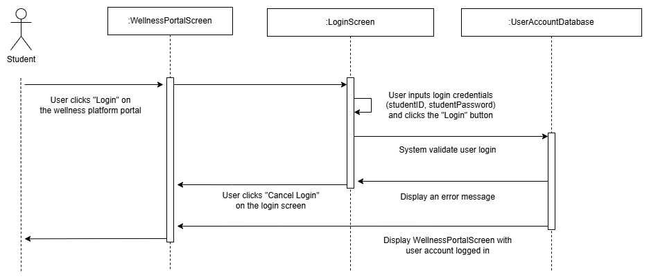

### 3.1.2 Book Fitness Class

|  |  |
| --- | --- |
| **Requirement ID** | REQ_201 |
| **Description** | System shall allow users to book a class if spots are available. |
| **Author** | Fikrul Amsyar Azmin |

|  |  |
| --- | --- |
| **Requirement ID** | REQ_202 |
| **Description** | System shall decrease the number of available spots after a successful booking. |
| **Author** | Fikrul Amsyar Azmin |

|  |  |
| --- | --- |
| **Requirement ID** | REQ_203 |
| **Description** | System shall display a confirmation message when a booking is successful. |
| **Author** | Fikrul Amsyar Azmin |

|  |  |
| --- | --- |
| **Requirement ID** | REQ_204 |
| **Description** | System shall display a table of available fitness classes. |
| **Author** | Fikrul Amsyar Azmin |

|  |  |
| --- | --- |
| **Requirement ID** | REQ_205 |
| **Description** | System shall prompt the user if they want to book the selected class. |
| **Author** | Fikrul Amsyar Azmin |

Use Case Table

|  |  |  |
| --- | --- | --- |
| **Use Case ID** | UC002 | |
| **Feature** | F002 Book Fitness Class | |
| **Purpose** | To allow users to book for a fitness class. | |
| **Actor** | Student | |
| **Trigger** | User clicks on “Book Fitness Class” button on the wellness platform portal. | |
| **Precondition** | User account is logged in; User is in the wellness platform portal | |
| **Scenario Name** | **Step** | **Action** |
| **Main Flow** | 1 | User clicks “Book Fitness Class” button on the wellness platform portal. |
|  | 2 | System displays a table of available fitness classes with “Book” button on each row, and a “Go back” button at the top left near the table. |
|  | 3 | User clicks a “Book” button on the fitness classes table. |
|  | 4 | System displays a dialog box to the user if they want to book a class. |
|  | 5 | User clicks “Yes” button in the dialog box. |
|  | 6 | System displays a confirmation message that a booking is successful. |
|  | 7 | Back to Main Flow Step 2 |
| **Alternate Flow – User clicks “No” in the dialog box** | 1 | User clicks “No” button in the dialog box. |
|  | 2 | Back to Main Flow Step 2 |
| **Alternate Flow – User clicks “Go back” in the table of available fitness classes** | 1 | User clicks “Go back” button in the table of available fitness classes page. |
|  | 2 | System displays the wellness platform portal. |
| **Rules** |  | |
| **Author** | Fikrul Amsyar Azmin | |

Sequence Diagram for Book Fitness Class

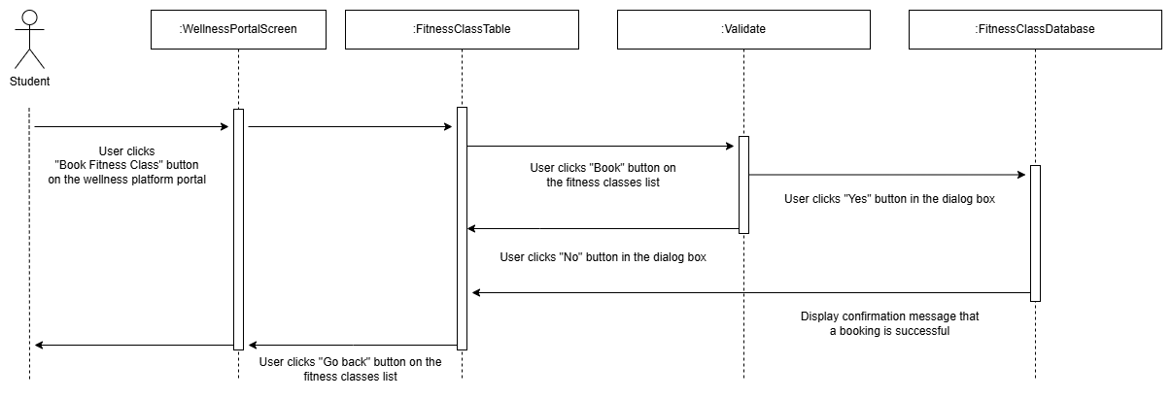

### 3.1.3 Cancel Fitness Class

|  |  |
| --- | --- |
| **Requirement ID** | REQ_301 |
| **Description** | System shall allow users to cancel the selected class that the users booked. |
| **Author** | Fikrul Amsyar Azmin |

|  |  |
| --- | --- |
| **Requirement ID** | REQ_302 |
| **Description** | System shall increase the number of available spots after a cancellation. |
| **Author** | Fikrul Amsyar Azmin |

|  |  |
| --- | --- |
| **Requirement ID** | REQ_303 |
| **Description** | System shall display a confirmation message after a successful booked class cancellation. |
| **Author** | Fikrul Amsyar Azmin |

|  |  |
| --- | --- |
| **Requirement ID** | REQ_304 |
| **Description** | System shall prompt the user if they want to cancel the selected booked class. |
| **Author** | Fikrul Amsyar Azmin |

Use Case Table

|  |  |  |
| --- | --- | --- |
| **Use Case ID** | UC003 | |
| **Feature** | F003 Cancel Fitness Class | |
| **Purpose** | To allow users to cancel a booked fitness class. | |
| **Actor** | Student | |
| **Trigger** | User clicks “Cancel” button on the manage fitness class screen. | |
| **Precondition** | User is in the manage fitness class booking screen | |
| **Scenario Name** | **Step** | **Action** |
| **Main Flow** | 1 | User clicks “Cancel” button on the fitness class table. |
|  | 2 | System displays a dialog box to the user if they want to cancel the selected class. |
|  | 3 | User clicks “Yes” button in the dialog box. |
|  | 4 | System displays a confirmation message that the selected booked class is cancelled. |
|  | 5 | System displays the manage fitness class booking screen. |
| **Alternate Flow – User clicks “No” in the dialog box** | 1 | User clicks “No” button in the dialog box. |
|  | 2 | System displays the manage fitness class booking screen. |
| **Rules** |  | |
| **Author** | Fikrul Amsyar Azmin | |

Sequence Diagram for Cancel Fitness Class

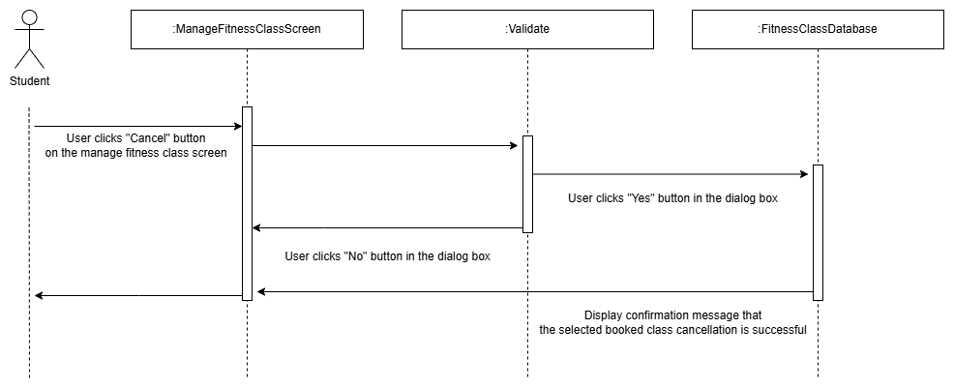

### 3.1.4 Schedule Health Centre Appointments

|  |  |
| --- | --- |
| **Requirement ID** | REQ_401 |
| **Description** | System shall allow users to schedule health centre appointments. |
| **Author** | Fikrul Amsyar Azmin |

|  |  |
| --- | --- |
| **Requirement ID** | REQ_402 |
| **Description** | System shall display a table of available health centre appointments. |
| **Author** | Fikrul Amsyar Azmin |

|  |  |
| --- | --- |
| **Requirement ID** | REQ_403 |
| **Description** | System shall display a confirmation message after a successful schedule health centre appointment. |
| **Author** | Fikrul Amsyar Azmin |

|  |  |
| --- | --- |
| **Requirement ID** | REQ_404 |
| **Description** | System shall prompt the user if they want to make an appointment on the selected schedule. |
| **Author** | Fikrul Amsyar Azmin |

Use Case Table

|  |  |  |
| --- | --- | --- |
| **Use Case ID** | UC004 | |
| **Feature** | F004 Schedule Health Centre Appointments | |
| **Purpose** | To allow users to schedule health centre appointments. | |
| **Actor** | Student | |
| **Trigger** | User clicks “Schedule Health Centre Appointments” button on the wellness platform portal. | |
| **Precondition** | User account is logged in; User is in the wellness platform portal | |
| **Scenario Name** | **Step** | **Action** |
| **Main Flow** | 1 | User clicks “Schedule Health Centre Appointments” button on the wellness platform portal. |
|  | 2 | System displays a table of available health centre appointments with “Schedule appointment” button on each row, and a “Go back” button at the top left near the table. |
|  | 3 | User clicks a “Schedule appointment” button on the table of available health centre appointments. |
|  | 4 | System displays a dialog box to the user if they want to make an appointment on the selected schedule. |
|  | 5 | User clicks “Yes” button in the dialog box. |
|  | 6 | System displays a confirmation message that the appointment schedule is successful. |
|  | 7 | Back to Main Flow Step 2. |
| **Alternate Flow – User clicks “No” in the dialog box** | 1 | User clicks “No” button in the dialog box. |
|  | 2 | Back to Main Flow Step 2. |
| **Alternate Flow – User clicks “Go back” in the table of available health centre appointments** | 1 | User clicks “Go back” button in the table of available health centre appointments. |
|  | 2 | System displays the wellness platform portal. |
| **Rules** |  | |
| **Author** | Fikrul Amsyar Azmin | |

Sequence Diagram for Schedule Health Centre Appointments

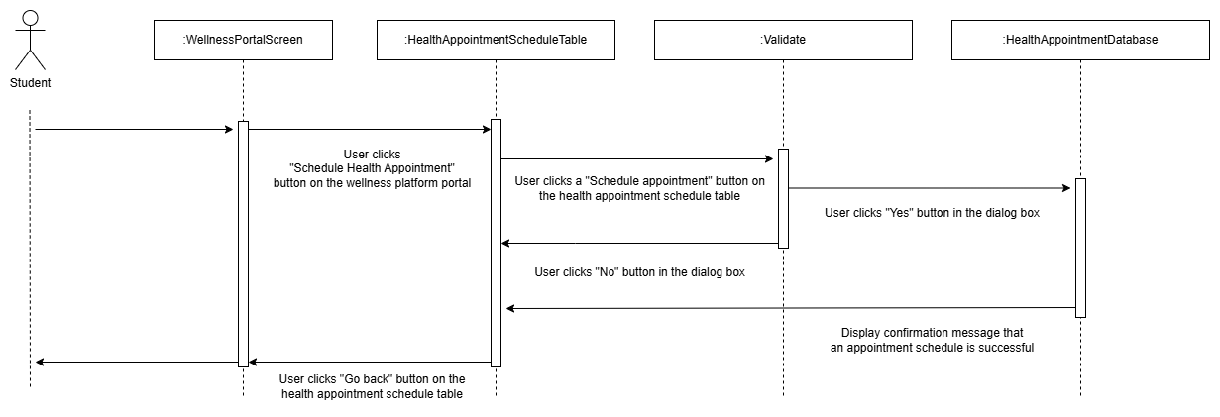

### 3.1.5 Cancel Health Centre Appointments

Functional Requirement for Cancel Health Centre Appointment

|  |  |
| --- | --- |
| **Requirement ID** | REQ_501 |
| **Description** | System shall allow the user to cancel a health centre appointment. |
| **Author** | Muhammad Anas |

|  |  |
| --- | --- |
| **Requirement ID** | REQ_502 |
| **Description** | System shall prompt the user to confirm if they want to cancel the selected appointment. |
| **Author** | Muhammad Anas |

|  |  |
| --- | --- |
| **Requirement ID** | REQ_503 |
| **Description** | System shall display a confirmation message that the selected appointment has been cancelled. |
| **Author** | Muhammad Anas |

|  |  |
| --- | --- |
| **Requirement ID** | REQ_504 |
| **Description** | System shall update user’s appointments to reflect cancellation of appointment. |
| **Author** | Muhammad Anas |

Use Case Table

|  |  |  |
| --- | --- | --- |
| **Use Case ID** | UC005 | |
| **Feature** | F005 Cancel Health Centre Appointments | |
| **Purpose** | To allow users to cancel their scheduled health centre appointments. | |
| **Actor** | Student | |
| **Trigger** | User clicks on “Cancel Appointment” button on a given appointment. | |
| **Precondition** | User is in the manage health centre appointment screen | |
| **Scenario Name** | **Step** | **Action** |
| **Main Flow** | 1 | User clicks on manage health centre appointment screen. |
|  | 2 | User clicks on “Cancel Appointment” for a given appointment. |
|  | 3 | System displays dialog box to confirm if the user wants to cancel said appointment. |
|  | 4 | User clicks on “Yes” in the dialog box. |
|  | 5 | System updates user’s appointment table to reflect the cancelled appointment. |
|  | 6 | System displays confirmation message that the appointment has been cancelled. |
|  | 8 | System displays the health centre appointment screen with the cancelled appointment now updated. |
| **Alternate Flow – User clicks “No” in the dialog box** | 1 | User clicks on “No” in the dialog box. |
|  | 2 | System displays the health centre appointment screen. |
| **Rules** | * User must already have an existing scheduled appointment. | |
| **Author** | Muhammad Anas | |

Sequence Diagram for Cancel Health Centre Appointment

### 3.1.6 Track Wellness Goals

Functional Requirement for Tracking Wellness Goals

|  |  |
| --- | --- |
| **Requirement ID** | REQ_601 |
| **Description** | System shall display the user’s wellness goals over the past month in the dashboard. |
| **Author** | Muhammad Anas |

|  |  |
| --- | --- |
| **Requirement ID** | REQ_602 |
| **Description** | System shall allow the user to set new wellness goals. |
| **Author** | Muhammad Anas |

|  |  |
| --- | --- |
| **Requirement ID** | REQ_603 |
| **Description** | System shall allow the user to update their wellness goals. |
| **Author** | Muhammad Anas |

Use Case Table

|  |  |  |
| --- | --- | --- |
| **Use Case ID** | UC006 | |
| **Feature** | F006 Track Personal Wellness Goals | |
| **Purpose** | To allow users to monitor, set and update their personal wellness goals. | |
| **Actor** | Student | |
| **Trigger** | User clicks on “Wellness Goals” button on the platform portal. | |
| **Precondition** | User is in the wellness platform portal. | |
| **Scenario Name** | **Step** | **Action** |
| **Main Flow – Monitoring wellness goals** | 1 | User clicks on “Wellness Goals” button on the platform portal. |
|  | 2 | System displays wellness goals dashboard to the user. |
| **Alternate Flow – Setting new wellness goals** | 3 | User clicks on “Set new wellness goal” button. |
|  | 4 | System prompts the user to input their wellness goal. |
|  | 5 | System updates the user’s wellness goal database. |
|  | 6 | System displays confirmation message that the wellness goal has been added. |
|  | 7 | System displays the updated wellness goal dashboard. |
| **Alternate Flow – Updating existing wellness goals** | 1 | User clicks on “Update” button on a given wellness goal. |
|  | 2 | System prompts the user to update the values for the wellness goal. |
|  | 3 | System updates the user’s wellness goal database. |
|  | 4 | System displays confirmation message that the wellness goal has been updated. |
|  | 6 | System displays the updated wellness goal dashboard |
| **Rules** | - | |
| **Author** | Muhammad Anas | |

### 3.1.7 View Fitness Class Notifications

Functional Requirement for Viewing Notifications

|  |  |
| --- | --- |
| Requirement ID | REQ_701 |
| Description | System shall allow the user to view any fitness class notifications. |
| Author | Muhammad Anas |

|  |  |
| --- | --- |
| Requirement ID | REQ_702 |
| Description | System shall display the fitness class notifications to the user. |
| Author | Muhammad Anas |

Use Case Table

|  |  |  |
| --- | --- | --- |
| **Use Case ID** | UC007 | |
| **Feature** | F007 View Fitness Class Notifications | |
| **Purpose** | To allow users to view their fitness class notifications. | |
| **Actor** | Student | |
| **Trigger** | User clicks on “Notifications” button on the platform portal. | |
| **Precondition** | User is in the wellness platform portal. | |
| **Scenario Name** | **Step** | **Action** |
| **Main Flow** | 1 | User clicks on “Notifications” button on the platform portal. |
|  | 2 | System displays the fitness class notifications to the user. |
| **Rules** | * Users must be signed up/have booked a fitness class. * Without it, notifications will be empty. | |
| **Author** | Muhammad Anas | |

Sequence Diagram for viewing fitness class notifications

### 3.1.7 View Personalized Health Tips

Functional Requirements for View Personalized Health Tips

|  |  |
| --- | --- |
| Requirement ID | REQ_801 |
| Description | |  | | --- | | System shall retrieve health tips tailored to the student’s profile and goals. |  |  | | --- | |  | |
| Author | Nicholas Thong Meng Shui |

|  |  |
| --- | --- |
| Requirement ID | REQ_802 |
| Description | System shall display retrieved health tips in the student’s dashboard. |
| Author | Nicholas Thong Meng Shui |

|  |  |
| --- | --- |
| Requirement ID | REQ_803 |
| Description | System shall allow the student to request more details on any displayed tip. |
| Author | Nicholas Thong Meng Shui |

Use Case Table

|  |  |  |  |
| --- | --- | --- | --- |
| **Use Case ID** | UC_008 | | |
| **Feature** | |  | | --- | |  |  |  | | --- | | View Personalized Health Tips | | | |
| **Purpose** | Provide curated health and wellness tips based on student profile. | | |
| **Actor** | |  | | --- | |  |  |  | | --- | | Student | | | |
| **Trigger** | Student selects “View Health Tips.” | | |
| **Precondition** | Student is logged in; tips database is accessible. | | |
| **Scenario Name** | **Step** | **Action** |
| **Main Flow – User viewing health tips** | 1 | |  |  | | --- | --- | |  | Student clicks “Health Tips” menu. | |
| 2 | |  | | --- | | System retrieves tailored tips (REQ_801). | |
| 3 | |  |  | | --- | --- | |  | System displays tips list (REQ_802). | |
| 4 | |  | | --- | | Student selects a tip for more details. | |
| 5 | System shows full tip details (REQ_803). |
| **Alternate Flow – No Tips Available** | 2a | If no tips match profile, System displays “No personalized tips available.” |
| **Rules** | Tips must be relevant to current wellness goals. | | |
| **Author** | Nicholas Thong Meng Shui | |

### 3.1.8 Manage Health Centre Appointments

Functional Requirement for Manage Health Centre Appointments

|  |  |
| --- | --- |
| Requirement ID | REQ_901 |
| Description | System shall allow the user the view their health centre appointments (scheduled and cancelled). |
| Author | Muhammad Anas |

Use Case Table

|  |  |  |
| --- | --- | --- |
| **Use Case ID** | UC009 | |
| **Feature** | F009 Manage Health Centre Appointments | |
| **Purpose** | To receive and update a user’s scheduled and cancelled health centre appointments. | |
| **Actor** | University Health Portal | |
| **Trigger** | User clicks on “Schedule Appointment” or “Cancel Appointment” button on the “Health Centre Appointments” screen. | |
| **Precondition** | User is in the Health Centre Appointments screen. | |
| **Scenario Name** | **Step** | **Action** |
| **Main Flow – User scheduled an appointment** | 1 | User clicks on “Schedule Appointment” button on the Appointments screen. |
|  | 2 | System prompts the user to set appointment date. |
|  | 3 | System updates the appointments database for the user. |
|  | 4 | System displays updated appointments table to the user. |
| **Alternate Flow – User cancelled an appointment** | 1 | User clicks on “Cancel Appointment” on the Appointments screen |
|  | 2 | System displays dialog box to confirm if the user wants to cancel their appointment. |
|  | 3 | User clicks on the “Yes” button in the dialog box. |
|  | 4 | System updates the appointments database for the user. |
|  | 5 | System displays updated appointments table to the user. |
| **Rules** | - | |
| **Author** | Muhammad Anas | |

### 3.1.9 Manage Fitness Class Booking

Functional Requirements for Manage Fitness Class Booking

|  |  |
| --- | --- |
| Requirement ID | REQ_901 |
| Description | System shall display a list of the student’s current class bookings. |
| Author | Nicholas Thong Meng Shui |

|  |  |
| --- | --- |
| Requirement ID | REQ_902 |
| Description | System shall allow branching to either the Book or Cancel use case based on action. |
| Author | Nicholas Thong Meng Shui |

|  |  |
| --- | --- |
| Requirement ID | REQ_903 |
| Description | Upon completion of the child use case, system shall refresh the bookings list. |
| Author | Nicholas Thong Meng Shui |

|  |  |
| --- | --- |
| Requirement ID | REQ_904 |
| Description | If the Book or Cancel use case produces an error, system shall display it. |
| Author | Nicholas Thong Meng Shui |

Use Case Table

|  |  |  |  |
| --- | --- | --- | --- |
| **Use Case ID** | UC_009 | | |
| **Feature** | |  | | --- | |  |  |  | | --- | | Manage Fitness Class Booking | | | |
| **Purpose** | Allows students to view, book and cancel fitness-class reservations from one page. | | |
| **Actor** | |  | | --- | |  |  |  | | --- | | Student | | | |
| **Trigger** | |  | | --- | |  |  |  | | --- | | Student navigates to the “Manage Fitness Class Booking” screen. | | | |
| **Precondition** | Student is logged in; “Manage Fitness Class Booking” page is displayed. | | |
| **Scenario Name** | **Step** | **Action** |
| **Main Flow – Student view, book or cancel fitness class** | 1 | |  |  | | --- | --- | |  | System displays a table of the student’s current class reservations. | |
| 2 | Student views scheduled fitness classes |
| 3 | |  |  |  |  |  | | --- | --- | --- | --- | --- | |  | |  | | --- | |  |  |  |  | | --- | --- | | |  | | --- | | Student clicks either “Book Class” or “Cancel Class.” | | | |
| 3.1 | |  |  |  | | --- | --- | --- | | |  | | --- | |  |  |  | | --- | | If “Book Class”: invoke **UC002 Book Fitness Class** | | |
| 3.2 | If “Cancel Class”: invoke **UC003 Cancel Fitness Class** |
| 4 | System refreshes and re-displays the updated reservations table. |
| **Alternate Flow – Table error** | 1a | Recreation Portal API returns error during table request. |
| 1b | System logs and displays error |
| **Rules** | Booking requests must include valid student and class identifiers. | | |
| **Author** | Nicholas Thong Meng Shui/ Fikrul Amsyar Azmin | |

### 3.1.11 View system logs

Functional requirements for view system logs

|  |  |
| --- | --- |
| Requirement ID | REQ_1101 |
| Description | System shall allow administrators to filter logs by date range, severity level, and source module. |
| Author | Nicholas Thong Meng Shui |

|  |  |
| --- | --- |
| Requirement ID | REQ_1102 |
| Description | System shall display a paginated list of log entries matching the selected filter criteria. |
| Author | Nicholas Thong Meng Shui |

|  |  |
| --- | --- |
| Requirement ID | REQ_1103 |
| Description | System shall show full details (timestamp, actor, action, message, stack trace) for any log entry. |
| Author | Nicholas Thong Meng Shui |

|  |  |
| --- | --- |
| Requirement ID | REQ_1104 |
| Description | System shall allow administrators to export filtered log entries in CSV or JSON format. |
| Author | Nicholas Thong Meng Shui |

|  |  |
| --- | --- |
| Requirement ID | REQ_1105 |
| Description | System shall restrict access to the View Logs feature to users with the “Wellness System Admin” role. |
| Author | Nicholas Thong Meng Shui |

|  |  |
| --- | --- |
| Requirement ID | REQ_1106 |
| Description | System shall log each “view” or “export” action performed by administrators for audit purposes. |
| Author | Nicholas Thong Meng Shui |

Use Case Table

|  |  |  |  |
| --- | --- | --- | --- |
| **Use Case ID** | UC_011 | | |
| **Feature** | View System Logs | | |
| **Purpose** | |  | | --- | |  |  |  | | --- | | Provide administrators with on-demand access to system logs for monitoring and troubleshooting. | | | |
| **Actor** | |  | | --- | |  |  |  | | --- | | Wellness System Admin | | | |
| **Trigger** | |  | | --- | |  |  |  | | --- | | Admin selects “View System Logs” in the admin console. | | | |
| **Precondition** | |  | | --- | |  |  |  | | --- | | Admin is authenticated and has “Wellness System Admin” role.; Central log store is reachable. | | | |
| **Scenario Name** | **Step** | **Action** |
| **Main Flow – User scheduled an appointment** | 1 | |  |  | | --- | --- | |  | Admin navigates to the “System Logs” page in the admin console. | |
| 2 | |  | | --- | | System displays filter controls (date range, severity, source). (*REQ-1101)* | |
| 3 | |  |  |  |  | | --- | --- | --- | --- | |  | |  | | --- | |  |  |  | | --- | | Admin enters filter criteria and clicks “Search.” | | |
| 4 | |  |  |  | | --- | --- | --- | | |  | | --- | |  |  |  | | --- | | System retrieves matching log entries, paginates them, and displays a summary list. (*REQ-1102)* | | |
| 5 | Admin clicks on a specific log entry. |
| 6 | System shows full details of that entry (timestamp, actor, action, message, stack trace). (*REQ-1103)* |
| **Alternate Flow – No Matching Logs** | 4a | If no log entries match the filter, System displays “No records found” and offers to clear filters. |
| **Alternate Flow – Export Logs** | 7a | Integration Service receives data with unexpected format from one portal. |
| 7b | System generates the export file and makes it available for download. (*REQ-1104)* |
| 7c | System records the “view” and/or “export” action in an audit log. (*REQ-1106)* |
| **Rules** | - Only one export operation can run at a time per admin session.  - Log entries must be retained for at least 90 days.  - All actions on the View Logs page (search, view details, export) must themselves be logged for audit. | | |
| **Author** | Nicholas Thong Meng Shui | |

## 3.2 Performance Requirements

The performance for the Campus Wellness Portal are as follows:

|  |  |  |  |
| --- | --- | --- | --- |
| **Requirement ID** | **Description** | **Priority** | **Author** |
| REQ_P001 | The average response time of Wellness Portal functions shall be less than 2 seconds. | High | Muhammad Anas |

## 3.3 Usability Requirements

## 3.4 Interface Requirements

This section covers the external interface requirements of the Campus Wellness Portal, separated by the features of the system.

### 3.4.1 Login Interface

|  |  |  |  |
| --- | --- | --- | --- |
| **Requirement ID** | REQ_IO101 | **Version** | 1.0 |
| **Item** | Student ID (input) | | |
| **Description** | Input student ID on the portal login | | |
| **Purpose** | To allow the student to log into the portal | | |
| **Format** | String/Text | **Valid Range** | Not applicable |
| **Related I/O** | None | | |
| **Author** | Muhammad Anas | | |

|  |  |  |  |
| --- | --- | --- | --- |
| **Requirement ID** | REQ_IO102 | **Version** | 1.0 |
| **Item** | Student password (input) | | |
| **Description** | Input student password on the portal login | | |
| **Purpose** | To allow the student to log into the portal | | |
| **Format** | String/Text | **Valid Range** | Not applicable |
| **Related I/O** | None | | |
| **Author** | Muhammad Anas | | |

### 3.4.2 Health Centre Appointment Interface

|  |  |  |  |
| --- | --- | --- | --- |
| **Requirement ID** | REQ_IO103 | **Version** | 1.0 |
| **Item** | ‘Schedule Appointment’ button | | |
| **Description** | Button to schedule an appointment | | |
| **Purpose** | To allow the student to schedule an appointment | | |
| **Format** | Button | **Valid Range** | Not applicable |
| **Related I/O** | None | | |
| **Author** | Muhammad Anas | | |

|  |  |  |  |
| --- | --- | --- | --- |
| **Requirement ID** | REQ_IO104 | **Version** | 1.0 |
| **Item** | ‘Cancel Appointment’ button | | |
| **Description** | Button to cancel a scheduled appointment | | |
| **Purpose** | To allow the student to cancel a scheduled appointment | | |
| **Format** | Button | **Valid Range** | Not applicable |
| **Related I/O** | None | | |
| **Author** | Muhammad Anas | | |

## 3.5 Logical Database Requirements

## Design Constraints

## 3.7 Software System Attributes

This section specifies the attributes that are expected from the Wellness Portal and its implementations.

### 3.7.1 Security

The security requirements for the Wellness Portal are as follows:

|  |  |  |  |
| --- | --- | --- | --- |
| **Requirement ID** | **Description** | **Priority** | **Author** |
| REQ_Q001 | The Wellness Portal may only be accessed by students of the university. | High | Muhammad Anas |

## 3.8 Supporting Information

# 4.0 Verification

# 5.0 Appendices