**Computer Networks HW 3**

# Interesting Fact:



We see that there is no clear linear relationship between the time a website takes to load and the Speednet.com download rate, which may be understood because there are several rounds of 6 TCP connections to get the full webpages, so the speedup may be compounded. There may also be problems with the speed testing done online, although they were tested within a minute of running the page.  
UH:  
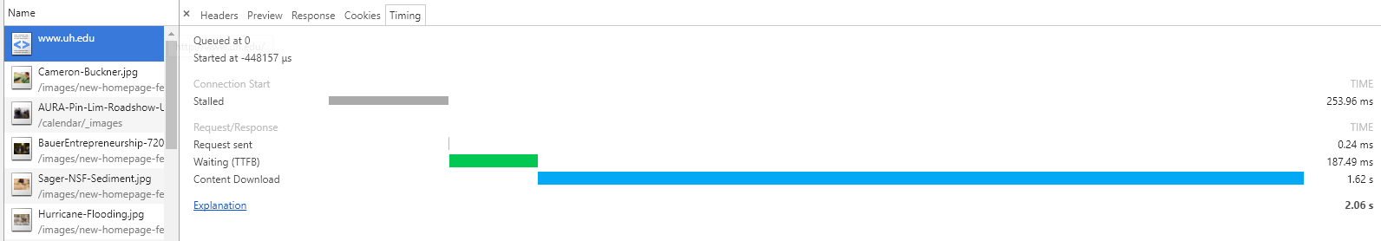

Instead of the Cameron-Buckner.jpg taking the most amount of time, the uh.edu document type took the longest, despite being a tenth the size of the Cameron-Buckner.jpg the uh.edu document type is taking half a second longer to load, even though the bulk of the time spent is on the Content Download.

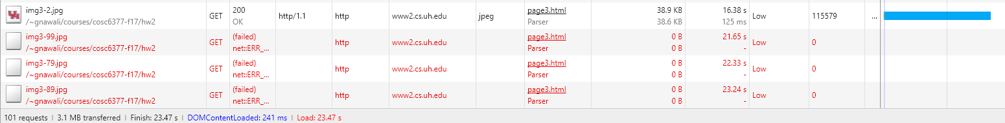  
We see that on the Page 3 site, we get a web-timeout on 3 images, which do not load on the webpage, this is because of a timeout from an anomalous image 2 taking 16 seconds to load, and the timeout being set at 21.65 seconds. When repeated the webpage loads correctly and nothing takes significantly longer, (but this example is more interesting and will be used). This timeout can obviously be resolved by refreshing the page, as it appears these are dropped packets.  
  
Home:

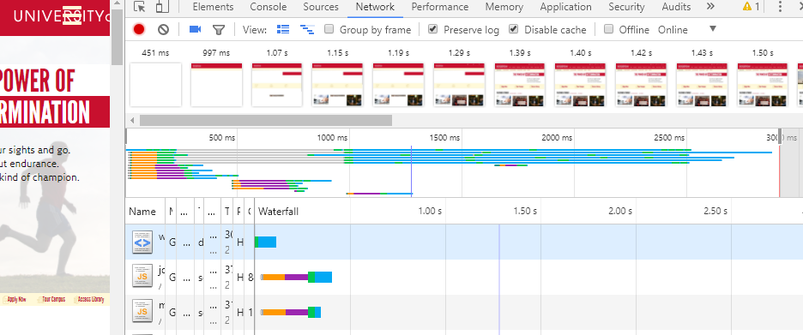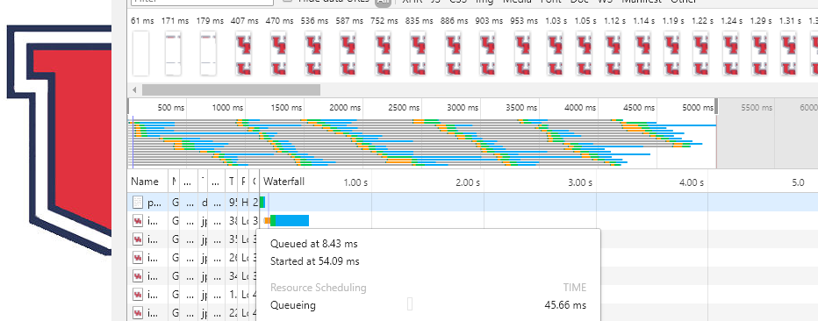  
The pages take: 3000 ms, and 5000 ms to load completely respectively, and there are no anomalies.

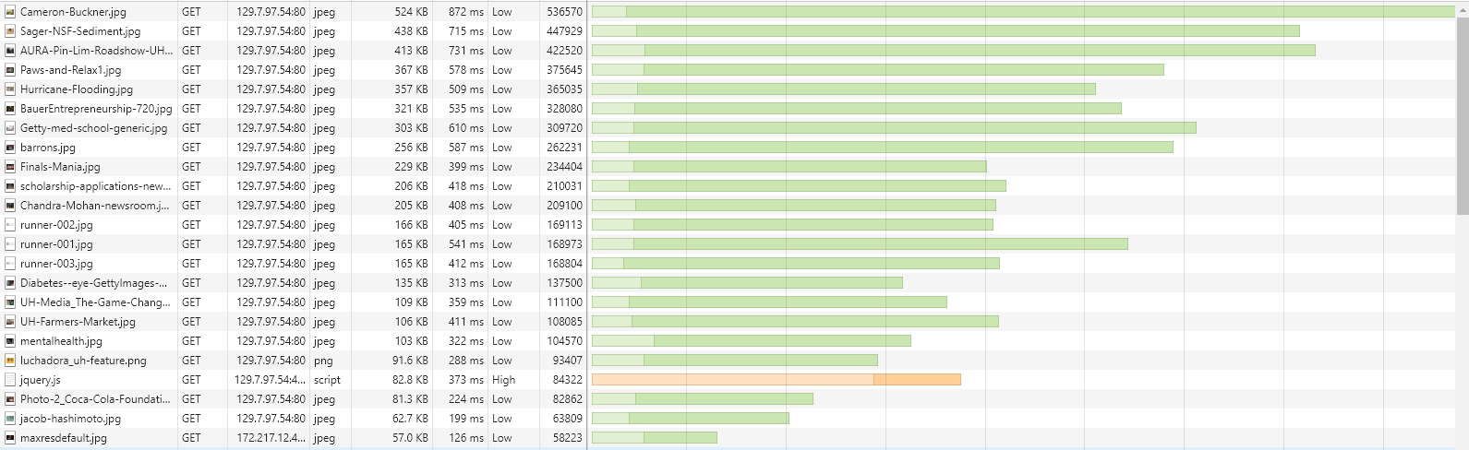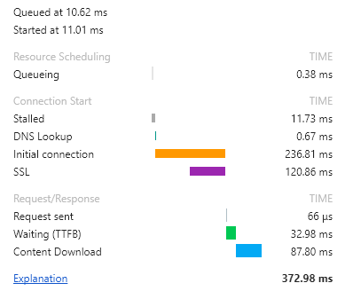Cameron-Buckner.jpg takes the most amount of time to run, since it is the largest image, and can be sped up mostly by improving the network speed.

We do see that there is a definite order to the uh.edu page, it takes js/css, then css headers/footers, css, and finally moves onto images. This proves that the browser is taking a top down approach.

The Javascript components take roughly 240 ms to establish an initial connection, which “is the time taken to establish a connection, including TCP handshake/retries and negotiating a SSL.” This is a networking problem, and can be fixed by speeding up the throughput of downloads.

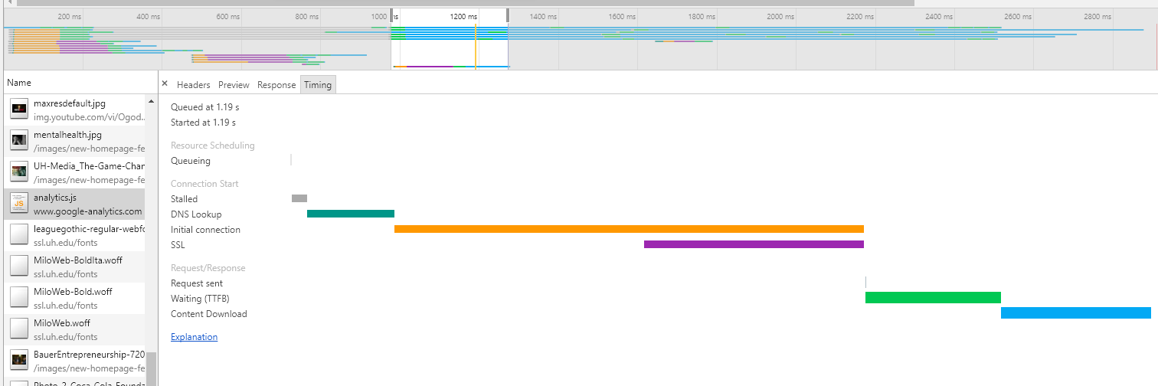  
The biggest holdup in the pipeline is the analytics.js that is executed after the fonts are downloaded, and is a tangles mess of javascript functions, that holds up the entire webpage loading with a comparatively slow DNS Lookup, connection, SSL handshake, and the lengthy Time to First Byte.  
This is a networking related problem, of a key component of the website having a lengthy latency and time intensive handshake.  
Starbucks:

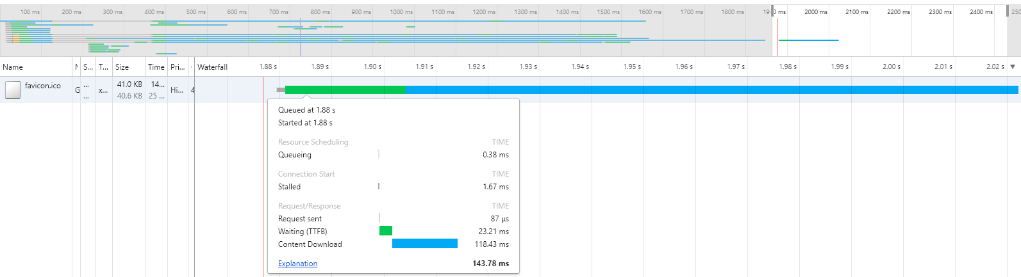

We see a strange anomaly in the favicon loading, (favicon icon used as the url image in this case a UH insignia), where it appears to be requested after everything else has finished, but the waterfall never finishes, and the details show it finishes in 150 ms. The webpage has a favicon in the url, so it appears to have finally loaded, and this seems like an error with the network analyzer, and not the network itself, (unless the packet was lost and then received after the last image finished).  
  
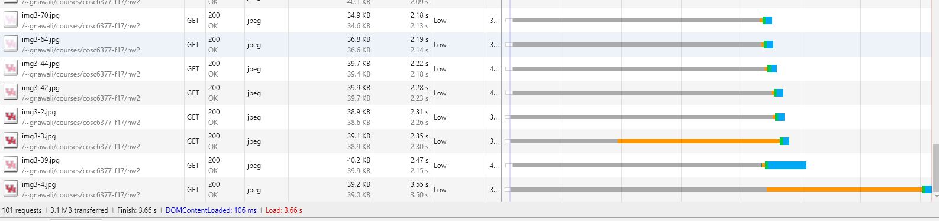

We see that uniquely there is a long DNS lookup in retrieving some of the images in Page 3, when we rerun the page there are no DNS lookups longer than the actual download. This seems like a single bad DNS search that is independent to a single page download and resolves itself with repetition.  
HTTP/HTTPS Proxy 78.47.72.8:8998:  
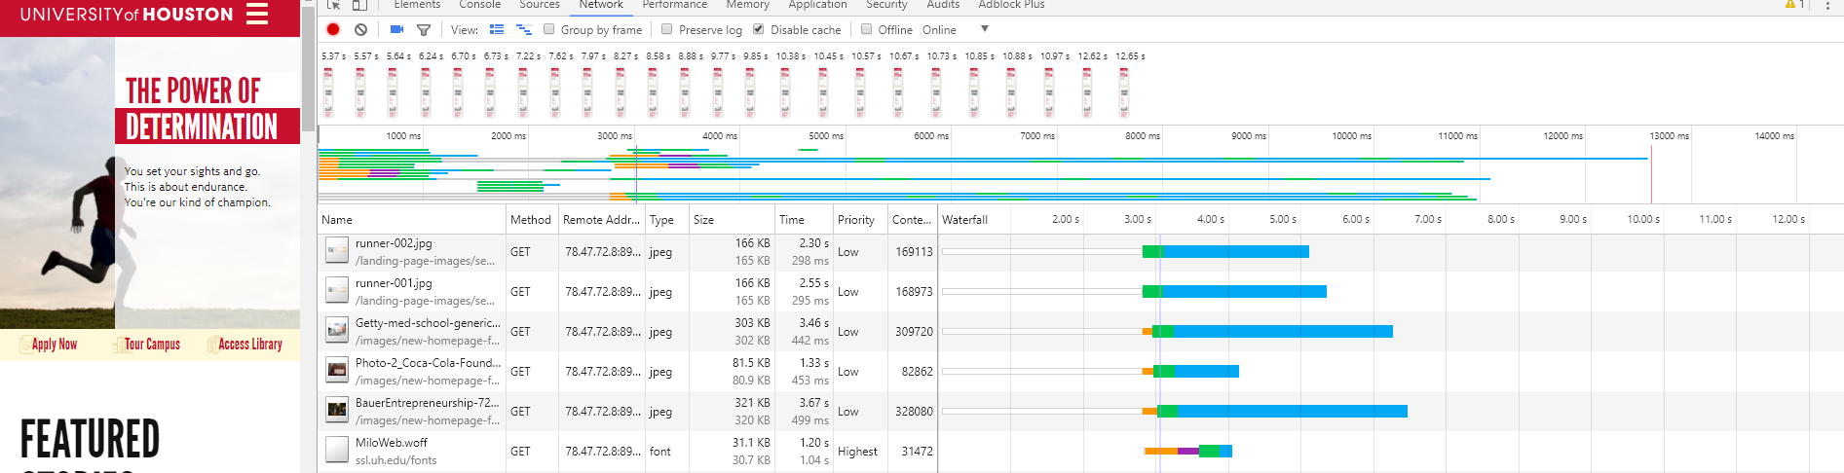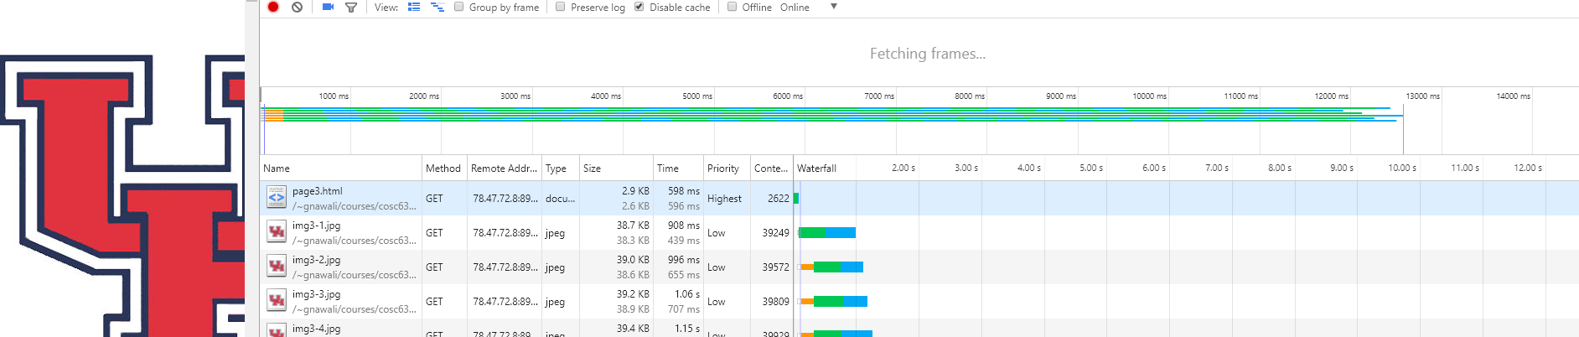  
The German proxy reacts normally with no non-network problems. We see that compared to every other network, we see noticeably slower performance, which makes sense since the network latency is so long, (since we are connecting through Germany to retrieve Houston information and then deliver back to Houston).