Zabbix installation:
Prerequestites:virtual box,ubuntu
Open the zabbix.com in browser and select the options based on the below screenshot
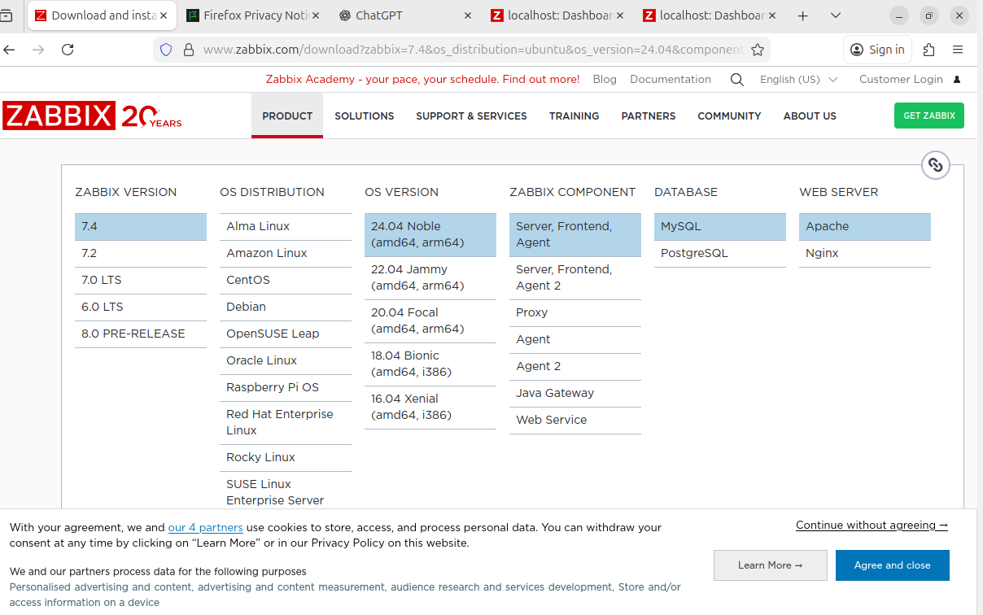

Step-1:Updating the ubuntu by using the command :sudo apt update
Step-2:Become root privilege by using command sudo-s
Step-3:install zabbix repositories using the following commands
# wget https://repo.zabbix.com/zabbix/7.4/release/ubuntu/pool/main/z/zabbix-release/zabbix-release_latest_7.4+ubuntu24.04_all.deb
# dpkg -i zabbix-release_latest_7.4+ubuntu24.04_all.deb
# apt update
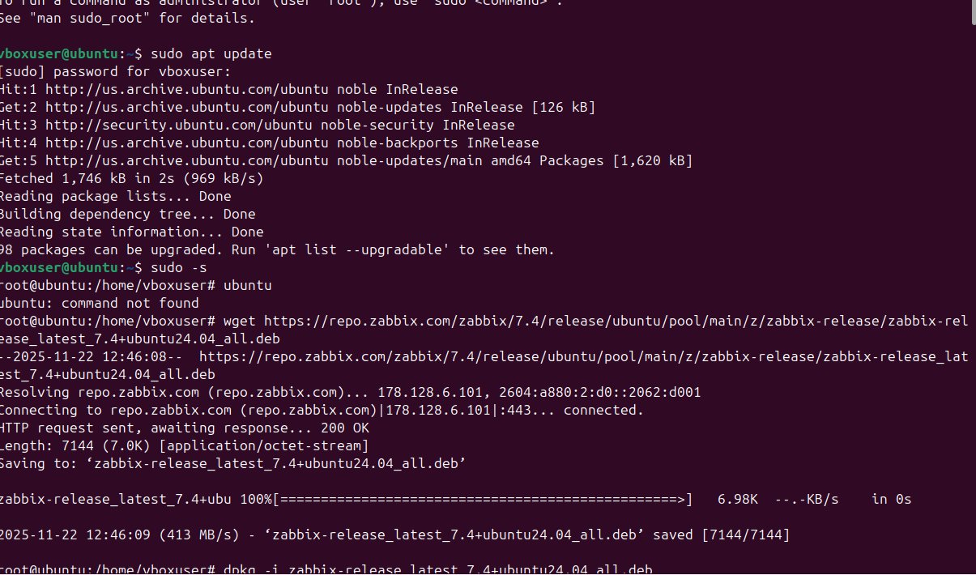
Step-4:Install Zabbix server, frontend, agent by running the following command
# apt install zabbix-server-mysql zabbix-frontend-php zabbix-apache-conf zabbix-sql-scripts zabbix-agent
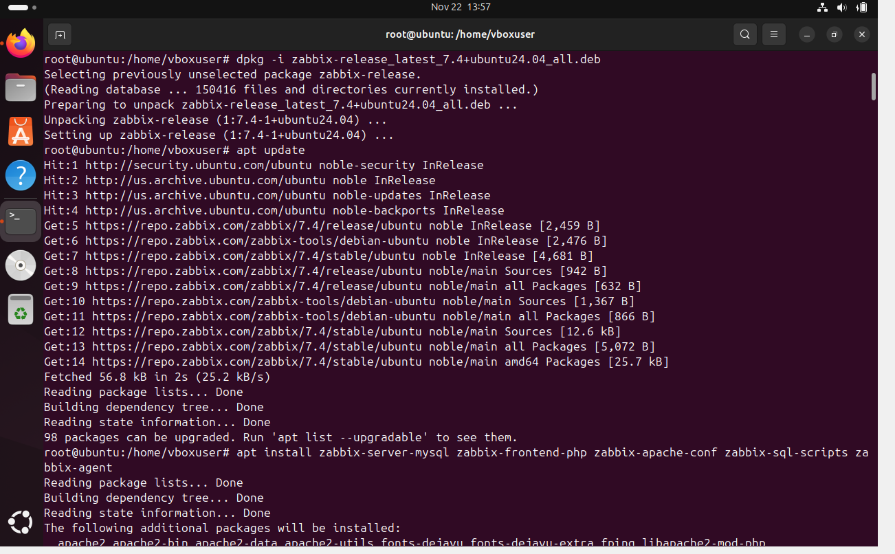

Step-5:Installing mysql by using the command sudo apt install mysql-server
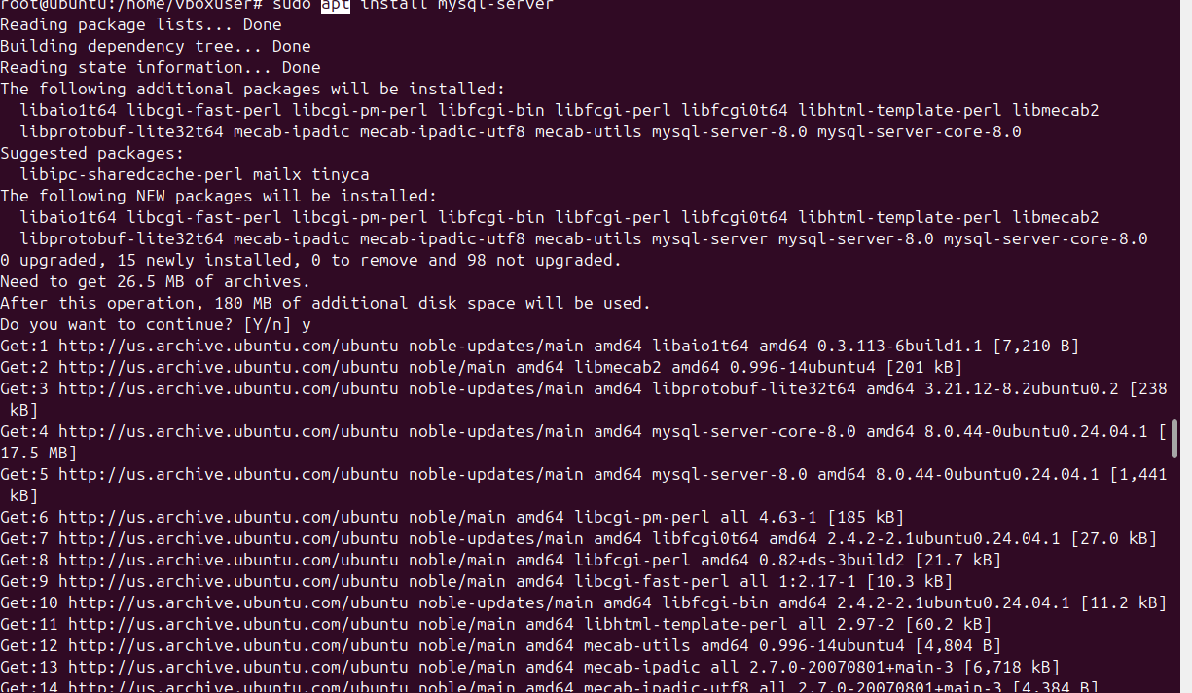
Step-6:starting the mysql service using the command :service mysql start
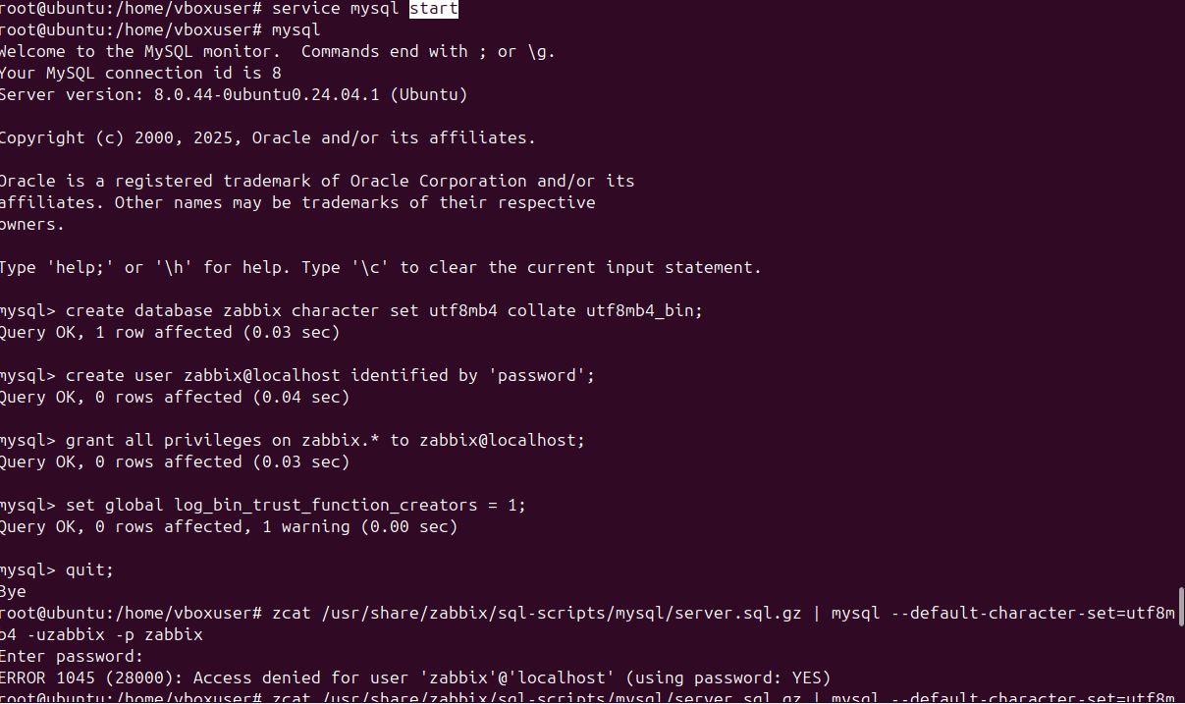

Step-7:Create initial database
mysql> create database zabbix character set utf8mb4 collate utf8mb4_bin;
mysql> create user zabbix@localhost identified by 'password';
mysql> grant all privileges on zabbix.* to zabbix@localhost;
mysql> set global log_bin_trust_function_creators = 1;
mysql> quit;
Step-8: On Zabbix server host import initial schema and data. You will be prompted to enter your newly created password.(password=password)
# zcat /usr/share/zabbix/sql-scripts/mysql/server.sql.gz | mysql --default-character-set=utf8mb4 -uzabbix -p zabbix
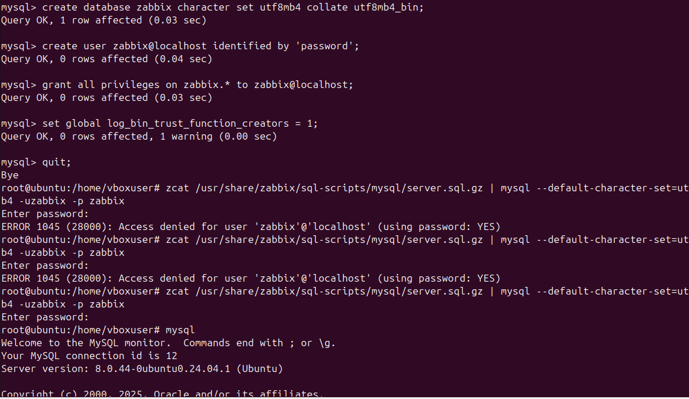
Step-9:Edit file /etc/zabbix/zabbix_server.conf using the command sudo nano /etc/zabbix/zabbix _server.conf
Change password=password as shown in below screenshot
Step-10:
Start Zabbix server and agent processes
Start Zabbix server and agent processes and make it start at system boot.
# systemctl restart zabbix-server zabbix-agent apache2
# systemctl enable zabbix-server zabbix-agent apache2
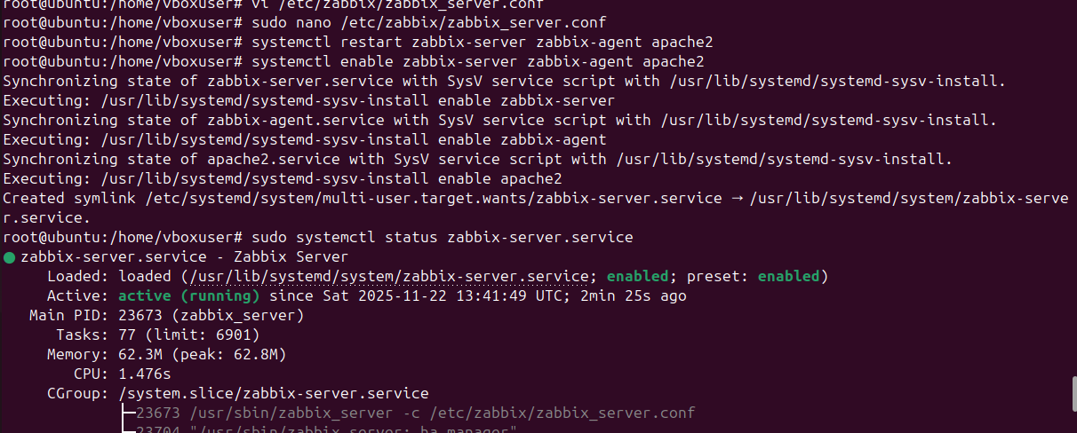

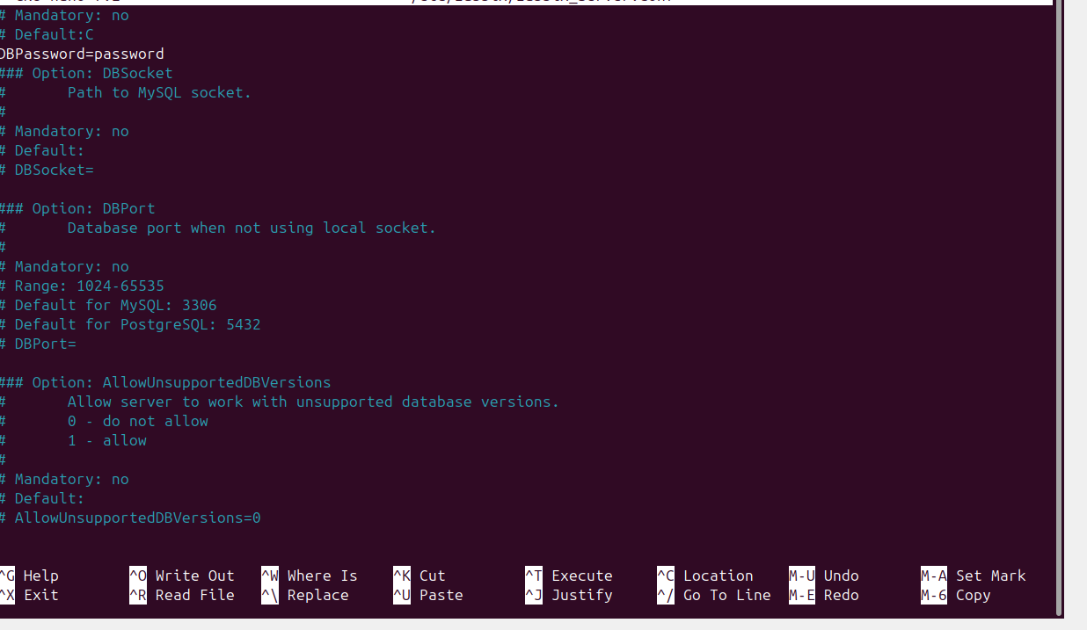
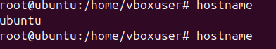
Step-11:
Open Zabbix UI web page
The default URL for Zabbix UI when using Apache web server is http://host/zabbix

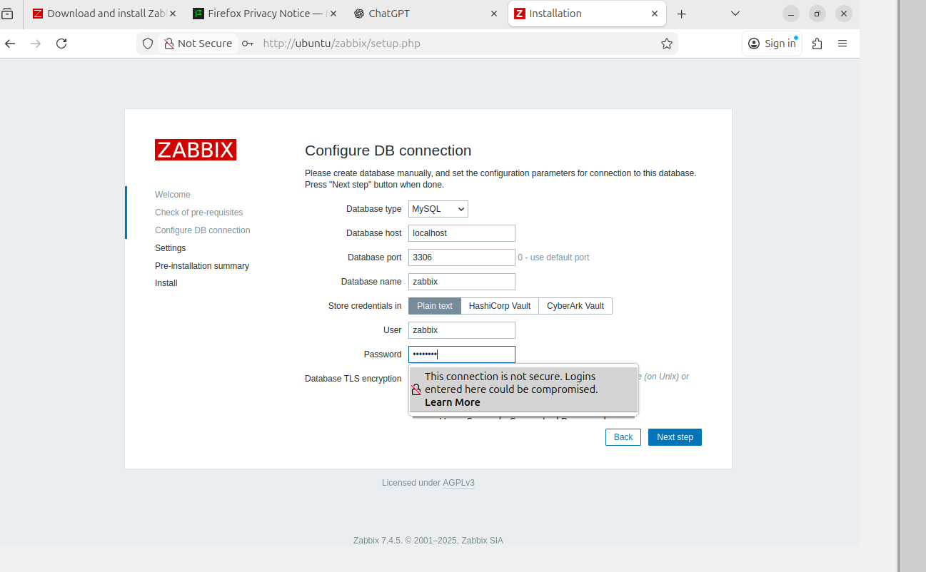
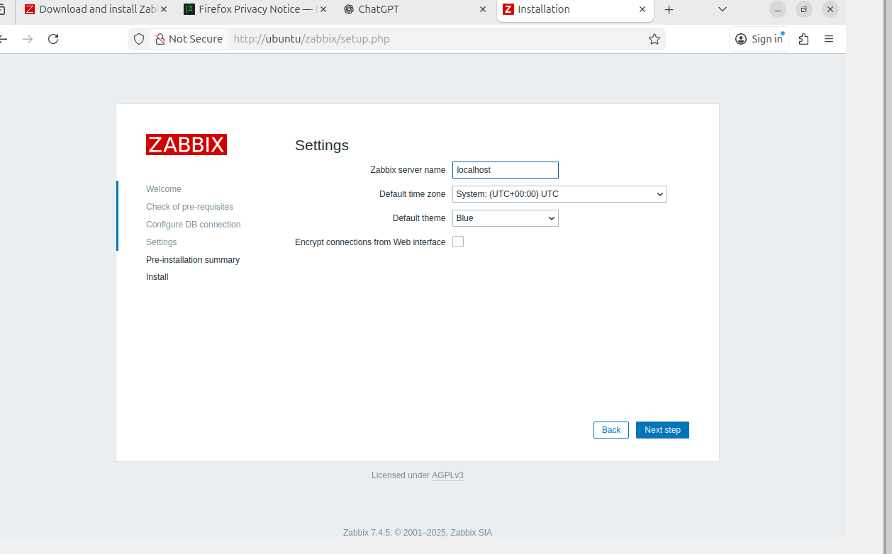
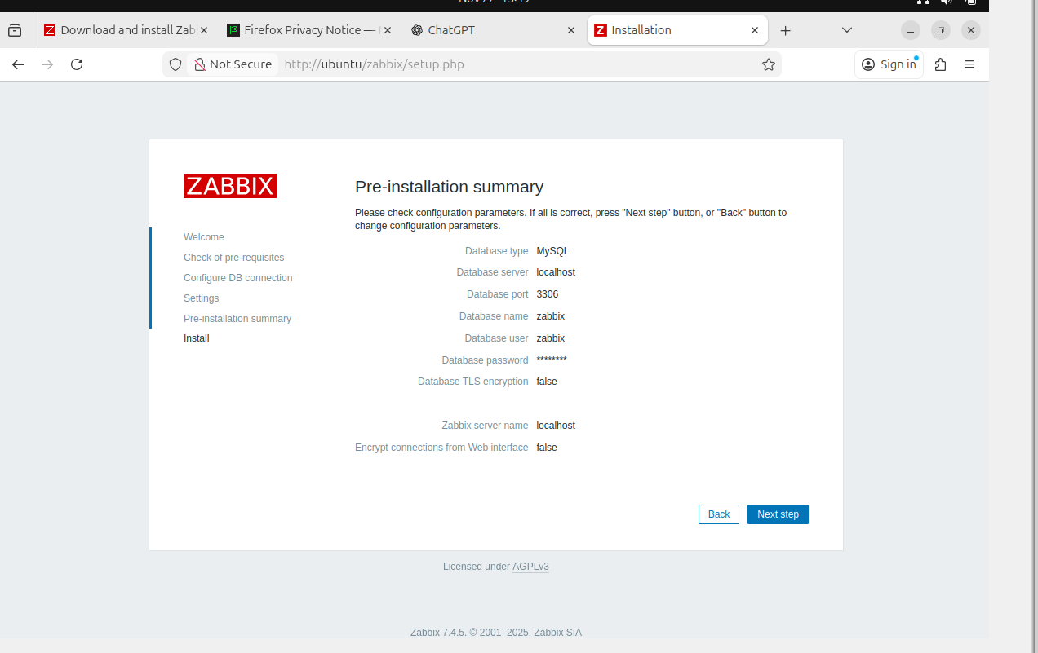
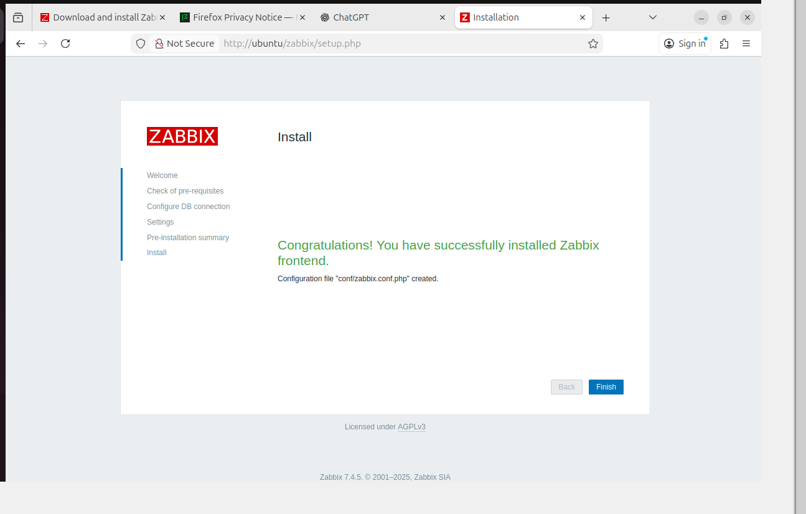

Login to Zabbix using
Username:Admin
Password:password
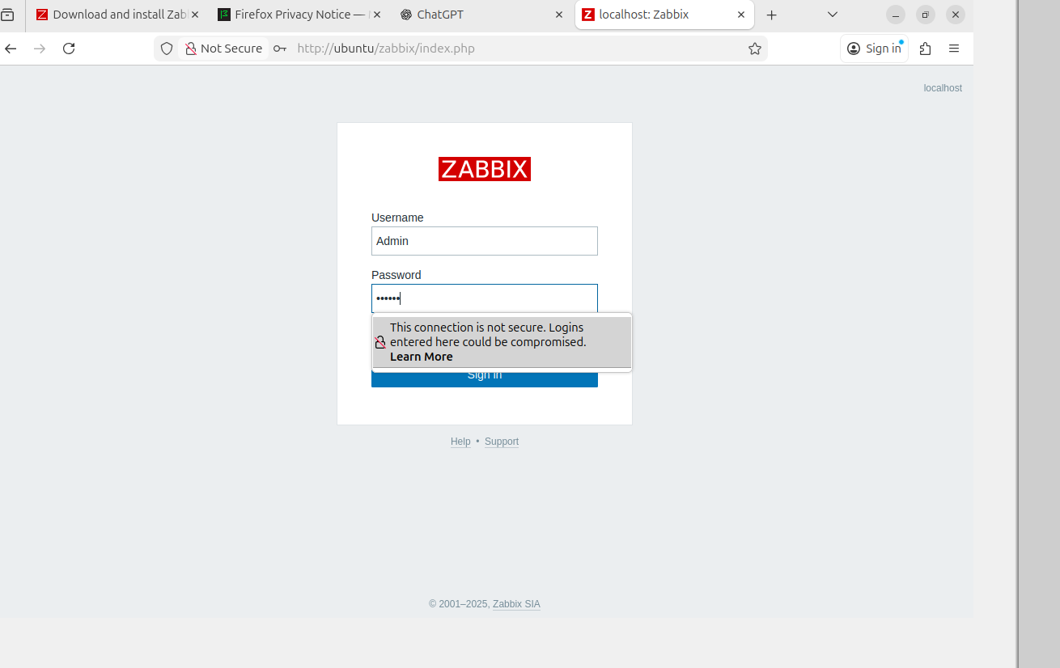
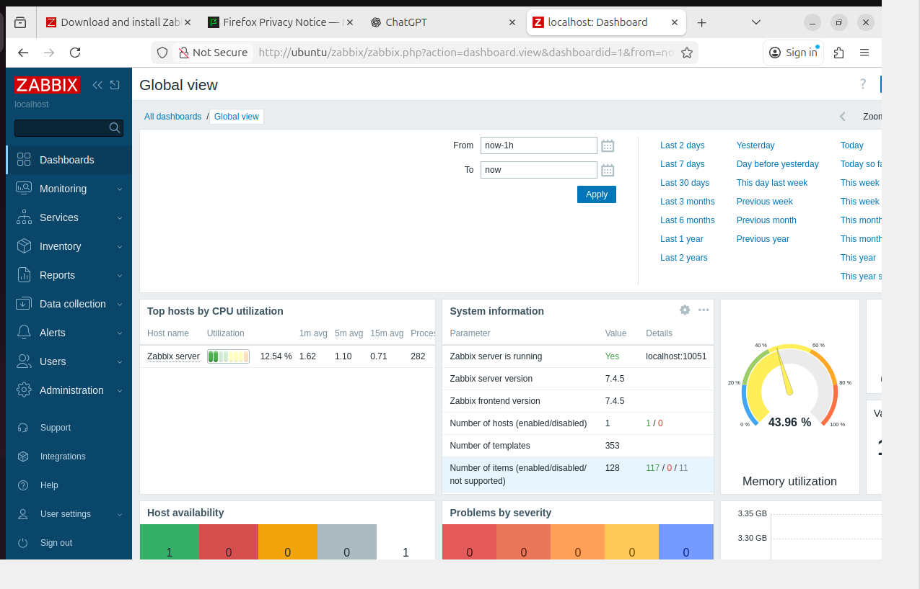

Monitoring web using Zabbix:
Step-1:Adding website to monitor
Select Data Collection=>Hosts=>web=>select create web scenario and add the websites wants to monitor
Step-2:select monitoring=>latest data=>select host Zabbix-server=>where you can observe the response code(200)
