Nicholas Smith
CS 485
Project 1
2/19/15

Collaboration with:
Brian Goga
1a. For this problem, we were supposed to do a 1D Gaussian smoothing to the data Rect_128.txt
First we had to read In the txt file and apply a mask to the data. This mask consisted of Sigma 1, Sigma 5, and Sigma 11. This was to show the difference between different sigmas.

For Sigma 1 I got:
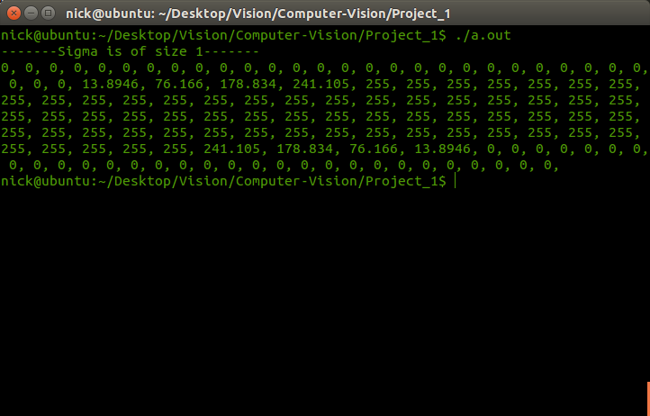

This did what was expected and as the numbers got closer to the center, they were smoothed over more. Until all the numbers that were being smoothed were the same. This caused the points to not change. Then as you got closer to the end the points were smoothed out in the same way that they were in the beginning.

For Sigma 5:
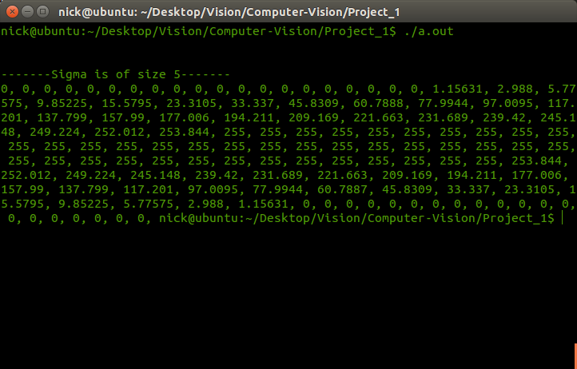
This had the same effect as Sigma 1, but the results were more dramatic. The numbers were smoothed further. This is caused by having a larger sigma and larger mask from the sigma. As before the smoothing is symmetric.

For Sigma 11:
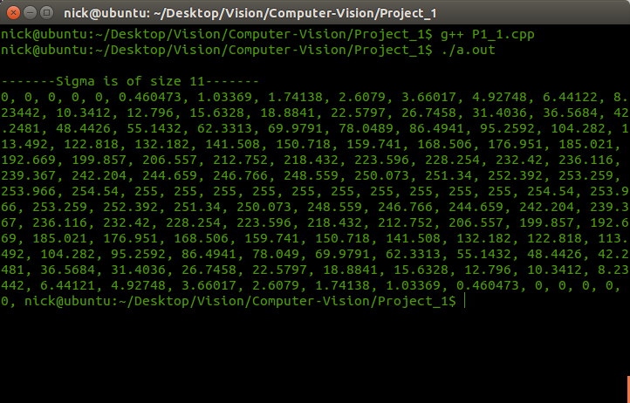
Again the same effect as with sigma 1 and 5, but was way more prominent. Since we have such a large sigma, the smoothing effects points close to the beginning unlike sigma 1 where the points affected were close together.
1b. We were to first apply a mask to the image, with a sigma of 5, and then apply another mask, also with sigma of 5, to the image. Using the formula I(x) = (I(x) * G(x)) * G(x). Then we were to compare that to an image that had a mask, with sigma sqrt(2)*sigma. This could be done by applying a mask to another mask, then applying that to the image.

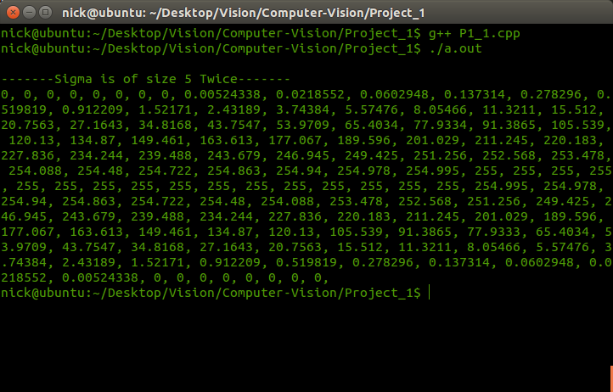
For I(x) = (I(x) * G(x)) * G(x):

For I(x) = I(x) * (G(x) * G(x)):
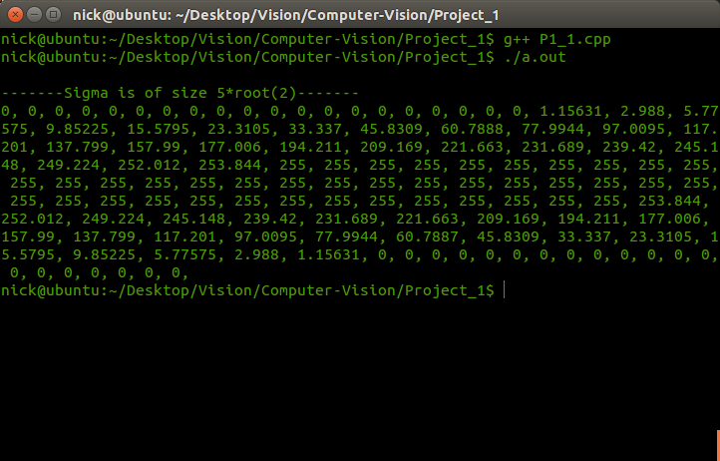

Theses two images have different points. They should be the same. An explanation for this is that while dealing with floating point numbers, the compiler truncated or rounded numbers while doing the compilations. This being said, the first image is smoothed more compared to the second.
1c. For this problem, we were to apply a 2D Gaussian to the image lenna, using sigma 1, 5, and 11. Doing this would cause a bluing of the image, reducing the noise of the image, allowing for better data.

Original: Sigma 1:
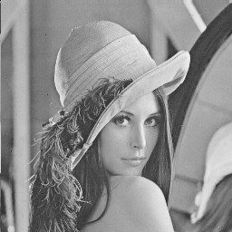
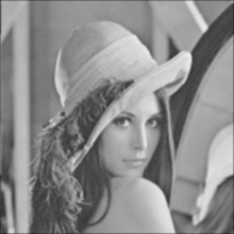

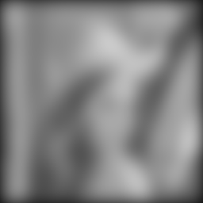
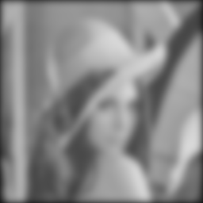
Sigma 5: Sigma 11:

As shown, the image blurs more, the larger the sigma. This reduces noise in the image allowing for better manipulation of the image.
1d. For this we were to do the same at 1c, applying a 2D mask to lenna, but this time we are implementing it as a 1D Gaussian. We are doing this by applying the mask to the rows round a point, then applying the mask to the points after applying the first mask, this will give us the center point.

Original: Sigma 1:
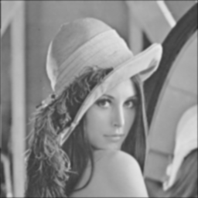

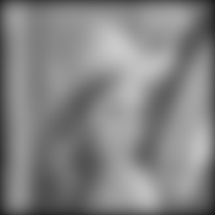
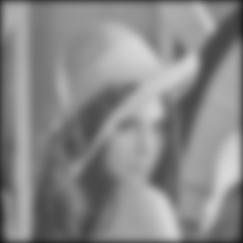
Sigma 5: Sigma 11:

This effect has the same result as in 1c. The difference between the two is that implementing the mask as a 1D rather than a 2D, is that the 1D will run in O(n), where 2D will run in O(n^2). This allows the smoothing to be done much quicker.
2. For this problem, we were to do edge detection. First was edge detection in the X direction. Second was edge detection in the Y direction. Then we were to find the magnitude. Then the arc Tan of the image. Then apply a threshold to the magnitude.

Edge-Detection X- Direction Lenna: Edge-Detection X-Direction SF:
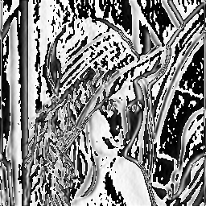
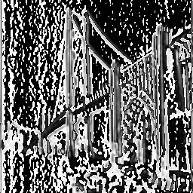

This is lenna.pgm after doing edge This is sf.pgm after doing edge
detection in the X direction. detection in the X direction.

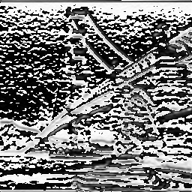
Edge-Detection Y-Direction Lenna: Edge-Detection Y-Direction SF:
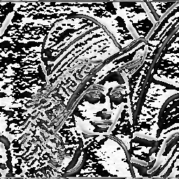

This is lenna.pgm after doing edge This is sf.pgm after doing edge
detection in the Y direction. detection in the Y direction.

Magnitude of lenna: Magnitude of SF:
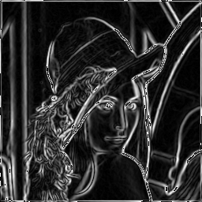
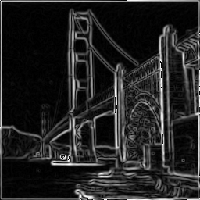

This is lenna after finding the This is sf after finding the
magnitude. magnitude.

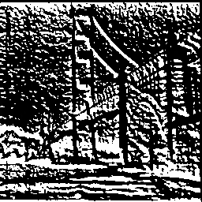
Gradient Direction of lenna: Gradient Direction of SF:
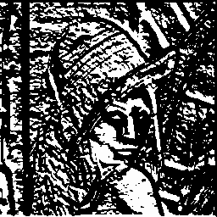

This is lenna after finding the This is sf after finding the
gradient direction. gradient direction.
Threshold lenna: Threshold SF:
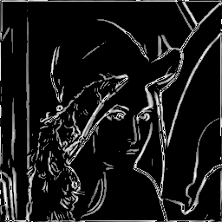
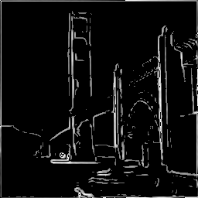

This is the image of lenna after applying This is the image of sf after applying a
a threshold of 100. threshold of 100.

3. For this problem, we were to create a Gaussian pyramid of the image lenna.

Scale 1: Scale 2:
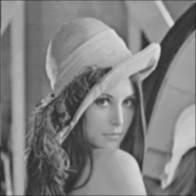
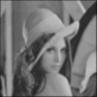

This is after a scaling of 2,
and a smoothing of sigma 1.
Size 128x128.

This is the original image after smoothing
with sigma 1. Size 256x256.


Scale 4: Scale 8:
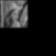

This is after scaling of 8
and a smoothing of sigma 1.
This is after scaling of 4 Size 32x32.
and a smoothing of Sigma 1.
Size 64x64.

