Nicholas Smith
CS 485
Project 2
3/3/15

S1:

Original:
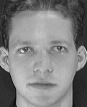

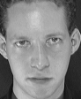

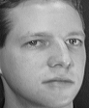
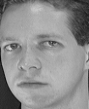
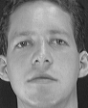
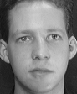
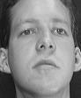

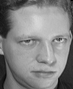

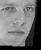
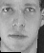
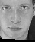

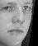
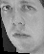
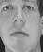
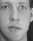
Result


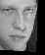

File | Transformation A | Transpose B | Error
1.pgm
2.pgm
3.pgm
4.pgm
5.pgm
6.pgm
7.pgm
8.pgm
9.pgm
10.pgm

S2:

Originals:












Resulting:











File | Transform A | Transpose B | Error
1.pgm
2.pgm

3.pgm

4.pgm

5.pgm

6.pgm

7.pgm

8.pgm

9.pgm

10.pgm

Formula for calculating error:

Error = ( Sqrt( (Calculated X – Correct X)^2 + (Calculated Y – Correct Y)^2 ))

The result of this assignment was overall good. Comparing facial features in the resulting images , it is shown that the SVD computes the correct values for the transformation matrix with the coordinates given, accurately. These results are not the best, since there are not enough parameters in the transformation to map 4 features accurately. This can been seen in some of the images where the image was not taken from a flat perspective.

For S1 that error was varying between 2 and 2.5. In S2 that error was varying between 1.6 and 1.9 with a spike for image 8. Other then the spike error these numbers are good, since the image is a 56x46. If the errors were larger then they would be quite noticeable in the image.

