**Project GEOFF**

*Critical Design Review*

Team Built Illiterate

Jackson Fezell

Nicholas Giampetro

Ankit Gupta

Sebastian Nahme

Davis Wetzel

AERSP 497.3 Autonomous Vehicle Preliminary Design Capstone

The Pennsylvania State University

April 27th, 2024

# **Executive Summary**

Travel at sea can present many dangers to crew and passengers aboard all types of vessels in the open ocean. One such danger is simply falling from the vessel into the sea in a man overboard event. While falling off a ship may intuitively not seem that dangerous, they are very deadly events with only a small fraction of people recovering from such incidents. This is due to many factors, from the chance of injury or death on the fall, risk of sucked into the ship’s screw, to just the simple fact that a person going overboard might not be noticed till it is far too late. Barring all the issues just listed, assuming a person survives the fall and is noticed immediately there is still the issue of inertia. Large ocean-going vessels can displace more than one hundred thousand tons and travel 12-30 knots. To maneuver something with that much momentum can take a lot of time and space which can be a serious challenge for saving a man overboard.

One possible engineering solution to help increase the survivability of man overboard scenarios would be to have an unmanned aerial vehicle that can be launched to deploy a life support package. Project GEOFF is a demonstrator vehicle for a competition that is able to perform a scaled down version of this mission for testing and development purposes.

Project GEOFF is a small quad rotor capable of deploying a proprietary 25-gram payload approximately one meter or closer to a target beacon. The system utilizes an ultrasonic sensor and a Pozyx shield to determine location data for navigation. An Arduino will be the flight computer that will utilize PD/PID to control the quad rotor in combination with individual electronic speed controllers for each motor. The airframe will be 3D printed out of separate PLA+ parts assembled with steel hardware while the propellers will be bought online.

The competition scoring is based on the performance of GEOFF’s autonomous performance as well as system weight and project cost. The final weight of the system is 890 grams and the project cost finished at $292.97. Built Illiterate placed first out of three teams in the competition with a final score of roughly 0.6 due to the absence of autonomous features.

Contents

**Executive Summary** 1

**Introduction** 5

**Team Overview and Capabilities** 6

**Concept of Operations (CONOPS)** 7

**Requirements** 9

**Final System Designs** 11

**Subsystem Design** 13

Structural Design 13

Payload Mechanism and Mounting 15

Propeller Selection and Analysis 16

Quantitative Propeller Research Assessment 16

Category 17

Criteria 18

Result 20

Navigation, Flight Planning, and Control 20

Power Analysis 21

Battery Analysis 22

Positioning Analysis 23

**Design Challenges, Risks, and Mitigations** 24

Flight Safety Checkout Milestone 24

Manual Flight Milestone 24

**Testing Strategy** 26

**Final Flight Test Results** 27

**As-built Schedule and Budget** 27

**Conclusion and Lessons Learned** 29

**Appendix** 31

**References and Citations** 34

List of Figures

Figure 1 - Scoring Formula 5

Figure 2 - Team role breakdown 6

Figure 3 – Key Phases of Flight Operations 7

Figure 4 – Flight Profile of Drone 8

Figure 5 - End to End Communication Diagram 9

Figure 6 - Three view sketch of the vehicle assembly (mm) 12

Figure 7 - Full body FEA analysis at 5N of force per arm 14

Figure 8 - Mode shape 1 and 2 from vibration testing 15

Figure 9 - Payload mechanism design 15

Figure 10 – The Gemfan Durable 5536 [2], Gemfan Flash 6042 [3], and APC B6x4E [1] from left to right 17

Figure 11 – Navigation and Control Simulated Testing 21

Figure 12 - Cooper-Harper handling qualities rating scale 25

Figure 13 – Original Gantt chart demonstrating spring semester schedule 28

Figure 14 – Final Gantt chart depicting real spring semester schedule 29

List of Figures

Table 1 – Skills matrix for each team member 6

Table 2 - List of Requirements 10

Table 3 - Vehicle weight budget 12

Table 4 - Propeller Trade Study 18

Table 5 - List of the Electronics' Required Voltages and Currents 21

Table 6 – Trade Study for Altitude Sensor 23

Table 7 - Component cost breakdown 27

# **Introduction**

Something very few consider as a hazard when traveling at sea is the danger of a man overboard (MOB) event. While rare, such events are highly likely to result in death with only 40% of overboard passengers being rescued at the safest cruise lines and most operators have survival rates lower than that [4]. While policies could be implemented to help mitigate this problem, especially around alcohol consumption on cruise liners, there will always be MOB situations for as long as humanity continues to travel at sea. This necessitates the pursuit of engineering efforts to address this issue.

The challenge with a MOB scenario is that even if the MOB is detected immediately, it can take a large ship a distance in the order of miles to turn around [4]. A proposed technology for increasing the survivability of MOBs is to have a drone that can be deployed from the ship which can autonomously navigate to a MOB and deploy lifesaving aid in a timely manner. This paper details the design of a surrogate vehicle, project Get Every Overboard Fella Fastly (GEOFF), to participate in a competition to establish early capabilities required for such a MOB aid vehicle.

The competition will take place in a 10×10×6-meter volume inside a hanger in calm conditions. The demonstrator vehicle is to weigh 1000 grams or less and the project will have a maximum budget of $500. The vehicle will have five attempts to fly a successful mission during the competition. A successful mission would be defined as a fully autonomous flight from the launch area to the target beacon where it will descend to 1 meter altitude for 5 seconds and deploy a 25-gram payload within 1 meter of the beacon’s location then return to within 2 meters of the launch location. The scoring criteria and formula is laid out below in Figure 1.

* F = 1 Fully automatic from takeoff to landing and rotors stopped; F = 0.1 automatic for takeoff and ascent but reverted to manual prior to the drop or landing; F = 0 otherwise.
* H = 1 achieved for hover at 1 meter for 5 seconds; H = 0.5 for hover time or altitude requirements; H=0 for neither requirement achieved.
* D = 1 if mechanism drops gear within 1 meter of beacon; , if mechanism drops gear in a commanded way greater than 1 meter away from beacon; D = 0 if mechanism drop fails.
* R = 1 if vehicle lands without damage within 2 meters of start point, R = 0.5 if it does not.

Figure 1 - Scoring Formula

# **Team Overview and Capabilities**

The first activity the group did was develop a team capability matrix to assess our individual skills in all the areas which are necessary for the creation of the drone. Each member was asked to rank their abilities of each skill group from 1-5, with 1 being the lowest and 5 being the highest. The results from this capability matrix are shown below.

Table 1 – Skills matrix for each team member

|  |  |  |  |  |  |
| --- | --- | --- | --- | --- | --- |
| Skill | Ankit | DaviS | Jackson | NicK | Sebastian |
| Structural | 1 | 4 | 2 | 2 | 3 |
| Electrical | 4 | 3 | 2 | 1 | 2 |
| Coding | 4 | 1 | 3 | 4 | 3 |
| Control Systems | 3 | 1 | 1 | 3 | 1 |
| Technical Writing | 2 | 3 | 4 | 3 | 1 |
| Manufacturing | 3 | 5 | 3 | 3 | 3 |

The skills listed in table 1 are a breakdown of the necessary skills to complete the competition requirements. ‘Structural’ represents the ability to not only design structural components but perform and understand the different methods of structural analysis. ‘Electrical’ requires skills in circuit design and an understanding of software to hardware interactions. ‘Coding’ involves any form of software development, which ties into the ‘Control Systems’ skill, which is understanding the mathematical processes behind the software. ‘Technical Writing’ is an important aspect for developing reports and write ups during the project. Finally, ‘Manufacturing’ is based on the ability to perform hardware integrations, component production and assembly, and hardware testing. Table 1 gives a spread of each members’ capabilities and helps define specific roles for each member.

Once the team capability matrix was finalized, the group looked over the finalized results and determined the best role for each group member. The team organization chart was created to demonstrate the assigned roles for each group member and is shown below.

Figure 2 - Team role breakdown

# **Concept of Operations (CONOPS)**

To complete the mission of the competition, the demonstrator vehicle will have several key phases of operation. There is the initial set up phase where the ground crew must load the payload into the dropper mechanism. This process should be done with ease to make preparing follow-up flights simpler. Once the drone is in the takeoff location it will be turned on and armed with a switch on the radio controller which will be indicated by an LED on the vehicle to alert anyone nearby to clear the area. The vehicle will then transition to the autonomous takeoff phase where it will take a few seconds to calibrate its sensors then begin flight operations by autonomously ascending to 2.5 meters. From takeoff the system will transition to the navigation phase which can be manually performed if needed. After the navigation to the beacon is complete the deployment phase will begin as the drone lowers to the 1-meter drop altitude and hovers for 5 seconds before releasing the payload which can also be manually flown. At this point the mission is successful, and the recovery phase begins as the vehicle returns to its launch point. After recovery the vehicle will be inspected and repaired as needed necessitating modularity. A qualitative visualization of the flight operation phases can be seen below in Figure 2.

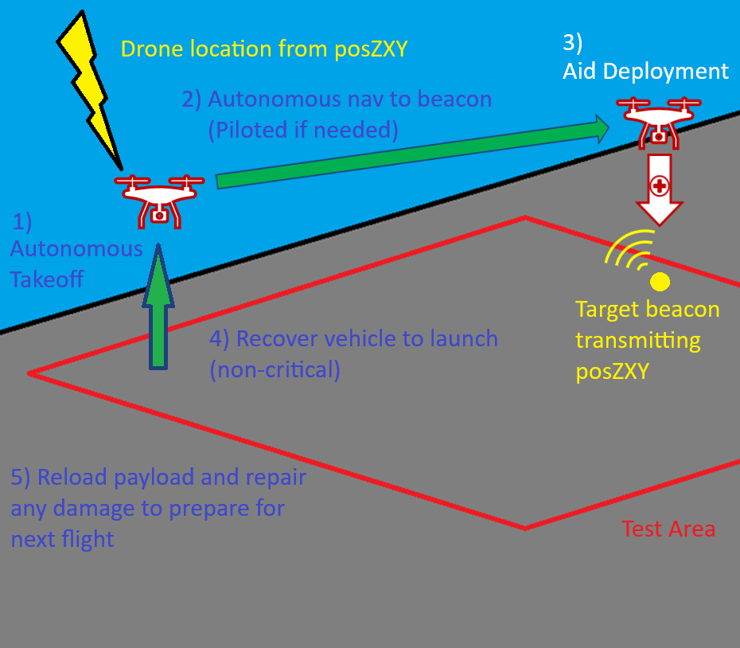

Figure 3 – Key Phases of Flight Operations

A more quantitative visualization of the flight profile is shown below in Figure 3. A single mission should not last more than one minute even at slow speeds. This flight profile should never require the vehicle to travel much faster than 1 meter/second even for the longest-range scenario within the test volume.

Figure 4 – Flight Profile of Drone

To facilitate flight operations, the vehicle design must have an electronics system suited to the task. The heart of such a system will be a sufficiently powerful flight computer for flight planning, navigation, and control of the vehicle. The computer will receive data from the Pozyx sensor to understand its location in the XY plane as well as the roll-pitch-yaw angles of the craft. An additional sensor will be added to gain additional altitude data which will be fused with the Pozyx data through a Kalman Filter to correct for the higher noise that Pozyx will generate in the Z dimension due to limitations of the test environment. A radio receiver will also be critical to allow the operator to issue commands from the remote control as well as enable manual flight control if necessary. The flight computer utilizes this information to produce output commands which will be sent to the electronic speed controllers (ESCs) which then direct the motors themselves. Not shown below in Figure 4 below is any of the electrical power systems, it is purely a visual for data flow.

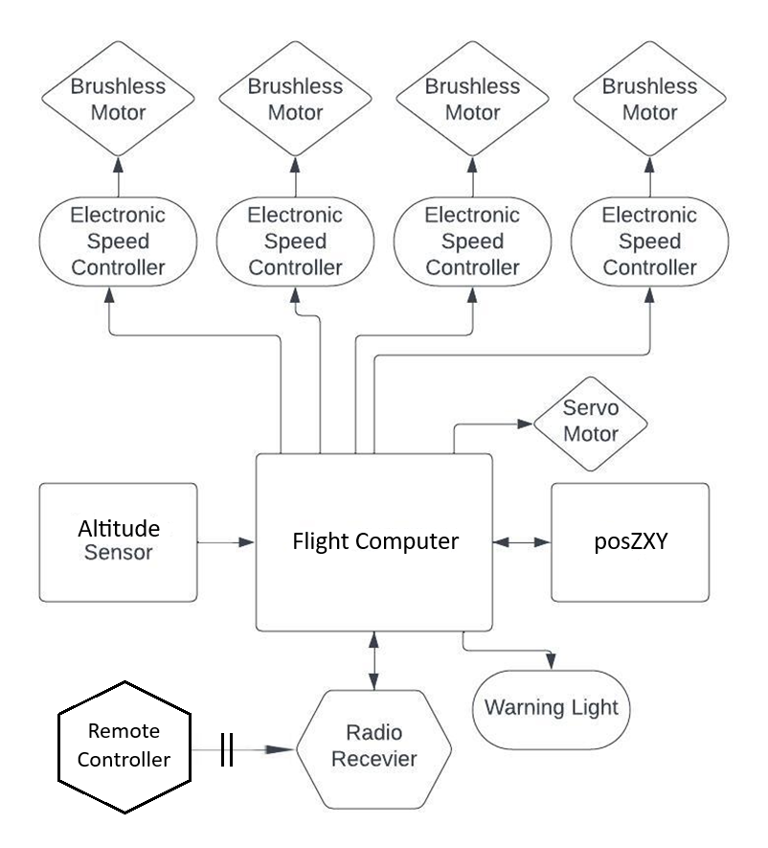

Figure 5 - End to End Communication Diagram

# **Requirements**

Based on the request for proposal (RFP) along with the CONOPS the requirements can be derived for project GEOFF These have been broken down flight requirements (FR) pertaining to flight operations, platform requirements (PR) pertaining to the vehicle platform, and logistical requirements (LR) pertaining to the logistical needs for this competition. Requirements table shown below in Table 2.

Table 2 - List of Requirements

|  |  |
| --- | --- |
| Legend | |
| FR = Flight Requirement  PR = Platform Requirement  LR = Logistical Requirement | |
| Number | **Requirement** | | **Source** |
| FR1 | The vehicle shall take-off and autonomously fly to the location of a beacon sensor for. | | RFP |
| FR1.1 | The vehicle shall hover over the beacon sensor for 5 seconds and descend to an altitude within 1-meter of the beacon sensor. | | RFP, FR1 |
| FR1.1.1 | Vehicle controller shall autonomously fly the drone in a calm sea state. | | FR1, FR1.1, RFP |
| FR1.1.1A | Navigation shall accurately determine XYZ position and roll-pitch-yaw angles. | | FR1.1.1, CONOPS |
| FR1.1.1B | Vehicle shall takeoff autonomously. | | FR1.1.1, CONOPS |
| FR1.1.1C | The vehicle will return to a location within 2-meters of its origin point and land safely. | | FR1.1.1, RFP |
| FR1.1.1D | Vehicle will have a thrust to weight ratio of 2 or greater. | | FR1.1.1, CONOPS |
| FR1.2 | Vehicle shall have a manual flight control mode as a backup. | | FR1, RFP, CONOPS |
| FR1.2.1 | Vehicle manual control will be easy to use. | | FR1.2, CONOPS |
| FR1.2.2 | Vehicle manual control shall be able releases the payload. | | FR1.2, CONOPS |
| FR2 | The vehicle shall drop an object weighing 25 grams. | | RFP |
| FR2.1 | The payload will be delivered within 1-meter of the target beacon. | | FR2, RFP |
| FR2.2 | The deliver mechanism will passively close. | | FR2, CONOPS |
| FR2.3 | Vehicle will be easily reloaded. | | FR2, CONOPS |
| FR2.4 | Payload shall be proprietary for the vehicle. | | FR2, RFP |
| FR3 | Vehicle shall have enough battery capacity to fly 5 consecutive flights. | | RFP |
| FR3.1 | Vehicle will be able to fly for 8 minutes. | | FR3 |
| PR1 | Vehicle shall be a quad rotor layout. | | RFP |
| PR2 | Vehicle shall weigh at most 1000g. | | RFP |
| PR3 | The project shall cost at most $500. | | RFP |
| PR4 | The vehicle shall have a vehicle-armed warning indicator. | | CONOPS |
| LR1 | The vehicle will feature modular design. | | CONOPS |
| LR2 | The vehicle battery will be easily accessible. | | CONOPS |

# **Final System Designs**

The basis of the airframe design was based on commercially available airframes used for camera work and recreation. The design is a two-layer planform that gives adequate space for flight hardware and payload equipment. The two main concerns with the prebuilt system were hardware integration and airframe weight. The listed weight of the airframe was between 350 – 400 grams, which was anticipated as too high for the needs of the design problem. This led to a custom 3D printed airframe that could be tailored to fit weight requirements, along with custom fitted to any additional hardware required for flight. The final design planform is shown in Figure 6 below.

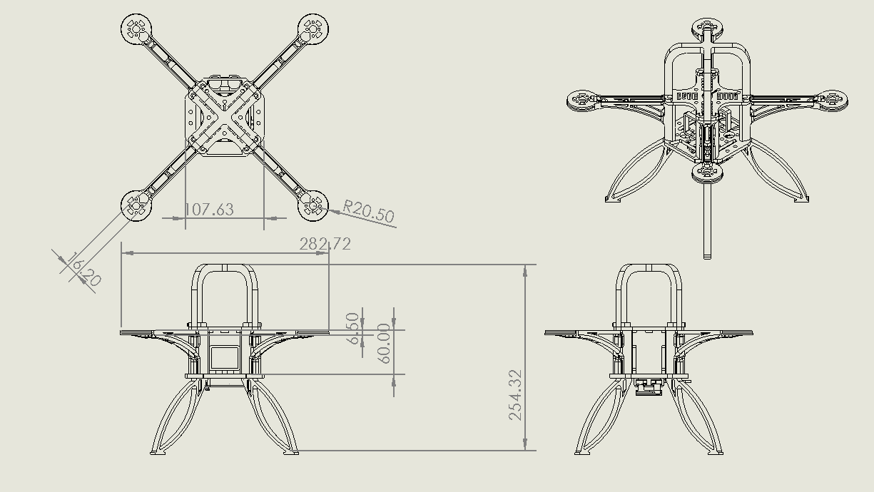

Figure 6 - Three view sketch of the vehicle assembly (mm)

The initial design leading into the testing phase put the full structural weight at 285 grams – well below the typical weight of commercial frames within the design’s sizing. This sizing includes assembly hardware, mounting plates for flight controllers, and the payload delivery mechanism. As testing began, additional changes to the design were needed to account for the impact force on the legs during crashes. Increasing the durability of the vehicle resulted in a final structural weight of 363 grams.

A design choice that was made from the first iteration of the drone structural design was changing from a push prop to a conventional pull prop design. This design choice was made because of the high center of gravity. There was concern about the center of thrust being at or lower than the center of gravity, which would have thrown off the stability of the system. This was solved by flipping the motors and maintaining a higher center of thrust with a conventional prop orientation.

Maintaining a mass below 1 kilogram is a high priority in the system design, in order to perform well in the recovery competition. Table 3 lists the weights of all components on the current airframe. Any items listed as measured have been physically measured and confirmed. Hardware has been factored into the weight of the structural components

Table 3 - Vehicle weight budget

|  |  |  |  |  |
| --- | --- | --- | --- | --- |
| **Component** | **Weight per Unit (g)** | **Quantity** | **Total Weight (g)** | **Percent of total** |
| Airframe w/ hardware (Measured) | 363 | 1 | 363 | 40.79% |
| Battery | 195 | 1 | 195 | 21.91% |
| Motors | 30 | 4 | 120 | 13.48% |
| Arduino + IMU w/ hardware (Measured) | 50 | 1 | 50 | 5.62% |
| Payload mechanism w/ hardware (Measured) | 48 | 1 | 48 | 5.39% |
| Propellors | 6.5 | 4 | 26 | 2.92% |
| ESC | 5.5 | 4 | 22 | 2.47% |
| Ultrasonic Sensor w/ hardware (Measured) | 15 | 1 | 15 | 1.69% |
| Wiring + Solder + Duct Tape | 40 | 1 | 40 | 4.49% |
| Power Distribution Panel | 11 | 1 | 11 | 1.24% |
| Total |  |  | 890 | 100.00% |

# **Subsystem Design**

## Structural Design

The rotor arm assemblies are based on standard commercially available drone frames. They have the characteristics of a cantilevered beam and utilize a tapered geometry to control the stiffness. Most standard rotor arms use a slotted truss design, but it was found during testing that the same stiffness was achievable with a much lighter structure by designing a twin cantilevered beam system with corresponding underarm supports. This design not only dramatically cut down on part weight, but it allowed for easy consolidation of electronic components within the arm sections. By utilizing infill and wall thicknesses, the arm assemblies were finely tuned to have the stiffest geometric properties while being as light weight as possible. The final iteration utilizes a multicell octet infill at 15% volume, and a 3 mm thick top layer to increase the cross-sectional moment of inertia. The internal structure of the arm was also designed to capture a small fraction of downwash from each propellor, directing the flow into the center frame of the vehicle. This increased airflow over the electronics, helping with cooling, as well as protecting the plastic components.

The upper and lower plates are designed to transfer load effectively between rotor arm mounting bolts. The upper plate is a minimum geometry design with ribs running from the mounting points on the bottom side of the plates. The minimum dimension design is used to control the compressive force that the upper plate experiences. The bottom plate functions more as a mounting point for other equipment, so it has a larger footprint with a strategic mounting pattern built in. Both plates are designed with a diagonal grid to increase load transfer between the arm assemblies and are printed at 15% infill volume. They are both designed also with directional vents, that use the motion of the drone through the air to direct air over the electronic components, minimizing overheating effects.

The leg assemblies are designed as shock absorbers to cushion the impact of a fall or hard landing. They are specifically designed springs to act like shock absorbers. They are bolted to the underside to the bottom plate, which allows for quick replacement in case of a leg failure. The outward facing geometry provides a larger landing surface, allowing the drone to land at steeper angles.

All structural designs were created using SolidWorks. Using the built in simulation software, Finite Element Analysis (FEA) and Natural frequency calculations were performed to verify the structural integrity of the airframe. The main goal when designing the structures was to limit the tip deflection at the end of the rotor arms. Limiting the tip deflections to less than a millimeter prevents major thrust vectoring, which can affect the flight stability. Simulation results indicate that the current rotor arm designs are limited to less than 1.5mm with a simulated 5N upwards force. Results from full structural FEA are shown in figure 7 below. Utilizing the structural analysis, areas of high stress, like the fillet joint between the main body upright and the arm structure, were reinforced with geometric structures and an additional strengthening flange running the underside of the entire arm.

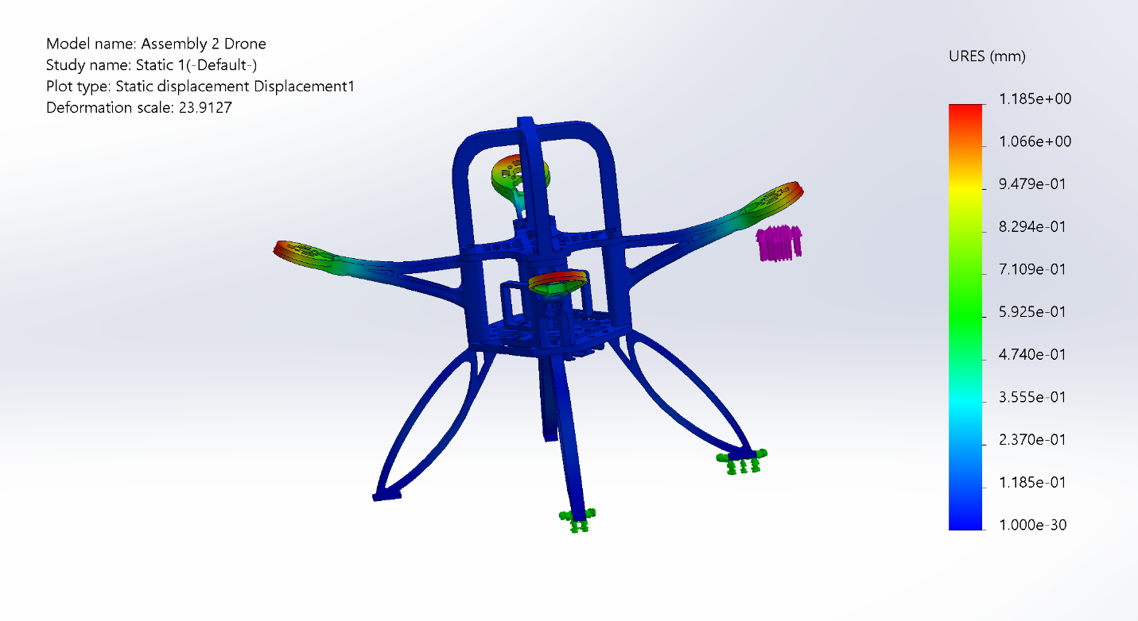

Figure 7 - Full body FEA analysis at 5N of force per arm

Vibrational design played a role in determining the geometry and mounting methods for sensor hardware. Using the vibrational frequency analysis software, natural frequencies for the entire drone assembly. Tests were performed through a sweep of throttle settings, where an average first mode natural frequency was determined to be approximately 47Hz, with a second natural frequency at approximately 60Hz. Once hardware can be further tested, mass tuning along with software implementation will be used to avoid exciting the structures natural frequency. The first two modal analysis results are shown in figure 8 below.

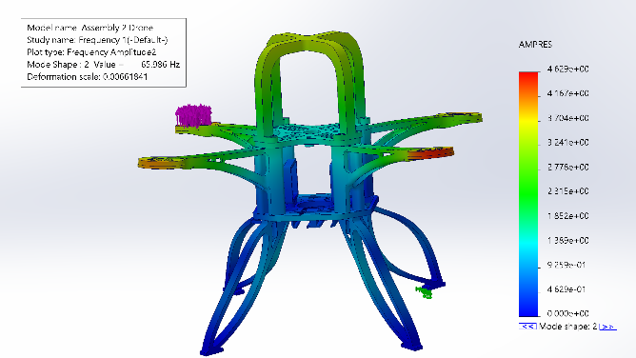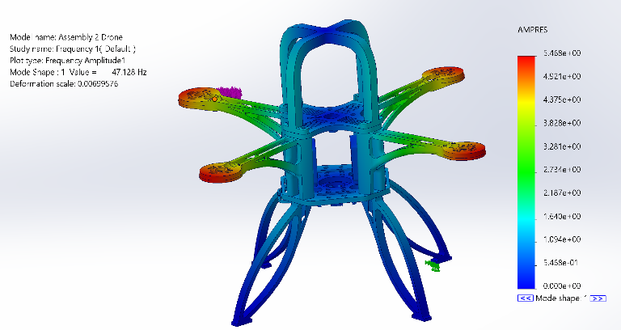

Figure 8 - Mode shape 1 and 2 from vibration testing

The airframe is a bolted structure, requiring all four rotor arms to be bolted to the top and bottom plates. Structural components like the legs are designed to be fast to manufacture and detachable, the final assembly will utilize threaded heat inserts to limit the size of hardware required to secure the structure. The entire frame has been designed to utilize M3 hardware to streamline the assembly process.

## Payload Mechanism and Mounting

A key element for the design challenge is being able to deliver a payload to the target. The main design considerations for the payload mechanism on the drown were to be simple, yet reliable. The current design is a grabber mechanism driven by a single 9-gram servo. The design has been load tested with physical prototypes to reliably hold payloads weighing 30 grams. The design includes a spring mechanism that maintains gripping force during flight, negating the need to supply a constant voltage, saving power during the flight. The system is undermounted on the bottom plate. A diagram of the payload mechanism is shown in figure 8 below.

Figure 9 - Payload mechanism design

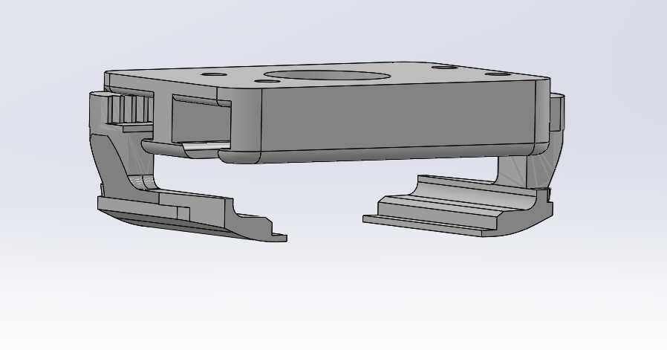

The working mechanism within the grabber is a single drive gear that moves two rack gears, operating the jaws. The entire mechanism is 3D printed and can be rapidly loaded during the maintenance period between runs. A custom payload will be manufactured that will be optimized to be held by the mechanism.

Along with the payload mechanism, an ultrasonic sensor will be mounted on the underside of the bottom plate. This will be secured using heat inserts within the bottom plate to negate the use of nuts protruding into the midsection of the drone. The power distribution board will be mounted in a similar fashion, but to the upper plate. It will utilize nylon standoffs to thermally isolate the board from the structural plates.

## Propeller Selection and Analysis

The selection of the propeller is affected by many factors that go into the design of the drone. Any time that a structural design is changed, this will affect the weight of the whole system. When changing electrical components, this not only affects the weight of the system, but also changes the availability of power to be used by the propellers. Therefore, it is important to maintain a thrust-to-weight ratio (TWR) of at least 2 to allow the drone to be easily controlled and maneuvered. The TWR can be expressed as

where is the total thrust produced by the propellers and is the total weight of the drone.

Beyond this requirement, the drone is expected to perform in an ocean-like environment. Considering the variable high winds over the ocean, an increase of 20% will be applied to the TWR to ensure control and maneuverability in the environment.

With the new TWR defined to be at least 2.4, a baseline has been set to conduct trade study research to find a propeller that meets the TWR and throttle percentage requirements.

### Quantitative Propeller Research Assessment

Through researching different brands and types of propellers, as well as using xcopterCalc by eCalc [6] to ensure the TWR and throttle percentage requirements were met, three propellers were ultimately selected to be compared. Those three propellers are the Gemfan Durable 5536, the Gemfan Flash 6042, and the APC B6x4E pictured from left to right in Figure 10. The thrust and flight time category values were calculated through [6] and the price and weight were found on the propellers’ respective websites [1],[2],[3].

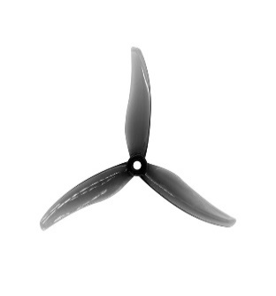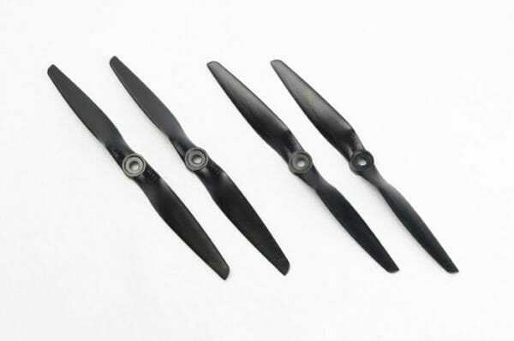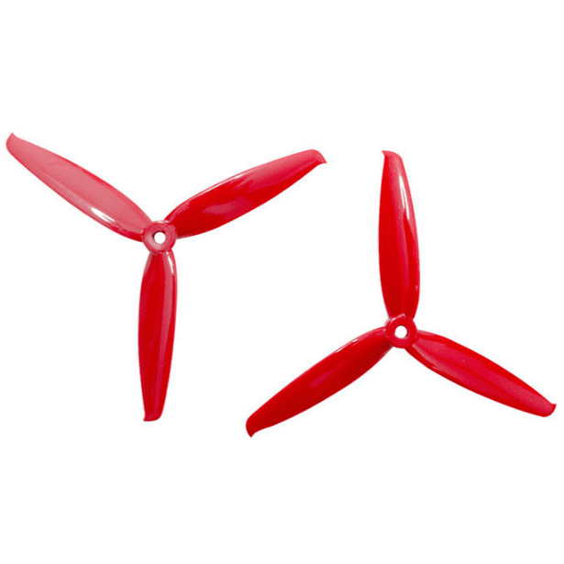

Figure 10 – The Gemfan Durable 5536 [2], Gemfan Flash 6042 [3], and APC B6x4E [1] from left to right.

Within xcopterCalc, each propeller was measured using the same environment: a sea level of 366 m (about 1200 feet) and standard air temperature and pressure. They were also measured using the same components: a 300 mm (about 1 foot) air frame, a 2200 mAh 3S 80/120C battery at 85% max discharge, a Suppo 30A ESC as it provides a constant power of 30A and is capable of 40A bursts, and an EMAX RS2205 – 2300 KV motor. The weight of the drone was overestimated at 750 g (about 1.65 lbs) to allow for any additional weight gain in the future.

### Category

The following six categories were used to aid in selecting the best propeller for the mission given the team’s unmanned aerial vehicle (UAV) configuration.

Thrust (25%): Thrust is an essential aspect of the UAV being able to hover and maneuver. As long as the propellers are able to achieve a TWR of greater than 2.4, then they are suitable for the drone. However, there is no defined upper limit on the TWR to prevent the drone from being overly responsive and hard to control. Due to no hardline for an upper limit but being necessary for any type of control off of the ground, the thrust category achieved a maximum weight of 25%.

Cost (25%): The cost is one of two key factors that can be easily controlled by the team to increase the overall score. Since a change in cost can lead to the greatest change in the score for the team and continue to grow with broken parts, it was given a maximum weight of 25%

Flight Time (20%): The flight time of the UAV is crucial for performing multiple flights in the same day without recharging the battery. The flight time should not last long (<1 minute) given the small 10x10x10 meter search area, but if the flight simulation does not work as well as intended, available battery power will be needed for additional flights. Under these considerations, flight time was given a weight of 20%.

Weight (15%): The weight is the other key factor that can be easily controlled by the team to increase the overall score. The score value for weight cannot change as much as the cost due to how the scoring is defined, but it will remain constant through testing. Since weight is important, but not as impactful as cost, it was given a weight of 15%.

Noise Reduction (10%): The noise and vibrations caused by the propellers of the UAV can impact the amount of noise the sensors measure. An increase in the noise could lead to less accurate readings, which would affect the flight time needed to find the beacon. The noise reduction was given a weight of 10% because it is not necessary but would aid in reducing flight time.

Safety (5%): A bright colored propeller adds better visibility to the UAV to prevent the team from accidentally damaging it while working and moving around. As it does not impact performance at all, it was given the lowest weight of 5%.

Table 4 - Propeller Trade Study

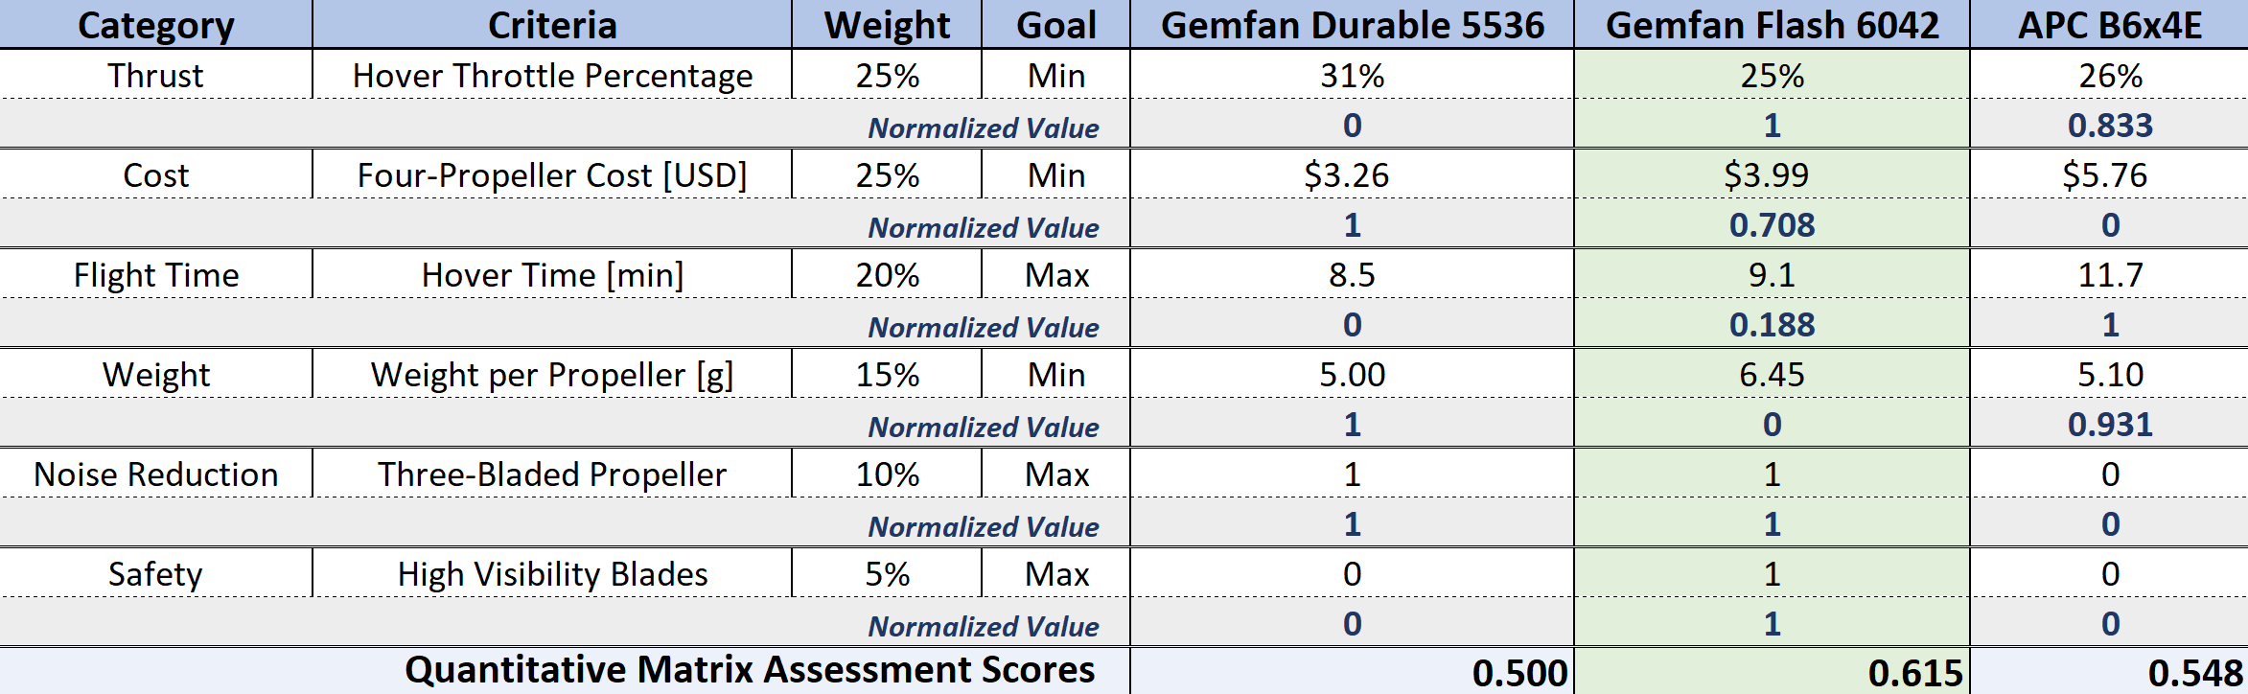

### Criteria

Hover Throttle Percentage: The hover throttle percentage is inversely related to the TWR, so as the TWR increases, the percentage of maximum throttle needed to maintain the same number of thrust decreases. The team used the logarithmic value of hover throttle percentage because this is the style of throttle that the team’s manual controller will be using. The designed throttle percentage at hovering is 25% - 50%, and the lower this is kept in the designed range, the greater the flight time and maneuverability that can be achieved.

The Gemfan Flash 6042 (GF) has the lowest calculated hover throttle percentage of 25%, awarding the GF a normalized value of 1. The APC B6x4E (APC) is narrowly in second place with a hover throttle percentage of 26%, awarding it a normalized value of 0.833. In last is the Gemfan Durable 5536 (GD) with a hover throttle percentage of 31%, leading to a normalized value of 0 for this category [6].

It is to be noted that all propellers meet the requirements of a TWR of 2.4 or greater. Both the GF and APC have TWRs of 3.6, while the GD has a TWR of 3.0. Using hover throttle percentage rather than TWR as a metric better defines the system requirement since all propellers exceed a TWR of 2.4 [6].

Four-Propeller Cost: The cost of a pack of four propellers is significant due to the team’s ability to control the total cost. As test flights occur in the future, it is likely that propellers will break. To replace the propeller, another needs to be bought in its place. The difference in cost between the propellers multiplies with the more replacements that are needed. Knowing this, the best score in the cost criteria is awarded to the cheapest propeller.

The propeller that scored a normalized value of 1 is the GD as it only cost $3.26 for four propellers [2]. The next cheapest set of propellers is the GF at a dollar per propeller [3], scoring a normalized value of 0.708. The most expensive set of propellers is the APC at $5.76 [1], earning it a normalized value of 0.

Hover Time: The flight time of the UAV is not able to be accurately calculated beforehand, especially for an autonomous mission where the path the UAV takes is dependent on how it filters the data. To use a better metric to compare the flight times using the three different types of propellers, the hover time is used. This overestimates the available flight time of during the mission since no maneuvering is involved, but the flight time will not be much lower due to the small area and speed limitations. The propeller that has the greatest estimated hover time is awarded the greatest score.

The most efficient propeller is the APC with an estimated hover time of 11.7 minutes, earning a value of 1 for the trade study. At over 2.5 minutes worse is the GF with a hover time of 9.1 minutes, earning a normalized value of 0.188. The least efficient propeller is the GD with a hover time of 8.5 minutes, earning none of the 20% metric [6].

Weight per Propeller: The weight for each propeller will remain the same throughout the testing of the UAV. Even if a propeller breaks, it will just replace the broken one, resulting in no change to weight. The propeller that weighs the least will receive the full 15% of the metric.

The lightest propeller in the trade study is the GD at 5.00 g [2], scoring a 1. The APC is just heavier than the GD at 5.10 g [1], earning a normalized value of 0.931. The GF is much, respectively, heavier than the other two propellers at 6.45 g [3], earning it a 0.

Three-Bladed Propeller: Nicola Kloet et al. stated that propellers with three blades produce less noise at the same rotations per minute (RPM), pitch, and diameter than those with two blades [5]. This information pushes for the use of a propeller with three blades instead of two for the purposes of less vibrations in the airframe and more accurate sensor readings. The propellers will receive full points if they are 3-bladded and 0 if they are 2-bladed.

Therefore, the GF and GD both receive the full 10% for this criterion, while the APC receives a score of 0.

High Visibility Blades: A blade that is brightly colored has a much better chance of being seen in a working environment and preventing accidental from someone running into the UAV. If a propeller has the option to have a color of blade that is not black or grey, it will receive full credit. If not, then it will be scored a 0.

The GF is the only propeller that has the option for a high visibility color. Therefore, the GF earns a score of 1 while the GD and APC earn a 0.

### Result

By conducting the trade study with the GD, GF, and APC, it is shown that the GF will be the blade used for project GEOFF. It combines the best of all categories while achieving a hover time and TWR that will be suitable for the mission.

## Navigation, Flight Planning, and Control

The navigation system will primarily be focused on calculating accurate orientation and position to provide the controller with information to maintain vehicle stability. For the purposes of this demonstrator, Pozyx will be able to provide accurate enough data for the XY coordinates on its own. However, the Z coordinate will require higher accuracy than provided by Pozyx. By combining information from Pozyx data with data from the ultrasonic altimeter on board the vehicle the Z position can be more accurately estimated. The navigation system will achieve this by applying a Kalman filter to data from both Pozyx and the ultrasonic sensor to fuse the data into a more reliable result. Flight planning will consist of a series of waypoints calculated by the flight computer following the profile of Figure 3 for any arbitrary location of the target beacon. Flight planning and navigation are both areas that will require significant further development in the simulator as more accurate values for the system dynamics become available from testing of the physical system.

The controller design is a combination of PID/PD control depending on the direction of movement. PID is utilized for control along the Z axis where eliminating steady state error is more crucial to avoid collision with the ground as well easing the work required to satisfy FR1.1. For the X and Y dimensions where collision is less likely a PD controller is being implemented with a velocity limit to prevent the vehicle from reaching unnecessarily high speeds and endangering personnel on the ground. PD is also being used for attitude control, which is being coupled with a bank limit for safety concerns. A position correction term is also being included in the X and Y controllers to correct for any deviations between where navigation thinks the drone is and the real location.

Development of these navigation and control systems is being aided by a simulator which allows for testing of the code before the completed vehicle is made. Integration work will be further aided with this simulator as the model gets made more accurate to the physical vehicle and gain values get further refined.

The code of the current simulated controller can be found in Appendix 1.1, 1.2 and 2.

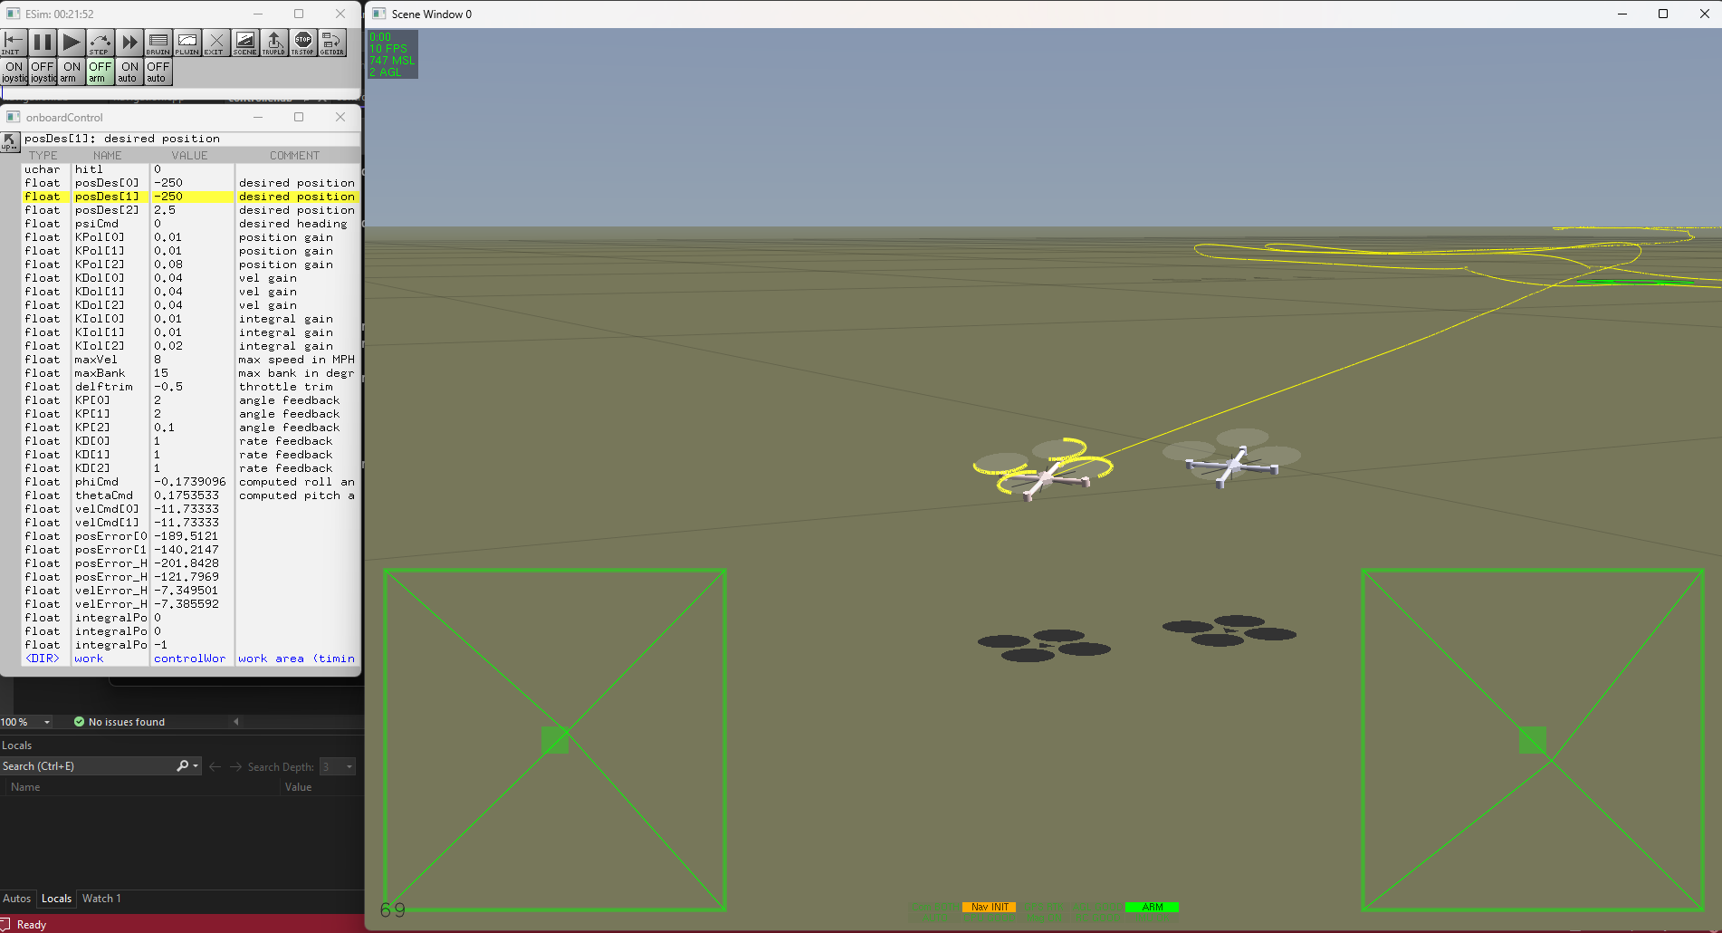

Figure 11 – Navigation and Control Simulated Testing

Power Analysis

In the Power analysis for the system’s components, the following specifications have been identified:

Table 5 - List of the Electronics' Required Voltages and Currents

|  |  |  |
| --- | --- | --- |
| **Component** | **Voltage (V)** | **Current (A)** |
| Brushless Motors | 8 – 10.8 | 4 – 10 |
| ESC | 8 – 10.8 | 1 – 3 |
| Servo Motor | 5 – 10.8 | 0.5 |
| Ultra Sonic Sensor | 5 – 10.8 | 0.5 |
| Arduino | 6 – 10.8 | 0.5 |
| Pozyx | 6 – 10.8 | 0.5 |
| Receiver | 5 – 10.8 | 0.5 |
| LED | 3.3 | 0.5 |

For optimal operational considerations, the throttle should be maintained at 25-50% to achieve hovering. The estimated flight time is 1 minute, and the system should be capable of performing 5 flights using the same battery to ensure efficiency. The analysis also considers the energy lost due to resistance in wires/electronics and the idle power consumption.

After these consideration points, the overall energy requirement for the system is calculated to be in the range of 120 to 160 Watts. This energy budget is crucial for the engineering and design of the system to ensure that all components function correctly, and that the device can operate within the defined parameters.

To regulate voltage and current across the electronics onboard the GEOFF, a Power distribution board with built in voltage regulator will be used. The board connects to the battery directly and supplies the regulated voltage to the other components.

Battery Analysis

The analysis of battery configurations, specifically between 4-cell(4S) and 3-cell(3S) battery, is essential for determining the optimal power source for the GEOFF. The key factors that influence this decision include the size, number of cells, weight, discharge rate, capacity, and the type of material used in the batter. The size and weight are critical, as they directly impact the design and performance of the GEOFF. The number of cells, represented by ‘S’, dictates the voltage of the battery. The 3S battery operates at 11.1 Volts and 4S at 14.8V. The discharge rate, represented by ‘C’ on battery, is significant as it determines how quickly the battery can release its stored energy, which is vital during the mission. The material commonly used in this battery is Lithium Polymer, as it can store good amount of energy compared to its counterparts and is cheaper Lithium-Ion battery. To calculate the capacity of the battery the following equations are used:

Where:

E = Energy (Watt-hour)

C = Capacity (Amp-hour)

V = Voltage (volts)

D = Depth of Discharge (%) = 0.8

BE = Battery Efficiency (%) = 0.9

P = Power need by the system (Watt) = 120 to 160

t = time (hours) = 9 minutes/ 0.15 hours

Using these parameters, the following Capacity of Battery was achieved:

1690 mAh < C < 2250 mAh for V = 14.8 V (4S)

2250 mAh < C < 3000 mAh for V = 11.1 V (3S)

The battery chosen after this analysis and doing a trade study was a Lithium Polymer battery with 3 cells which have a capacity of 2200 mAh and has a discharge rate of 80C. The weight of the battery is 196 grams with dimensions of 26*34.5*107.5mm.

Positioning Analysis

The Pozyx shield will be used for its real time position tracking capabilities, this system will provide high precision positional data. While the system yields accurate coordinates along the x and y axes, it was observed that the z-axis (height) measurements were neither precise nor reliable. To enhance the altitude determination of the GEOFF, another altitude sensor will be used. The sensors under consideration are an ultrasonic sensor and an Infrared sensor.

An ultrasonic sensor operates on the principle of sonar. It emits ultrasonic pulses and measures the interval until the echo returns after striking an object. This method allows the sensor to calculate distance. An infrared sensor operates by emitting an IR beam that reflects off the surface of objects. The sensor then measures the angle or intensity of the returned light. This variation is used to calculate the object's distance from the sensor.

To choose between these two, a trade study was conducted as follows.

Table 6 – Trade Study for Altitude Sensor

|  |  |  |
| --- | --- | --- |
| Legend | Bad | |
| Good | |
| **Criteria** | **Ultrasonic Sensor** | **Infrared sensor** |
| Principle | Emit ultrasonic waves and measure bounce-back time | User laser pulses to measure distance |
| Accuracy | Accurate in close range | Highly accurate over long range |
| Cost | Less expensive | More expensive |
| Environmental Limitations | Performance degrades over uneven surface | More robust in various conditions |
| Application Suitability | Suited for low altitude | Precise altitude over wide ranges |
| Cost Vs Performance | Cost effective | Superior Performance but more expensive |

Based on the trade study in table 6, ultrasonic sensor was a better choice than an infrared sensor. In addressing the challenges posed by the individual inaccuracies and reliability issues of altitude data from the Pozyx and ultrasonic sensors, a solution is proposed. The approach includes the implementation of a noise filter algorithm, specifically a Kalman Filter, to minimize inaccuracies inherent in the sensor data. Furthermore, synchronizing the data acquisition frequency across both sensors is essential to ensure consistency in the readings. The anticipated outcome has: an enhancement in data reliability, which is crucial for altitude stabilization, and the empowerment of the GEOFF to maintain a consistent and precise altitude. This integrative strategy is expected to mitigate the risks associated with altitude variance, thus improving the operational stability and performance of the GEOFF system.

# **Design Challenges, Risks, and Mitigations**

## Flight Safety Checkout Milestone

The flight safety checkout (FSC) was the first milestone that the team was planned to reach and roughly half of the spring semester was spent working towards this. The FSC milestone was to ensure that the drone is considered “airworthy” and would be checked for the mechanical components, wiring, center of gravity placement, structural integrity, and seeing if the drone correctly responds to operator inputs. This milestone was considered a success if one of the three professors felt that the drone passed all the safety criteria to their standards.

No major challenges were encountered through the process of preparing GEOFF to be able to safely begin flight testing, but there were a few steps that took longer than others. One of these steps was creating the controller for throttle and maneuvering the drone. The trouble started with mapping the throttle to an appropriate number range for the Arduino to understand the pulse width modulation (PWM) output for the motors. Then, tuning the logic for controlling the speed of each motor during roll, pitch, and yaw became tedious. Sometimes a motor would stop spinning, other times the motors would try to correct the drone in the wrong direction, but most of the time the motors did not react enough to the user or automatic correction inputs. Through trial and error, GEOFF was able to pass the flight safety checkout, but Built Illiterate officially became three weeks behind the initial schedule.

## Manual Flight Milestone

The primary roadblock to achieving the manual flight demonstration was realizing that the issue with the drone not flying correctly was the low pass filter and not the gain values. The group was stuck for 12 days on tuning the gain values before realizing that the true issue was the implementation of the low pass filter in the code. This segment of the controller simply needed commented out, and the drone was able to be manually controlled.

The manual flight (MF) milestone was the second milestone that Bulit Illiterate had set and is where most of the issues arose from. The purpose of this milestone was to ensure that GEOFF was able to be controlled using the handheld flight controller provided to the team at the beginning of the fall semester. A successful MF was achieved through considering qualitative feedback from the pilot, not using any form of calculations. The qualitative feedback was mapped to the Cooper-Harper handling qualities scale, which is an assessment conducted by the pilot of the vehicle on how well they feel the vehicle can be controlled.

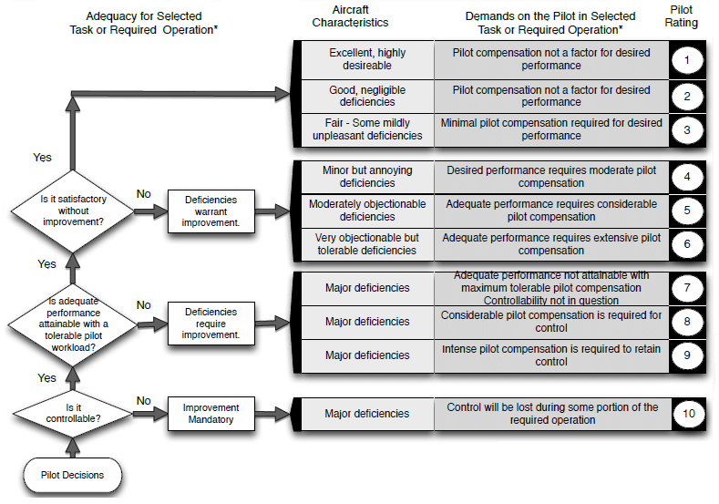

Figure 12: Cooper-Harper handling qualities rating scale

Figure 12 shows the metrics used for determining the pilot rating of the flight, where a 10 is not at all controllable and a 1 represents a vehicle with near-perfect handling. In our case, we were looking for a 6 at the highest setting. This would mean that our drone would be able to be controlled but could just use some gain value tuning during the process of working towards the Dynamic Path Planning Milestone. Our initial flights put the drone at a 10 since it was extremely difficult to even get it off the ground. Once issues were resolved, the team pilot felt that the drone had a handling quality of 4, marking the manual flights as an official team success.

During the time leading up to the test, there were several problems that arose. The first of which was the rigidity of the legs on the drone. As tests with awkward landings continued to happen, they began to permanently deform. This resulted in the drone starting off slanted sidewise, and it would try to correct itself before it could even get off the ground, making it harder to tune the gain values needed for stable flight. To correct this behavior, new legs were designed. They are more structurally sound at the expense of increasing weight, but it was deemed as a necessary change by the team. In addition to this, Loctite was added to all screws on the frame to quasi-permanently keep them screwed in because some started to loosen themselves during testing.

Another major issue that held the team back was something that was not recognized as a problem until shortly before the successful MF of GEOFF. It was initially thought the gain values of the drone were far off and the difficulty to compare those to the working simulation drone became apparent. After much frustration, Built Illiterate took a look at other potential solutions and discovered that the poor feedback was due to the drone having a low pass filter, which was delaying the inputs from the IMU. It took 12 days to figure out that the low pass filter was causing the issue – not the gain values. Since they were collectively believed by the group to be the problem, searching for a different answer was not a thought. This segment of the controller simply needed commented out, and the drone was able to be manually controlled.

# **Testing Strategy**

The scoring formula has guided several principles of the strategy behind project GEOFF. Most notably, the weight and cost terms of the score equation is an area where much consideration should be placed. It is critically important to strike a balance between cost and weight. Based on the formulas in Figure 1, reducing cost is of slightly higher value than weight since reducing cost has a higher impact on increasing score overall. Reducing the initial cost would also be critical to ensuring a lower overall project cost as components get damaged and need replaced during testing. That said, it is still important to focus on reducing design weight since that is effectively a fixed multiplier on score based off the design of GEOFF whereas cost will only rise over time.

Other critical focuses of the development of project GEOFF were the autonomous takeoff regime and the dropper mechanism. Autonomous takeoff was required to score any points during and same applied to the dropper mechanism functioning. The accuracy of the dropper is less critical, even at 4 meters away from the drop, the score will still be 0.25.

Having robust and simple manual control will also be critical to this competition. While the goal was to have full autonomous capabilities at the start of the spring semester, timelines were pushed back, and autonomous takeoff became the end goal. After takeoff, manual flight will not completely mitigate the score, but rather only reduce it. Having a manual controller that allows the pilot to accurately maneuver the vehicle to the target, meet the hover requirements, and deploy the payload near the beacon would ensure that Built Illiterate received the greatest score possible. Due to the lack autonomy within the drone, more switches were able to be utilized for handling, safety, and mechanical features.

Recovery was a very low priority in the autonomy strategy since an unrecovered mission only results in getting half the score of an equivalent mission with successful recovery. For this reason, and only having MF capabilities, it was assumed that the drone would be able to return within close range to the starting location.

To prepare for tests and flights altogether, the team tested different aspects of GEOFF during the build process to limit the amount of hardware that might need to be removed for being faulty. With the drone fully built, the team moved to mapping the controller values to match a similar result as the flight simulation code. From there, a PD (and eventually PID) control system was implemented to allow the drone to correctly respond to pilot inputs. Finally, an altitude controller was being worked on, but the result was many crashes leading to many crashes that delayed testing. Ultimately, an autonomous takeoff was not able to be successfully created and all competition flights were done so manually to gain the most points possible.

# **Final Flight Test Results**

On the day of the final flight competition, the drone performed 5 flights, 4 of which were deemed successful to the group. For a flight to be deemed successful to the group, the drone was required to take off manually, drop the payload within 1 meter of a target, and land safely. The group scored points in the competition due to the successful flights, and therefore won first place among the other groups who attended the competition.

Out of the three teams meant to compete in the challenge, only two were able to enter the competition. Through the flip of a coin, team Built Illiterate chose to go second to be able to have extra time repairing the drone that had broken the previous evening. There was an extraordinary last-minute effort by the team went into preparing it for the competition, so the more time available to double check all systems operated properly before flying, the better.

The first flight by the team came at the tail end of the allotted 10-minute window and was used to flight test our systems. When attempting the first official flight, the pilot accidentally took GEOFF outside the confines of the testing zone when attempting to takeoff, resulting in 0 for the first attempt. When trying to achieve autonomous takeoff during testing, gain values were changed and created an uncontrollable drone. After rechecking hardware and reverting to prior versions of the code, the team managed to have four straight successful flights. These included hovering, dropping the payload within 1m of the MOB, and returning within 1m of the landing position.

By the end of the competition, Built Illiterate was the only team that was able to fly and by default had been awarded first place. No team had achieved any level of autonomy, and therefore no points should have been awarded according to the formula. However, in what was believed to be an attempt to allow points to be earned, the scoring formula was altered mid-competition. Within the summation, those point values were now added together on each attempt, not multiplied. This small change allowed Built Illiterate to ≈0.6 points over the course of the competition.

# **As-built Schedule and Budget**

Listed in Table 7 below are the estimated costs of all of the components that are planned to be used on the vehicle. Maintaining a low budget was critical to balancing any lower scores caused by a high vehicle weight. The final cost spent on project GEOFF was $292.97. The budget includes any extra components that were deemed to have a high importance and that could cause significant delays if one were to go bad without a replacement.

Table 7 - Component cost breakdown

|  |  |  |  |
| --- | --- | --- | --- |
| **Part** | **Price Per Item** | **Quantity** | **Price ($)** |
| EMAX (knockoff) RS2205 2300Kv (4pcs) | $37.00 | 1 | $37.00 |
| iFlight XING 2205 2300Kv | $17.99 | 4 | $71.96 |
| Spedix ES30 HV 3-6S 30A ESC | $11.95 | 5 | $59.75 |
| RaceDayQuad Lipo battery 3s 2200mah | $27.00 | 1 | $27.00 |
| GalaxyElec PDB-XT60 BEC 5V&12V | $12.00 | 1 | $12.00 |
| Gemfan Flash 6042 Tri-Blade 6" Prop 4 Pack | $3.99 | 4 | $15.96 |
| Propeller Reducers (2.9, 3.1, 4mm) (4 pcs) | $0.25 | 4 | $1.00 |
| Ultrasonic Sensor Module HC-SR04 (2pcs) | $6.77 | 1 | $6.77 |
| WWZMDiB SG90 Micro Servo Motor | $8.00 | 1 | $8.00 |
| ELEGOO PLA Plus, Printer Filament, Black | $15.99 | 1 | $15.99 |
| M3 Assorted Lengths | $11.99 | 1 | $11.99 |
| M3 x 4.6mm x 5.7mm Heat Inserts, 150pcs | $7.99 | 1 | $7.99 |
| Nylon Spacers 3mm, 100pcs | $6.59 | 1 | $6.59 |
| Elegoo Jumper Ribbon Wires | $6.98 | 1 | $6.98 |
| Zip Ties 4 inch by Tantti Supply | $3.99 | 1 | $3.99 |
| Total |  |  | $292.97 |

The team created a Gantt chart at the end of the fall semester to plan out the timeline of the spring semester. The purpose of this was to make the team meet deadlines for each milestone to ensure that the drone would be ready to be flown for the competition. This Gantt chart accounted for incremental capabilities by increasing the testing time the further that the semester progresses and had multiple flight test and tuning sessions to perfect the drone before the competition. By spending more time testing the drone after each step, the total debugging and testing time was predicted to be less, ensuring that the complete drone still works as intended after each new iteration.

Figure 13 – Original Gantt chart demonstrating spring semester schedule

Due to the reality of engineering, the team was not able to follow the schedule as planned. Once the FSC deadline was missed by three weeks, tasks continued to get backed up and were not completed on time. As a result, a new milestone “Autonomous Hover” was included, “Simulation Autonomous Flight” and “Full Autonomous Flight” were removed. The final goal of the semester was to be able to perform an autonomous hover using a developed altitude controller, but this was unsuccessful and the milestone was not met.

Figure 14 – Final Gantt chart depicting real spring semester schedule

# **Conclusion and Lessons Learned**

Several steps were taken and are shown in this critical design review to prepare the drone to be finalized in time for the competition in late spring. The competition request for proposal was read over and utilized to create a mission plan, CONOPS, requirements and strategy to plan the next steps to take in the building and testing of the drone. After breaking down the necessary steps to create the drone, the skills required to do so were brainstormed and each group member ranked themselves on a scale from 1-5 in a team capability matrix. Using the team capability matrix, tasks were assigned based on the strengths of the group members and shown in the team organization chart.

After tasks were assigned, each member worked on their individual portion to be completed for the critical design review. The software team worked on designing the autopilot feature and making it work on the simulator. The structure team worked on fabricating the frame for the drone and making it structurally stable. And the hardware team worked on finding the ideal parts to go on the drone that all work symbiotically.

Sticking to the Gantt chart as originally developed proved harder than initially thought. Tasks became easier to fall behind on when full focus was not put into them during class. The team could have better parallelized the workflow throughout the semester to reach the milestones sooner. Doing so could have allowed autonomous hover to be possible during the flight competition. However, it is impossible to predict all the troubles that will be encountered over the course of a project, especially one where no one has had much experience in.

To be able to achieve what Built Illiterate did in the given time is worth a pat on the back. Many, many hours were put into GEOFF outside of class hours and all members went above and beyond for 8 months. It was a what seemed like a very realistic experience to the professional world, and being able to constantly push through losses is one of the most important aspects to being an engineer. There is not always a set solution to a problem, so taking a step to reevaluate the situation can mitigate the time spent on pushing through those losses. Regardless of the challenges faced along the way, the journey was exciting and educational, and greatly worth the outcome of first place.

# **Appendix**

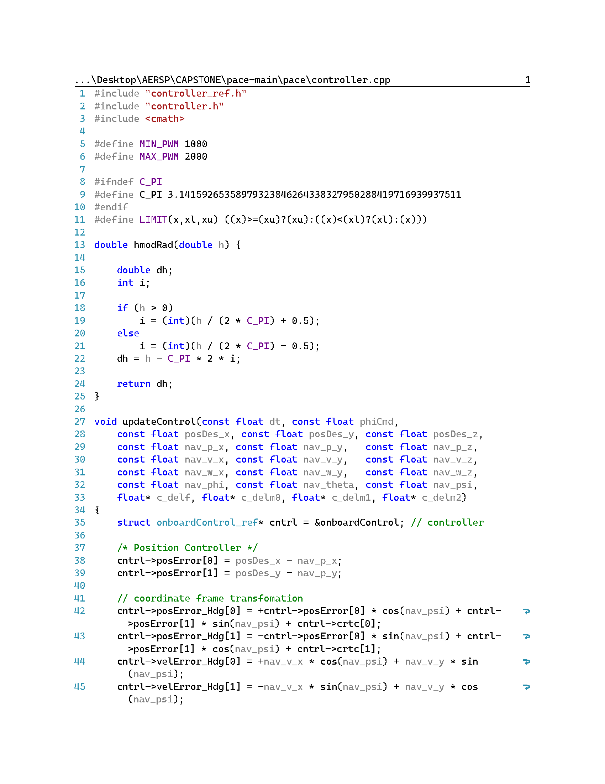

Appendix 1.1 - controller.cpp from Simulator Code

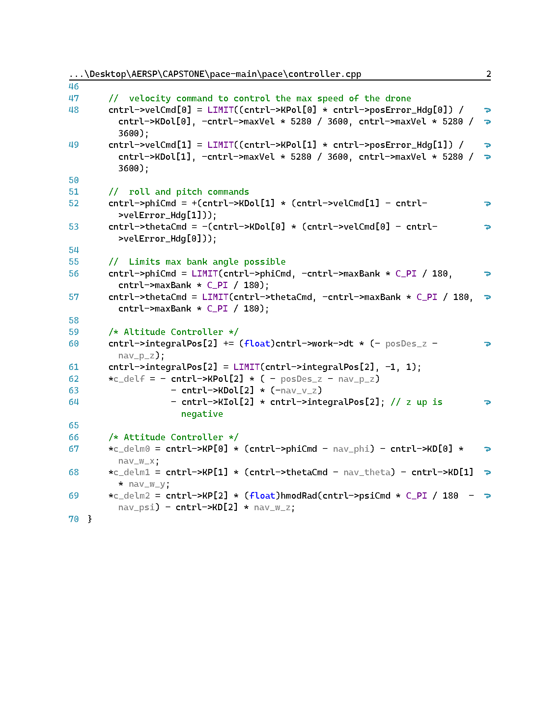

Appendix 1.2 - controller.cpp from Simulator Code

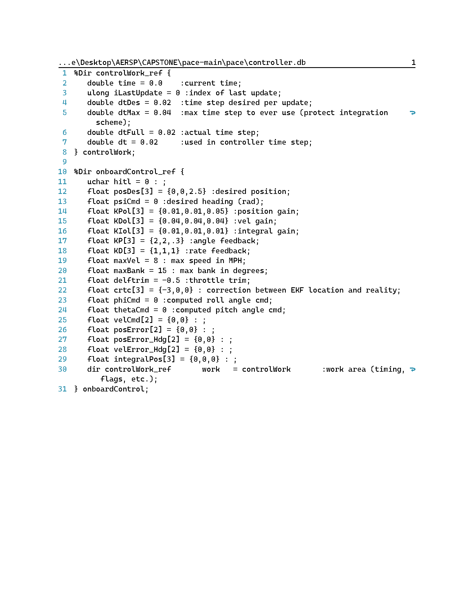

Appendix 2 - controller.db File from Simulator Code

**References and Citations**

[1] “B6x4e-B4,” *APC Propellers* Available: <https://www.apcprop.com/product/b6x4e-b4/>. (Accessed Dec. 10, 2023).

[Z] “Gemfan durable 5536 Tri-Blade 5.5" Prop 4 pack - choose your Colorclear Gray,” *RaceDayQuads* Available: <https://www.racedayquads.com/products/gemfan-durable-5536-tri-blade-5-5-prop-4-pack-choose-your-color?variant=39699628359793>. (Accessed Dec. 10, 2023).[2] “Gemfan durable 5536 Tri-Blade 5.5" Prop 4 pack - choose your Colorclear Gray,” *RaceDayQuads* Available: <https://www.racedayquads.com/products/gemfan-durable-5536-tri-blade-5-5-prop-4-pack-choose-your-color?variant=39699628359793>. (Accessed Dec. 10, 2023).

[X] “Gemfan Flash 6042 durable 3 blade propeller (set of 4 - red),” *www.getfpv.com* Available: <https://www.getfpv.com/gemfan-flash-6042-durable-3-blade-propeller-set-of-4-red.html?utm_source=google&utm_medium=cpc&utm_campaign=DM%2B-%2BNB%2B-%2BPMax%2B-%2BShop%2B-%2BNo-index%2B-%2BSM%2B-%2BALL%2B%7C%2BFull%2BFunnel&utm_content=pmax_x&utm_keyword=&utm_matchtype=&campaign_id=20799936859&network=x&device=c&gc_id=20799936859&gad_source=1&gclid=Cj0KCQiA4NWrBhD-ARIsAFCKwWv74SrXyfzymunPmwf2qoUmTd24hBU93c3bOQhvARoKsYbqTPllRH4aAgmqEALw_wcB>. (Accessed Dec. 10, 2023).[3] “Gemfan Flash 6042 durable 3 blade propeller (set of 4 - red),” *www.getfpv.com* Available: <https://www.getfpv.com/gemfan-flash-6042-durable-3-blade-propeller-set-of-4-red.html?utm_source=google&utm_medium=cpc&utm_campaign=DM%2B-%2BNB%2B-%2BPMax%2B-%2BShop%2B-%2BNo-index%2B-%2BSM%2B-%2BALL%2B%7C%2BFull%2BFunnel&utm_content=pmax_x&utm_keyword=&utm_matchtype=&campaign_id=20799936859&network=x&device=c&gc_id=20799936859&gad_source=1&gclid=Cj0KCQiA4NWrBhD-ARIsAFCKwWv74SrXyfzymunPmwf2qoUmTd24hBU93c3bOQhvARoKsYbqTPllRH4aAgmqEALw_wcB>. (Accessed Dec. 10, 2023).

[4] K. Cho. “Why falling off a cruise ship is so deadly.” The Washington Post. <https://www.washingtonpost.com/travel/2023/07/31/cruise-ship-fall-death/>. (Accessed Nov. 1, 2023).​

[5] Kloet, N., Watkins, S., Wang, X., Prudden, S., and Clothier, R., “Drone on a preliminary investigation of the acoustic impact of unmanned ...,” *ResearchGate* Available: <https://www.researchgate.net/profile/Nicola-Kloet/publication/332006855_DRONE_ON_A_PRELIMINARY_INVESTIGATION_OF_THE_ACOUSTIC_IMPACT_OF_UNMANNED_AIRCRAFT_SYSTEMS_UAS/links/5c9ac525a6fdccd4603cd71f/DRONE-ON-A-PRELIMINARY-INVESTIGATION-OF-THE-ACOUSTIC-IMPACT-OF-UNMANNED-AIRCRAFT-SYSTEMS-UAS.pdf>. (Accessed Dec. 10, 2023).

[6] M. Mueller, “xcotperCalc – Multicopter Calculator,” eCalc, <https://www.ecalc.ch/xcoptercalc.php>. (Accessed Dec. 4, 2023).  ​