Harry Potter - Philosophers Stone
THE BOY WHO LIVED
Meet the Dursleys, a family who lived in a nice house at number four, Privet Drive. Mr. and Mrs. Dursley were very proud of their normal lives and didn't like anything strange or mysterious. Mr. Dursley worked at a company called Grunnings, which made drills. He was a big man with a big mustache and not much of a neck. Mrs. Dursley was thin and blonde, and had a long neck, which she used to look over the fences and spy on the neighbors. They had a son named Dudley, and they thought he was the best boy in the whole world.
The Dursleys had everything they wanted, but they had a secret that they were afraid someone would find out. They were scared that people would discover that they were related to the Potters. Mrs. Potter was Mrs. Dursley's sister, but the Dursleys tried very hard to hide this fact. They didn't want anyone to know about the Potters because they were afraid of what might happen if anyone found out.
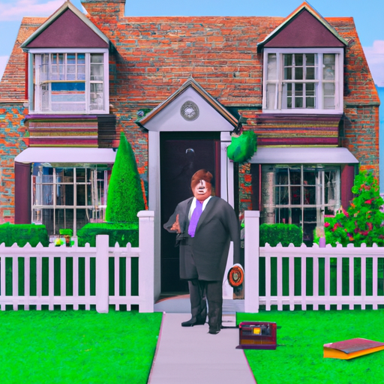
The Dursleys had not seen their sister and her husband for many years. In fact, Mrs. Dursley pretended she didn't have a sister at all because her sister and her husband were very different from the Dursleys. The Dursleys were worried about what the neighbors would think if the Potters came to visit. They also knew that the Potters had a young son, but they had never even met him. The Dursleys didn't want their son, Dudley, to play with a child like that.
On a dull, gray Tuesday morning, Mr. and Mrs. Dursley woke up and went about their usual routines. Mr. Dursley hummed while he chose a boring tie for work, and Mrs. Dursley chatted happily while she fed a screaming Dudley his breakfast. None of them noticed a large, tawny owl fly past the window.
At 8:30, Mr. Dursley grabbed his briefcase, kissed Mrs. Dursley on the cheek, and tried to kiss Dudley goodbye, but Dudley was throwing a tantrum and throwing his cereal everywhere. "Little rascal," Mr. Dursley chuckled as he left the house. He got in his car and backed out of the driveway at number 4.
As Mr. Dursley drove down the street, he saw something strange – a cat reading a map. Mr. Dursley couldn't believe what he saw and looked again. There was a tabby cat on the corner of Privet Drive, but there was no map in sight. Mr. Dursley must have been seeing things. He blinked and looked again, but the cat was gone.
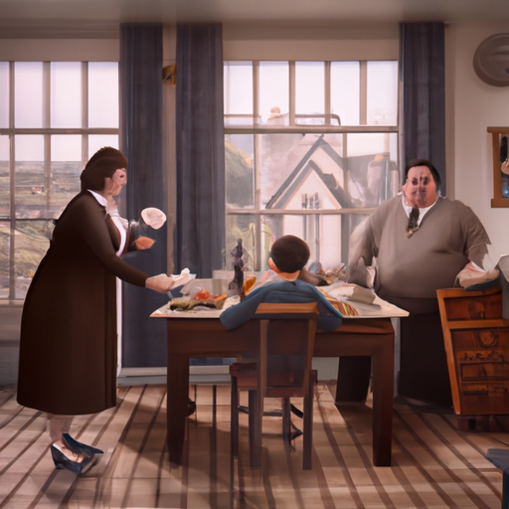
Mr. Dursley saw a cat staring at him as he drove around a corner and up the road. He glanced at the cat in the mirror, but quickly dismissed it from his mind. All he could think about was a large order of drills he hoped to get that day. But as he sat in the usual morning traffic jam, he noticed a lot of people dressed in strange cloaks. Mr. Dursley didn't like people who dressed in funny clothes and assumed it was some new fashion trend. He saw a group of these weirdos standing close by, whispering excitedly to each other. Mr. Dursley was annoyed to see that some of them weren't even young. One man, who was wearing an emerald-green cloak, was older than Mr. Dursley. Mr. Dursley figured they were probably collecting for something and dismissed them from his mind. When the traffic moved on, Mr. Dursley arrived at the Grunnings parking lot, his thoughts returning to drills.
Mr. Dursley always sat with his back to the window in his office on the ninth floor. If he had faced the window, he might have been distracted by the sight of owls flying past in broad daylight. People on the street pointed and stared in amazement as owl after owl flew overhead, most of them having never seen an owl even at night. But Mr. Dursley had a completely normal, owl-free morning. He yelled at five different people and made several important phone calls.
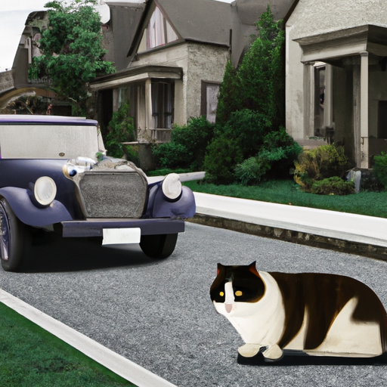
Mr. Dursley had a great morning at work, but his good mood was ruined when he went to buy a bun from the bakery across the road. As he walked back to the office, he noticed a group of people wearing cloaks standing next to the baker. They made Mr. Dursley uneasy, and he glared at them as he walked past. On his way back, he overheard them talking about someone named Harry Potter. Mr. Dursley froze in fear and considered calling his home, but then he realized he wasn't even sure if his nephew was named Harry. He didn't want to worry his wife, who always got upset at the mention of her sister. Mr. Dursley tried to brush off his concerns and went back to work, but he couldn't shake the feeling that those people in cloaks were up to no good.
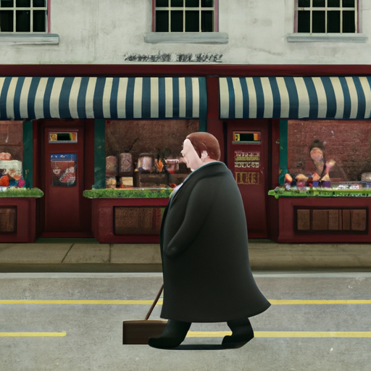
One afternoon, a man named Mr. Dursley had a hard time focusing on his drills. When he left the building at five o'clock, he was so worried that he accidentally walked into someone standing just outside the door.
"Sorry," Mr. Dursley mumbled, as the small old man stumbled and almost fell. It took Mr. Dursley a few seconds to realize that the man was wearing a violet cloak. Instead of being upset, the old man had a big smile on his face and said in a high-pitched voice that made people nearby stare, "Don't be sorry, my dear sir! Nothing can upset me today! You-Know-Who is gone at last! Even Muggles like you should be celebrating this happy, happy day!" The old man then hugged Mr. Dursley around the middle before walking away.
Mr. Dursley was shocked. He had just been hugged by a stranger and had been called a Muggle, which he didn't understand. He quickly got into his car and drove home, hoping that he was just imagining things. When he arrived at his house, the first thing he saw was the tabby cat he had seen that morning. It was now sitting on his garden wall. Mr. Dursley was sure it was the same cat because it had the same markings around its eyes.
"Shoo!" Mr. Dursley said loudly.
The cat just stared at him and didn't move. Mr. Dursley wondered if this was normal cat behavior. He tried to calm down and went inside his house.
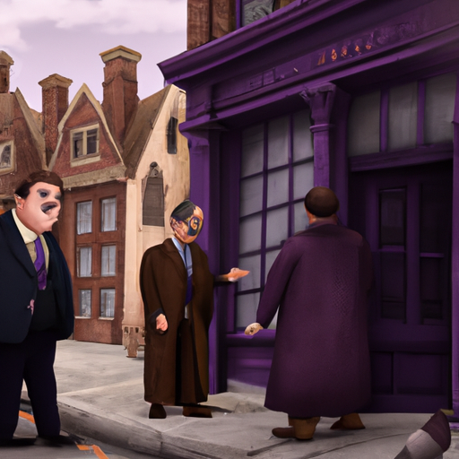
One day, Mr. Dursley had a normal day at work and came home to a normal dinner with his wife and son, Dudley. Mrs. Dursley told him about her neighbor's daughter's problems and how Dudley had learned a new word ("Won't!"). Mr. Dursley tried to act normal, but when he sat down to watch the evening news, he heard a report that all of the nation's owls were behaving strangely, flying in daylight and not following their normal sleeping patterns. Experts couldn't explain the sudden change. The weatherman on the news even mentioned that people from all over the country were reporting strange rain showers of shooting stars. Mr. Dursley was shocked and couldn't believe what he was hearing. There were also reports of mysterious people in cloaks everywhere and whispers about a family called the Potters.
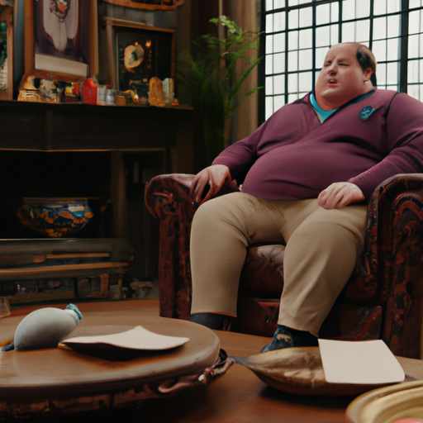
Mrs. Dursley came into the living room with two cups of tea. Mr. Dursley knew he had to say something to her. He cleared his throat nervously. "Petunia, have you heard from your sister lately?"
Mrs. Dursley looked shocked and angry. They usually pretended she didn't have a sister.
"No," she said sharply. "Why?"
"There have been some strange things on the news," Mr. Dursley mumbled. "Owls, shooting stars, and a lot of weird-looking people in town today."
"So?" snapped Mrs. Dursley.
"I was just thinking that maybe it had something to do with your sister's friends."
Mrs. Dursley sipped her tea through pursed lips. Mr. Dursley wondered if he should tell her he had heard the name "Potter." He decided not to. Instead, he said as casually as he could, "Their son would be about Dudley's age now, wouldn't he?"
"I suppose so," said Mrs. Dursley stiffly.
"What's his name again? Howard, right?"
"Harry. It's a common, nasty name if you ask me."
"Oh, yes, I agree," said Mr. Dursley, feeling his heart sink.
They went to bed without saying another word about the subject. While Mrs. Dursley was in the bathroom, Mr. Dursley crept to the bedroom window.
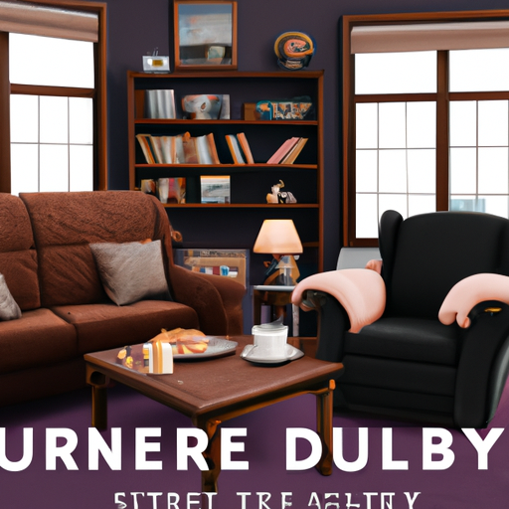
Mr. Dursley peered out the window and saw the cat in the front garden. It was staring at Privet Drive as if it were waiting for something to happen. Mr. Dursley wondered if he was just imagining things, or if the Potters had something to do with all this. He couldn't bear the thought of being related to a pair of—well, he didn't even want to think about it.
The Dursleys went to bed, with Mrs. Dursley falling asleep quickly. Mr. Dursley, however, lay awake, thinking about everything that had happened. He tried to reassure himself that even if the Potters were involved, there was no reason for them to come near him and Mrs. Dursley. The Potters knew how he and his sister felt about them and their kind. He couldn't see how he and Petunia could get mixed up in anything that might be going on. He yawned and turned over, thinking that it couldn't possibly affect them.
But Mr. Dursley was very wrong.
The cat on the wall outside showed no signs of sleepiness. It sat completely still, its eyes fixed on the far corner of Privet Drive. It didn't even move when a car door slammed nearby or when two owls flew overhead. In fact, it wasn't until midnight that the cat moved at all.
Suddenly, a man appeared on the corner that the cat had been watching. He appeared so suddenly and silently that it seemed as if he had just popped out of the ground. The cat's tail twitched and its eyes narrowed.
No one on Privet Drive had ever seen a man like this before. He was tall, thin, and very old, with silver hair and a long beard.
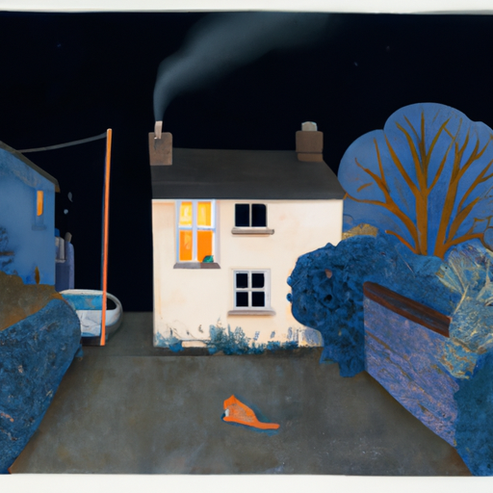
Albus Dumbledore was a man with a long, crooked nose that looked like it had been broken multiple times. He wore long robes, a purple cloak that trailed on the ground, and high-heeled, buckled boots. His bright blue eyes sparkled behind his half-moon glasses as he rummaged through his cloak. He seemed to be searching for something, but he was also aware of the cat watching him from the end of the street. Dumbledore found what he was looking for - a silver cigarette lighter. He held it up and clicked it, causing the nearest street lamp to go out with a pop. He repeated this process until all the street lamps were turned off and the only light came from the cat's eyes. Dumbledore then approached the cat and sat down on the wall next to it. "Fancy seeing you here, Professor McGonagall," he said to the cat.
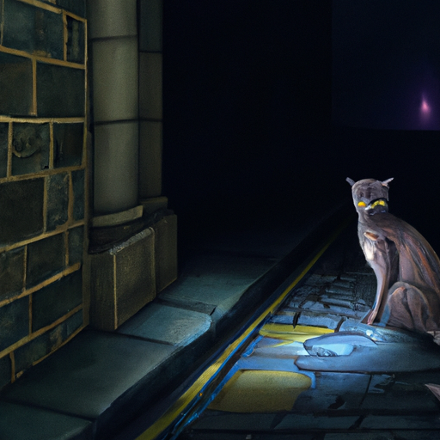
The man turned to smile at the tabby cat, but it was gone. Instead, he was smiling at a woman wearing glasses that looked like the markings around the cat's eyes. She had on a green cloak and her black hair was pulled into a tight bun. She seemed upset.
"How did you know it was me?" she asked.
"Professor, I've never seen a cat sit so stiffly," the man replied.
"You'd be stiff too if you sat on a brick wall all day," the woman, Professor McGonagall, said.
"All day? When you could have been celebrating?" the man asked. "I saw lots of parties on my way here."
Professor McGonagall huffed. "Everyone's celebrating, but they're not being very careful. Even the Muggles have noticed something's going on. It was on their news. Owls flying everywhere and shooting stars. Well, they're not completely clueless. They were bound to notice something with all those shooting stars in Kent. I bet that was Dedalus Diggle. He was never very smart."
"You can't blame them," the man, Dumbledore, said kindly. "We haven't had much to celebrate for eleven years."
"I know that," Professor McGonagall said impatiently. "But that's no reason to get careless. People are walking around in broad daylight like it's no big deal."
