LearnOSM

Common Editing Mistakes
Reviewed 2016-09-21
There are a number of common mistakes that mappers make when they start using OpenStreetMap. In this chapter we’ll identify a few of the most frequent errors and offer some tips for mapping better.

Connecting Objects

Some Objects Should Not Connect
When you are creating polygons and lines that are not supposed to be connected, make sure that they are not merged together by sharing a node. For example, highway nodes should not be snapped to buildings, because no one likes a road that leads directly into a wall! In josm, if you want to disconnect two or more objects that share the same node, select the node and go to Tools->UnGlue Ways or press <<G>>.
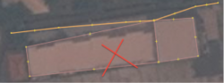
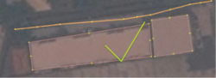

But, Some Objects Should Connect!
Roads that intersect should always share a node. If they do not share a common node, then the computer has no way of knowing that the roads actually connect to each other.
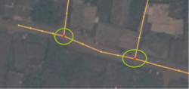
The only time that you would NOT have intersecting roads share a node is if one of the roads goes over the other road, and they do not, in fact, connect.

Overlapping Objects
A common error is to have overlapping polygons when the objects they represent do not overlap in real life. A building cannot overlap another building. This mistake is commonly made with buildings and landuse polygons. For example, a polygon drawn to represent a park outside a building should not overlap with the building. Instead it should be drawn next to the building.
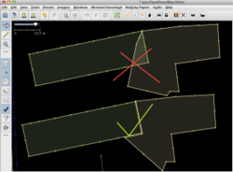
There are some exceptions to this rule, such as schools. Within a school yard you might identify individual buildings using polygons, yet you also might want to create a polygon around the entire school yard. In this case it is fine for the polygons to overlap, but the rule to follow here is to make sure that the buildings are completely inside the landuse polygon.
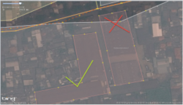

Summary
We all make mistakes, but the more you map the less you will make less mistakes! Just remember that even if you upload data that contains mistakes, you can always fix your mistakes and upload the changes again. This is what is great about OSM: you can always make it better!
Was this chapter helpful? Let us know and help us improve the guides!
- learnosm@hotosm.org
- @learnOSM
- Hosted on Github
Official HOT OSM learning materials


