Prank for friend.

Interrogation where he can answer only yes.

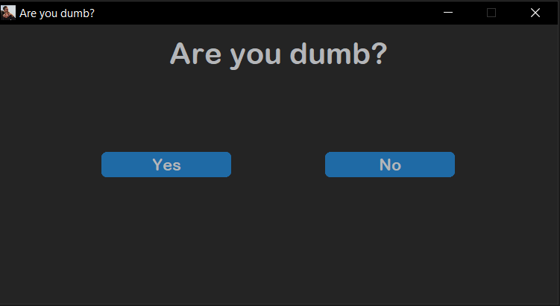Ready program window looks like this:

If you want to change a question or win title.

You need to change this lines:



And



If you want to change a question or win icon.

You need to change this line:



And

Insert the icon in the ".ico" extension into the root folder with the application

The person you are pranks will not be able to close the window through the cross and will not be able to press no because the no button runs away from the cursor

How to compile a .py script into an executable?

Previously you need to install customtkinter library.

You can read documentation how to pack into .exe [here](https://github.com/TomSchimansky/CustomTkinter/wiki/Packaging)

You need to open the console and write there:





Such as 

And then

pyinstaller --noconfirm --onefile --windowed --add-data "C:/Users/Nitro/AppData/Local/Programs/Python/Python310/Lib/site-packages/customtkinter;customtkinter/" -i "iconName.ico" main.py

After all you need to go to the “dist” folder and find there main.exe.

Then you need to go to the “application” folder and copy from there files to “dist” folder

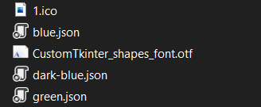

As the result in “dist” folder you'll have:

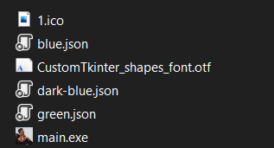

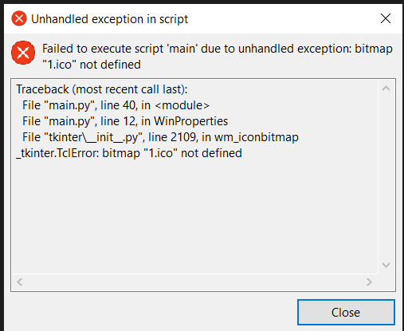Now all will work properly

If you get this error:

It means that you forgot to copy image to

“dist” folder