**Functional Requirements Document**

**Election Platform**

|  |  |  |  |
| --- | --- | --- | --- |
| **Version** | **Description of Change** | **Author** | **Date** |
| 1.0 | Add some basic information | Xinyu Liu(Nick) | Oct 9, 2019 |
| 1.1 | Update the diagrams for functional requirements | Xinyu Liu(Nick) | Oct 22,2019 |

CONTENTS

1 INTRODUCTION 4

1.1 Purpose 4

1.2 Scope 4

1.3 Background 4

1.4 References 4

1.5 Assumptions and Constraints 4

1.6 Document Overview 5

2 METHODOLOGY 5

3 FUNCTIONAL REQUIREMENTS 5

4.1 Context 5

4.2 User Requirements 5

4.3 Data Flow Diagrams 6

4.4 Logical Data Model/Data Dictionary 6

4.5 Functional Requirements 6

5 OTHER REQUIREMENTS 6

5.1 Interface Requirements 6

5.2 Data Conversion Requirements 7

5.3 Hardware/Software Requirements 7

5.4 Operational Requirements 7

APPENDIX A - GLOSSARY 11

# INTRODUCTION

Election platform website is a web platform to show the candidates’ information and anonymous citizens opinions.

## Purpose

The purpose of the functional requirements document is to provide work logics and system’s requirement of election platform website to help developers to finish the platform well. Also, for the election platform, this platform is going to gather citizens view for candidates without recording their names.

## Scope

The document will show logic graph, architecture diagram and UML diagrams.

For the election platform system, anonymous users can express their comments for different candidates though the website, so part of citizens can have more chances to know the candidates.

## Background

The election platform developer team is a group of students which are responsible for build a greater voting environment for the election. The document is being produced by the election platform developer team which is helpful for developers to write the logic of system.

## References

Meeting summaries, interface sketches, activity diagram for logic and data diagram for the website.

## Assumptions and Constraints

[Provide a list of contractual or task level assumptions and/or constraints that are preconditions to preparation of the FRD. Assumptions are future situations beyond the control of the project, whose outcomes influence the success of a project.]

The platform requires lots of official data to make sure all the information in the platform are true, otherwise it will affect the public trust of the platform. Also, security of the platform is really important to keep users to be anonymous.

### Assumptions

It assumes that it is available for us establish a web and have a web server, and it is legal to build a general election platform and have comments.

### Constraints

One of the constraints is hard to prevent the comments to be bias which make the platform have lower public trust.

## Document Overview

The document begins with basic conception of the election platform. Then it shows the different type diagrams which reflect whole platform’s logic and date flow.

# METHODOLOGY

The platform is built on the website. There is an activity, UML and data diagram to help users to understand the platform.

# FUNCTIONAL REQUIREMENTS

## Context

This is an activity diagram which show basic logic of the platform system. It begins with the index page, then users need to log in their account first which own three types of account. Then the web skip to the own homepage which can edit profile and check election information to see and reply comments. In the end, user can log out.

Exhibit 2 - Activity Diagram

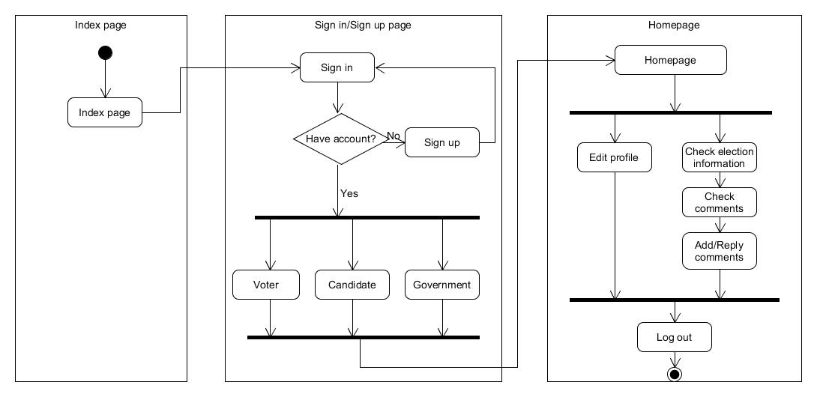

## User Requirements

* Users want to comment or show their opinions for the candidate.
* Users want to see most meaningful opinions which can help them to make better choices.
* Users want to know more information about the candidate.

## Data Flow Diagrams

For the data flow diagram, it is divided into three parts which are view, controller and model. Users interact with the view part which is consisted with HTML and CSS files. According to users’ action, view will send the request to controller. Then controller will process the request by the PHP and JavaScript files and form view to users. Controller also can request necessary data from the model which is web database.

**Exhibit 3 - UML Diagram**

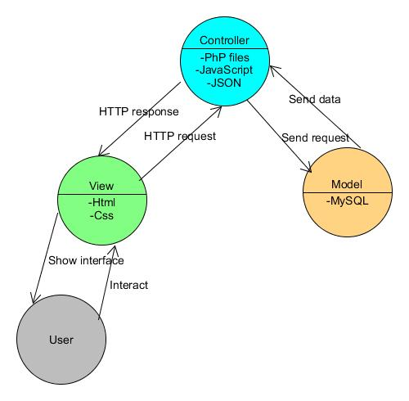

## Logical Data Model/Data Dictionary

For the data diagram, there are four tables to record the all data. User table is for storing the basic accounts’ information which include unique id, made up username and some of basic information. Government table is one of the accounts which has the authority to open new election. Election table records each election’s information, and comment table records comment data which is related to users and candidates.

**Exhibit 4 - Data Diagram**

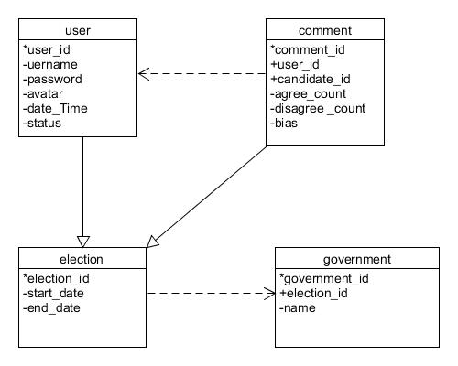

## Functional Requirements

1. Space of data
2. Web address
3. Public source

### Functional Requirements Group 1

Exhibit 5 - Requirements Group 1

| **Section/ Requirement ID** | **Requirement Definition** |
| --- | --- |
| FR1 | The system shall have a database for storing data. |
| FR2 | The system shall have an appropriate web address for the platform. |
| FR3 | The system shall need public source for candidates’ information. |

# OTHER REQUIREMENTS

[Describe the non-behavioral requirements.]

## Interface Requirements

[Describe the user interfaces that are to be implemented by the system.]

### Hardware Interfaces

[Define hardware interfaces supported by the system, including logical structure, physical addresses, and expected behavior.]

### Software Interfaces

[Name the applications with which the subject application must interface. State the following for each such application: name of application, external owner of application, interface details (only if determined by the other application).

It is acceptable to reference an interface control document for details of the interface interactions.]

### Communications Interfaces

[Describe communications interfaces to other systems or devices, such as local area networks.]

## Data Conversion Requirements

[Describe the requirements needed for conversion of legacy data into the system.]

## Hardware/Software Requirements

[Provide a description of the hardware and software platforms needed to support the system.]

## Operational Requirements

[Provide the operational requirements in this section.

Do not state how these requirements will be satisfied. For example, in the Reliability section, answer the question, “How reliable must the system be”? Do not state what steps will be taken to provide reliability.

Distinguish preferences from requirements. Requirements are based on business needs, preferences are not. If, for example, the user requires a special response but does not have a business-related reason for it, that requirement is a preference.

Other applicable requirements on system attributes may be added to the list of subsections below.]

Operational requirements describe how the system will run and communicate with operations personnel.

### Security and Privacy

[Provide a list of the security requirements using the following criteria:

A. State the consequences of the following breaches of security in the subject application:

1. Loss or corruption of data
2. Disclosure of secrets or sensitive information
3. Disclosure of privileged/privacy information about individuals
4. Corruption of software or introduction of malware, such as viruses
5. State the type(s) of security required. Include the need for the following as appropriate:
6. Physical security.
7. Access by user role or types.
8. State access control requirements by data attribute. For example, one group of users has permission to view an attribute but not update it while another group of users has permissions to update or view it.
9. State access requirements based on system function. For example, if there is a need to grant access to certain system functions to one group of users, but not to another. For example, "The system shall make Function X available to the System Administrator only".
10. State if there is a need for certification and accreditation of the security measures adopted for this application]

*The Security Section describes the need to control access to the data. This includes controlling who may view and alter application data.*

### Audit Trail

[List the activities recorded in the application’s audit trail. For each activity, list the data recorded.]

### Reliability

A. [State the following in this section:

1. State the damage can result from failure of this system—indicate the criticality of the software, such as:
2. Loss of human life
3. Complete or partial loss of the ability to perform a mission-critical function
4. Loss of revenue
5. Loss of employee productivity
6. What is the minimum acceptable level of reliability?

B. State required reliability:

1. Mean-Time-Between-Failure is the number of time units the system is operable before the first failure occurs.
2. Mean-Time-To-Failure is the number of time units before the system is operable divided by the number of failures during the time period.
3. Mean-Time-To-Repair is the number of time units required to perform system repair divided by the number of repairs during the time period.]

*Reliability is the probability that the system processes work correctly and completely without being aborted.*

### Recoverability

[Answer the following questions in this section:

A. In the event the application is unavailable to users (down) because of a system failure, how soon after the failure is detected must function be restored?

B. In the event the database is corrupted, to what level of currency must it be restored? For example “The database must be capable of being restored to its condition of no more than 1 hour before the corruption occurred”.

C. If the processing site (hardware, data, and onsite backup) is destroyed, how soon must the application be able to be restored?]

*Recoverability is the ability to restore function and data in the event of a failure.*

### System Availability

[State the period during which the application must be available to users. For example, “*The application must be available to users Monday through Friday between the hours of 6:30 a.m. and 5:30 p.m. EST.* If the application must be available to users in more than one time zone, state the earliest start time and the latest stop time. Consider daylight savings time, too.

Include use peak times. These are times when system unavailability is least acceptable.]

*System availability is the time when the application must be available for use. Required system availability is used in determining when maintenance may be performed.*

### General Performance

[Describe the requirements for the following:

A. Response time for queries and updates

B. Throughput

C. Expected rate of user activity (for example, number of transactions per hour, day, or month, or cyclical periods)

Specific performance requirements, related to a specific functional requirement, should be listed with that functional requirement.

### Capacity

[List the required capacities and expected volumes of data in business terms. Do not state capacities in terms of system memory requirements or disk space—if growth trends or projections are available, provide them]

### Data Retention

[Describe the length of time various forms of data must be retained and the requirements for its destruction.

For example, “The system shall retain application information for 3 years”. Different forms of data include: system documentation, audit records, database records, access records.]

### Error Handling

[Describe system error handling.]

### Validation Rules

[Describe System Validation Rules.]

### Conventions/Standards

[Describe system conventions and standards followed.

For example: Microsoft standards are followed for windows, Institute of Electrical and Electronics Engineers (IEEE) for data formats, etc.]

# APPENDIX A - GLOSSARY

[Define terms, acronyms, and abbreviations used in the FRD.]