2802ICT – Intelligent Systems – Assignment 1
By Nick van der Merwe – s5151332 – Griffith University

Part Alpha – Environment Structure (Queen Class)
The biggest issue of starting this was optimising the class enough to support the search. A typical implementation would involve saving the entire board, toggling ‘danger’ spots and marking where the positions are available. However, the bigger issue is the memory being used to save all the boards while not making danger-checks time consuming. Due to the proposed structure looking confusing, it will be quickly explained here.
As such, this environment utilises a coordinate-based system to store the data. Its main array is ‘queens’ and each queen denotes a row and its position in the array denotes the column. For example, queens = [1, 3, 0, 2] is the same as:
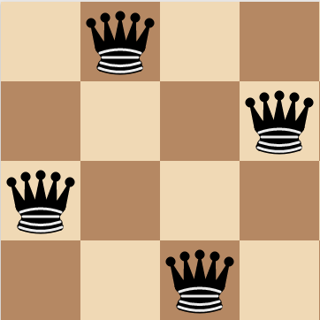
Note that this is using a numerical coordinate system and not the original system – this is purely useful for operations. To calculate whether a position is a danger zone is easy too, for example, given a chess board queens = [1, 3, 0] (one state before the one above), for each queen you:
- Mark choices[queen[i]] = false (vertical)
- Mark choices[queen[i] + nextRow – i] (diagonal)
- Mark choices[queen[i] – nextRow + i] (antidiagonal)
Essentially the +nextRow represents the diagonal movements. For example, take queen[2], the one on the leftmost column. Its ‘i’ value would be 2 since its third in the array, nextRow would currently be 3 because that’s the row of the next queen, and queen[i] is 0. Thus we mark choice[queen[3]] = 0 (the value right below it), choice[queen[3] + 3 – 2] = 1, the diagonal to the right, and the last would overflow into the negatives so its ignored.
The core of this structure is that:
Complexity of adding a Queen: O(n) where n=queens added so far
Space complexity: O(n) where N = number of queens

Other comments
- This algorithm may seem unusually fast due to my compile options. If you compile it yourself, it will be a fair chunk slower due to the compiling flags used.
- This program was written in Windows Subsystem for Linux so you may have problems compiling it yourself, however, Cygwin worked fine.
- The code is not written in a style that would normally be used, but justifications are placed at the start of the file

Part A – Uninformed Search
Formal Problem Definition
- Initial State: An empty board
- Actions: Place a queen
- Goal test: N queens are placed
- Transition model: A queen that can be placed in the next row without getting attacked (AKA a legal move)
- Path cost: constant

Question 1: Implement an algorithm: Breadth First Search (BFS)
BFS was implemented from the slides – see badBFS(). However, a tip was given that checking for previous values is not necessary as no duplicates appear – see BFS(). This is the benchmark that is reported here.

Question 2: Benchmarking
Firstly, unless your algorithm has boards that are sub 10 bytes each or the user’s computer has >=32GB of RAM this will not be possible to run in BFS up to N = 20. Due to it using O(b^{d-1}) memory, by the time the user hits N=16, its storing ~200 million boards at peak. This is 10GB of data in primary storage (as seen in Figure 1.2), and it still needs to get multiplied by 16, 17, 18 and 19 (max number of branches) to reach N = 20. This evaluates to ~930,240GB of data by N=20 stored in the RAM.
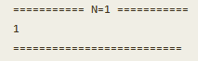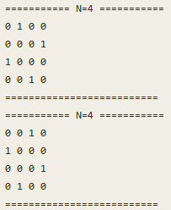 | 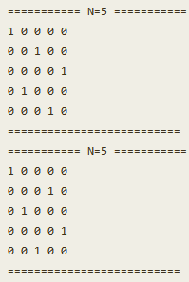 | 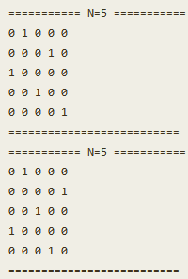
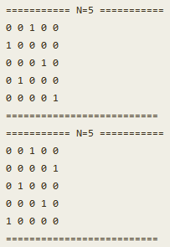 | 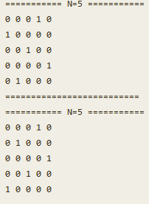 | 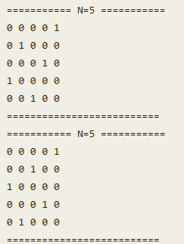
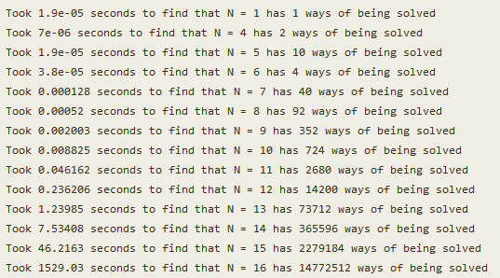
  - Figure 1.1 – BFS Verification and Benchmarks
Due to N = 16 using the swap space on a solid-state drive instead of using RAM there is a large growth in the time spent to find a solution as visible in Figure 1.1. Additionally, it should be noted that early problems seem to complete too fast for the chrono library to record them properly – these times should be considered as negligible. Logically the computer would utilise its CPU’s registers instead of RAM for earlier boards, splitting the benchmarks into three sections.
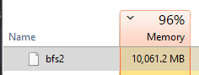
  - Figure 1.2: The task manager by N = 16
- To run this benchmark, select ‘BFS’ and ‘1 17 1’ in the program.

Question 3: Based on those results, how long would N=30 take?
We can use the N values to calculate the sizes of the trees. BFS’s time complexity is O(b^{d}), but this gives an unrealistic answer as it makes the number of branches a constant. A logical approach is to use a formula that reduces the number of branches each time: N! It’s obvious that this is the trend by N=3: in the first choice, there are three columns the queen can go [1, 2, 3], in the second choice there’s two because one was taken up, and the last only one. Thus nodes = N! is correct in this case. Note this only works because the number of options reduces by one every time.
Note that this only includes searching for legal moves by removing vertical checks. Since the algorithm removes illegal diagonal moves too, it would be different. However, the point of this is to generate a simple formula for the trend.
Due to variable allocation though, there is a significant amount of overhead. Additionally, C++ would be doing shortcuts to compress the data as the size increases, which leads to the data appearing to say that it is not factorial. This is shown below by the fact that the growth of time is not the previous value multiplied by N.

  - Table 1.1: Increases in time taken
N = | Time taken | Times bigger than previous
1 | 0.000019 | N/A
2 | N/A | N/A
3 | N/A | N/A
4 | 7.00E-06 | N/A
5 | 0.0000019 | 0.271428571
6 | 0.000038 | 20
7 | 0.000128 | 3.368421053
8 | 0.00052 | 4.0625
9 | 0.002003 | 3.851923077
10 | 0.008825 | 4.405891163
11 | 0.046162 | 5.23082153
12 | 0.236206 | 5.116892682
13 | 1.23985 | 5.249019923
14 | 7.53408 | 6.076606041
15 | 46.2163 | 6.134299078
16 | 1529.03 | 33.08421488
Table 1.1 confirms that early solutions are negligible as well by the fact that N = 6 to N = 7 grows by a factor of 20 once more memory starts being required, and by N = 16 the time is multiplied by 33.
A table of predictions using the naïve method can be made using the factorial operator we can get a simple answer using a single formula $time=\frac{\left(timestamp\right)}{old N!}×new N!$
  - Table 1.2 – Table of Predicted times
OldN | newN | Predicted time (seconds) | Predicted time (years)
1 | 30 | 5.04E+27 | 1.60E+20
2 | 30 | N/A | N/A
3 | 30 | N/A | N/A
4 | 30 | 7.74E+25 | 2.45E+18
5 | 30 | 4.20E+24 | 1.33E+17
6 | 30 | 1.40E+25 | 4.44E+17
7 | 30 | 6.74E+24 | 2.14E+17
8 | 30 | 3.42E+24 | 1.08E+17
9 | 30 | 1.46E+24 | 4.64E+16
10 | 30 | 6.45E+23 | 2.05E+16
11 | 30 | 3.07E+23 | 9.73E+15
12 | 30 | 1.31E+23 | 4.15E+15
13 | 30 | 5.28E+22 | 1.67E+15
14 | 30 | 2.29E+22 | 7.27E+14
15 | 30 | 9.37E+21 | 2.97E+14
16 | 30 | 1.94E+22 | 6.15E+14

In Table 1.2 its visible that this prediction is highly inaccurate by the fact that the shortest and the longest times are a factor of 1,000,000 apart. A neater way is just to model this using Excel and use their trend equation with the power model. If done by hand, this would give an inaccurate model.

  - Figure 1.3 – nQueens BFS Graph trend. Note that the y axis is the logarithm of the time to make it more readable.
This generates the model $2E-09e^{1.6041N}$ and at N = 30 returns 1.58702E+12 seconds, or 50,324.18 years. This is likely more accurate than the factorial model.

Question 4: Suggest a way to prune the search tree to make it faster and give new benchmarks
Instead of exploring the entire tree, it can get split in half at the first step. Take the solution to N = 4 for example, it has two solutions, and each is just a mirrored version of the other. If only the first half of the board is considered for the first step, the number of branches can effectively get halved. The difficult part is being able to tell how many rotations/flips are valid.
To find all valid rotations and flips, there are four steps. Add the initial board, and rotate it three times, then add the mirrored version and its rotated version three times. The fastest way to check if the board has already been found is to use a std::set<> structure that automatically filters the results.
However, the downside of this is that it uses a large amount of memory. By the time N = 15 two million solution boards must be stored, but at that point over 100 million boards are in the queue.
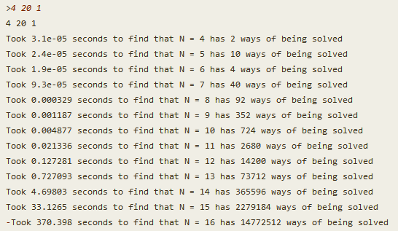
  - Figure 1.4 – Pruned BFS benchmarks

It is surprising that Figure 1.4 does not offer a direct half in time spent to solve the problem. However, it makes sense as the function to rotate/flip the board is expensive. Additionally, it reduced the higher number of boards by a significant amount (370 seconds now vs 1529 seconds before), and this shows how important the memory usage is here. As visible in Figure 1.5, it still fills the RAM, but since half as many boards need to get stored the amount of memory written to swap space would be significantly less.
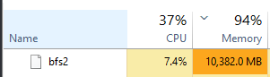
  - Figure 1.5 – Task manager at N=16
- Note: This algorithm only prints unrotated boards, however, this is enough for verification as the number of solutions is still correct

Question 5: Bonus: High end DFS Benchmarks
In the code DFS and prunedDFS were implemented as well. While BFS suffers from memory loss, these essentially explore the entire tree with linear space complexity $(O(bd))$. However, prunedDFS would become crippled from memory eventually as well; it got ran at N=17 for a couple of minutes, and that approached $≈$9GB of RAM. Here are a few extreme benchmarks that were done to show the future trend of the pruning DFS search:
  - Figure 1.6 – High end DFS Benchmarks. Note that 670 million is not the actual answer to N=19 as the integer data type overflowed – there are 4,968,057,848 solutions. Subtract $2×(2^{31}-1)$ and it is the printed answer.
  - Table 1.3 – Predicted Times from Excel
N = | Predicted time (seconds)
17 | 1393.510447
18 | 6930.459138
19 | 34467.81757
As visible in Figure 1.6 and 1.3, the excel predictions have a reasonable amount of error in them. However, since the benchmarks took so long the computer was being used for other tasks and as such the processor may not have been running at its full potential through those.

Part B – Local Search
Formal Definition of problem
- Initial State: A board randomly filled with N queens
- Actions: Move a queen
- Goal test: There are no collisions
- Transition model: Where queens can move
- Path cost: constant

Question 1 – Implement an algorithm: Hill Climbing (HC)
Cost Function
The most logical way to evaluate the price of the board is the number of pairs of queens with collisions. This is because it will take at least that many moves to solve the game. For example, given a board with a single collision, it will take at least a single move to solve that configuration.
An issue is that calculating this can be expensive if it is direct collisions. For example, given a board of 8 queens where each queen is in the same column, the value would be 7 as there are 7 direct collisions. To calculate this, we would have to check every individual square that a queen’s attacks ‘cover’, verify if there’s a queen, and if there is stop searching in that direction.
Instead, we could take the coordinates of two queens, check that they are on the same column, and count that as a ‘collision’. While this increases the cost to 49 in this scenario and no longer makes the value function admissible, it still works as a function and reduces the evaluation cost of the board by a factor of N.
To calculate whether two pieces are in direct collision we can use these formulas: (note vertical collision is impossible in the 1D method of storing queens so it is skipped)
$$Horizontal Collision:queen 1 y==queen 2 y$$
$$Diagonal collision:queen 1x==queen 1 x+(queen 1 y-queen 2 y)$$
$$Anti-diagonal collision:queen 1x==queen2 x+\left(queen 1 y-queen 2 y\right)$$
The last two checks can get compressed into a single function using the absolute function. Additionally, this would not change the number of collisions as having a multiple collision between two queens is impossible.
$$abs\left(queen 1 y-queen 2 y\right)==abs(queen 1 x-queen 2 x)$$
However, this formula was used in practice with multiple other ways of organising the if statements, and a straight-forward approached proved to be the most efficient. This is likely due to the C++ compiler simplifying the operation further than this by knowing the individual operations.
Verification
Here are a few solutions:
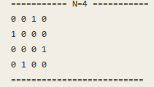 | 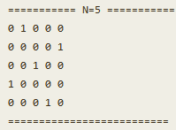 | 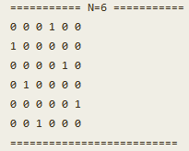
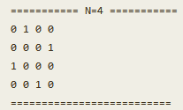 | 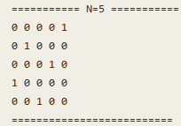 | 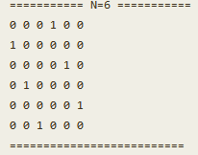
  - Figure 2.1 – Verification of hill climbing solution. You can run this by typing ‘hc 1 7 1’. However, it has a high fail rate so ‘hcrr 1 7 1’ is recommended.
Benchmarking
This algorithm is reasonably quick and can solve significantly harder problems than uninformed searches. It does not get often if the board size is greater than $≈$10.
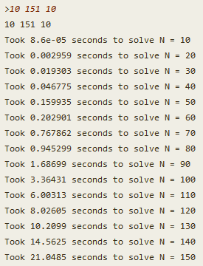
  - Figure 2.2 – Benchmark of Hill Climbing Solution
Two other forms of hill climbing were also made, one with stochastic search and the other using random restart. These resulted in this for their speeds:
Stochastic Search  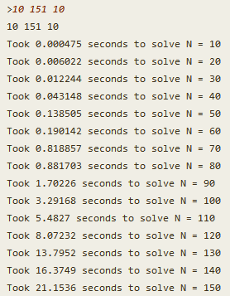 | Random Restart  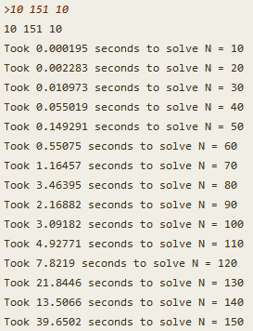
  - Figure 2.3 – Benchmarks of algorithm modifications
In general, hill climbing does not need a random restart method as it does not get stuck often. Stochastic search is probably enough to get out of most of the cases and does not increase the amount of time to solve the problem, as visible in Figure 2.4.

  - Figure 2.4 – Graphed Benchmarks of Hill Climbing Search
Another idea for benchmarking was measuring how often the search fails as stating it fails ‘around N = x’ is not quantitative. However, the implementation required either a complete redesign of the functions to pause at a certain time or using multithreading and redesigning the algorithms to declare when they’re done with atomic flags. Since this seemed outside the scope of the course, it was skipped.

Question 2 – Compare Two searches – Simulated Annealing (SA) and Hill-climbing
Hill-climbing can become too slow at larger numbers, and in that case running simulated annealing could be faster. However, the downside is that setting its temperature could be complicated and it is usually dependent on the time allowed to solve the problem. In the case of small boards, the temperature can be practically non-existent, and it would still solve the board reasonably quickly. As such, this section explores a few cases: temperature set to 0 from the beginning and the temperature set to $≈$10,000 with a cooling of 0.98 to represent a randomly picked number, mostly to compare it to hill-climbing. After that, it explores deciding temperature/cooling with mathematical functions.
Note the methods that were added include the normal simulated annealing search and random restart.

Temperature = 0
Setting the temperature and cooling to zero changes this algorithm into attempting random moves until a better state is found. This turns it into something closer to hill climbing that accepts the first better move it finds.
Temperature = 0 & cooling = 0
Plain SA  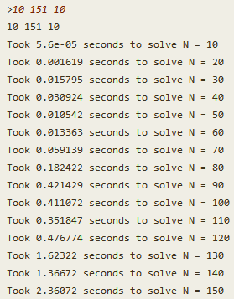 | Random Restart SA  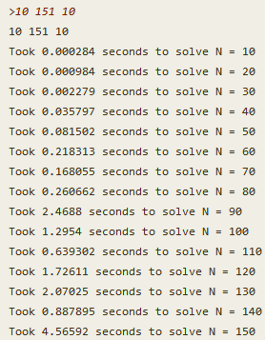
  - Figure 2.5 – Light Simulated Annealing Benchmarks
As visible in the benchmarks, this proves to be significantly faster than hill climbing (e.g. N =150 in 2.36 seconds vs 21.15 seconds). Additionally, this search does not get stuck often if N is not low, and even with using random restart the solutions are still found significantly faster than hill climbing. This is in large due to the structure of the problem – there is an abundance of valid solutions, and they usually do not need that many changes to be found.

Selecting a Temperature and Cooling
We can scale the problem up to significantly larger problem sizes as simulated annealing’s strength typically only shows in cutting edge cases., and due to its randomness, the results vary too much in simple cases.
  - Table 2.1 – Simulated Annealing High-end Benchmarks
 | Temperature = 0 |  |  | Temperature = 10,000 & cooling = 0.98
N = | SA | SARR |  | SA | SARR
200 | 7.67637 | 19.5491 |  | 8.21105 | 13.7443
205 | 15.2952 | 41.0346 |  | 15.8153 | 15.1333
210 | 5.9945 | 15.5393 |  | 6.1112 | 18.8769
215 | 9.32381 | 25.1238 |  | 8.48518 | 27.2623
220 | 6.45063 | 47.1695 |  | 36.2226 | 14.2811
225 | 8.37139 | 27.7002 |  | 6.71525 | 8.51859
230 | 6.60212 | 27.1485 |  | 9.05883 | 21.3759
235 | 21.1385 | 24.1456 |  | 6.31565 | 16.6488
240 | 12.1982 | 61.7048 |  | 13.5149 | 11.457
245 | 19.9644 | 15.03 |  | 17.8084 | 34.0156
250 | 20.5692 | 54.3139 |  | 26.5057 | 63.3742
255 | 11.7205 | 38.1545 |  | 29.7659 | 95.2241
260 | 15.6325 | 23.8086 |  | 12.9404 | 69.9496
265 | 33.1168 | 63.33 |  | 17.3434 | 39.7482
270 | 22.7357 | 52.745 |  | 32.4133 | 18.2267
275 | 26.5649 | 67.295 |  | 31.533 | 77.6958
280 | 87.5297 | 55.2099 |  | 13.9593 | 95.9507
285 | 23.9483 | 39.1848 |  | 75.6371 | 42.8737
290 | 12.9648 | 103.889 |  | 14.3809 | 22.2163
295 | 59.7398 | 51.1489 |  | 48.7125 | 34.3762
MEDIAN | 15.46385 | 40.1097 |  | 15.0981 | 24.7393
AVERAGE | 21.376866 | 42.66125 |  | 21.572493 | 37.0474645
STD.S | 19.8969481 | 21.97056 |  | 17.31392082 | 28.10859068

*Note: SA = Simulated Annealing and SARR = Simulated Annealing Random Restart STD.S = standard deviation of a sample
Looking at the medians in Table 2.1, it is visible that setting a temperature and cooling at this level has an impact – SARR has a median time of 24.73 seconds with a temperature, as opposed to 40 without one. However, whether this decreases the distribution is ambiguous as SARR’s distribution increases with temperature, and SA’s distribution decreases with temperature.

  - Figure 2.6 – Simulated Annealing Benchmarks Graph; SA Zero: temp = 0 and Heated is when temperature = 10,000
The purpose of the trend lines in Figure 2.6 is not to make predictions, but to see the general curve as they are moving averages. The solid lines represent benchmarks with a temperature (10,000 and cooling = 0.98), and the dotted ones without temperatures. Considering random restart has significant changes in its trend, its best to follow the plain simulated annealing instead in most cases as it does not get stuck often.
In other problems such as the Travelling Salesperson, a maximum amount of time is allocated for how long the problem can be solved in and how much the problem improves, however, this problem demands only the solution to be given. Due to this, setting the temperature and cooling is quite complicated. Ideally, a formula should be made that takes in N and returns the best cooling such that the last ~10-20% of the search has a temperature of 0.
A simple solution is to simply pick two points, calculate the optimal temperature and cooling there, then generate an equation for temperature and cooling using these points. However, this must be done at a point where temperature starts to be worth using and solving these take time. This means that calculating this would take time if many combinations are tested or require regression to move around, otherwise this selection would also be near random. As such, it was not done here due to it appearing to be outside the scope of this paper.

Bonus fun facts! AKA Feedback to improve future studies
I track how long all my assignments take, and this one took me a whopping 25 hours. This is the 3rd biggest assignment I’ve done at Griffith so far in the Bachelor of Computer Science in terms of code, but it’s the largest report written so far.
The difficulty of this assignment was 8/10 to me where 5 is the average assignment so far and 1806ICT was a 9 . This is relative to the content taught and the amount of time given. At as guess, I don’t think more than two other students would have done this assignment as comprehensively as I have.
In my opinion, this assignment could have been improved by:
- Release the assignment a week earlier
- Not having a lecture that contains this same problem so that we work out the cost function on our own. However, it makes sense since working this out takes a while and the due date was quite soon. It’s just that working out the cost function is the hard part of local searches – without it, they’re easy.
- Strictly define how far the scope of this should be. This report seems overly comprehensive given the scope.

