2801ICT – Assignment #2 – Max the Score
  - By Nick van der Merwe – s515132 – nick.vandermerwe@griffithuni.edu.au

Section 1: Introduction and Fundamental Algorithm
Since this problem is given specific constraints, there is not much flexibility in the algorithm. Granted that we can use a priority queue using heap, it means we can only have access to a) the constructor b) enqueue and c) dequeue. As such, any algorithm that pops from one heap and searches for that value in the other is not allowed.
In this game there are two players, and each has different priorities. Ideally, there would be two priority queues to represent this, and the $pop()$ operation would simply return their next move. Which means that a max heap will have to be used for efficient operations. However, if one player has picked a ball, the other must be able to know they did it, and either remove or ignore that ball as a choice.
Instead, we can share objects with indicators whether they have been popped and represent each player’s balls in separate priority queues. Considering that C++ is being used, the easy approach to this is to use int* as their state instead. If we pop an object, we can set the value of the pointer to $0$, and we can see this in the partner queue. In the partner priority queue, if we see a zero, we have two choices. We could float it down and delete it (probably $O(\log\left(n\right))$, or simply act as if its children are that value itself.
For example, if we want to float a value down, we must find the minimum value of a parent’s children. When it encounters a zero, it recursively searches down until it finds a left and right value that are a minimum value. A visualisation is in Figure 1.1 – when the search encounters the zero, it starts searching the children of that zero. It would compare the 7 and the 6, then compare 7 to 4, and return 7’s index as the greatest child.
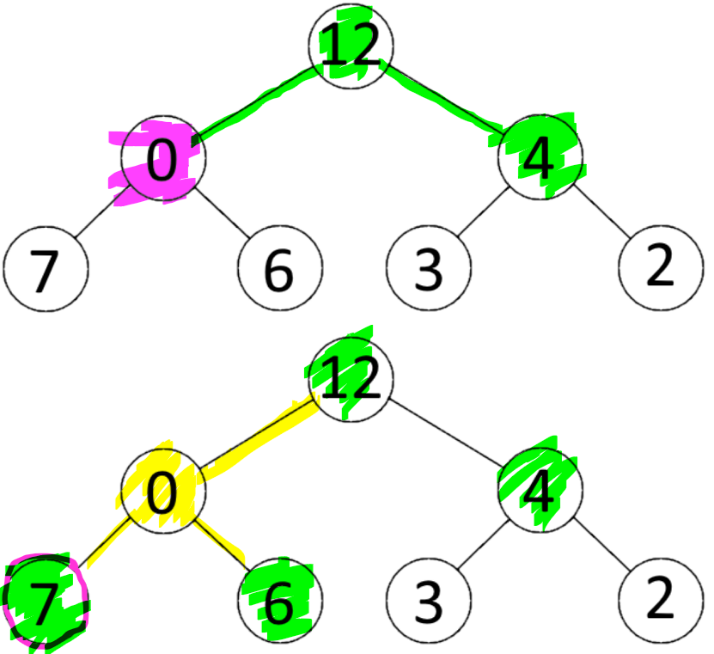
  - Figure 1.1 – Find Max Child visualisation – Searching for 12’s greatest child should return 7
The downside of this is that the amount of time spent searching is increased, however, removing the zero would be significantly more costly. The easiest way would be to float it down to the bottom and erase it, however, the movement alone would be $O(\log\left(n\right))$ and the removal could be $2^{k}-1$ where $k=layer of tree$ operations.
In the next sections we will cover 2. The “Zero Heap Priority Queue” data structure 3. Its complexity 4. Its correctness and 5. Conclusion and other approaches.

Section 2: ‘Zero Heap Priority Queue’
Our priority queue will be structured with these elements:
  - Pseudo code 2.1 – Priority Queue Class using heap
class zero heap priority queue<type>:
public:
zero heap priority queue(data<type>)
insert(val)
getTop()
deleteTop()
private:
vector<type*> data
getLeftChild(parentIndex)
getRightChild(parentIndex)
getParent(childIndex)
getMaxChild(parentIndex)
getMaxNode()
floatUp(index)
floatDown(index)
The core idea is that any type with the correct comparator functions can be inserted, which enables us to simply design the priority queue and focus on the classes being inserted for Rusty and Scott’s actual decisions. Additionally, outside of the $getMaxChild()$ operation, everything will function exactly like a normal priority queue using heap. Since what $getLeftChild()$, $getRightChild()$ and $getParent()$ do is obvious, they will be skipped.
An added function in Pseudo Code 2.1 is the constructor. This will not be using the normal insert operation of a priority queue, as building heap can be $O(n)$ instead of $O(n*\log\left(n\right))$ by using the $insert()$ function.
  - Pseudo code 2.2 – getMaxChild()
getMaxChild(parentIndex):
left = getLeftChild(parentIndex)
right = getRightChild(parentIndex)
// recursively search for largest non-zero
if(left < data.size and *data[left] == 0):
left = getMaxChild(left)
if(right < data.size and *data[right] == 0):
right = getMaxChild(right)
// since we cannot gaurentee the position of children
// e.g. right can actually be behind left
// we have to check if both exist
if(right >= data.size):
return left
if(left >= data.size):
return right
// now we know both exist, return the larger of them
if(*data[left] > *data[right]):
return left
return right
getMaxNode():
if(*data[0] == 0):
return getMaxChild(0)
return 0
In Pseudo code 2.2, the only finicky section is that we have to check that both right and left exist. This is because if right is found instantly, left can be ahead of it, which is different to the normal algorithm. Such a case would occur in Figure 1.1.
All that $floatUp()$ and $floatDown()$ do is check if the child or parent is larger than the current element, and if it is, then swap it over and over until its in the right position.

  - Pseudo Code 2.3 – floatUp and floatDown functions
floatUp(index):
parent = getParent(index)
while(parent >= 0):
if(*data[index] > *data[parent]):
swap(data[index], data[parent])
else:
stop searching
index = parent
parent = getParent(index)
floatDown(index):
maxChild = getMaxChild(index)
while(maxChild < data.size):
if(*data[index] < *data[maxChildIndex]):
swap(data[index], data[maxChildIndex])
index = maxChild
maxChild = getMaxChild(index)
The functions implemented in Pseudo Code 2.3 define the backend of the max heap function. To use these, the interface was defined. As stated earlier, the constructor is built differently to a normal algorithm as it goes from the middle of the structure upwards and floats everything down. Essentially what this does is it skips the last layer of comparisons, and since each layer multiplies the total size by two, we can half the number of comparisons. However, in technical analysis this reduces the complexity down to $O(n)$, which will be explored later.
  - Pseudo Code 2.4 – Priority Queue interface
priority queue(inputData<type>):
for val in inputData:
data.append(&val)
for data.size / 2 - 1 to 0:
floatDown(i)
insert(val)
data.append(&val)
floatUp(data.size - 1)
getTop()
if empty(data) return 0 // this won't affect anything outside
top = getMaxNode
return *data[top]
deleteTop()
if empty(data) do nothing // nothing to delete
top = getMaxNode
// set the inside to 0 so the other player knows
// that it was picked
*data[top] = 0
// normal algorithm: move bottom to the top, erase the bottom
// and floatdown the top
data[0] = data[data.size() - 1]
delete data[data.size - 1]
floatDown(0)
Now the complicated section is defining what data structures each player actually passes into the priority queue for their decisions to get represented properly. For Rusty to play optimally, he must use all of his turns and a key detail is that when there are two nodes with the same sum of value, he must pick the larger of the two.

  - Pseudo Code 2.5 – Rusty’s Ball Structure
class rustysBall:
public:
rustysBall(val)
= operator
() operator
< operator
> operator
== operator
private:
int * value
int sumOfDigits
getSumOfDigits(val)
The only method in Pseudo Code 2.5 that needs much logic is the getSumOfDigitis, which is in Pseudo Code 2.6:
  - Pseudo Code 2.6 – Get sum of digits
getSumOfDigits(val):
sum = 0
while (val != 0):
sum += val % 10
val /= 10
return sum
The rest of the methods are simply defined such that this looks like an integer from the front end:
  - Pseudo Code 2.7 – RustysBall Interface Functions
rustysBall(val):
value = &val
sumOfDigtis = getSumOfDigits(val)
= operator(other):
*value = other
sumOfDigits = sumOfDigits(other)
() operator():
return *value // only return its value as if its an int
< operator(ball1, ball2):
// return true if ball1 < ball2 2
if(ball1.sumOfDigits < ball2.sumOfDigits):
return true
if(ball1.sumOfDigits > ball2.sumOfDigits):
return false
// in the case that they are equal:
return *ball1.value < ball2.value
> operator(other):
// just the inverted version of the above
// return true if ball1 < ball2 2
if(ball1.sumOfDigits > ball2.sumOfDigits):
return true
if(ball1.sumOfDigits < ball2.sumOfDigits):
return false
// in the case that they are equal:
return *ball1.value > ball2.value
== operator(int other):
// we only bother comparing the actual value:
return *r1.value == other
With this complete, all the functions for the backend are done and we can model the game:

  - Pseudo Code 2.8 – Match
match(vector<int> balls, int maxTurnsPerRound, bool scottsTurn):
priorityQueue<int> scottsPriorities(balls);
// calls the rustyBalls constructor on each element and inserts them into
// a new vector
auto rustysBalls = turnIntVectorToRustyBallVector(balls);
priorityQueue<rustysBall> rustysPriorities(rustysBalls);
int totalTurnsTaken = 0, scottsScore = 0, rustysScore = 0
while(turnsTaken < balls.size):
for i in 0 to maxTurnsPerRound and turnsTaken < balls.size:
if(scottsTurn):
scottsScore += scottsPriorities.getTop()
scottsPriorities.deleteTop()
else:
rustysScore += rustysPriorities.getTop()
rustysPriorities.deleteTop()
turnsTaken++
scottsTurn != scottsTurn // flip flop the turns each for loop
At the end of Pseudo Code 2.8, $rustysScore$ and $scottsScore$ contain the answers.

Section 3: Correctness of Algorithm
This section is split into each important function mentioned in the previous section. Since a few of them are obvious or simply describe classes they can get skipped. From the group up, the important functions are (3.1) $getMaxChild()$, (3.2) $FloatUp$() and $floatDown()$, (3.3) the constructor, (3.4) $deleteTop(),$ and finally the match algorithm.

Algorithm 3.1 – $getMaxChild()$

Algorithm 3.2 – $FloatUp()$and $FloatDown()$

Algorithm 3.3 – Priority Queue Constructor

Algorithm 3.4 – Priority Queue $deleteTop()$

Algorithm 3.4 - Match

Section 4: Performance Analysis

Section 5: Conclusion

Section 6: Comments and Understanding the Code

