Reading Handwriting using Machine Learning

Griffith University – s5151332 – Written for Intelligent Systems, 2802ICT – Due on 17/05/2020

# Part 1: Calculating a neural network by hand

We were tasked to do a neural network’s calculations by hand by doing stochastic gradient descent with backpropagation. As a quick foreword, the example we were given does a single round of generating outputs, errors, and then updates all the weights with a single sample – taking 6 pages. If we do these four times over (two sets of samples twice) we’re going to make 24 pages! Have fun reading this.

z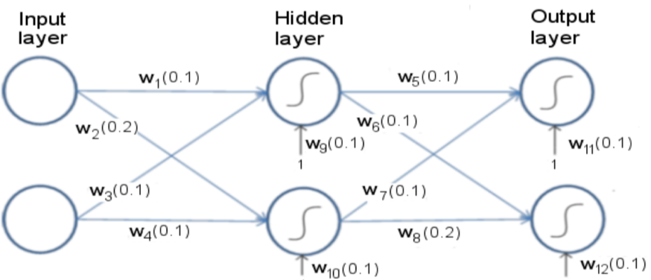



$$Let: Batch size=2 ;Learning rate=0.1;$$

$$Samples:X_{1}=\left(0.1, 0.1\right); X_{2}=\left(0.1, 0.2\right); Y_{1}=\left(1, 0\right); Y_{2}=\left(0, 1\right)$$

## Forwards Pass 1

We can start with $X_{1}$. Presumably this means i1 = 0.1 and i2 = 0.1 then we batch $X_{2}$ with it, and use the squared error function with all the generated errors together.



$$net_{h1}=w_{1}×i_{1}+w_{3}×i_{2}+b_{1}×w_{11}$$

$$Let i_{1}=0.1 \& i_{2}=0.1 \left(X_{1} sample\right)\& b_{1}=1 (image)$$

$$net_{h1}=0.1×0.1+0.1×0.1+1×0.1$$

$$net_{h1}=0.12$$

$$out_{h1}=\frac{1}{1+e^{-net_{h1}}}$$

$$out_{h1}=\frac{1}{1+e^{-0.12}}≈0.5299640517645717$$

Now carrying out that same process for $h_{2}$:





$$net_{h2}=w_{2}×i_{1}+w_{4}×i_{2}+b_{1}×w_{10}$$

$$Let i_{1}=0.1 \& i_{2}=0.1 \left(X_{1} sample\right)\& b_{1}=1 (image)$$

$$net_{h2}=0.2×0.1+0.1×0.1+0.1×1$$

$$net_{h1}=0.13$$

$$out_{h1}=\frac{1}{1+e^{-net_{h1}}}$$

$$out_{h2}=\frac{1}{1+e^{-0.13}}≈0.5324543063873187$$

$$net_{o1}=w_{5}×net_{h1}+w_{7}×net_{h2}+b_{2}×w_{12}$$

$$net_{o1}=0.1×0.5299640517645717+0.1×0.5324543063873187+0.1×1$$

$$=0.20624183581518907$$

$$out_{o1}=\frac{1}{1+e^{-net_{o1}}}$$

$$out_{o1}=\frac{1}{1+e^{-0.20624183581518907}}$$

$out_{o1}$ = 0.5513784696896066



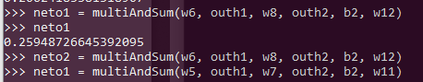

= 0.5645102463659317

## Error

$$E_{total}= \sum{\frac{1}{2}{\left(target-output\right)}^{2}}$$

$E_{o1}=\frac{1}{2}{\left(1-0.5513784696896066\right)}^{2}$ = 0.10063063872901962

$E_{o2}=\frac{1}{2}{\left(0-0.5645102463659317\right)}^{2}$ = 0.15933590912606246

$$E_{total}=E_{o1}+E_{o2}=0.2527076596804409$$

## Backwards Pass 1

Now we shift into finding the partial derivatives of these

$$\frac{∂E_{total}}{∂w_{5}}=\frac{∂E_{total}}{∂out_{o1}}×\frac{∂out_{o1}}{∂net_{o1}}×\frac{∂net_{o1}}{∂w_{5}}$$

$$\frac{∂E_{total}}{∂out_{o1}}=2×\frac{1}{2}{\left(target_{o1}-out_{o1}\right)}^{2-1}×-1+0$$

$$=-\left(0.1- 0.5513784696896066\right)= 0.5413784696896066$$

$$out_{o1}=\frac{1}{1+e^{-net_{o1}}}$$

$$\frac{∂out_{o1}}{∂net_{o1}}=out_{o1}\left(1-out_{o1}\right)=0.5513784696896066\left(1- 0.5513784696896066\right)$$

$$=0.2473602528523542$$

$$net_{o1}=w_{5}×out_{h1}+ w_{7}×out_{h2}+b_{2}×w_{11}$$

$$\frac{∂net_{o1}}{∂w_{5}}=out_{h1}= 0.5324543063873187$$

Now we put this back into:

$$\frac{∂E_{total}}{∂w_{5}}=\frac{∂E_{total}}{∂out_{o1}}×\frac{∂out_{o1}}{∂net_{o1}}×\frac{∂net_{o1}}{∂w_{5}}$$

$$=0.5413784696896066×0.2473602528523542×0.5324543063873187$$

$$=0.071303892734354847$$

Note that this is the same for $w_{5}$ and $w_{7}$ as the variables end up being the exact same.

Now we must do this for $\frac{∂E_{total}}{∂w_{8}}$ $$\frac{∂E_{total}}{∂w_{8}}=\frac{∂E_{total}}{∂out_{o2}}×\frac{∂out_{o2}}{∂net_{o2}}×\frac{∂net_{o2}}{∂w_{5}}$$

$$\frac{∂E_{total}}{∂out_{o1}}=2×\frac{1}{2}{\left(target_{o1}-out_{o1}\right)}^{2-1}×-1+0$$

$$=-\left(0.1- 0.5645102463659317\right)= 0.5545102463659317$$

$$out_{o1}=\frac{1}{1+e^{-net_{o1}}}$$

$$\frac{∂out_{o1}}{∂net_{o1}}=out_{o2}\left(1-out_{o2}\right)=0.5645102463659317\left(1- 0.5645102463659317\right)$$

$$=0.24583842811380679$$

$$net_{o2}=w_{8}×out_{h1}+ w_{6}×out_{h2}+b_{2}×w_{12}$$

$$\frac{∂net_{o2}}{∂w_{8}}=out_{h2}= 0.5324543063873187$$

Now we put this back into:

$$\frac{∂E_{total}}{∂w_{5}}=\frac{∂E_{total}}{∂out_{o1}}×\frac{∂out_{o1}}{∂net_{o1}}×\frac{∂net_{o1}}{∂w_{5}}$$

$$=0.5545102463659317×0.24583842811380679×0.5324543063873187$$

$$=0.072584132358376610$$

Notice this is valid for both partial derivatives by $w_{8}$ and $w_{6}$.

## Forwards Pass 2



$$net_{h1}=w_{1}×i_{1}+w_{3}×i_{2}+b_{1}×w_{11}$$

$$Let i_{1}=0.1 \& i_{2}=0.2\left(X_{1} sample\right)\& b_{1}=1 (image)$$

$$net_{h1}=0.1×0.1+0.1×0.2+1×0.1$$

$$net_{h1}=0.13$$

$$out_{h1}=\frac{1}{1+e^{-net_{h1}}}$$

$$out_{h1}=\frac{1}{1+e^{-0.13}}≈0.5324543063873187$$

Now carrying out that same process for $h_{2}$:





$$net_{h2}=w_{2}×i_{1}+w_{4}×i_{2}+b_{1}×w_{10}$$

$$Let i_{1}=0.1 \& i_{2}=0.1 \left(X_{1} sample\right)\& b_{1}=1 (image)$$

$$net_{h2}=0.2×0.1+0.1×0.1+0.1×1$$

$$net_{h2}=0.14$$

$$out_{h1}=\frac{1}{1+e^{-net_{h1}}}$$

$$out_{h2}=\frac{1}{1+e^{-0.14}}≈0.5349429451582145$$

Now we can calculate the outputs:



$$net_{o1}=w_{5}×net_{h1}+w_{7}×net_{h2}+b_{2}×w_{12}$$

$$net_{o1}=0.1×0.5324543063873187+0.1×0.5349429451582145+0.1×1$$

$$=0.20673972515455333$$

$$out_{o1}=\frac{1}{1+e^{-net_{o1}}}$$

$$out_{o1}=\frac{1}{1+e^{-0.20673972515455333}}$$

$out_{o1}$ = 0.5515016245695407





$$net_{o2}=w_{6}×out_{h1}+w_{8}×out_{h2}+b_{2}×w_{12}$$

$$=0.1×0.5349429451582145+0.2×0.5515016245695407+1×0.1$$

$$=0.2602340196703748$$

$$out_{o1}=\frac{1}{1+e^{-net_{o1}}}$$

$$out_{o1}=\frac{1}{1+e^{-0.2602340196703748}}$$

$out_{o2}$ = 0.5646938181510764

Calculating Total Error

$$E_{total}= \sum{\frac{1}{2}{\left(target-output\right)}^{2}}$$

$E_{o1.1}=\frac{1}{2}{\left(1-0.5513784696896066\right)}^{2}$ = 0.10063063872901962

$E_{o1.2}=\frac{1}{2}{\left(0-0.5645102463659317\right)}^{2}$ = 0.15933590912606246

$E_{o2.1}=\frac{1}{2}{\left(0-0.5515016245695407\right)}^{2}$ = 0.15207702095142128

$E_{o2.2}=\frac{1}{2}{\left(1-0.5646938181510764\right)}^{2}$ = 0.09474573597794406

$E_{total}=E_{o1.1}+E_{o1.2}+E_{o2.1}+E_{o2.2}$ = 0.5067893047844474

## Backwards Pass