3806ICT Workshop 9

Nick van der Merwe s5151332

# Task 1­­­

The important thing is that that is conditional probability. When you pick a single door, the odds of the goat behind the door you chose is $\frac{1}{3}$ and the chance of it being in the other two is 2/3. If the host opens one of the doors that you have not chosen, when you swap the odds of that door being correct is still 2/3.­­­

## Source code explanation: lines 1 $→$ 37

Essentially this section tries to estimate the probability of the car behind the do when you swap. First, we define an enumerator for door1, door2, and door3 so they are equal to different integers, and define a variable for car, guess, goat, and final from lines 4-7. Our goal is that the guess is where the car is, and it is the final guess.

PlaceCar on line 11 places a car behind door1, door2, or door3 and is random. After that, Guest is used with pcase, and Goat opens one of the remaining doors that has a goat behind it. TakeOffer changes the guess to the one that is not the current guess or the goat that got shown, and NotTakeOffer keeps the current guess. These both set final to true to show its done.

Sys_Take_Offer runs the placecar, guest, goat and take offer processes, and assert Sys_Take_Offer asserts what the probability of taking the offer having the car is. This essentially runs the games, changes the guess, and prints the probability of it having the car behind it. Following that, Sys_Not_Take_Offer is defined which runs PlaceCar, Guest, Goat and NotTakeOffer and is asserted with probability of working. In other words, it checks the probability of getting the car when the guess is not changed.

## What is the probability of staying/swapping?

We can verify this by running pat. The chance when swapping is 0.66667 or 2/3

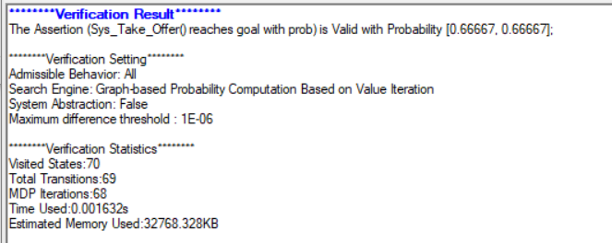

And for not swapping its 0.3333

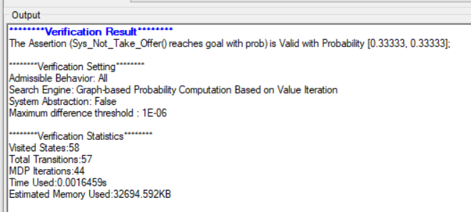

# Task 2

