3806ICT – Workshop 10

nick van der merwe – s5151332

# Size of grid world

9 columns and 7 rows

# Initial Q Values

It’s set to 0 unless the cell is marked as H, which in that case its negative infinity.

# Line of code that performs Q-learning update

This is at line 220 in the jupyter notebook. In other words its this line:

|  |
| --- |
| # update self.Q table  self.Q[s[0],s[1],a] **+=** alpha*(r + gamma * np.max(self.Q[s1[0],s1[1],:]) - self.Q[s[0],s[1],a]) |

# Set starting point to (2, 4)

NOTE this is different to the result you get in the lab, but its still seven steps.

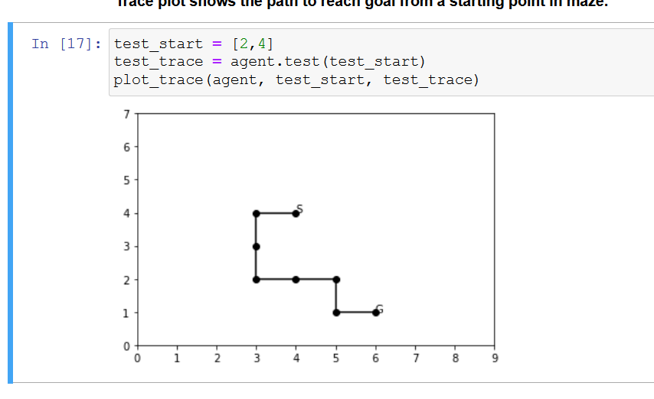

# Custom 20x20 world

This is our world:

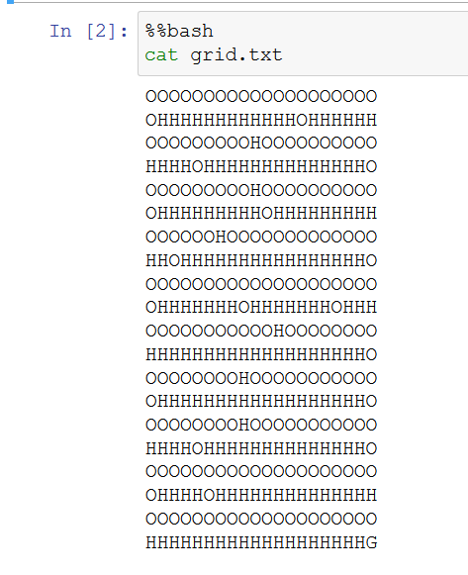

Its solution from 0,0 is:

