Week 9 Lab – 3806ICT

Nick van der Merwe – s5151332

# Task 4 – USV at (3, 5) and Survivors at (3, 2)

By setting it to BFS the minimum number of moves is ten. In this it covers all nine squares and returns home the fastest.

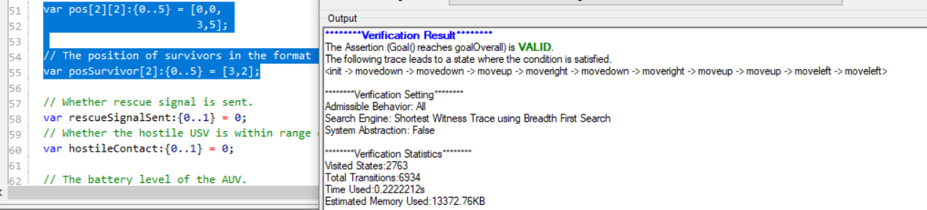

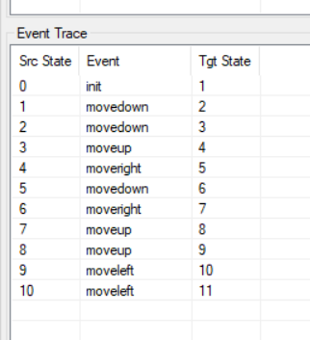

# USV at (3, 5) and Survivors at (1, 2)

shows it goes out, finds the survivor and returns to base.

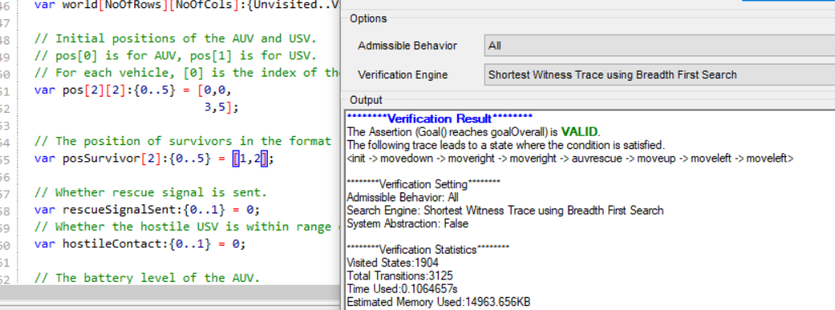

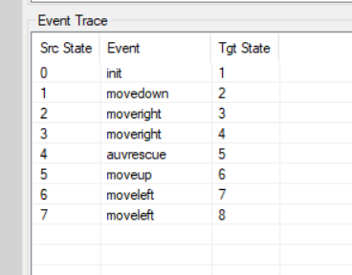

# USVHostile = (4, 3) and survivor = (3, 2)

It goes out, contacts the USV and returns to base in seven moves.

