姓名：陳建宇 系級：四機械四甲　學號：B10303008

Exam1：

將原圖以上下切完三個區塊

透過HSV通道中的H做色彩轉換

由上到下分為轉換 60度、180度 及300度

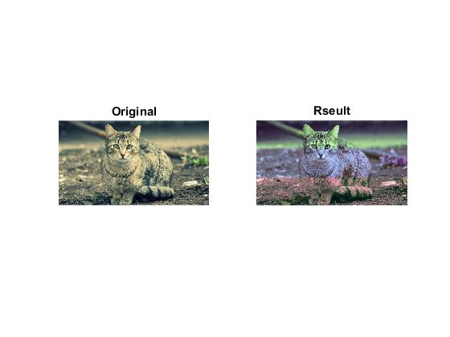

程式碼：

clear all;clc;close all

imgOrigin = imread('cats.jpg');

imgHSV = rgb2hsv(imgOrigin)

[rows,cols] = size(imgHSV);

distance = floor(rows/3)

imgHUp = imgHSV(distance\*0 + 1:distance\*1,:,1);

imgHMid = imgHSV(distance\*1 + 1:distance\*2,:,1);

imgHBottom = imgHSV(distance\*2 + 1:distance\*3,:,1);

imgHUpPlus60 = imgHUp(:,:,1)+60/360;

imgHUpPlus60 = mod(imgHUpPlus60,1);

imgHMidPlus180 = imgHMid(:,:,1)+180/360;

imgHMidPlus180 = mod(imgHMidPlus180,1);

imgHBottomPlus300 = imgHBottom(:,:,1)+300/360;

imgHBottomPlus300 = mod(imgHBottomPlus300,1);

imgHSV(distance\*0 + 1:distance\*1,:,1) = imgHUpPlus60;

imgHSV(distance\*1 + 1:distance\*2,:,1) = imgHMidPlus180;

imgHSV(distance\*2 + 1:distance\*3,:,1) = imgHBottomPlus300;

result = hsv2rgb(imgHSV);

subplot(1,2,1),imshow(imgOrigin),title('Original');

subplot(1,2,2),imshow(result),title('Rseult');

exam2：

遍布所有的pixel 將pixel value統計做成直方圖

以 pixel value 小到大製作累積圖，使用百分比

依照每個pixel value在於所有點的百分比位置做等化動作

為了讓等化更明顯，所以添加了把每三個pixel value做合併的動作

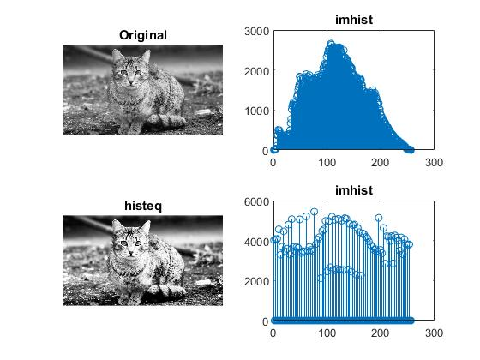

程式碼：

clear all;clc;close all

imgOrigin = imread('cats.jpg');

imgGray = rgb2gray(imgOrigin);

[rows,cols] = size(imgGray);

pTotal = rows\*cols;

pValArr = zeros(1,256);

minValue = 255 + 1;

maxValue = 0 - 1;

for r=1:rows

for c=1:cols

pValue = imgGray(r,c);

pValArr(1,pValue+1) = pValArr(pValue+1) + 1;

if pValue < minValue

minValue = pValue;

end

if pValue > maxValue

maxValue = pValue;

end

end

end

pValPercentArr = zeros(1,256);

count = 0;

for i=1:256

count = count + pValArr(i);

pValPercentArr(i) = double(count)/double(pTotal);

end

imgGrayEq = imgGray;%copy image

disDiv = double(maxValue-minValue+1);

pRseultValArr = zeros(1,256);

for r=1:rows

for c=1:cols

pValue = imgGray(r,c);

pPercent = pValPercentArr(pValue);

pEqValue = floor(pPercent\*255);

pEqValue = pEqValue - mod(pEqValue,3);

imgGrayEq(r,c) = pEqValue;

pRseultValArr(1,pEqValue+1) = pRseultValArr(pEqValue+1) + 1;

end

end

subplot(2,2,1),imshow(imgGray),title('Original');

subplot(2,2,2),stem(pValArr),title('imhist');

subplot(2,2,3),imshow(imgGrayEq),title('histeq');

subplot(2,2,4),stem(pRseultValArr),title('imhist');

exam3：

遍布所有的pix 針對每個點做指定函數運算

將圖片及直方圖呈現

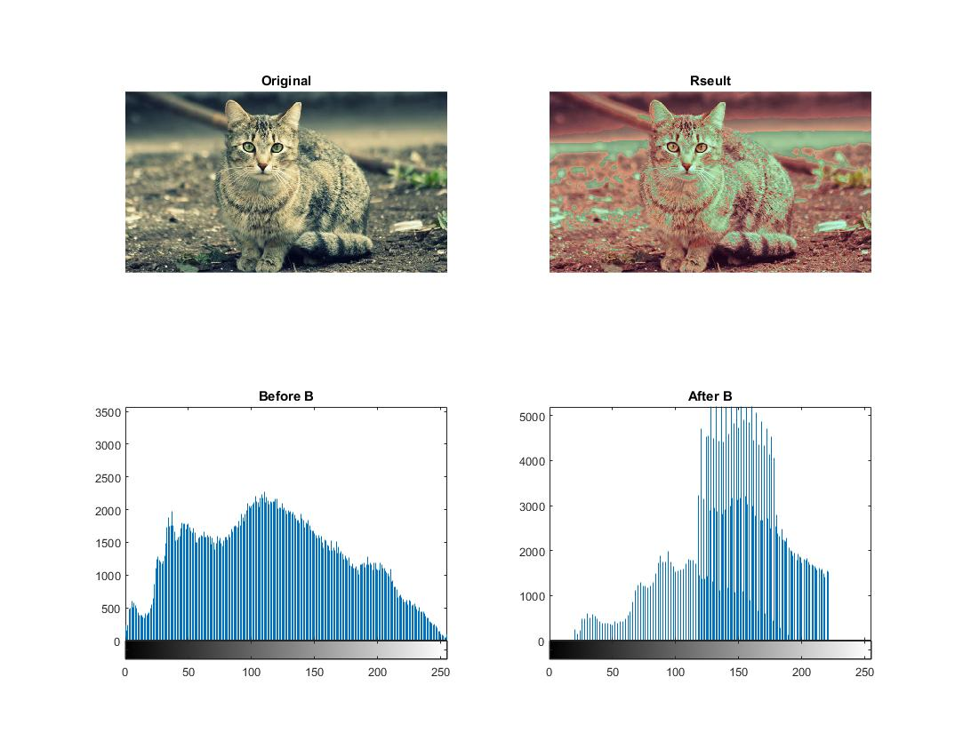

程式碼：

clear all;clc;close all

imgOrigin = imread('cats.jpg');

imgB = imgOrigin(:,:,1)

[rows,cols] = size(imgB);

imgNewB = imgOrigin(:,:,1)%copy B channel

for r=1:rows

for c=1:cols

x = imgB(r,c);

if x<80

x = 2\*x + 20;

elseif x< 160

x = 1.2\*x + 30;

else

x = 0.8\*x - 10;

end

imgNewB(r,c) = x;

end

end

rseult = imgOrigin; %copy image

rseult(:,:,1) = imgNewB;

subplot(2,2,1),imshow(imgOrigin),title('Original');

subplot(2,2,2),imshow(rseult),title('Rseult');

subplot(2,2,3),imhist(imgB),title('Before B');

subplot(2,2,4),imhist(imgNewB),title('After B');

Exam4：

遍布所有的pix，將YCbCr通道的CbCr做轉換來壓縮圖片

以911的方，以3x3的區塊做一次壓縮

將周圍的設定為中心區塊的YcYr

程式碼中有 盡量少用常數 讓程式碼可調 及 避免陣列指定時溢出的防呆

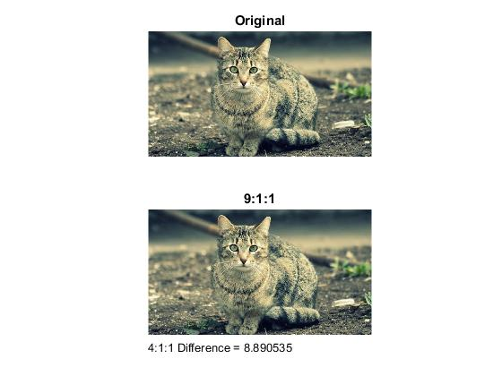

clear all;clc;close all

imgOrigin = imread('cats.jpg');

imgYcBcr = rgb2ycbcr(imgOrigin);

[rows,cols,n] = size(imgYcBcr);

LoopStep = 3;

DisSideToCenter = 1;% pixCountFromSizeTocenter

for r=1:LoopStep:rows-LoopStep+1 %avold the extend array size

for c=1:LoopStep:cols-LoopStep+1 %avold the extend array size

for x=r:r+LoopStep-1

for y=c:c+LoopStep-1

imgYcBcr(x,y,2) = imgYcBcr(r+DisSideToCenter,c+DisSideToCenter,2);

imgYcBcr(x,y,3) = imgYcBcr(r+DisSideToCenter,c+DisSideToCenter,3);

end

end

end

end

img911 = ycbcr2rgb(imgYcBcr);

img911d = reshape(double(img911),numel(img911),1);

imgd = reshape(double(imgOrigin),numel(imgOrigin),1);

Diff911 = sum(abs(img911d./norm(img911d)-imgd/norm(imgd)));

fprintf(1,'9:1:1 Difference = %f\n',Diff911);

t = sprintf('4:1:1 Difference = %f\n',Diff911);

subplot(2,1,1),imshow(imgOrigin);title('Original');

subplot(2,1,2),imshow(img911);title('9:1:1');

text(0,size(imgOrigin,1)+70,t);