**Task**

* Create an app to help students revise for a test.
* This will be a cross Platform, built with Xamarin.
* Backed onto a Cosmos Database. This will be online.
* Task is to create a user interface and navigation scheme, suitable for a mobile platform.
* Users should be able to Create, Update, Delete and Read the **flash Cards** & **Groups**.

**Software**

Github

Cosmos DB

Azure

Structure of App.

Below is a light idea of how the app could work

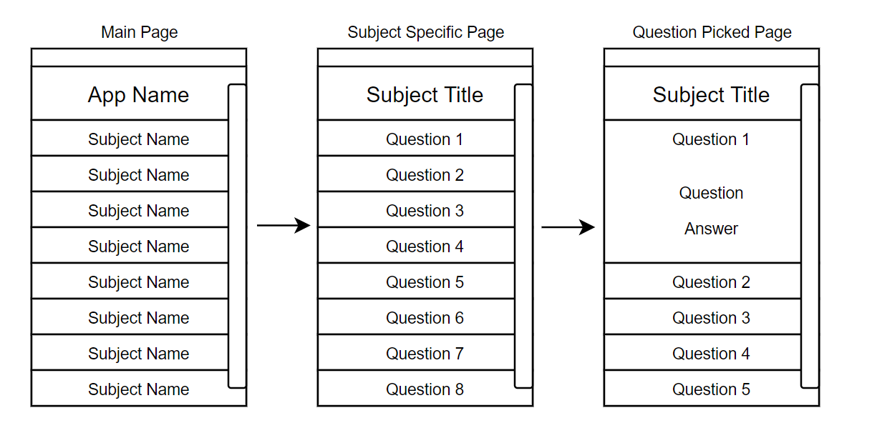

The main Page displays the groups (Subjects). Once you select a subject, it moves onto the specific page.

These subjects will be based on a generic class, which will store questions inside of.