ОПИСАНИЕ:

1. Я подключился к VK API и написал ETL, выложенный в github(https://github.com/Nick2201/vk_analyst)

* есть возможность выбрать любое сообщество или человека, для сбора необходимой информации со стены

2. Представлен вариант с пабликом (https://vk.com/science_technology)

#1: время суток публикации:

```

WITH interval_data AS (

SELECT

EXTRACT(HOUR FROM date) AS t_pub_hour,

likes,views

FROM

wall_social_media

WHERE

likes IS NOT NULL

AND

views IS NOT NULL

AND DATE_PART('year', date) IN (2023,2022,2021)

)

SELECT

t_pub_hour,

ROUND(AVG(likes)) AS avg_likes,

ROUND(AVG(views)) AS avg_views

FROM interval_data

GROUP BY t_pub_hour

ORDER BY avg_likes

```

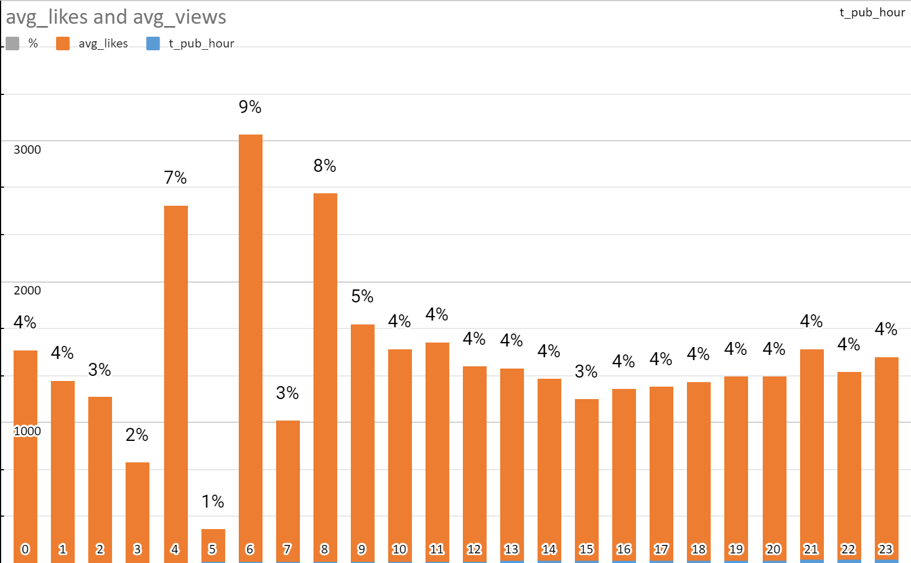

#2: день недели

```

SELECT

avg(likes),

EXTRACT(ISODOW FROM wall_social_media.date) as day_of_week

FROM wall_social_media

WHERE DATE_PART('year', date) IN (2023,2022,2021)

GROUP BY EXTRACT(ISODOW FROM wall_social_media.date)

ORDER BY day_of_week;

```

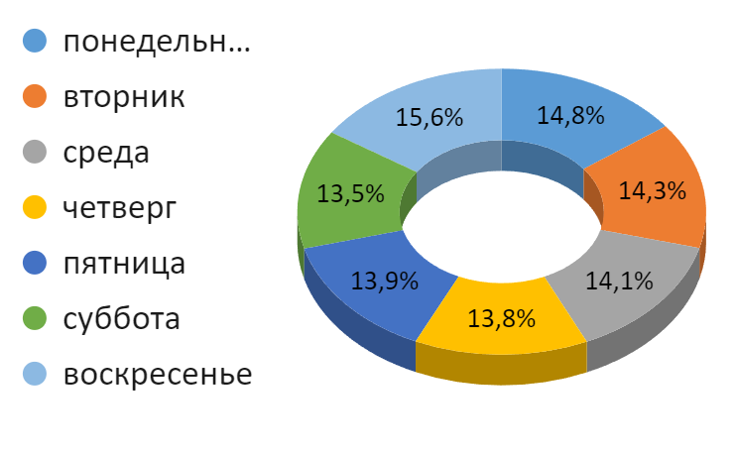

#3 промежуток между постами:

```

WITH interval_data AS (

SELECT

likes,views,

EXTRACT(HOUR FROM (LEAD(date) OVER (ORDER BY date) - date)) AS interval_between_posts_hours

FROM

wall_social_media

WHERE

likes IS NOT NULL

AND

views IS NOT NULL

AND DATE_PART('year', date) IN (2023,2022,2021)

)

SELECT

interval_between_posts_hours,

ROUND(AVG(likes)) AS avg_likes,

ROUND(AVG(views)) AS avg_views

FROM

interval_data

GROUP BY

interval_between_posts_hours

ORDER BY

avg_likes

```

