**Mathematica for Students**

Thank you for your request to install a copy of Wolfram’s Mathematica. It is available at no charge to Davidson College Students. Please follow the instructions below to download the software. You will need to create and validate a Wolfram account and then you will need an activation code to download the software.

**CREATE A WOLFRAM ACCOUNT**

1. Go to the Wolfram User Portal web site: <https://user.wolfram.com/portal>
2. Create an account by clicking on the “Create Account” button.



1. To create an account, you will enter your Davidson College email address (the one that ends with @davidson.edu), your first and last name, and you will create and confirm a password.
2. Once you create your account, you will see the following, confirming that you have created your account:

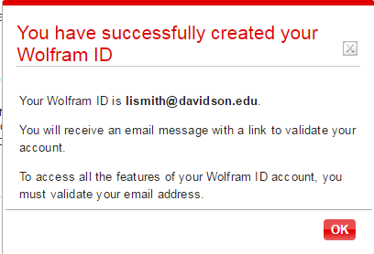

Click on OK to close this window and then check your Davidson College email for a message from [info@wolfram.com](mailto:info@wolfram.com) with the subject line “Validate your Wolfram ID.”

1. Open the email message and click on the link contained at the end of the sentence, “To validate your email address, please click the following link:” The link will start with <http://user.wolfram.com>. You will receive a “thank you” for validating your Wolfram ID.

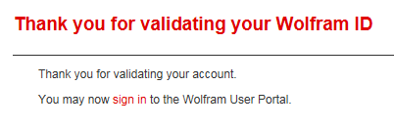

**REQUEST AN ACTIVATION KEY**

1. Next, **open a new tab in your web browser** and paste in the following link. It will take you to the Wolfram Activation Key Request Form.

<https://user.wolfram.com/portal/requestAK/b046a095bc2583cd711b04855cd13affdc3f18ff>

You MUST fill in:

* first name
* last name
* email address (use your Davidson email account!)
* department for which you need this software
* your anticipated graduation month and year.

The form should automatically fill in the product name - Mathematica for Students for Sites (Single Machine) - and the version (11.0.0.0). You can select this manually if it doesn’t automatically fill in.

Once you complete this form, you will receive an activation key that you will use to download the software.

1. Click on the link to “Product Summary page.”

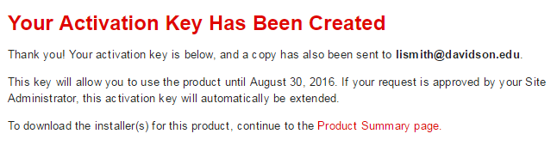

Or, if necessary, log back into Wolfram <https://user.wolfram.com/portal>

**DOWNLOAD THE SOFTWARE**

1. Click on the My Products and Services tab. Scroll down until you see “Downloads” and pick the version you want to download based on your operating system.