Interactive Visualization Tool

1. Project Description

Investigate, research, design, and implement an interactive visualization tool using both a Microsoft Kinect and standard projector. Using Microsoft's Kinect as my camera and its open-sources TDK for C#/C++, I hope to develop a platform capable of running applications to both visualize data and interact with users. The visuals will be projected to a surface while the Kinect is used to analyze this space and feed information back to the program to update the visuals. This will create an environment that can be both interpreted and interacted with via this system.

2. Purpose

Many unique applications can be developed and implemented via this idea. Interactive teaching experiences or PE activities, measuring objects, visualizing angles and object locations, and even interactive game boards.

Inspirations:

<https://www.youtube.com/watch?v=xSFL_4r0UaQ>

<https://www.youtube.com/watch?v=9Z6-i9pZrSU>

<https://www.youtube.com/watch?v=CE1B7tdGCw0>

3. Project Design

I intend to follow the example of the PE activity. This will involve making a simple, yet interactive game. The game will be to hit targets against the game’s projected surface. This interaction will be possible by using the Kinect and its ability to measure depth to tell when an object has entered a distance suitable to interact with the game. This contact maybe quick, such as with a ball being thrown, but the Kinect was design for motion games and should be capable of detecting this type of activity. The type of object, whether that be a ball or a person’s hand, shouldn’t matter either as the game shall be design around monitoring the depth away from the surface.

4. Diagram

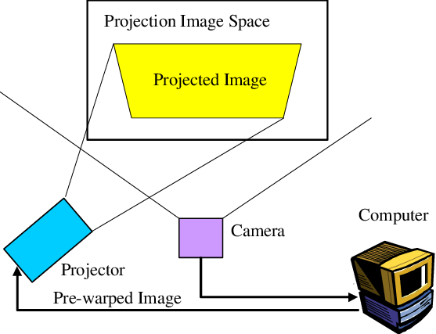

<https://www.researchgate.net/figure/Camera-Projector-Camera-System_fig3_242100535>

5. Test Cases

* Test the game and its interactions
  + The game should be fully functional with both moving targets and score keeping
  + The game should be interactive and be waiting for input from the Kinect
* Test the Kinect and its sensor capabilities
  + The Kinect should be capable of detecting all objects within a certain depth from the projected surface
  + The Kinect should be fast enough to detect and process quick moving objects, such as a ball being thrown