Interactive Visualization Tool

1. Install

# The code is contained in a Visual Studios C# project, although to use the project one must have the proper drivers and software installed. By following the tutorial in the link below, “Kinect with Me Part 1 – Setting Up Your Machine”, it’ll walk through the proper procedure for installing and running a C# project with Microsoft’s Kinect SDK. Once able to run sample projects from the SDK, one will be able to download and run this project’s code.

<https://blogs.msdn.microsoft.com/cdndevs/2014/10/23/kinect-with-me-part-1-setting-up-your-machine/>

<https://developer.microsoft.com/en-us/windows/kinect>

2. How to Use

Once installation is complete, one should be able to run the code with a proper Kinect plugged in and detected by the host machine. First, setup the projected image in relation to the Kinect sensor as seen in the diagram. After this, one should be able to start the screen calibration process. To do so, hit the “calibration” button in the lower right-hand corner of the applications menu. This should toggle a depth map image on the screen that should display the surface at which the Kinect is facing. By aligning this image flush with the wall and recalibrating, the threshold detection of the application should be set properly. By orientating the Kinect sensor properly, the detection of objects thrown at the wall should align with the green dots displayed whilst playing the game. If this is not the case, adjustments to the Kinect’s position as needed and rework the calibration process.

3. Diagram

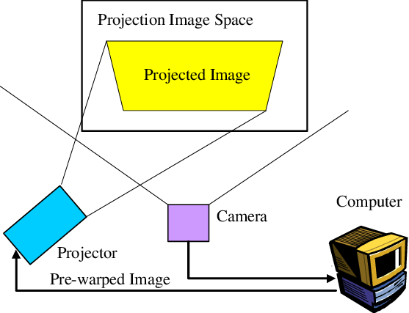

<https://www.researchgate.net/figure/Camera-Projector-Camera-System_fig3_242100535>