**44-663 App Development in C#.NET**

**Assignment 01**

**Objective:** Covers the usage of class, methods, loops, control structures and datatypes.

**Scenario:** B & B Theatre wants to automate their online movie ticket booking system.

Write a program in C# .NET for meeting the requirements given below.

Using this application the customer should be able to book movie ticket successfully on three different screens (Standard, Imax and Imax 3D).

**NOTE:**

* Read every instruction carefully and follow them.
* Check the sample output to know how the results need to be printed.
* Do not change the name of the attributes, and method given below.
* You are required to validate several input values that user will enter through the console.
* Write your solution in one Main class in such a way that it pass all the possible test cases.

Attributes are given in this table. You must use the names given here, with the same capitalization as shown here.

|  |  |  |
| --- | --- | --- |
| **Attribute** | **Type** | **Attribute Description** |
| **Name** | **String** | Name of the Customer; should not be empty or null when the customer enters for the prompt. |
| **Age** | **int** | Age of the Customer |
| **totalAmount** | **double** | Total bill amount to be paid |
| **cost** | **decimal** | Cost of each ticket. **It should be 7.85 per ticket for any screen.** |

**Part I: Reading Input values from the console**

**Sample validations:**

All the validations should be done while reading the input in Main class.

**Name Validation:**

Please enter the full name:

If no name is entered, user should be prompted to enter the name again as below.

Sorry, Please enter your name?

**Age Validation:** There are three validations for age.

**Enter your age:**

1. If no age is entered, user should be prompted to enter the age again as below.

Sorry, Please enter your age?

1. If age is below 15 then the below error message should be displayed

Your Age is below 15, you cannot book ticket online. Please talk to your parent or guardian!!

1. If age is above 90 then the below error message should be displayed.

You are too old to watch a movie, sorry!

**Sample output:**

**Table I:**

|  |
| --- |
| **** Welcome to B&B Theatre ****  Please enter the full name :  John Michael  Enter your age (>=15, <= 90)?  14  Your Age is below 15, you need a guardian to book a ticket.  Do you want to continue again (y/n)?  y  Please enter the full name :  John Michael  Enter your age (>=15, <= 90)?  91  You are too old to watch a movie! |

If the name and age attributes satisfy the above validations, then only perform the following steps. See the sample input and output given in Table II.

1. Once the user validated the name and age, display the types of screen. Refer Figure 01
   1. Standard
   2. Imax
   3. Imax-3D
2. User should be prompted to select the screen type from the console.
3. If user selects screen type as Standard or Imax, they will be prompted to buy number of tickets.
4. If user selects screen type as Imax – 3D (Option 3) then user will be prompted the below question :
5. Do you want 3D glasses? (y/n)
6. If user enters **y**, they will be charged extra $2.00 per ticket for glasses
7. If user enters n, the user will not be charged for the glasses

**Ticket Validation: For a given transaction,** user is allowed to buy a maximum of 3 tickets irrespective of the screen type. If the user wants to purchase more than 3 tickets, display the following error message and prompt the user to select number of tickets again.

“You can only buy 1 or 2 or 3 tickets per transaction. Sorry!!”

**Sample Output:**

**Figure 01**

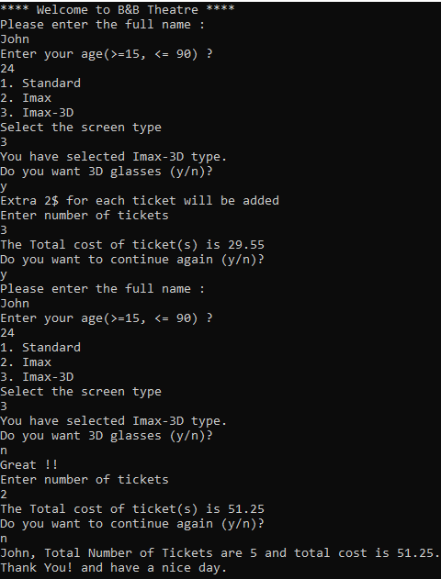

**Submit your solution by following the steps below:**

* Save your files in **Visual Studio**.
* Zip your entire Project. (It should be called ***Lastname*_Assignment01**.zip where the **Lastname** is your last name.)
* Submit the Zip file to the **Assignment01** dropbox.
* Download the Zip file you have submitted.
* Look in the Zip file and verify the files in the Zip folder are updated. If not, resave your project in **Visual Studio** and resubmit.