**Nicholas Christopher Allee**

**816-787-4041**

31470 Sherry Ln. Maryville Missouri 64468

**nickallee8529@gmail.com**

GitHub Portfolio:

GitHub:

**Education**

* Northwest Missouri State University Maryville, MO
* Graduation Date: May 2020
* GPA: 3.5/4.0
* **Bachelor of Science in Computer Science and Information Systems**
* **Bachelor of Science in Cybersecurity**

**Work Experience**

* Teaching Assistant
  + Computer Science Department Northwest Missouri State University Maryville MO
  + January 2017 – Present
  + Programming 1, Scientific Computing, Data Structures, and Machine Learning (Graduate Level)
  + Grade papers, quizzes, and tests
  + Assist students with coursework
  + Conduct study sessions to increase core competencies
  + Assist the instructor with his lectures by coding on the overhead screen and managing PowerPoints
  + Create programming projects
* Technical School Computer Teacher
  + Northwest Technical School Maryville, MO
  + January 2019 - Present
  + Conduct instructional classes regarding basic technology skills
  + Educate students in fundamentals of using windows, browsers, and basic settings
  + Improve competencies in basic computer security and best secure practices for browsing the web
* Factory Machine Operator
  + Kawasaki Motors Maryville, MO
  + May 2019 - July 2019
  + Operate heavy machinery to develop cylinder heads for lawn mower engines
* 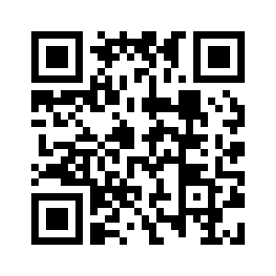Fully Trained Pizza Worker
  + Pagliai’s Pizza Maryville, MO
  + February 2014 - February 2019
  + Craft custom food and manage point of sale transactions
  + Manage six to eight employees cleaning and closing of the restaurant
  + Train new employees on proper working techniques
  + Ensure delivery of food to customers both inside and out of town with company car

**Skills and Activities**

* Python, C, Java, Bash, Solidity, Linux command line,  
  C#, OSForensics, WinHex, Git source control, and  
  Wireshark
* TestOut Ethical Hacking Certification (In Progress)
* TestOut PC Pro Certification (Completed May 2016)
* Cyber Defense Club
* National Honor Society for the  
  Computing Disciplines
* Association of Computing Machinery

**References**

* **Dr. Charles Hoot** 
  + Northwest Missouri State University (Computer Science)
  + Drc.hoot@gmail.com
  + 660-562-1600
* **Lori Tally** 
  + Northwest Technical School
  + Tally@maryviller2.com
  + 816-262-5431
* **Dr. Nathan Eloe**
  + Northwest Missouri State University (Computer Science)
  + Eloe@nwmissouri.edu
  + 660-562-1600