# Algorithm Projected Performance

### Results Plot

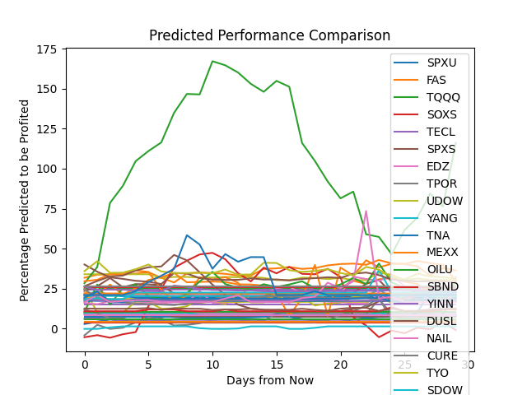

The Best Overall Performing ETF Was: OILU, with an average growth of: 104.8128

ETF: SPXU grew 7.1431627%. During testing, the Neural Network generated a Training Loss of ~483, and a Validation Loss of ~492

ETF: FAS grew 36.459457%. During testing, the Neural Network generated a Training Loss of ~1297, and a Validation Loss of ~1253

ETF: TQQQ grew 24.881556%. During testing, the Neural Network generated a Training Loss of ~1267, and a Validation Loss of ~1263

ETF: SOXS grew 3.6847656%. During testing, the Neural Network generated a Training Loss of ~199, and a Validation Loss of ~250

ETF: TECL grew 24.161201%. During testing, the Neural Network generated a Training Loss of ~1114, and a Validation Loss of ~880

ETF: SPXS grew 7.8339734%. During testing, the Neural Network generated a Training Loss of ~524, and a Validation Loss of ~479

ETF: EDZ grew 9.138208%. During testing, the Neural Network generated a Training Loss of ~504, and a Validation Loss of ~491

ETF: TPOR grew 6.4358225%. During testing, the Neural Network generated a Training Loss of ~299, and a Validation Loss of ~318

ETF: UDOW grew 32.017445%. During testing, the Neural Network generated a Training Loss of ~2048, and a Validation Loss of ~2180

ETF: YANG grew 20.10883%. During testing, the Neural Network generated a Training Loss of ~492, and a Validation Loss of ~488

ETF: TNA grew 19.846628%. During testing, the Neural Network generated a Training Loss of ~1078, and a Validation Loss of ~1144

ETF: MEXX grew 26.90198%. During testing, the Neural Network generated a Training Loss of ~602, and a Validation Loss of ~579

ETF: OILU grew 104.8128%. During testing, the Neural Network generated a Training Loss of ~1831, and a Validation Loss of ~1567

ETF: SBND grew 18.370506%. During testing, the Neural Network generated a Training Loss of ~73, and a Validation Loss of ~78

ETF: YINN grew 15.0350685%. During testing, the Neural Network generated a Training Loss of ~1225, and a Validation Loss of ~1314

ETF: DUSL grew 23.15408%. During testing, the Neural Network generated a Training Loss of ~432, and a Validation Loss of ~436

ETF: NAIL grew 23.743532%. During testing, the Neural Network generated a Training Loss of ~934, and a Validation Loss of ~842

ETF: CURE grew 19.704046%. During testing, the Neural Network generated a Training Loss of ~1080, and a Validation Loss of ~1157

ETF: TYO grew 17.182854%. During testing, the Neural Network generated a Training Loss of ~697, and a Validation Loss of ~671

ETF: SDOW grew 8.975881%. During testing, the Neural Network generated a Training Loss of ~380, and a Validation Loss of ~444

ETF: OILD grew 7.170785%. During testing, the Neural Network generated a Training Loss of ~2, and a Validation Loss of ~3

ETF: PILL grew 29.902548%. During testing, the Neural Network generated a Training Loss of ~465, and a Validation Loss of ~455

ETF: KORU grew 25.528582%. During testing, the Neural Network generated a Training Loss of ~721, and a Validation Loss of ~618

ETF: TZA grew 3.814997%. During testing, the Neural Network generated a Training Loss of ~430, and a Validation Loss of ~352

ETF: DRV grew 4.8734813%. During testing, the Neural Network generated a Training Loss of ~457, and a Validation Loss of ~536

ETF: DFEN grew 22.31348%. During testing, the Neural Network generated a Training Loss of ~512, and a Validation Loss of ~576

ETF: RETL grew 17.285755%. During testing, the Neural Network generated a Training Loss of ~1207, and a Validation Loss of ~1170

ETF: FNGD grew 6.2873154%. During testing, the Neural Network generated a Training Loss of ~535, and a Validation Loss of ~595

ETF: TMF grew 18.12322%. During testing, the Neural Network generated a Training Loss of ~718, and a Validation Loss of ~587

ETF: DRN grew 20.470379%. During testing, the Neural Network generated a Training Loss of ~749, and a Validation Loss of ~736

ETF: URTY grew 17.27859%. During testing, the Neural Network generated a Training Loss of ~954, and a Validation Loss of ~784

ETF: FNGU grew 21.96265%. During testing, the Neural Network generated a Training Loss of ~734, and a Validation Loss of ~664

ETF: SMDD grew 10.540519%. During testing, the Neural Network generated a Training Loss of ~1148, and a Validation Loss of ~1317

ETF: TMV grew 11.109219%. During testing, the Neural Network generated a Training Loss of ~488, and a Validation Loss of ~488

ETF: TYD grew 18.16449%. During testing, the Neural Network generated a Training Loss of ~1125, and a Validation Loss of ~986

ETF: TTT grew 12.098426%. During testing, the Neural Network generated a Training Loss of ~497, and a Validation Loss of ~554

ETF: FAZ grew 8.17816%. During testing, the Neural Network generated a Training Loss of ~1436, and a Validation Loss of ~1039

ETF: EDC grew 18.216606%. During testing, the Neural Network generated a Training Loss of ~902, and a Validation Loss of ~817

ETF: TECS grew 4.165658%. During testing, the Neural Network generated a Training Loss of ~246, and a Validation Loss of ~199

ETF: SOXL grew 22.472294%. During testing, the Neural Network generated a Training Loss of ~1070, and a Validation Loss of ~1069

ETF: DPST grew 18.52483%. During testing, the Neural Network generated a Training Loss of ~1071, and a Validation Loss of ~1158

ETF: SQQQ grew 4.4353895%. During testing, the Neural Network generated a Training Loss of ~177, and a Validation Loss of ~162

ETF: LABD grew 5.784597%. During testing, the Neural Network generated a Training Loss of ~514, and a Validation Loss of ~539

ETF: UMDD grew 25.798344%. During testing, the Neural Network generated a Training Loss of ~875, and a Validation Loss of ~931

ETF: UPRO grew 23.990955%. During testing, the Neural Network generated a Training Loss of ~1438, and a Validation Loss of ~1315

ETF: SPXL grew 31.590109%. During testing, the Neural Network generated a Training Loss of ~1456, and a Validation Loss of ~1438

ETF: UTSL grew 20.427128%. During testing, the Neural Network generated a Training Loss of ~1450, and a Validation Loss of ~1415

ETF: MIDU grew 26.141361%. During testing, the Neural Network generated a Training Loss of ~1280, and a Validation Loss of ~1372

ETF: LABU grew 35.592033%. During testing, the Neural Network generated a Training Loss of ~1508, and a Validation Loss of ~1630

ETF: SRTY grew 0.90835506%. During testing, the Neural Network generated a Training Loss of ~388, and a Validation Loss of ~454

ETF: EURL grew 28.320463%. During testing, the Neural Network generated a Training Loss of ~1743, and a Validation Loss of ~1735