# Algorithm Projected Performance

### Results Plot

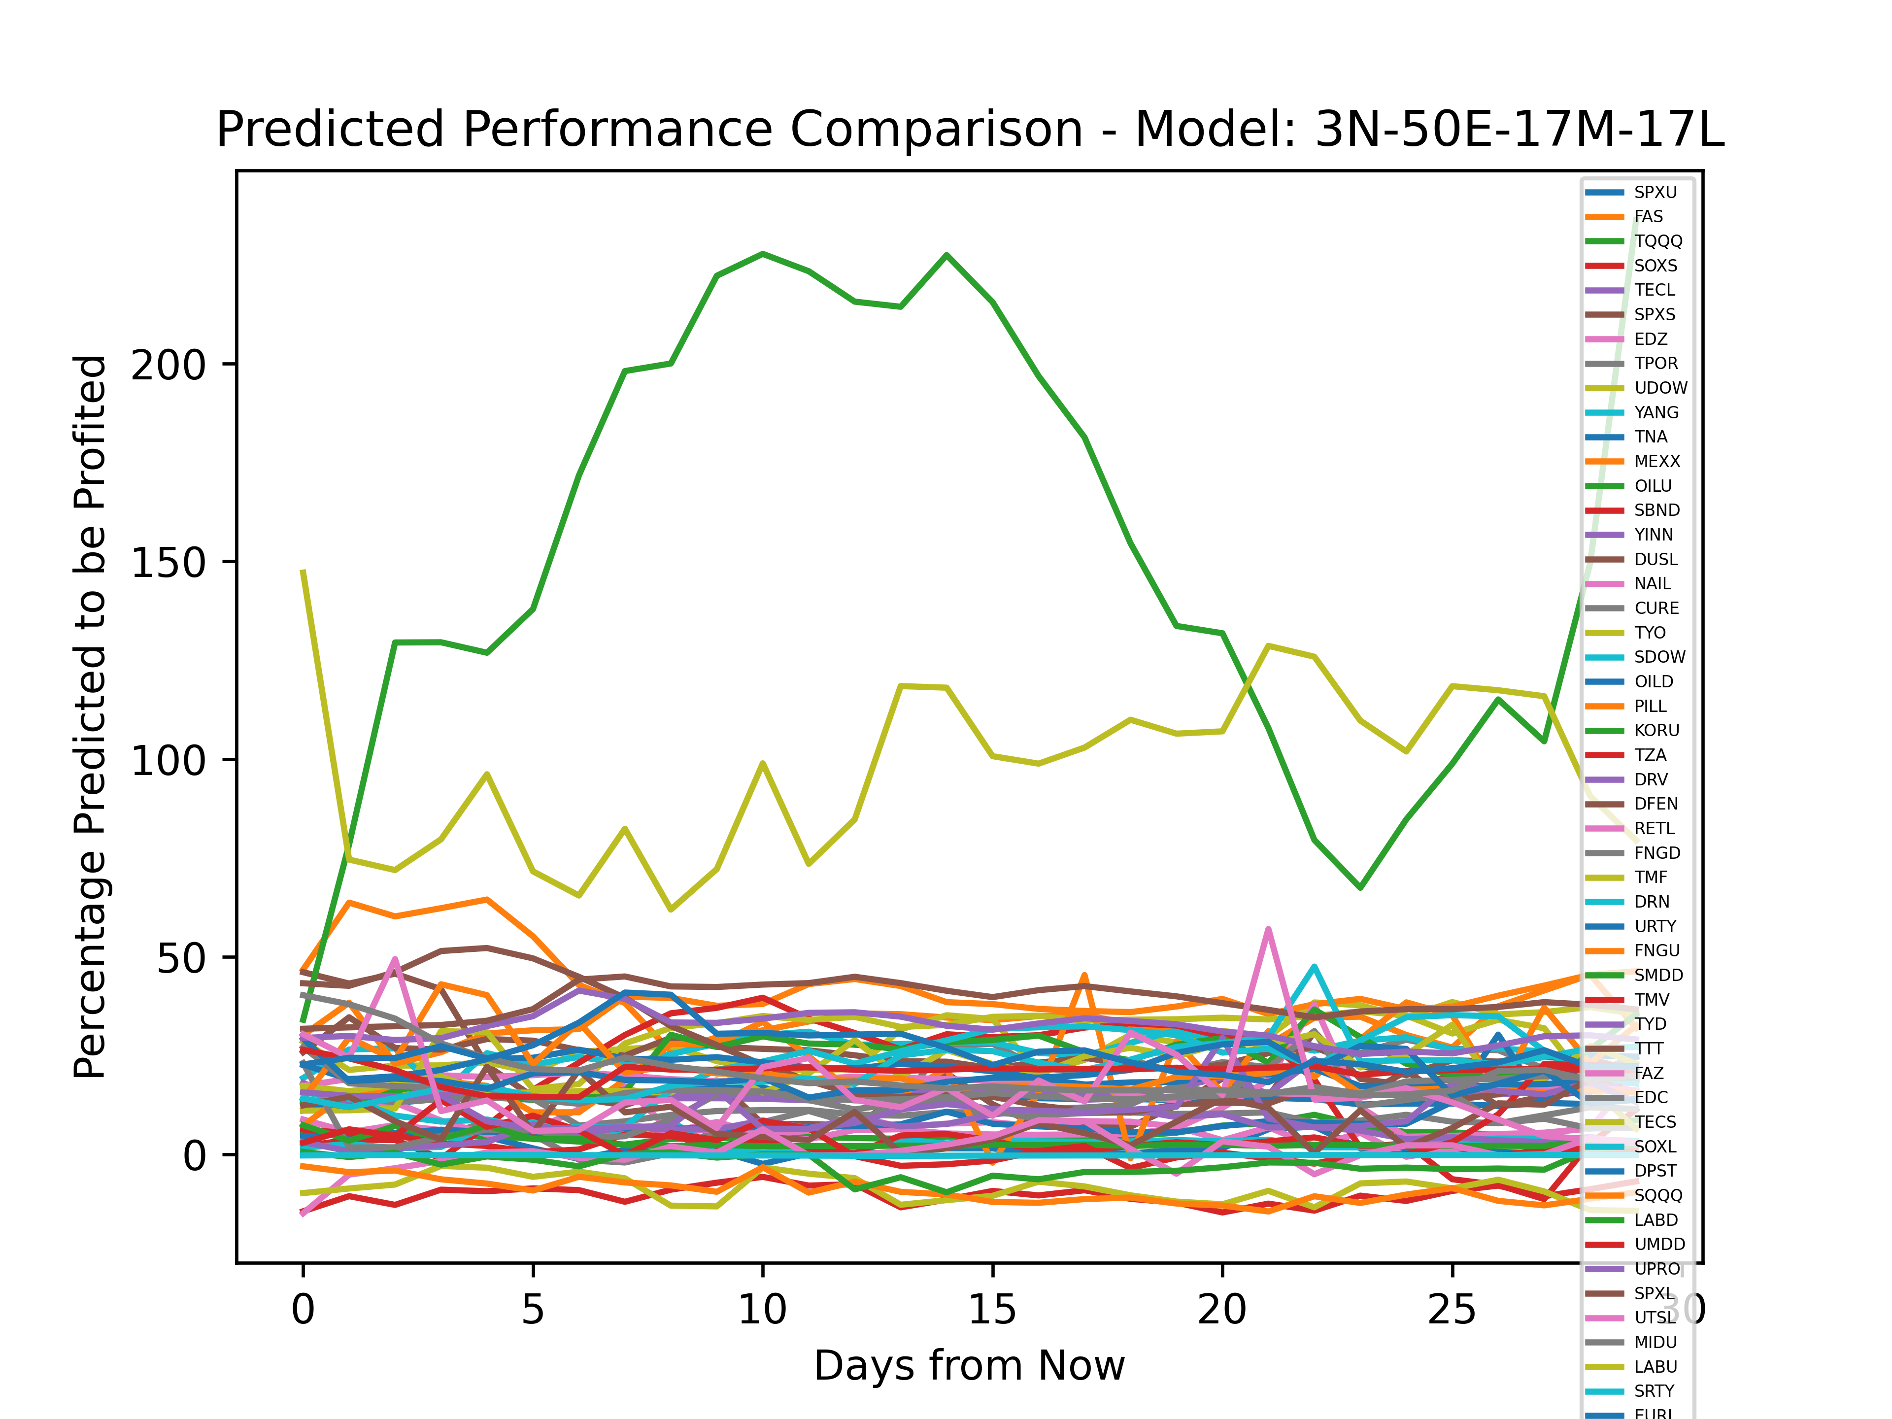

The Best Overall Performing ETF Was: OILU, with an average growth of: 153.18063

ETF: SPXU profited 1.7908511%. The Neural Network generated a Training Loss of ~390, and a Validation Loss of ~441

ETF: FAS profited 38.99763%. The Neural Network generated a Training Loss of ~1077, and a Validation Loss of ~1104

ETF: TQQQ profited 5.237172%. The Neural Network generated a Training Loss of ~1010, and a Validation Loss of ~1103

ETF: SOXS profited -10.182775%. The Neural Network generated a Training Loss of ~167, and a Validation Loss of ~255

ETF: TECL profited 14.941944%. The Neural Network generated a Training Loss of ~865, and a Validation Loss of ~708

ETF: SPXS profited 18.789661%. The Neural Network generated a Training Loss of ~465, and a Validation Loss of ~476

ETF: EDZ profited 6.2551446%. The Neural Network generated a Training Loss of ~440, and a Validation Loss of ~485

ETF: TPOR profited 15.145671%. The Neural Network generated a Training Loss of ~207, and a Validation Loss of ~251

ETF: UDOW profited 28.8819%. The Neural Network generated a Training Loss of ~1746, and a Validation Loss of ~1905

ETF: YANG profited 26.033913%. The Neural Network generated a Training Loss of ~438, and a Validation Loss of ~432

ETF: TNA profited 13.909012%. The Neural Network generated a Training Loss of ~907, and a Validation Loss of ~1091

ETF: MEXX profited 37.361732%. The Neural Network generated a Training Loss of ~582, and a Validation Loss of ~571

ETF: OILU profited 153.18063%. The Neural Network generated a Training Loss of ~3248, and a Validation Loss of ~2832

ETF: SBND profited 18.299473%. The Neural Network generated a Training Loss of ~44, and a Validation Loss of ~70

ETF: YINN profited 16.01936%. The Neural Network generated a Training Loss of ~1062, and a Validation Loss of ~1153

ETF: DUSL profited 25.146425%. The Neural Network generated a Training Loss of ~390, and a Validation Loss of ~425

ETF: NAIL profited 8.87826%. The Neural Network generated a Training Loss of ~712, and a Validation Loss of ~782

ETF: CURE profited 10.378574%. The Neural Network generated a Training Loss of ~947, and a Validation Loss of ~962

ETF: TYO profited 28.68237%. The Neural Network generated a Training Loss of ~599, and a Validation Loss of ~677

ETF: SDOW profited 3.4061239%. The Neural Network generated a Training Loss of ~341, and a Validation Loss of ~401

ETF: OILD profited 9.211008%. The Neural Network generated a Training Loss of ~3, and a Validation Loss of ~3

ETF: PILL profited 21.56263%. The Neural Network generated a Training Loss of ~362, and a Validation Loss of ~430

ETF: KORU profited 23.981962%. The Neural Network generated a Training Loss of ~588, and a Validation Loss of ~568

ETF: TZA profited 2.7371433%. The Neural Network generated a Training Loss of ~365, and a Validation Loss of ~316

ETF: DRV profited 6.298085%. The Neural Network generated a Training Loss of ~379, and a Validation Loss of ~465

ETF: DFEN profited 24.683462%. The Neural Network generated a Training Loss of ~470, and a Validation Loss of ~499

ETF: RETL profited 17.853682%. The Neural Network generated a Training Loss of ~1015, and a Validation Loss of ~1159

ETF: FNGD profited 11.925312%. The Neural Network generated a Training Loss of ~417, and a Validation Loss of ~496

ETF: TMF profited 21.846378%. The Neural Network generated a Training Loss of ~641, and a Validation Loss of ~568

ETF: DRN profited 22.447222%. The Neural Network generated a Training Loss of ~703, and a Validation Loss of ~708

ETF: URTY profited 20.868065%. The Neural Network generated a Training Loss of ~849, and a Validation Loss of ~708

ETF: FNGU profited 20.98141%. The Neural Network generated a Training Loss of ~605, and a Validation Loss of ~574

ETF: SMDD profited 3.044566%. The Neural Network generated a Training Loss of ~832, and a Validation Loss of ~907

ETF: TMV profited 4.8212976%. The Neural Network generated a Training Loss of ~407, and a Validation Loss of ~441

ETF: TYD profited 11.875762%. The Neural Network generated a Training Loss of ~867, and a Validation Loss of ~766

ETF: TTT profited 9.184702%. The Neural Network generated a Training Loss of ~409, and a Validation Loss of ~497

ETF: FAZ profited 0.54919887%. The Neural Network generated a Training Loss of ~1201, and a Validation Loss of ~1080

ETF: EDC profited 16.538002%. The Neural Network generated a Training Loss of ~763, and a Validation Loss of ~779

ETF: TECS profited -8.727517%. The Neural Network generated a Training Loss of ~194, and a Validation Loss of ~156

ETF: SOXL profited 21.992495%. The Neural Network generated a Training Loss of ~932, and a Validation Loss of ~1092

ETF: DPST profited 20.11846%. The Neural Network generated a Training Loss of ~998, and a Validation Loss of ~1176

ETF: SQQQ profited -9.203391%. The Neural Network generated a Training Loss of ~151, and a Validation Loss of ~147

ETF: LABD profited -2.5720515%. The Neural Network generated a Training Loss of ~433, and a Validation Loss of ~439

ETF: UMDD profited 20.932467%. The Neural Network generated a Training Loss of ~726, and a Validation Loss of ~797

ETF: UPRO profited 31.829245%. The Neural Network generated a Training Loss of ~1298, and a Validation Loss of ~1159

ETF: SPXL profited 38.834034%. The Neural Network generated a Training Loss of ~1288, and a Validation Loss of ~1342

ETF: UTSL profited 17.091688%. The Neural Network generated a Training Loss of ~1275, and a Validation Loss of ~1204

ETF: MIDU profited 20.79581%. The Neural Network generated a Training Loss of ~1115, and a Validation Loss of ~1196

ETF: LABU profited 97.70576%. The Neural Network generated a Training Loss of ~1168, and a Validation Loss of ~1131

ETF: SRTY profited -0.19381545%. The Neural Network generated a Training Loss of ~335, and a Validation Loss of ~380

ETF: EURL profited 26.20207%. The Neural Network generated a Training Loss of ~1522, and a Validation Loss of ~1677