# Algorithm Projected Performance

### Results Plot

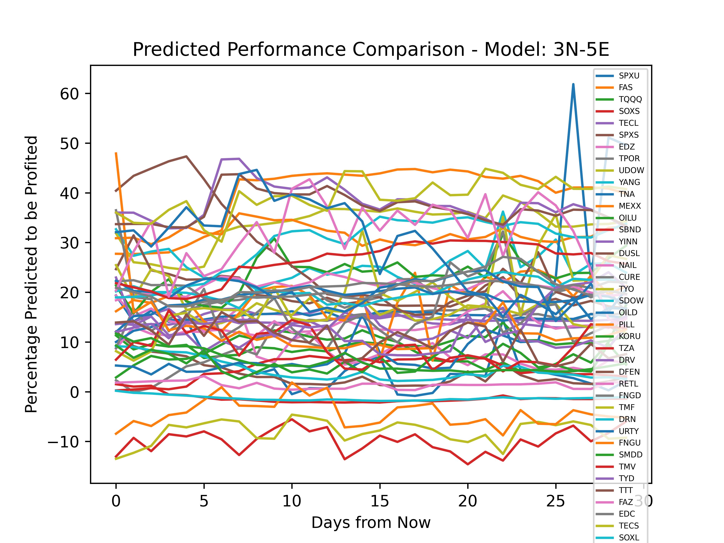

The Best Overall Performing ETF Was: FAS, with an average growth of: 39.721638

ETF: SPXU profited 5.496177%. The Neural Network generated a Training Loss of ~472, and a Validation Loss of ~459

ETF: FAS profited 39.721638%. The Neural Network generated a Training Loss of ~1319, and a Validation Loss of ~1263

ETF: TQQQ profited 9.507248%. The Neural Network generated a Training Loss of ~1289, and a Validation Loss of ~1227

ETF: SOXS profited -9.858516%. The Neural Network generated a Training Loss of ~184, and a Validation Loss of ~232

ETF: TECL profited 14.86143%. The Neural Network generated a Training Loss of ~1091, and a Validation Loss of ~821

ETF: SPXS profited 3.6211882%. The Neural Network generated a Training Loss of ~518, and a Validation Loss of ~498

ETF: EDZ profited 8.429042%. The Neural Network generated a Training Loss of ~506, and a Validation Loss of ~489

ETF: TPOR profited 12.100781%. The Neural Network generated a Training Loss of ~355, and a Validation Loss of ~338

ETF: UDOW profited 33.470345%. The Neural Network generated a Training Loss of ~2213, and a Validation Loss of ~2168

ETF: YANG profited 25.4883%. The Neural Network generated a Training Loss of ~485, and a Validation Loss of ~444

ETF: TNA profited 14.894648%. The Neural Network generated a Training Loss of ~1075, and a Validation Loss of ~1151

ETF: MEXX profited 31.772394%. The Neural Network generated a Training Loss of ~658, and a Validation Loss of ~598

ETF: OILU profited 8.29883%. The Neural Network generated a Training Loss of ~4774, and a Validation Loss of ~4284

ETF: SBND profited 4.53424%. The Neural Network generated a Training Loss of ~115, and a Validation Loss of ~106

ETF: YINN profited 14.274274%. The Neural Network generated a Training Loss of ~1219, and a Validation Loss of ~1268

ETF: DUSL profited 19.984713%. The Neural Network generated a Training Loss of ~496, and a Validation Loss of ~468

ETF: NAIL profited 14.023274%. The Neural Network generated a Training Loss of ~1023, and a Validation Loss of ~956

ETF: CURE profited 17.927763%. The Neural Network generated a Training Loss of ~1126, and a Validation Loss of ~1049

ETF: TYO profited 14.869869%. The Neural Network generated a Training Loss of ~653, and a Validation Loss of ~628

ETF: SDOW profited 4.3736744%. The Neural Network generated a Training Loss of ~370, and a Validation Loss of ~422

ETF: OILD profited 12.602666%. The Neural Network generated a Training Loss of ~8, and a Validation Loss of ~6

ETF: PILL profited 18.612387%. The Neural Network generated a Training Loss of ~503, and a Validation Loss of ~506

ETF: KORU profited 23.70183%. The Neural Network generated a Training Loss of ~712, and a Validation Loss of ~598

ETF: TZA profited -1.3080316%. The Neural Network generated a Training Loss of ~420, and a Validation Loss of ~334

ETF: DRV profited 12.229304%. The Neural Network generated a Training Loss of ~455, and a Validation Loss of ~538

ETF: DFEN profited 26.623238%. The Neural Network generated a Training Loss of ~577, and a Validation Loss of ~565

ETF: RETL profited 21.134508%. The Neural Network generated a Training Loss of ~1322, and a Validation Loss of ~1236

ETF: FNGD profited 16.476915%. The Neural Network generated a Training Loss of ~554, and a Validation Loss of ~525

ETF: TMF profited 21.242727%. The Neural Network generated a Training Loss of ~732, and a Validation Loss of ~589

ETF: DRN profited 20.457243%. The Neural Network generated a Training Loss of ~832, and a Validation Loss of ~787

ETF: URTY profited 18.79379%. The Neural Network generated a Training Loss of ~972, and a Validation Loss of ~759

ETF: FNGU profited 12.731623%. The Neural Network generated a Training Loss of ~942, and a Validation Loss of ~688

ETF: SMDD profited 6.014565%. The Neural Network generated a Training Loss of ~1068, and a Validation Loss of ~1154

ETF: TMV profited 9.179473%. The Neural Network generated a Training Loss of ~488, and a Validation Loss of ~501

ETF: TYD profited 13.514859%. The Neural Network generated a Training Loss of ~1083, and a Validation Loss of ~931

ETF: TTT profited 10.623593%. The Neural Network generated a Training Loss of ~479, and a Validation Loss of ~524

ETF: FAZ profited 1.3651861%. The Neural Network generated a Training Loss of ~1284, and a Validation Loss of ~1059

ETF: EDC profited 21.17285%. The Neural Network generated a Training Loss of ~912, and a Validation Loss of ~842

ETF: TECS profited -8.026827%. The Neural Network generated a Training Loss of ~229, and a Validation Loss of ~170

ETF: SOXL profited 29.654533%. The Neural Network generated a Training Loss of ~1124, and a Validation Loss of ~1144

ETF: DPST profited 20.370178%. The Neural Network generated a Training Loss of ~1126, and a Validation Loss of ~1254

ETF: SQQQ profited -4.2922196%. The Neural Network generated a Training Loss of ~164, and a Validation Loss of ~152

ETF: LABD profited 6.0276814%. The Neural Network generated a Training Loss of ~526, and a Validation Loss of ~494

ETF: UMDD profited 26.181147%. The Neural Network generated a Training Loss of ~895, and a Validation Loss of ~908

ETF: UPRO profited 37.867634%. The Neural Network generated a Training Loss of ~1454, and a Validation Loss of ~1252

ETF: SPXL profited 36.96105%. The Neural Network generated a Training Loss of ~1428, and a Validation Loss of ~1457

ETF: UTSL profited 30.954664%. The Neural Network generated a Training Loss of ~1796, and a Validation Loss of ~1536

ETF: MIDU profited 20.739498%. The Neural Network generated a Training Loss of ~1346, and a Validation Loss of ~1354

ETF: LABU profited 39.198387%. The Neural Network generated a Training Loss of ~1659, and a Validation Loss of ~1561

ETF: SRTY profited -1.2874076%. The Neural Network generated a Training Loss of ~377, and a Validation Loss of ~408

ETF: EURL profited 28.665377%. The Neural Network generated a Training Loss of ~1924, and a Validation Loss of ~1860