Nick Bischoff  
ISP 5:15pm  
Term Project Final Report

Final Report

This is the final report of the Term project. After much hard work and long hours of planning, coding, and testing. It is complete. In this final report I will discuss the implementation. Since I did not have a group for this project, I will instead spend the contribution time talking about how I came up with the idea for the project and the resources I used to accomplish this. I will include screen shots as asked and discuss the lessons learned and possible future work. I went a different route than most people, I believe. I really want to make a career out of game development so that is why I chose to make an internet browser game rather than an online shopping website for the 4 tier web application.

Starting off jumping right into it. Let us talk about the implementation. The project uses HTML, JavaScript, CSS, and PHP. I used an object-oriented method of developing. I used a class for the player, the projectile, and the enemies. I found this method was easier and more functional. It was easier because computer Science II was object oriented and I enjoyed it, after writing more programs than expected it made the project more enjoyable for myself to develop. The use of objects and the “this” pointer made everything a little sleeker and easy to access the data. The Player class consists of a constructor and a makePlayer method that consists of a beginPath function and the arc method for making a circular object that would become the “player”. It also has the coloring and fill attributes in it. I used a canvas in a “2d” context for the arcade style, I made sure to use the innerWidth and innerHeight to get the most real estate with the browser. I used some const variables throughout the program they cover everything from centering the player to the coloring. I used some methods to make life easier such as the random predefined function for randomizing the enemies and setInterval as well as splice and the math library functions. This all primarily is for the enemies in the game. The projectiles and the enemies are kept in arrays and the splice function eliminates them one by one as the player shoots them. You will notice there are also update methods int eh classes for the projectiles and enemies to aide in eliminating them when necessary. Animation frames and event listeners for the movement and for the click to shoot feature are of use. This is most of the javaScript in the program. It also controls the start game button to kick everything off when pressed. Html is the what the javaScript and CSS are embedded into, the HTML controls the buttons for the “help” and “Technical Document” these are separate files that can go back and fourth to the game when needed. The Technical Document has the CSS links for the Power Point presentation and the Final Report doc. The help page is instructions for how to play the game and store and delete the score from the database. The Technical Document describes the architecture, business logic, database design and some of the special features of the program. The data base connection is written in PHP just like assignment 3 and uses a mySQL script to control the database.

This project took a lot of research and practice to get it right. I mostly used the W3Schools.com reference to find everything I needed to accomplish this as well as the examples from class and my prior knowledge and research on object oriented programming since most of it transfers to language to language as has been mention in class. This was a fun assignment I must say.

Lessons have been learned though. At first I tried to bite off more than I could chew trying to figure out how to transition the player and accomplish all the rest of the functionality that I had mentioned in the progress report. I ended up leaving the player movement out of the equation due to it was taking too much time to figure that out along with the rest of the list of things needing to get done, the player movement just didn’t fit in unfortunately. But this gave way to more atheistic design with the space background and allowed me to focus more on the smoothness of the enemies and the projectiles.

Having a game plan (no pun intended) however proved to be an excellent decision in developing this project. I had listed out all the functionality I wanted for the project and worked through if systematically until each piece was working flawlessly. This and knowing other languages helped a lot too such as C++ and Java really made this project a little more achievable.

Here’s some screen shots of the finished project verse the working project.

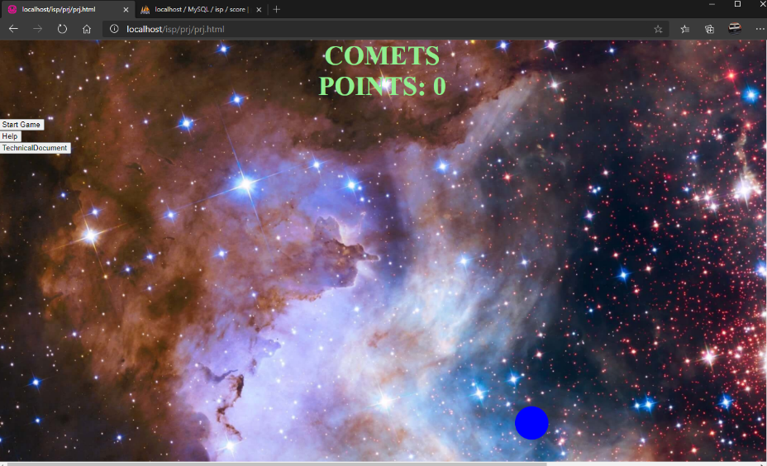 Then the working in progress

In the future, I can see myself pursuing a career in game development. That is what sparked this idea for the project. It has been a hobby of mine since the first assignment learning HTML, CSS, and JavaScript, I cannot get enough of it. There could be a few things I would still do to this project if I had the time, maybe implement the PHP to grab the score and automatically and put it in the database. Maybe do some cooler looking buttons and characters, try to make it look more professional. But all in all, I am pretty satisfied with my work on this. Many great games to come.