Assignment Title: UML Class Diagram for Student Registration System
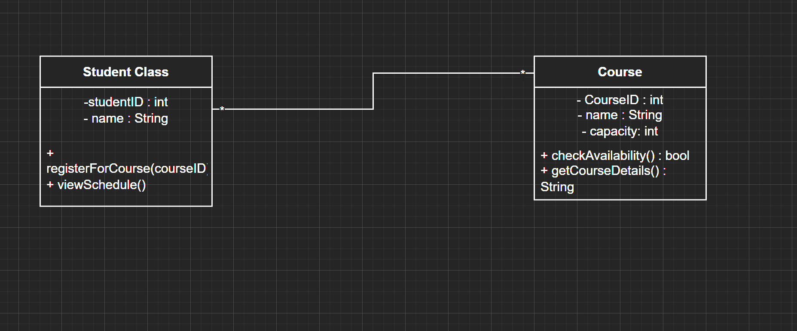
Part 2
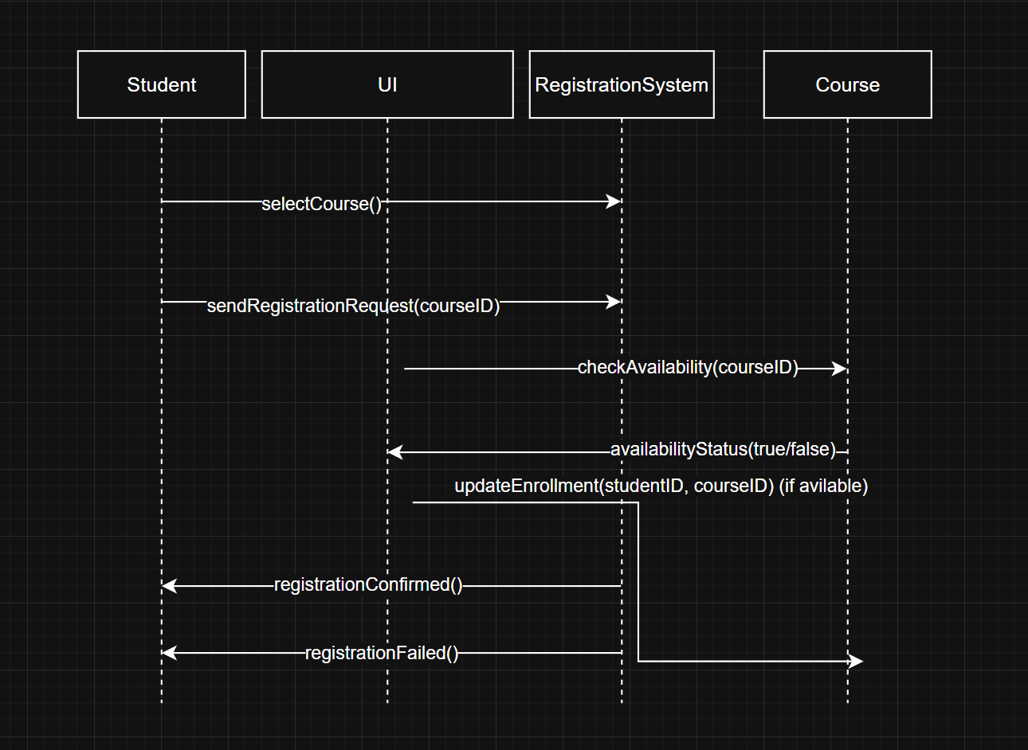

Assignment Title: UML Use Case Diagram for Student Registration System
