Style Guidelines for Final Year Project Reports

Final Year Project Interim Report

A 4th Year Student
An interim report submitted in part fulfilment of the degree of BSc (Hons.) in the School of Computer Science and Informatics with the supervision of Prof. Barry Smyth and moderated by Dr. Liam Murphy.


School of Computer Science and Informatics
University College Dublin

Project Specification
Your project specification goes here.
Abstract
This document serves as a style guide for final year project reports. It does not tell you how to write your final year reports, or what they should contain. It explains how they should be formatted and typeset. Please refer to your project guidelines document for information about report sizes and contents. NOTE: in your report, you should replace this with an appropriate Abstract for your project report.

Table of Contents
1 Introduction 4
2 Styles in Word 4
3 Page Layout & Size 6
4 Headings 6
4.1 Second Level Headings 7
4.1.1 Third Level Headings 7
4.2 A Word on Numbering 7
5 Figures and Charts 7
6 Program Code 8
7 Table of Contents 8
8 Getting Started 8

Introduction
This document is a style guide for final year project reports in the School of Computer Science and Informatics in University College Dublin. As such, it constitutes a collection of predefined Microsoft Word formatting styles for the production of your final report. These styles should be used without modification or replacement.
While this may well sound like a rather prescriptive approach to report writing, it is introduced for the following reasons.
- The style guide allows students to focus on the critical task of producing clear and concise content, instead of being distracted by font settings and paragraph spacing.
- By providing a comprehensive style guide the School benefits from a consistent and professional look to its internal project reports.
- The style guide also allows the School to properly control the size restrictions that are placed on reports.
The remainder of this document briefly outlines the main components and suggested use of this style guide.

Styles in Word
Every style defined in this document is essentially a collection of formatting commands (font commands, paragraph controls etc) for each of the common types of components that are likely to make up your project report.
As such the following standard styles have been defined:
- Normal – the style for the basic text of the document.
- Title – the main title style.
- Subtitle – the subtitle style.
- Author – the style used for the author’s name on the front page.
- H1, H2, H3 – styles for different levels of section headings.
- Figure – the style for a figure or table caption.
- Code – the style for program source code.
- Bulleted List – the style for a standard bulleted list such as this one.
- Numbered List – similar to the bulleted list style except that the list is numbered.
Normally, styles are selected from the Word style menu, which is located on the main Word toolbar (see Figure 1).
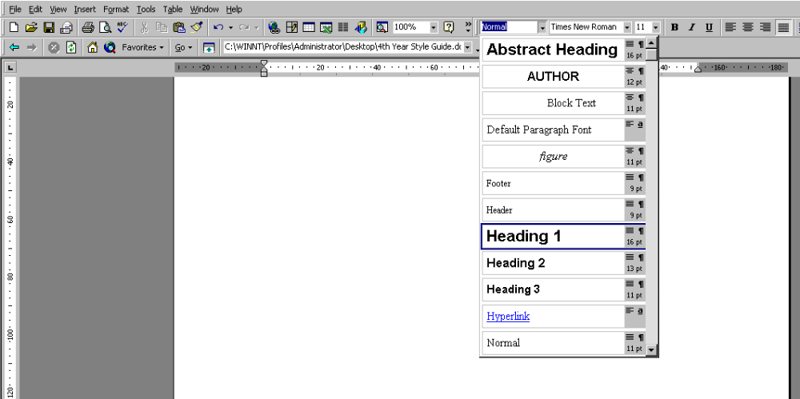
- Selecting the Heading 1 style from the Word style menu.
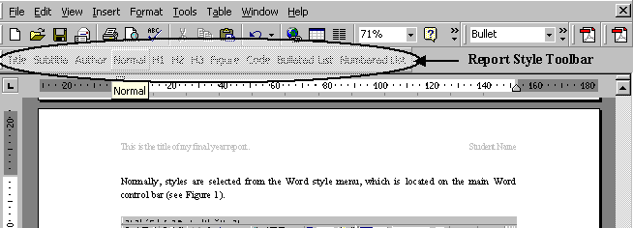
To help you with the standard styles, a new toolbar has been added to the top left of this document; if you cannot see it then select the toolbar called Report in the Toolbar menu within the View menu. This new toolbar displays a set of buttons for each of the main standard styles used in this document. Just click on a style button to activate the corresponding style (see Figure 2).
- The report style toolbar provides easy access to the approved styles.
It is important to emphasise that the above styles are the only styles that are approved for use in your report. Word comes with an expanded set of pre-defined styles and of course you can, in theory, define your own styles. However, we strongly suggest that you to stick to the approved styles. Of course, you may have a genuine need for a new style during the preparation of your report. However, we suggest that you consider whether one of the approved styles can be used before you rush to create a new style,. For example, we have not defined a specific style for the bibliographic entries that you will need at the end of your report. Instead we strongly suggest the use of a numbered list style for your bibliography, with citations in the text taking the form of “see [1,2] for related work”.

Page Layout & Size
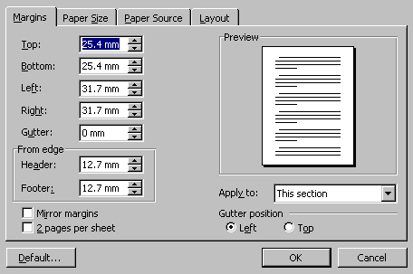
The page size and margins have been set in this document (see Figure 3). These should not be changed or adjusted. The page size, fonts and spacing have been chosen to allow for approximately 700 - 800 words per page of text or approximately 25,000 – 28,000 per 35-page document.
- Page settings defined for this document.
In addition, page headers and footers have been included. The footer should not need to be edited as it contains page number and date information that is always updated automatically. Similarly, the header is designed to update automatically once the appropriate field data (title and author have been provided); see Section 8 for information about how to do this.

Headings
Your report will be structured as a collection of number sections at different levels of detail. For example, the heading to this section is a first-level heading (it’s called Heading 1) and has been defined with a particular set of font and spacing characteristics. At the start of a new section, you need to select the appropriate heading style, Heading 1 in this case, by clicking H1 on the new style toolbar.

Second Level Headings
Second and third level headings have also been defined and can be accessed as H2 and H3 styles. For example, the heading in this subsection is a second-level heading.

Third Level Headings
The heading for this subsection is a third level heading. In general, it is unlikely that fourth of fifth level headings will be required in your final report. Indeed it is more likely that if you do find yourself needing them, then your document structure is probably not ideal. So, try to stick to three levels of heading provided.

A Word on Numbering
You will notice that the main section headings in this document are all numbered in a hierarchical fashion. You don’t have to worry about the numbering. It is all automatic as it has been built into the heading styles. Each time you create a new heading by selecting the appropriate style, the correct number will be assigned.
This form of automatic numbering is great when it works well, and while you are not responsible for the numbering itself, you are responsible for the correct use of heading styles. If you are not careful – for instance by setting a blank line to be a heading style – you will find headings to be numbered incorrectly. This is because the heading numbering works by counting the number of previous heading assignments (of a particular type – heading 1, 2 or 3) that occur up to a given point in the document.

Figures and Charts
Most final reports will contain a mixture of figures and charts along with the main body of text. In this document a style called figure (accessed as usual from the new report style toolbar) has been defined for the figure caption and should appear directly after the figure as seen in Figures 1 and 2 above. Once again, time has been spent defining this style to handle figure numbering but care needs to be taken to ensure that extra lines are not carelessly created in this style or else the numbering will not be correct.
Inserting and aligning figures and charts in Word can be a hit and miss affair at the best of times. As a tip, a fairly reliable way of inserting graphics and charts that have been copied to the clipboard is to use the “paste special” option in word and select a “picture” option, rather than pasting directly.
Figures, charts and tables should always be centred horizontally. This can be achieved by right-clicking the graphic, selecting the Format Picture option and then selecting the Layout tab to find various alignment options.

Program Code
A Code style has been prepared for formatting short excerpts of source code. It is a simple indented, single-spaced style using a fixed font (Courier New) to produce code that appears like the following:
static public void main(String[] args) {
try {
UIManager.setLookAndFeel(UIManager.getSystemLookAndFeelClassName());
}
catch(Exception e) {
e.printStackTrace();
}
new WelcomeApp();
}

Table of Contents
A table of contents (TOC) page has also been included in this report template and can be created using the TOC generator in Word. Ordinarily this is accessed via Index and Tables option in the in the Insert menu. However, to avoid the need to set certain TOC features, the best way to insert a new table of contents is to use the TOC macro defined in this document. This macro can be run by clicking on the TOC button on the report style toolbar to position a new table of contents at the current cursor position – so care needs to be take to properly position the cursor after he “table of contents” heading on page 3 of your report. Notice that you can update your existing table of contents by simply right clicking it and selecting the update field option.
A word of warning on this feature – the table of contents is automatically generated by compiling a table of all of the level 1, 2 and 3 headings in your document. This means that every line with one of these styles will appear in the table. If you use these styles for non-headings (of course you should not do this) then these non-headings will also appear in the table.

Getting Started
The simplest way to get started with your report is to save a copy of this document. Delete sections 1 to 8 and start adding your own sections using the styles provided.
Finally, you may have noticed some unusual entries on the cover page of this document. For example, the title and author sections are highlighted. These are field values that are used in various places throughout the document, such as the header and footer. Do not edit these highlighted sections of text directly. Instead to set up the document with your details you need to enter the title, author, supervisor, moderator and degree information by updating these fields. The simplest way of doing this is to select the entire document using “Ctrl A” (or through the Edit menu) and then press F9. You will be presented with a series of prompts to enter the appropriate information. Once you have updated the field information with your details this document is ready to go. You can re-enter or change these field values at any time by the same procedure.

