JD Tyres follow-up postcards
Editable working file — tweak, then produce the final print PDFs
How this file works
- The two FRONT pages are the finished design at the exact print size. Their headline wording is listed below as editable text — change it here and I’ll re-render the front, or edit the picture in your design tool.
- The two BACK pages are live, editable Word text. Change the message freely; the layout and the address clear-zone are already set correctly.
- When you’re happy, the polished print-ready PDFs get re-rendered from your edits (front + back, split, with bleed) ready to upload to Stannp.
Stannp print specification (built in)
Canvas size | 15.4 × 11.1 cm (1819 × 1311 px @ 300 dpi) — A6 148×105 mm + 3 mm bleed all round
Safe zone | Keep all text & logos 0.6 cm inside every edge
Address clear-zone | BACK only: keep the right block clear (from 9.19 cm across) for the address + postal indicia
Crop marks | None — Stannp trims automatically
Upload | Front = one page, Back = one page (separate files provided)
Front headline copy (editable)
CARD 1 front — overline: JD Tyres · Chippenham
CARD 1 front — headline: Your website’s still built — and still nothing to pay to look.
CARD 2 front — overline: A quick last word
CARD 2 front — headline: Last one from me — then I’ll leave you be.

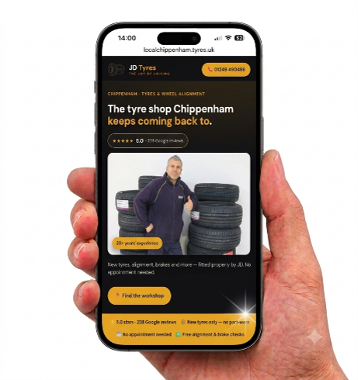
[Grab your reader’s attention with a great quote from the document or use this space to emphasise a key point. To place this text box anywhere on the page, just drag it.]
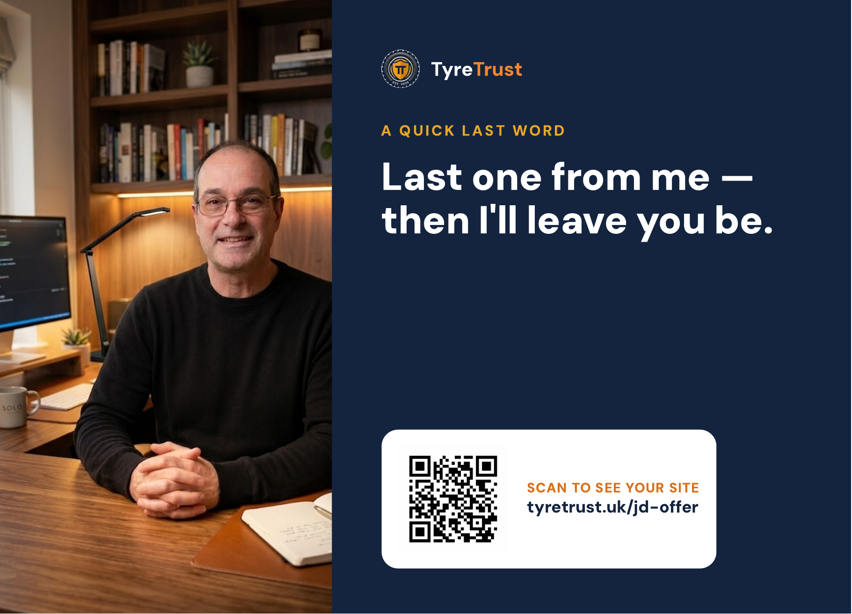
Julian —
No idea if my letter landed or ended up under a stack of tyre invoices. Either way, the site I built for JD Tyres is still there — and it still costs nothing to have a look.
Two minutes on your phone whenever you get a quiet one: point the camera at the code and it opens straight up. A link to your site’s at the top.
If it’s not for you, no worries at all. Keep up the brilliant work either way.
Nick — TyreTrust
07494 653018 · nick@tyretrust.uk

SCAN TO SEE YOUR SITE
tyretrust.uk/jd-offer



Julian —
This is the last you’ll hear from me, promise. I built the JD Tyres site as a one-off while I was starting out, so I won’t keep the free preview up forever — but it’s still there for now if you’ve been meaning to look.
No charge to see it, £9.99 a month to keep it live if you like it, and nothing at all if you don’t. No hard feelings either way — you’ve clearly built something people love.
If now’s the moment, scan the code. If not, thanks for reading this far.
Nick — TyreTrust
07494 653018 · nick@tyretrust.uk

SCAN TO SEE YOUR SITE
tyretrust.uk/jd-offer

