Team: Foodie-Saviors

Project name: Cooking recipe application (application name)

The idea is to create an application which is intended for users who are looking for a new cooking experience, for those who are looking for a dish based on their own limitations and opportunities, or just want to cook their dish as best as possible! And it copes with this problem with a bang!

Target Audience:

* By platform: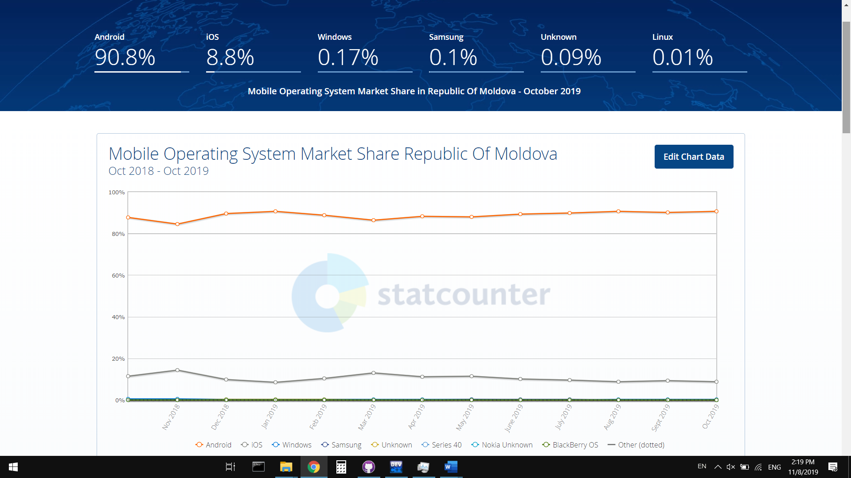

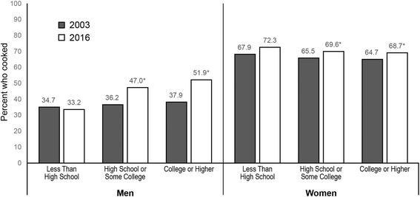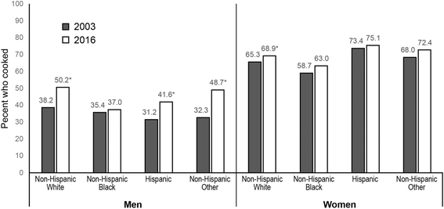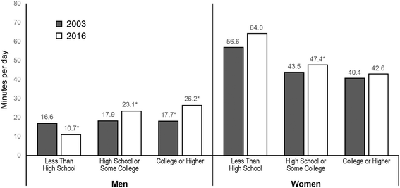

Analyze on the already existing solutions

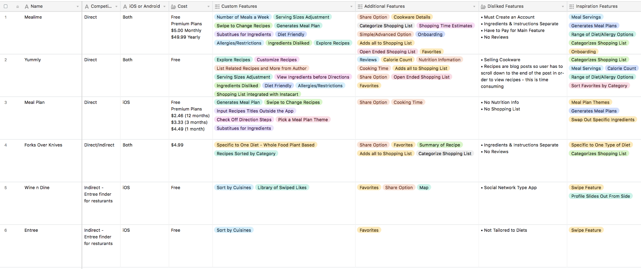

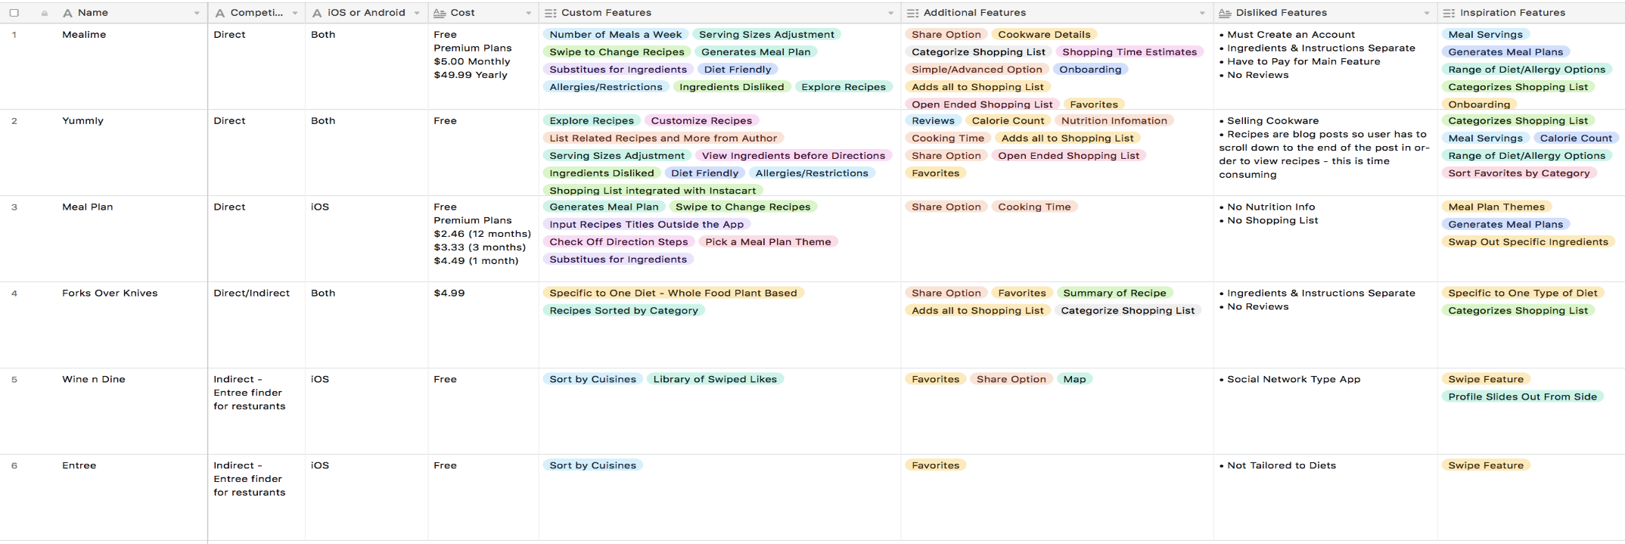

Solution description

Our cooking recipe application solution provides with the next useful possibilities:

1. To use an attractive, modern and understandable User Interface

2. To find most suitable recipes using filter by many parameters

3. To see a detailed description of nutrition facts, ingredients, cooking time

4. To use step by step guide of how to cook the dish chosen, sometimes also with a video instruction embedded

5. To create personal recipes, collections and categories.

6. To search from local available ingredients.

7. Works perfectly for local area (Moldova, Romania) users