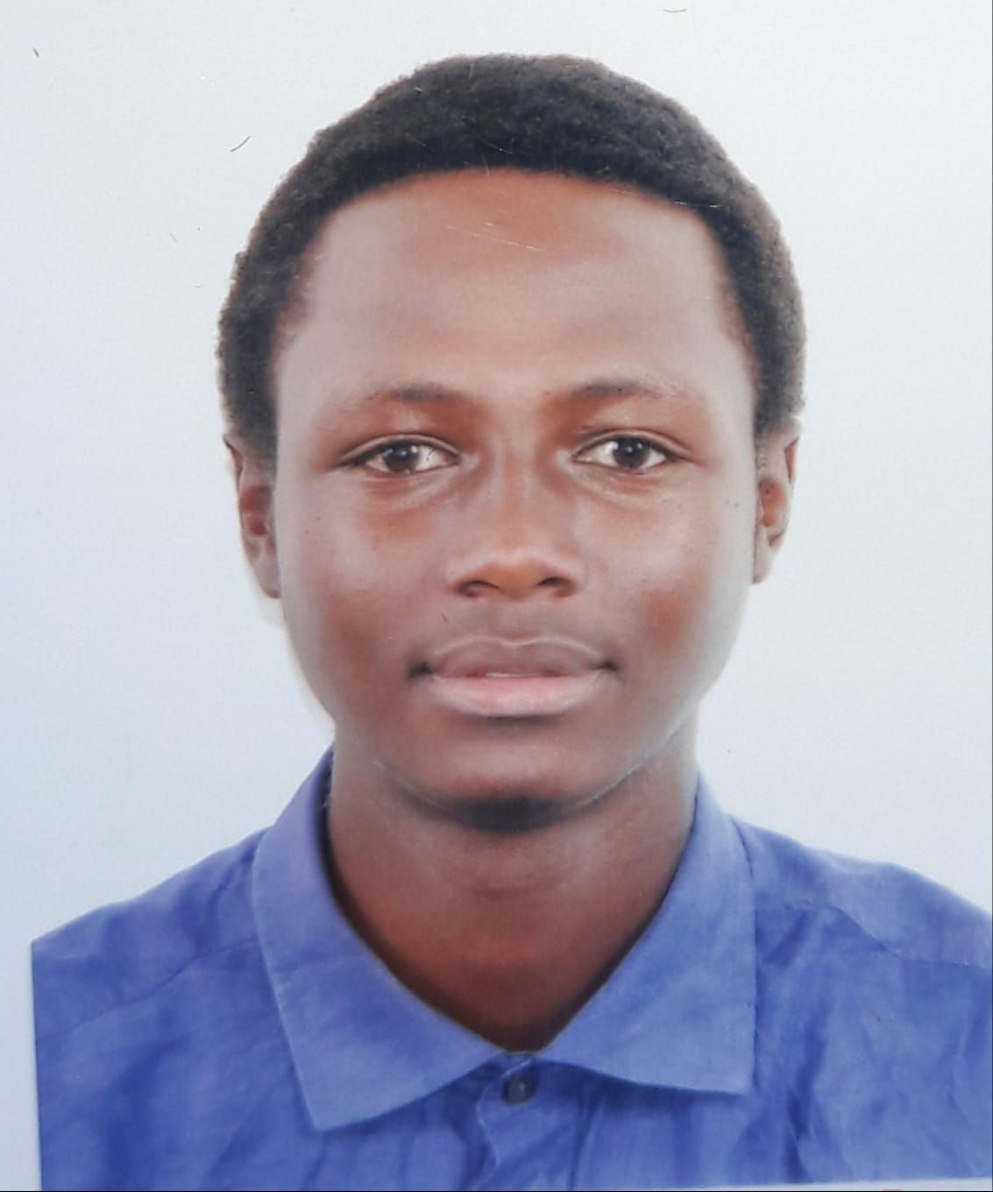

**NICHOLAS BIIY BWALLEY**

**DIPLOMAS Y HOBBIES**

**Formaciones :** Diplomados, Congresos, xxxxxxxxxx xxxxxx xxxxxxxxx xxxxxxxxxxxxxxxxx

**Hobbies:** xxxxxxxxxxxxxxxxxxxxxxxxxxxxxx



**CONTACT**



+254 714394332

**WORK EXPERIENCE**



2023

(NY, USA)

nickbwalley@gmail.com



**Moi Educational Centre**

Community Based Intern

* Assisted the school by working in different departments, an act of giving back to the community.
* Helped streamlining the process in the school library on book issuance to a student.

Nairobi, Kenya

**PROFILE SUMMARY**

A dedicated software developer with a specialization in the MERN stack, I bring a unique blend of technical proficiency and a strategic cybersecurity mindset to the table. With a proven track record of crafting efficient and secure applications, I am adept at translating intricate technical concepts into practical solutions that align with organizational objectives. I thrive in collaborative environments, leveraging strong communication skills to effectively liaise between technical and non-technical stakeholders.

**EDUCATION**

2021-2024

**Bachelor’s in Business Information Technology**

*Strathmore University*

Nairobi, Kenya

2019-2021

**Diploma in Business Information Technology**

**(Merit)**

*Strathmore University*

Nairobi, Kenya

2021-2024

**Bachelor’s in Business Information Technology**

**(Dean’s List award 2021/2022)**

*Strathmore University*

Nairobi, Kenya

**LANGUAGES**

English: Native

Swahili: Native

French: Fluent

Spanish: Intermediate

2021-2024

**Bachelor’s in Business Information Technology**

**(Dean’s List award 2022/2023)**

*Strathmore University*

Nairobi, Kenya

**SKILLS**

Problem Solving

Programming

Research

Teamwork

Leadership

Communication

xxx

**INTERESTS**

* Swimming
* Fitness/cross-fit/Gym
* Table Tennis
* Basketball

©AZURIUS - My-resume-templates.com

**Dear Job Seeker,**

If you're having difficulty composing your resume, here are some free resources available that can assist you in creating a strong resume that highlights your suitability for the position to potential employers:

* [How to Make a Good Resume](https://www.my-resume-templates.com/how-to-make-a-resume/?utm_source=Word_Doc&utm_medium=Model_CV_Link&utm_campaign=MDC_Downloads)
* [Skills to Put on a Resume](https://www.my-resume-templates.com/skills-to-put-on-a-resume/?utm_source=Word_Doc&utm_medium=Model_CV_Link&utm_campaign=MDC_Downloads)
* [Resume Objective Examples](https://www.my-resume-templates.com/resume-objective-examples/?utm_source=Word_Doc&utm_medium=Model_CV_Link&utm_campaign=MDC_Downloads)

Also, discover other free downloadable and ready-to-fill CV templates in Word format:

* [Basic Resume Templates](https://www.my-resume-templates.com/basic-resume-templates/?utm_source=Word_Doc&utm_medium=Model_CV_Link&utm_campaign=MDC_Downloads)
* [Modern Resume Templates](https://www.my-resume-templates.com/modern-resume-samples/?utm_source=Word_Doc&utm_medium=Model_CV_Link&utm_campaign=MDC_Downloads)
* [Creative Resume Templates](https://www.my-resume-templates.com/creative-cv-templates/?utm_source=Word_Doc&utm_medium=Model_CV_Link&utm_campaign=MDC_Downloads)
* [Professional Resume Templates](https://www.my-resume-templates.com/career-resume-templates/?utm_source=Word_Doc&utm_medium=Model_CV_Link&utm_campaign=MDC_Downloads)
* [Europass CV](https://www.my-resume-templates.com/europass-cv/?utm_source=Word_Doc&utm_medium=Model_CV_Link&utm_campaign=MDC_Downloads)

Best regards,

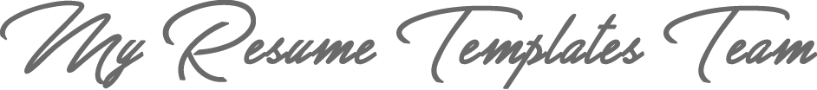

[www.my-resume-templates.com](https://www.modelos-de-curriculum.com/?utm_source=Word_Doc&utm_medium=Model_CV_Link&utm_campaign=MDC_Downloads)

**COPYRIGHT - PLEASE READ THIS MESSAGE**

©These examples of free resume templates are the property of Azurius S.L. You may   
download and modify them without any problem if they are for personal use.

Do not forget to remove this copyright notice before modifying and printing your CV.

You cannot resell these examples or their derivatives. You cannot make them available on other websites without our consent. For any related questions, please write to us at contact@my-resume-templates.com

Discover more resume templates at [www.my-resume-templates.com](https://www.my-resume-templates.com/)