**OCAS: An Online Car Auctioning System to Aid Competency in Auctioning and Bidding of Cars.**

**Bwalley Nicholas.**

**122790.**

**Submitted in partial fulfilment of the requirements of the Diploma of Business in Information Technology at Strathmore University**

**Strathmore Institute of Management and Technology**

**Strathmore University**

**Nairobi, Kenya**

**February 2020**

Declaration and Approval

I declare that this work has not been previously submitted and approved for the award of a diploma by this or any other University. To the best of my knowledge and belief, the research proposal contains no material previously published or written by another person except where due reference is made in the research proposal itself.

Student: Nicholas Bwalley

Sign: ________________________ Date: ________________________

Supervisor: Joseph Mungai

Sign: ________________________ Date: ________________________

Abstract

Acquiring a car in the contemporary days has been a challenge for potential buyers caused by over-exaggerated car price set by the car-broker’s given the tender by the car owner to sell a car. This results to potential buyer’s incapability to buy a car due to their high expense. In addition, customers find it challenging for them to buy a car due to insufficient knowledge on where to buy a car in which is in good quality car. This leads to time wastage for both the auctioneer and the potential buyer to get into contact, for them to conduct the auctioning process. In addition, auctioneers also find it challenging for them to sell their auction due to unavailability of the potential buyers as a result of their high expense. This later on results to high depreciation of the car which makes them to sell at a very low cost. The proposed solution is developing an online web-based platform that enables registered clients auction their car as well as place a bid of an available cars, giving all integral details of the car. Clients can view the location of the car from the auctioneer in case he or she needs to physically see it and if declared the bid winner. The proposed system will be developed using the waterfall methodology where the phases will be sequentially implemented.

Table of Contents

Declaration and Approval ii

Abstract iii

List of Figures vii

List of Abbreviations viii

Chapter 1. Introduction 1

1.1 Background of Study 1

1.2 Problem Statement 2

1.3 General Objective 2

1.3.1 Specific Objectives 3

1.4 Justification 3

1.5 Scope and Limitations 3

Chapter 2. Literature Review 4

2.1 Introduction 4

2.2 Auctioning Processes in Kenya. 4

2.2.1 Challenges Faced by Auctioneers in Kenya. 4

2.3 Related Works 5

2.3.1 E-Bay 5

2.3.2 Auto Auction Mall 6

2.3.3 Salvage Bid 7

2.4 Gaps of Existing Systems 8

2.5 Conceptual Framework 8

Chapter 3. Methodology 10

3.1 Introduction 10

3.2 System Development Approach 10

3.2.1 Requirement Analysis 10

3.2.2 System Design 11

3.2.3 Implementation 11

3.2.4 Testing and Integration 11

3.2.5 System Deployment 11

3.2.6 System Maintenance 11

3.3 System Analysis 11

3.3.1 Use Case Diagrams 12

3.3.2 System Sequence Diagrams 12

3.3.3 Class Diagrams 12

3.3.4 Tools and Techniques to be Applied 12

3.3.5 Hypertext Mark-Up Language 12

3.3.6 Cascading Stylesheets 12

3.3.7 Hypertext Preprocessor 12

3.3.8 My Standard Query Language 13

3.4 System Design 13

3.4.1 Database Schema 13

3.4.2 Entity Relation Diagram 13

3.5 System Deliverables and Milestones 13

3.5.1 Clients 13

3.5.2 Administrator 13

Chapter 4. System Analysis and Design 14

4.1 Introduction 14

4.2 Requirement Analysis 14

4.3 System Requirements 14

4.3.1 Functional Requirements 14

4.3.2 Non-Functional Requirements 15

4.4 System Design 15

4.4.1 Use Case Diagrams 15

4.4.2 System Sequence Diagram 16

4.4.3 Class Diagram 17

4.4.4 Entity Relationship Diagram 18

4.4.5 Database Schema 19

References 21

Appendix A: Gantt Chart 23

List of Figures

Figure 2.1 E-Bay 6

Figure 2.2 Auto Auction Mall 7

Figure 2.3 Salvage Bid 8

Figure 2.4 Conceptual Framework 9

Figure 3.1 Modified Waterfall Methodology 10

Figure 4.1 Use Case Diagram 16

Figure 4.2 Sequence Diagram 17

Figure 4.3 System Sequence Diagram 18

Figure 4.4 Class Diagram 19

Figure 4.5 Entity Relationship Diagram 20

Figure 4.6 Database Schema 21

Figure 4.7 Gantt Chart 25

List of Abbreviations

CSS – Cascading Style Sheet

DBMS – Database Management System

DFD – Data Flow Diagram

HTML – Hyper Text Markup Language

JS - JavaScript

MySQL – My Standard Query Language

PHP – Hypertext Preprocessor

USD – Use Case Diagram

# Introduction

## Background of Study

Online auctions are among the most influential e-business applications. Their impact on trading for businesses, as well as consumers, is both remarkable and inevitable. There have been considerable efforts in setting up market places, but, with respects to market volume, online trading is still in its early stages (Rumpe, 2003).

Having the auction in a physical location limits bidders and sellers to a single location or forces them to travel with large pieces of industrial equipment either to or from the auction location. These travel needs add extra costs to attending the auction as well as more heavy lifting than necessary. For buyers, this could mean making the trip to a traditional auction and risking not even acquiring the desired piece. For sellers, it limits the market of buyers and requires moving the large equipment for sale with no guarantee that the desired buyer will be at the auction. (Bidsuite, 2018)

 In recent years, the proliferation of the world wide web has led to an increase in the number of public auctions on the internet. One of the characteristics of online auctions is that a successful implementation requires a high volume of buyers and sellers at its website. Consequently, auction sites which have a high volume of traffic have an advantage over those in which the volume is limited. This results in even greater polarization of buyers and sellers towards a particular site. (Charu Aggarwal, 2009).

Auctions in the past decades were carried out in houses in which bids were made by the auctioneer delegating bids. This was limitation because it included the physical appearances of the bidder. This activity was unreliable because if the bidders fail to avail themselves the activity could not be carried out.

Traditional auctions take place in a physical location as a specified time with a time frame of a few hours, dependent on the length of bidding. To participate, bidders must attend the auction in person and, usually, all items for sale will be present as well. Exchange of contracts usually happens immediately and all purchases are often made in cash. (Bidsuite, 2018).

Prevalently, both the auctioneer and the clients used to spend a lot of time and money for them conduct their auctioning process. The auctioneer used to transport the car for long distances to the auction location in order to auction the car and sometimes faced a loss when the buyers refused to buy the product transported by the auctioneer. The clients as well used to spend a lot of money in order to avail themselves in the auction locations. Sometimes the bidders and end up losing the bid due to high competition of the other opponents willing to buy the same product. In addition, the clients used to find it challenging to find the exact location on where the bidding is carried out and this could lead to the clients unavailing themselves. The proposed system is a web application system which will therefore cater for an auctioneer posting his car in which other bidders view and place their bids for a specified duration in which the auctioneer determines the winner of the bid. The system will also help in provision of the exact location of the car in which the auctioneer decides on where to issue the car. This therefore caters both for the cost of transport for both the clients and the auctioneer to meet in order for the auctioning to be carried out.

## Problem Statement

Online auctions being the most influential e-business carried out worldwide. Despite the fact that considerable efforts have been set up in market places, trading online is laid in early stages. The astonishing concept of Internet market places is the conduction of online auctions. An online auction system holds online auctions for various products on a website. It creates a platform for buyers and sellers to come together and trade almost anything. (Muneeswaran Packiyaraj, 2016) Travelling by cars have become one of the major means of transport in which people use it not only for transport of goods but also to make a day to day living transporting of people and goods in different location. Prevalently, traditional auctioning process is seen to be a problem due to unavailability of both the buyers and auctioneers, caused by the high transport fares in order for the auctioneer to transport the product to auction location and for the buyers to avail themselves in the auction locations for the auctioning prowess to be carried out. The proposed solution is therefore developing a web application whereby an auctioneer posts his car and the buyers view the product and place their bid in the limited duration of time before the auction expires. The auctioneer thereby determines the winner of the bid after the expiry date. Afterwards, the auctioneer gives location to the winner of the bid where to acquire the car.

## General Objective

To develop a web application in which facilitates in an auctioneer posting his car and the clients place their bid in the limited duration of time given by the auctioneer, in which the auctioneer determines the winner of the bid after the time duration expires.

### Specific Objectives

1. To analyze the challenges faced by auctioneers and bidders in acquitting the auctioning process.
2. To analyze the current trends that have emerged and solved problems that were formally experienced.
3. To develop a web-based application that facilitates registration of new clients in which a client can auction a car as well as participate in bidding an auctioned product.
4. To test and implement the proposed system to ensure all functions works appropriately.

## Justification

Live auctions and online auctions are common auctioning carried out worldwide, but a lot of the auction companies are headed more online, with some companies now doing both live and online. One reason for going online vs. live auction is that all buyers have an equal playing field. Online auctions mainly break down and remove the physical limitations of live auctions such as geography, presence, time, space, and a smaller target audience. Auctions have evolved from live auctions to online auctions with the help of technology. (Institute, 2018)

The new proposed system facilitates in accomplishing auctioning of cars by creating a high level of buyer’s certainty on the type of cars they choose in their listed variety, in which they can place their bids effortlessly. The proposed system also facilitates in helping bidders to find location of the product and they can easily place their bids on filling in the information required.

The proposed system will be designed in a way that the auctioneer can view in details, all the people who have placed the bid but normal clients can only view the number of people who have placed the same bid. In addition, the auctioneer also issues a time of expiry in order to determine the winner of the bid placed.

## Scope and Limitations

The system allows registration of new users and a user can view all new bids and can become auctioneers when auctioning a bid. This online auction system only allows for the auctioning of cars and spares of the cars like tires and other vehicle parts. The system is limited to accommodate only citizens of Kenya located within the country. Only registered users can be allowed to place a bid and given authority to auction a car.

# Literature Review

## Introduction

In detailed explanations, this chapter explains how online auctions have been carried out previously and how bidding was performed, including all the limitations that the existing system used to face. In addition, illustrating the advantages and disadvantages of the new proposed system.

## Auctioning Processes in Kenya

Car auctioning is one of the online processes being carried out in presence of a web application. The process begins with an auctioneer posting the photo of his or her car to auction and giving details for instance whether the car is a brand new one of a second hand car and also description of the mileage of the car if the car is a second hand car. The seller also issues a minimum bid in their own oblivion in which they would accept. (Today Business, 2012).

In the past decades, car auctioning processes were done doctrinally. An auctioneer would organize a specific date and alert everyone within the region concerning the bidding, and bidders register with the auctioneer in advance before the actual day for the auctioning day.

Online auctioning is carried out in physical absence of bidding persons. This can only be achieved by a computer’s connection to the internet. The auctioning process is carried out whereby an auctioneer posts his car for sale and gives a date and time limitation constraint for the end of the bid, on which other bidders can bid on the same item at any time in any location. For example, if you place a bid on a car cost of Ksh100,000 and another bidder, places his bid on the same item at Ksh165,000 the person with the higher bid placed, knocks out the one with a lower bid. This bidding process continues until the duration of time expires in which the highest bidder is declared the winner of the item on bid. (Parsonburg, 2020). After the winner of the bid has been selected, the payments are done through cheques or credit card payments. (Today Business, 2012).

### Challenges Faced by Auctioneers in Kenya

Prevalently, auctioning process used to be carried out in a physical location within a very short time. To participate, bidders must register with the auctioneer and avail themselves in the place regardless of the distance from their homes. Contracts exchange were done immediately the bidder presents the cash to the auctioneer after being declared the winner of the product in bid.

This auctioning process is seen to be cumbersome as a result of time wastage in acquiring an appropriate bidder to meet your set standards. This was evident whereby an auctioneer auctioning his or her car used to spend several months or years in order to sell his car. As a result, this led to the auctioneer being forced to lower the price of the car in bid in order for the people in the region to meet the set standard and purchase the car.

Traditional auctions were being carried out in a substantial location with a time frame of a few hours, dependent on the length of bidding. To participate, bidders must attend the auction in person and, usually, all items for sale will be present as well. Exchange of contracts usually happens immediately and all purchases are often made in cash. The time taken before a car is purchased were assemblage. The auctioneer used to take several days, weeks or months before he gets an appropriate bidder to meet his set requirements, which causes him to undergo a loss by price depreciation in order for the buyers to settle in making a decision to purchase the car in bid. (Bidsuite, 2018).

High cost of the car in bid is another confrontation faced by the bidders where they fail to take part in the bidding process due to the high standards set by the auctioneer and low quality of the car in auction which leads the bidders registering in the bidding process.

## Related Works

This are systems advanced in order to conduct the auctioning process easily. In addition, these systems have been implemented and tested to the public in order to solve the problems in which live auctioneers face. The following systems include: E-bay, Auto Auction Mall, Salvage Bid.

### E-Bay

E-bay is an online web-based application that facilitates auctioning of products including new and used products. It is a multinational e-commerce corporation based in San Jose, California founded by Pierre Omidyar in the year 1995. E-bay is used for facilitation of consumer to consumer and business to consumer through buying and selling a wide variety of goods worldwide hence full delivery of customer’s needs. Although it’s short-comings is that, you will need to figure on how you will transport the car if you have won the auctioned bid. 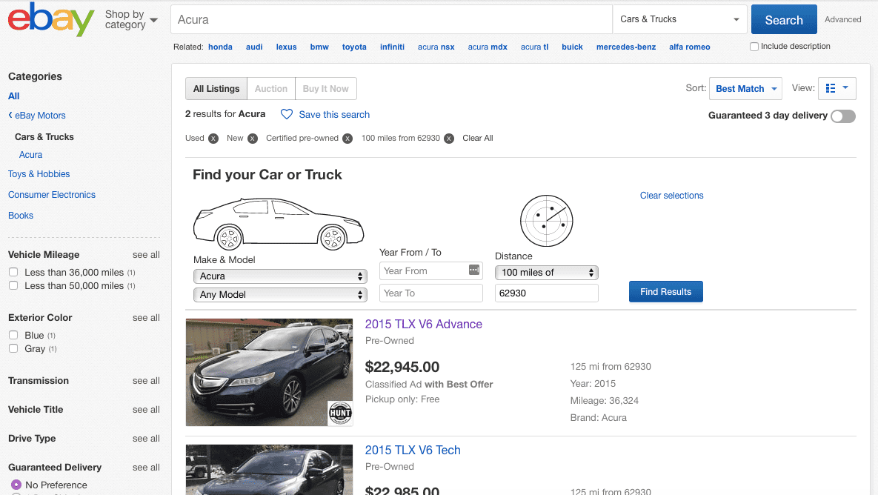

Figure 2.1 E-Bay

### Auto Auction Mall

Auto Auction Mall enables those potential buyers without a dealer's license the ability to bid on dealer-only auctions. These auctions often involve vehicles listed at wholesale prices, potentially guaranteeing you ultimate legitimacy and thus potential buyers save a lot of money. There are many varieties of cars available of all different makes and models auctioned.

Despite the fact that Auto Auction Mall facilitates linking a dealer and a buyer directly, after spending cash on a vehicle, you’ll be required to pay Auto Auction Mall a $299 fee for allowing you entry into the auctions on its website.

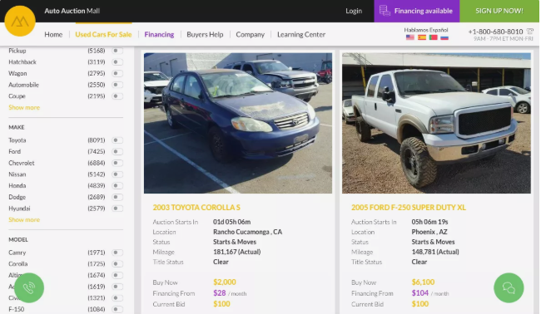

Figure 2.2 Auto Auction Mall

### Salvage Bid

Salvage bid is an online car auctioning platform in which cars are auctioned at affordable prices. To get started on the platform, you'll need to register freely. Salvage Bid offers a free membership that allows you to bid in cases of preliminary bids. You also only get to purchase one vehicle on the free plan. Annually you will be required to pay $200 to gain access to the Premium plan, which unlocks every auction and feature on the website.

Although Salvage bid facilitates in auctioning of cars at affordable prices, premium membership will cost $200 annually, regardless of how often you use it. In addition, live auction bidding, a premium membership is paramount.

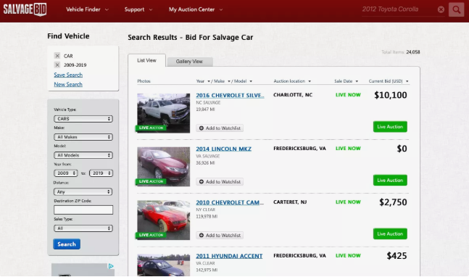

Figure 2.3 Salvage Bid

## Gaps of Existing Systems

There are some systems already implemented and deployed in the market that serve different countries in which they facilitate auctioning of cars in an online platform although they lack a number of artefacts, which are going to be resolved using my proposed system. There is need for a system that will facilitate cheaper payments from auctioneers after they have sold their cars and cheaper renewal of annual premiums. There is need for a system to facilitate in rating to a certain model or make of cars in order for the potential buyers to be able to be assisted in making a decision before settling in purchasing a particular product. There is need for a system that will facilitate payments in peculiar methods. There is need for a system that which not only an auctioneer can be able to post a picture of a car but also be able to post a short video of the car. My proposed system is aims to stipulate in a platform in which a client can be able to rate a car after purchasing the product, in addition, my proposed aims in developing other payment means apart from cheques. Instead one can also perform a direct bank to bank transfer.

## Conceptual Framework

The figure below shows a disentangled explanation of how my proposed system will operate as well as how transactions are going to be carried out. The entities involved in my proposed system are: clients and administrators. The client’s login to the system only if registered, in which they are inclined to a duet option of either auctioning of a car or taking part in bidding an auctioned car. If the client makes a decision to auction a car, he or she is requested to fill in details about the car model and make including other imperative details like the car mileage if it’s a second hand car. In addition, the auctioneer also specifies the time duration of when he wants to end the bidding process in order to determine the winner of the bid. If the clients make a decision to take part in a bidding a certain make of car, he can be able to make a search of which models he wants to take part in bidding and thereafter selecting the most suitable and proceeds to bidding the product. An administrator is responsible for handling feedback from the clients concerning bidding process, he can be able to delete a product in case of a raised complaint of clients, as well as system maintenance.

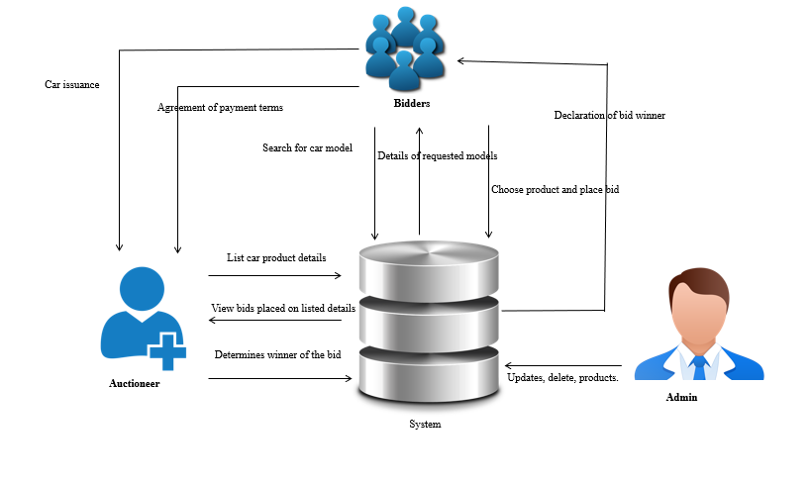

Figure 2.4 Conceptual Framework

# Methodology

## Introduction

This chapter rendezvouses on the different techniques and methodologies to use in developing of the system. The proposed system aims in enucleation of a web-based car auctioning system which aids in indulgency by concatenation of the potential buyers and the auctioneers who place their car to auction. The system methodology to be applied is the object-oriented analysis and design, whose main focus is on capturing the real-world objects in the current scenario that are of importance to the system. This methodology stresses more on data structure, as opposed to procedural structure. In this approach, objects are identified, and their relationships amongst each other, possible states that each object can be in, and finally how all objects collaborate with each other to achieve a broader system goal are identified.

## System Development Approach

The proposed system will be developed using the modified waterfall methodology, in which phases will be sequentially implemented in software development.

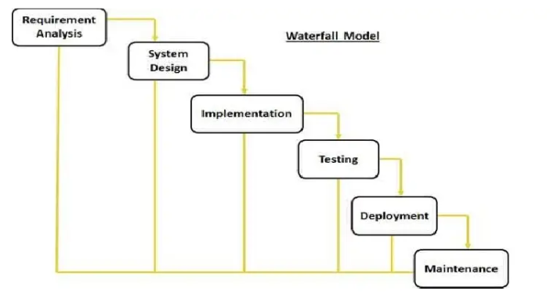

Figure 3.1 Modified Waterfall Methodology

### Requirement Analysis

In this phase, all clients and auctioneers’ requirements are captured and listed in order for them to be developed. The auction system database facilitates in storing the requirements by the buyers and sellers. Buyers provide detailed information of how they can post their product and get feedback of the available clients who need the product, as well as clients on how they can locate a car model of their own oblivion and be in a position to purchase the product.

### System Design

In this phase, a description of hardware to be used is issued. The proposed system will be developed using a laptop with configuration of a server like: XAMPP to be used as a local host. This phase also aims in definition of the overall architecture to be used in designing of the proposed system development.

### Implementation

Coding takes place in this phase. Information is taken in the previous stage by programmer’s in which they create a functional product. Code is implemented in small pieces in which integration is done at the end of this phase.

### Testing and Integration

At the end of the coding prowess, product testing is formally started. Testers sequentially find and report any problems. In case of a very serious issue, your project may need to return to phase one for reevaluation in order to make corrections for the testing and integration to be done again.

### System Deployment

After the system is tested and all faulty errors corrected, the system is then released to the market to perform the functionality as per how it was designed to operate.

### System Maintenance

A number of dilemmas might arise when released to the market or due to the major arise of the IT experts to conduct an upgrade to the system. Therefore, the system is therefore maintained by creating a newer version each and every time to curb this problem.

## System Analysis

System analysis is the process of data collection, problem identification and recommendation of feasible suggestion of improving the functionality of the problem. The major objectives of system analysis are to find out what is being done, how to do, and how it can be improved. There are various system analysis diagrams, tools and techniques to be used in development and implementation of the proposed system. They include:

### Use Case Diagrams

A use case diagram models the functionality of the system using actors present in the system and use cases implementation. Use case diagrams will be used in order to show who are the actors in the system, their specific roles to perform in the system sequence diagram.

### System Sequence Diagrams

The system sequence diagram shows different scenarios of a use-case, generation of events by external actors. The system sequence diagram will be used to elucidate the life line of each entity and the roles to take at specific times within the system.

### Class Diagrams

A class diagram will explain the class structure by showing their classes, attributes, and object relationship amongst others. The proposed system will illustrate different types of objects present in the system and how they relate with each other in order to facilitate in achievement of the objectives required by the buyer and the auctioneer of the product.

### Tools and Techniques to be Applied

The following tools and techniques are to be applied in the full development of the new proposed system. They include:

### Hypertext Mark-Up Language

HTML is a standard mark-up language designed in order to be displayed in the web browser. They include display of plain text, links, picture elements, sound and videos. Html are designed with special opening and closing tags. HTML will be used in my proposed system to sequentially develop it.

### Cascading Stylesheets

CSS is a style sheet language designed for presentation of data written in html document in a satisfactory way. Unlike html which is used in creating the skeleton layout of the document, CSS is used for adding styles to the designed html document for example adding color, animation, responsive images to your web document.

### Hypertext Preprocessor

Php is a server-side scripting language designed for interaction with the server. Php is embedded with html as it is used to fetch data filled in the client side and fill into the database. Information filled by the user in the system will be captured and posted to the database will aid of PHP.

### My Standard Query Language

MySQL is a relational database management system embedded with PHP in order to facilitate in storage of user’s information into a database. Information is written on the client-side using html and MySQL stores the information in the database.

## System Design

This phase elucidates the diagrams to be used in development of the new proposed system and the roles they play respectively.

### Database Schema

A database schema is structured diagrammatically to represent the relations in the database management system. A database schema will be used to illustrate how different entity in the system relate to one another and the multiplicities in which all the entities inhibit.

### Entity Relation Diagram

An entity relational diagram illustrates entity stored sets in a database. It is used to sketch out the design of a database. In the proposed system, the auctioneers and the clients cannot relate without the presence of the system. The auctioneers can directly relate with the database as well as the clients who can relate with the system in order to carry out their auctioning process.

## System Deliverables and Milestones

This entails what the proposed system is expected to do, and the different tasks that the entities are to perform within the system.

### Clients

The clients can be able to take part in a duet option which include: Auctioning a car or taking part in bidding an auctioned car. If the client makes a decision to auction a car, he is required to fill all details about that car and it is put to auction in which other bidders can be able to view.

### Administrator

The system has solitary central administrator who is responsible for transaction management which involves registration of bidders, process communication, tracking and purchase handling.

# System Analysis and Design

## Introduction

This chapter shrouds on the analysis and design to be used in development of the OCAS system. It explains in details how the system operates, giving the various analysis techniques used and finding the problem, finding the system’s general and specific designs and a theoretic representation of how the solution will be implemented.

## Requirement Analysis

This stage focuses on the analysis techniques to perform in order to develop a system to meet the needs and conditions of the users. The requirement analysis technique which will be used in development of the OCAS system is observation whereby the analyst generally observes how the current system operates and identifies the enigma experienced in the current system, thereby developing a methodical procedure of how to solve this dilemma.

## System Requirements

This are the systems configuration requirements requisite in order for a hardware or software to run efficiently and smoothly.

### Functional Requirements

1. Universal Login

A universal login will be pertinent for already registered users in the system in which they will be prompted to enter their username and user account password. Incase a user has forgotten his or her password, a forgot password link will be palpable in which they can click and a code sent to their email address in which they can use to reset their password.

1. Data Accessibility

The OCAS system will be available and accesses in the country with the aid of internet services, in order for potential buyers to access all available bids in which they can take part in auctioning.

1. Data Integrity

The OCAS system will have a Two-Factor-Authentication liturgy sent via an email address for admin’s login and for new users who sign up for the first time in the system.

A user who is an auctioneer can upload a car with full modification access rights of the information in which he or she can keep changing and updating overtime, while a user entitled as a bidder can be able to only bid the product but cannot change details set by the auctioneer.

1. System Security

A successfully registered user in the database is entitled to a user’s account in which their password is set to expire within a duration of 90 days.

Profile editing requires password authentication from the user with manually assigned rights.

A One Time Pass-code is sent to the user to verify in case of a forgotten password request sent by a user in the database which is set to expire within a duration of 2hours.

1. History Provision

The OCAS system provides history of transactions carried out in previous bidding processes, either as an auctioneer or as a bidder when they access their profiles.

A potential buyer can download in printed details of the and car in auction set by the auctioneer.

### Non-Functional Requirements

1. **Performance**

In the system homepage when the user accesses the webpage, the page takes less than 2 seconds to load which is fast to the user.

Dropdowns lists have standard response onclick which takes less time of loading the page.

The system is available for 24 hours 365 days in a year with scheduled exception and pre notified system maintenance downtime if needed.

1. **Interoperability**

The system works in different operating systems like on Windows version from windows 7, all Linux versions and Mac operating system.

1. **Portability**

The web-based application is designed in such a way that it is responsive to big devices and smaller devices like it is portable in Laptops, desktops, tablets and mobile phones of different sizes.

1. **Reliability**

The system software, hardware and software will satisfactorily perform the task designed for within the specified period of time and environment in which it was designed to operate.

## System Design

This phase focuses on the system designs tools and techniques to be used with diagrammatic illustrations, relationships and entity descriptions.

### Use Case Diagram

A use case diagram is a representation of user’s interaction with the system, including all the actor’s roles in the system and entities included in the system. The system has three actors namely: the auctioneer, the buyer and the client. OCAS system allows the clients to register, in which they are entitled to a duet option either to auction a car or take part in auctioning an auctioned car. If the user makes a choice to auction a car, he inputs all the integral details of the car, and set a duration of expiry of the auction in which the bid winner is declared immediately the auction expires. In case a user makes a decision to take part in auctioning a car, he enters and searches the car of his own oblivion in which he views the car description before placing a bid.

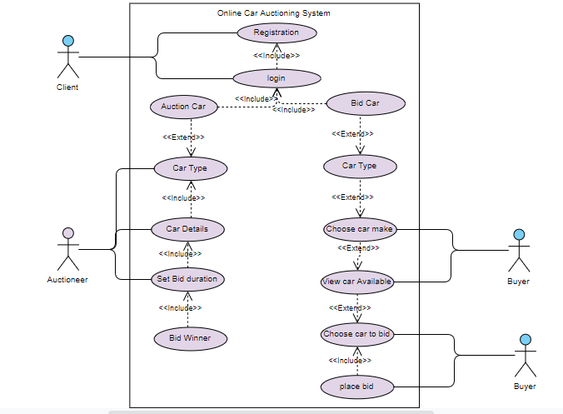

Figure 4.1 Use Case Diagram

### Sequence Diagram

A sequence diagram is used to illustrate interactions between parts within a system to carry out a specified task. In relation with the OCAS system, the entities incorporated are as follows: the bidder, the auctioneer, the administrator and the auction database. The auctioneer being the protagonist of the system, who lists an auction and specifies the duration for expiry in which the information is sent to the auction database, a verification is sent to the auctioneer for a successfully done transaction. The bidder on the other end searches for available auction in which he inputs the car details out of his own oblivion, thereafter the system sends a response corresponding to the user’s request. The bidder views the car description in which he places a bid to the car which he likes. After the bid expiry the system determines the highest bidder to be the bid winner in which a notification is sent back to the car auctioneer.

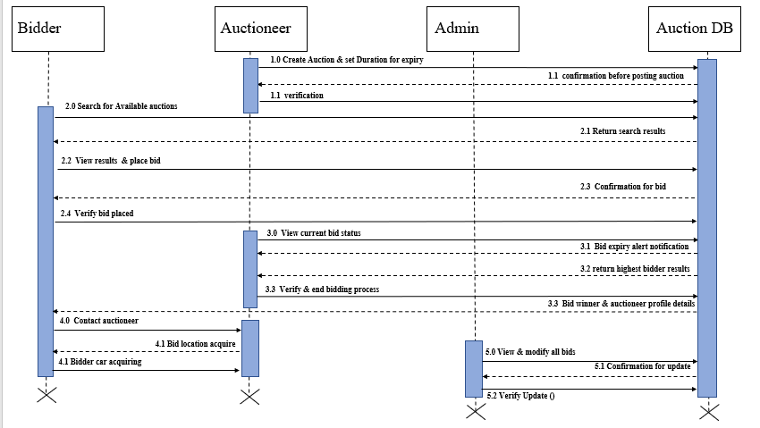

Figure 4.2 Sequence Diagram

### System Sequence Diagram

A system sequence diagram will be used to illustrate the relationship and interaction between the external entities of the system and the main system which facilitates main interaction.

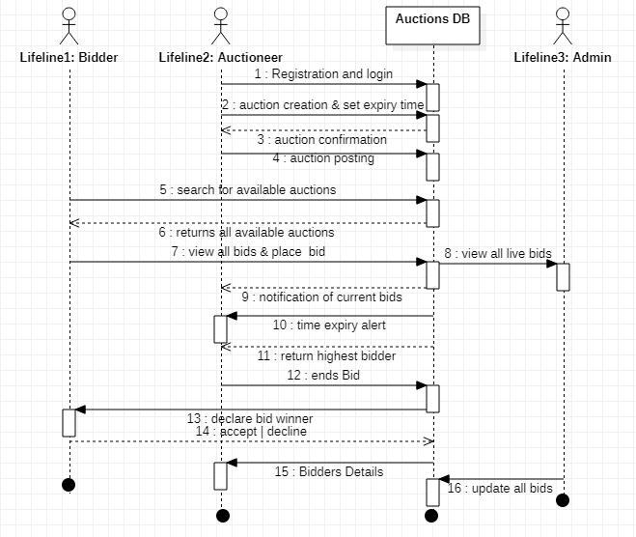

Figure 4.3 System Sequence Diagram

### Class Diagram

A class diagram is a static structure diagram describes the system’s structure showing its classes their operation and att65ributes and relationship among other objects. In relation with the OCAS system, the attributes involved in the system are the auctioneers, the bidders, the admin, and the products.

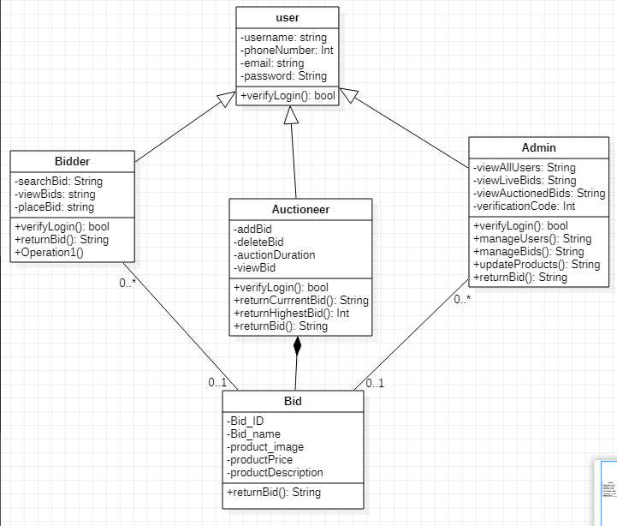

Figure 4.4 Class Diagram

### Entity Relationship Diagram

An ERD show the relationship of entities set stored in the database. Each entity is enticed to an attribute showing relationships between each other within the system.

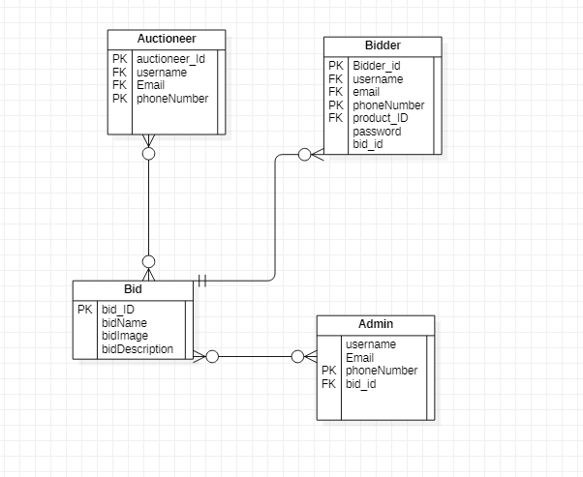

Figure 4.5 Entity Relationship Diagram

### Database Schema

A database schema is a structural delineation of the entire database with all the defined relations involved in the system. The OCAS system has four relations which include: the administrator, the bidders, the products and the orders.

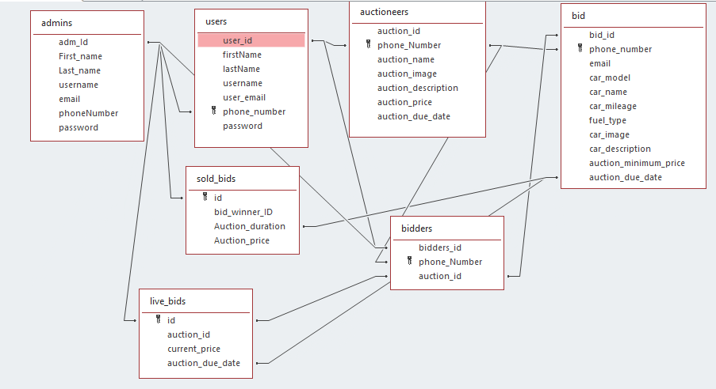

Figure 4.6 Database Schema

# System Implementation and Testing

## Introduction

This chapter focuses on how the system development was done, the physical design, hardware specifications, software specifications and the system dependency. In addition, the chapter explains how system was carried out in order to meet high standards.

## Description of the Implementation Environment

This section explains in precisely on the systems hardware and software specifications required for the system to fully and functionally operating.

### Hardware Specifications

With aid of a table illustration below, an explanation of how the system hardware requirements to aid in running the online car auctioning system are given below.

|  |  |  |
| --- | --- | --- |
| **Item** | **Minimal Specifications**  **(Both the Web and The Database Server)** | **Recommended Specifications (Both the Web and Database Server)** |
| **Processor** | 2 x 1.6GHZ CPU | 4 x 1.6GHZ CPU |
| **RAM** | 2GB | 4GB |
| **Hard-Disk Storage** | At least 40 GB free space is the most recommended | At least 40 GB free space is the most recommended |

The table below is used to show the hardware specifications in development of the Online Car Auctioning System

|  |  |
| --- | --- |
| **Item** | **Specifications** |
| **Processor** | 3.80GHZ |
| **RAM** | 8GB RAM |
| **Hard-Disk Storage** | 500GB SSD |

The developer’s computer meets all the minimum recommended specifications in order to develop and test the system.

### Software Specifications

The system was implemented using the LAMP (Linux, Apache, MySQL, PHP) environment.

References

Bidsuite. (2018, October 02). *Bidsuite*. Retrieved from Traditional and modern auctions: https://www.bidsuite.app/articles/traditional-vs-modern-auctions/

Bidsuite. (2018, October 23). *History of the auctions*. Retrieved from History of the auctioning world : ht tps://www.bidsuite.app/articles/history-auctioning-world-second-part/

Bidsuite. (2018, October 02). *traditional and modern auctioning* . Retrieved from Traditional and Modern Auctions: https://www.bidsuite.app/articles/traditional-vs-modern-auctions/

Charu Aggarwal, Phillip Su. (2009, July). *research gate*. Retrieved from Online auctions: There can only be one.: https://www.researchgate.net/publication/221542999_Online_Auctions_There_Can_Be_Only_One

Computer Hope. (2018, November 12). *https://www.computerhope.com/basic.htm: Computer Hope*. Retrieved from Computer Hope Web Site: https://www.computerhope.com/basic.htm

Institute, R. (2018, June 6). *How internet technology is changing auctions*. Retrieved from auctions over the internet: https://www.rliland.com/online-auctions-internet-technology-changing-auctions/

Muneeswaran Packiyaraj. (2016, August). *research gate*. Retrieved from An effective online auctions: https://www.researchgate.net/publication/310615150_An_effective_online_auction_system

Parsonburg. (2020, January). *Auctioneers and Appraisers*. Retrieved from Online bidding: http://www.amauctions.com/live-online-auctions/online-bidding-explained/

Rumpe, B. (2003, May). *research gate*. Retrieved from Online Auctions in the Context of the Internet Marketplace: https://www.researchgate.net/publication/244383087_Online_Auctions

Today Business. (2012, April 4). *Business Today*. Retrieved from online auction gaining ground in Kenya: https://businesstoday.co.ke/online-auction-gaining-ground-in-kenya/

Today Business. (2012, April 04). *Business Today*. Retrieved from Online auction gaining ground in Kenya: https://businesstoday.co.ke/online-auction-gaining-ground-in-kenya/

Appendix A: Gantt Chart

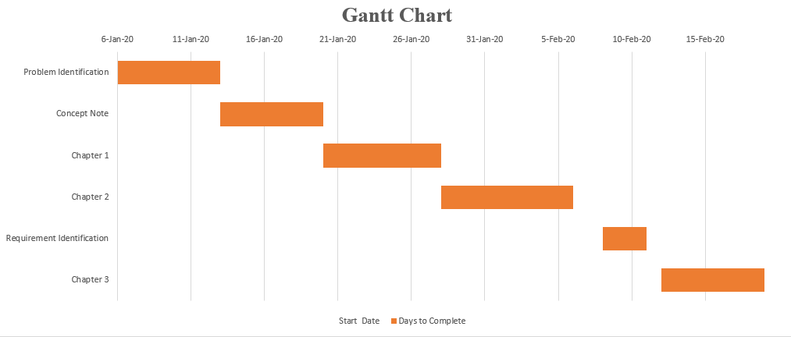

Figure 4.7 Gantt Chart