**Web-based Application Used to find and Contact Computer Technicians for Computer Repair and Maintenance**

**Nyakienji Chrispine Kanai**

**113360**

**Salma Ashina Ashney**

**111388**

**Submitted in partial fulfilment of the requirements of the Diploma of Business in Information Technology at Strathmore University**

**Strathmore Institute of Management and Technology**

**Strathmore University**

**Nairobi, Kenya**

**March 2019**

Declaration and Approval

We declare that this work has not been previously submitted and approved for the award of a diploma by this or any other University. To the best of our knowledge and belief, the research proposal contains no material previously published or written by another person except where due reference is made in the research proposal itself.

Student: Nyakienji Chrispine Kanai

Sign: ________________________ Date: ________________________

Student: Salma Ashina Ashney

Sign: ________________________ Date: ________________________

Supervisor: Kevin Omondi

Sign: ________________________ Date: ________________________

Abstract

Technology is important in today's world because it serves a variety of functions in many of the most important aspects of modern society, like education, communication, business and scientific progress. Therefore computer maintenance and repair should be a major concern. Previously finding a technician to fix a computer was quite cumbersome, therefore people spent a lot of time and money in order to find a technician yet there were many technicians around us equipped with the skills that were being looked for. Ascertaining the qualifications of the technician being approached was not assured therefore exposing the customers to endless risks. The solution is therefore a web based application that enables the customers to find and contact computer technicians who are within their proximity and have the best skills so as to save on time and expenses incurred when looking for computer technicians. Since computer technicians have been registered in the website application, it is easier to ascertain that the technicians have the required skills. The system has been developed using the modified waterfall methodology. The various phases of the system have been completed sequentially.

Table of Contents

Declaration and Approval ii

Abstract iii

List of figures vii

List of Abbreviations viii

Chapter 1. Introduction 1

1.1 Background 1

1.2 Problem Statement 2

1.3 General Objectives 2

1.3.1 Specific Objectives 2

1.4 Justification 3

1.5 Scope and Limitations 3

Chapter 2. Literature Review 4

2.1 Introduction 4

2.2 Computer Technicians in Kenya 4

2.2.1 Challenges Faced By Computer Technicians in Kenya 4

2.3 Related Works 5

2.3.1 Quick Find 5

2.3.2 PC Savior Technician 6

2.3.3 Tweaka Technician 7

2.3.4 Easy Technician 8

2.4 Gaps of Existing Systems 9

2.5 Conclusion 10

2.6 Conceptual Framework 10

Chapter 3. Methodology 12

3.1 Introduction 12

3.2 System Development Methodology 12

3.2.1 Requirements Analysis 13

3.2.2 Design 13

3.2.3 Implementation 13

3.2.4 Testing 13

3.2.5 Deployment 13

3.2.6 Maintenance 13

3.3 Functional requirements 13

3.4 Non-functional requirements 14

3.4.1 Interoperability 14

3.4.2 Portability 14

3.4.3 Security 14

3.5 Tools and Techniques to be applied 14

3.5.1 HTML 14

3.5.2 CSS 15

3.5.3 PHP 15

3.5.4 MySQL 15

3.6 Deliverables 15

3.6.1 Customers 15

3.6.2 Computer Technicians 15

3.6.3 Administrator 15

Chapter 4. System Analysis and Design 16

4.1 Introduction 16

4.2 Analysis 16

4.3 Design 16

4.3.1 Use Case Diagram 16

4.3.2 System Sequence Diagram 17

4.3.3 Dataflow Diagram 18

4.3.4 Database Schema 19

References 21

Appendix: Gantt Chart 22

List of figures

Figure 2.1 Quick Find 6

Figure 2.2 PC Savior 7

Figure 2.3 Tweaka Operator 8

Figure 2.4 Easy Application 9

Figure 2.5 Conceptual Framework 11

Figure 3.1 Modified Waterfall Methodology 12

Figure 4.1 Use Case Diagram 17

Figure 4.2 System Sequence Diagram 18

Figure 4.3 Context Level DFD 19

Figure 4.4 Level 0 DFD Diagram 20

Figure 4.5 Database Schema 21

Figure 4.6 Gantt Chart 23

List of Abbreviations

CSS – Cascading Style Sheet

DBMS – Database Management System

DFD – Data Flow Diagram

HTML – Hyper Text Markup Language

IT – Information Technology

MySQL – My Standard Query Language

PC – Personal Computer

PHP – Hypertext Preprocessor

SDLC – System Development Life Cycle

USD – Use Case Diagram

# Introduction

## Background

Computers are machines made of electronic parts. They include both software and hardware. In the absence of proper maintenance, your computer may fail to operate and you may end up with data loss and other critical errors (Dominguez, 2018). Computer technicians offer computer repairs and maintenance services all over and as more technological changes occur by invention of more enhanced computers, the technicians also better their skills further so as to be enable them to meet their customers’ needs by repairing and maintaining their computers in a good manner in order to prevent technical problems (TechCrunch, 2015).

For a person to qualify as a computer technician he has to be well educated with good skills on how to operate on the computers. The technicians should be sure they understand how computers interact with humans and learn how to match their thinking to the machine. Being a computer hardware field technician is not unlike being a private eye. Much of their job involves diagnosing and solving the problem, this task has a lot in common with solving a mystery. A big part of that job involves collecting as much pertinent information as possible in order to diagnose the problem. Problem-solving is vital to being a computer technician. Connecting the dots to determine the problem and then deciding the correct course of action to take in order to solve the problem is a very important part of the job (careertechnical, 2017).

A computer technician must be able to communicate effectively with clients and co-workers to share information and solve the problems that arise in their everyday life. A computer technician often ends up advising others on a variety of tasks (Career Technical Institute, 2016). A good technician is able to foresee the outcomes and effects of various IT strategies and advise management as to the best course of action accordingly. They must ensure that the equipment is operating properly within its environment. In order to determine what is not working properly, a technician must have a firm understanding of the equipment and all its components and how they work together to perform properly. This will help the computer hardware field technician narrow down the options when troubleshooting. Documenting and recording information are baseline metrics that computer hardware field technicians must keep track of in order to properly diagnose a healthy network or computer system. This information is essential to ensuring the system is running properly. It is important that technicians monitor the efficiency of computer hardware and make adjustments if the system is running slowly.

In order to create a smooth working network, a good IT technician must maintain a proactive strategy that involves maintenance, frequent virus scans, and creating safeguards. These activities will help to prevent any major issues or problems. A computer hardware field technician’s main job is in the maintenance and repair of electronic equipment. Computer systems, including desktop PCs, laptops, and mobile devices are all complex pieces of machinery, and the computer hardware field technician must know how to correct issues with them, repairs them when they break down and perform maintenance on them to prevent them from breaking down.

## Problem Statement

Almost everyone in the world’s population own at least one or more computer devices. These devices are used to undertake most of the tasks in ones day to day activities. These tasks may include rent payment, communication with friends and family or even sharing of information. This therefore indicates that a lot of importance should be put in the maintenance of these devices to prevent against data loss and computer breakdown. Today, in order to find a computer technician, customers have to incur the burden spending much time and money. Even after one finds a computer technician, the technician’s experience and qualifications are not assured therefore one faces a lot of risks as he is not sure whether the technician is right for the job. Some of the technicians do not even have the skills required in order to repair a computer. This exists yet there are a lot of technicians out there that have the skills and knowledge but are jobless or spend almost the whole day waiting for customers to come.

## General Objective

Came up with a web-based application that enables a customer to easily find and contact a computer technician that is within his/her proximity for computer repair and maintenance.

### Specific Objectives

1. Analyzed challenges faced by customers to find computer technicians.
2. Analyzed how customers had been locating and accessing computer technicians.
3. Designed and developed a web-based application that help customers to easily access computer technicians.
4. Tested and implemented the developed techniefind system.

## Justification

The techniefind system is designed to make customers access computer technicians with just the touch of a button. The system is built as a web-based application where the customer and the technician can interact efficiently and schedule for an appointment. The system also enable the customers to locate the technician because the technician details are available on the platform. Currently the computer technicians are available all over and most of them are self-employed. The techniefind system is therefore a web application that allows computer technicians to provide their qualifications, skills and working location. Customers on the other side have to register before accessing computer technicians that have been registered. After signing in the customer is able to view computer technicians that are in his proximity and also check the computer technician’s qualification and skills. He then chooses a computer technician of his choice and a message is sent to the computer technician so that he/she can approve that he is available on the date specified by the customer.

## Scope and Limitations

The techniefind system enables customers to register and check available computer technicians. Computer technicians register in order to be visible to the customers. Once a customer identifies a computer technician he can send him/her a message via the application.

The customer and technician have to be registered in the application in order to access services from the web-based application. The users have to be connected to the internet in order to use the system.

# Literature Review

## Introduction

This chapter explains who computer technicians are, giving a brief history of technicians in Kenya, challenges faced by computer technicians and similar systems that are being used.

## Computer Technicians in Kenya

A Computer Repair Technician, installs, evaluates, detects, and troubleshoots different types of issues affecting computer systems or servers or networks. The individual will diagnose faulty hardware or software of PCs or laptops and diagnose them (Computer Hope, 2018). After they identify the problems, they resolve them. Computer technicians, however, work more often with hardware peripherals than with software. They should be proficient with the widely used operating systems, such as Windows, Linux or macOS. They are the primary customer contacts support and service. Technicians should have first-rate analytical and problem-solving skills.  They would have to travel to clients’ premises to fix issues whenever required (Fieldengeneer, 2019).

Technicians are always in charge of user security, maintenance, upgrading and services of the computers and servers. They are also versed at replacing hardware or running the latest updates for the computers or the programs (Learn.org, 2003).

### Challenges Faced By Computer Technicians in Kenya

Computer technicians are faced with a lot of challenges in their day to day activities. Among the challenges is having very few customers visiting them in a day yet they have the experience and qualifications required to fix computer devices and peripherals (Chron Computers, 2017). Their market is also limited to a few people who are aware of their working location or people who live or work near their shops. This limits their profits and often results to huge losses since they have to pay shop rent regardless of whether they have made any sales.

Customers on the other hand, have to spend much time and money in order to find a computer technician who can repair their computer. They also have an issue in ascertaining that the computer technician has the skills, experience and qualifications required in order to work on their computer devices and peripherals. (The Tech Mentor, 2015)

Technology advances rapidly. Therefore, computer technicians must ensure that they clear old hardware devices that they have in stock to give room for new devices that are in line with the new technology. This becomes hard to accomplish if the computer technicians do not get regular customers to buy these devices. They therefore have to sell the devices at throw away prices hence incurring losses.

## Related Works

These are systems used to find and contact computer technicians for computers’ maintenance and repair. These systems have been implemented to the public to try to solve the problems faced by customers to access technicians. These systems include, Quick Find, PC Savior Technician, Tweaka Technician and Easy Technician.

### Quick Find

Quick Find is an application system based in India. It was implemented in 2018. Quick find helps you find qualified service providers within your local area, it gives you the ability to communicate and discuss the service you’re looking for. This could range from Builder, Plumber, Painter, Gardner, Carpenter, Dog-walker, IT technicians, Hairdresser, Leafleting and much more services. The purpose of Quick Find is to solve many issues that we all face on a daily basis when looking for the right person at that right time.

The application is compatible with only a few devices therefore not all the users can benefit from the application.

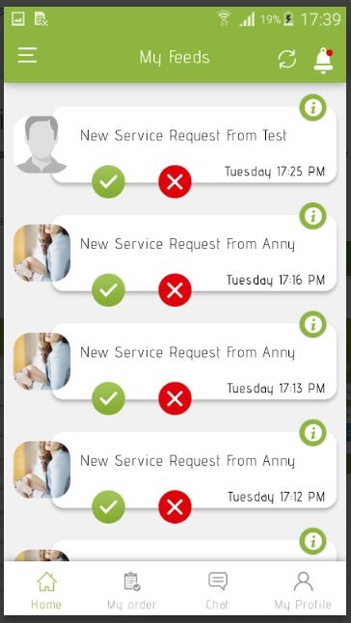

Figure 2.1 Quick Find

### PC Savior Technician

It was implemented in 2018. PC Savior smartphone application innovates the way the customers call technicians and the way they do their service. It will make the whole process more efficient for them to provide the service and cost effective for their customers to use the service. Customers are no longer required to make unnecessary long trip to visit a computer technician. The application requires one to enter a unique phrase which separates his data from everyone else’s data. Users have to first login before using the application.

The user interface of the application is not responsive, for example when trying to sign in the application gives an error therefore users cannot sign up in order to use the services offered in the application.

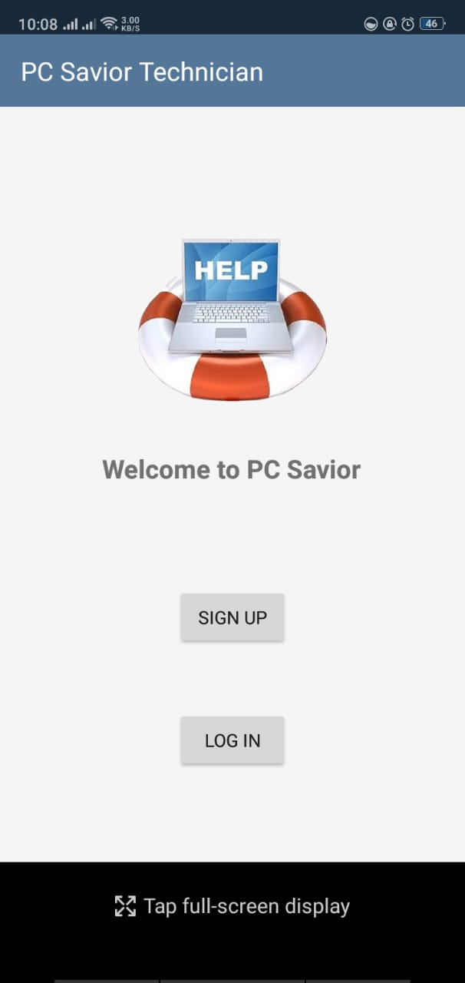

Figure 2.2 PC Savior

### Tweaka Technician

It was implemented in 2018 by a developer based in Mumbai. Tweaka Technician is an application designed to simplify the relationship between a Service provider and the End User. Specifically, any individual or business who is in need of a computer technician or a seller of computers and related accessories and peripherals. They provide customer access to thousands of verified technicians providing a variety of services at home or in offices. They also verify each one of the technicians who register with them in order to ensure that users are hiring reliable and verified technicians.  At present, there is an urgent need for a platform that utilizes top-notch tech and geo-targeting to empower verified technicians to provide fast, effective and on-time services. This is where Tweaka comes in. Tweaka provides its users with the best and verified technicians offering quality services at economical cost.

However, a technician can only get a task notification when his status is online. Once a technician gets a job he can change his status to offline therefore he does not get a notification from other customers. This may result to him missing customers if he forgets to change his status to online.

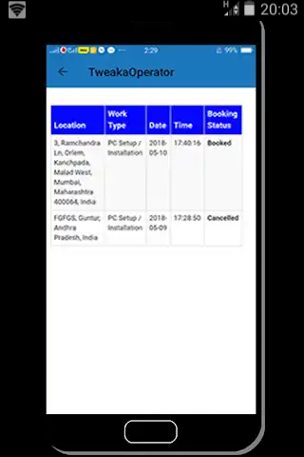

Figure 2.3 Tweaka Operator

### Easy Technician

It was implemented in 2016. Easy technician is an application designed to tell the customers which technicians are within the specified area. The customer simply enters the details and waits for a feedback from the application which sends two or more quotes from the Local Technicians of their own chosen area, and then the customers choose the best technician of their choice.

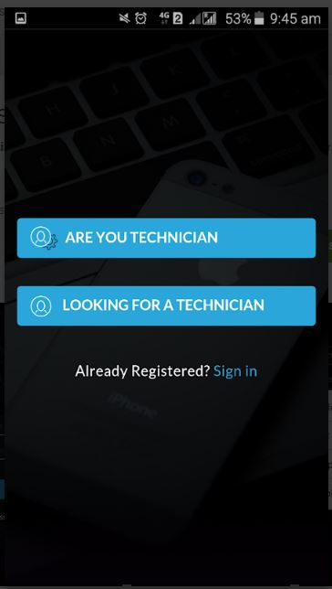

Figure 2.4 Easy Application

## Gaps of Existing Systems

There are systems already existing used to find and contact computer technicians, but they lack several services which are addressed using the techniefind system. There was need for a system that would enable the customers to rate computer technicians after they have offered repair services to enable users to be able to identify computer technicians that are better at their job. There was need for a system that allows computer technicians to give an approximate cost for the services which could be rendered. There was also need for a system that allows users to add computer technicians to their favorites so that they could easily contact them the next time they require services from them. There was also need for a system that allows computer technicians to add their customers to a warranty list for a specified period of time to allow customers to return their computers in case of failure within the warranty period. The techniefind system provides a platform, where customers can rate computer technicians in order to ensure that the technicians give quality services. It also allow computer technicians to create a list of customers that have warranty.

## Conclusion

It is therefore evident that there were gaps in the existing systems, from the market systems where people met and trade physically to online systems that tried to cover the gap of inconvenient traditional market system. The gaps that existed are lack of systems that could efficiently facilitate the interaction between a customer and a computer technician and ease the whole process of finding a computer technician. The techniefind system was aimed at covering the existing gaps. The techniefind system provides a platform where computer technicians and customers can directly interact in order to schedule for an appointment. The user requirements are put into consideration, whereby, customers are able to assess computer technicians within their proximity and choose the best among them and computer technicians are also able to display their skills to wide range of customers.

## Conceptual Framework

Figure 2.5 is a skeleton diagram which illustrates the functionality of the techniefind system. An overview of how the system works as well as how transactions take place is shown. In the techniefind system, the entities involved are: customers, computer technicians and the system administrator. The customers and computer technician log into the system as users. Customers can either request for a computer technician or view their pending works. A computer technician is able to view a list of their pending jobs, set a rough estimate of the price and update their skills and qualifications. The computer technician is then visible to all users in the system. The customer is able to view nearby computer technicians and their skills and rate the computer technicians based on their services. Once a customer selects a computer technician, a notification is sent to the computer technician and he is expected to reply with a price estimate and confirm his availability. The customer can then make a visit to the computer technician. The administrator provides system maintenance.

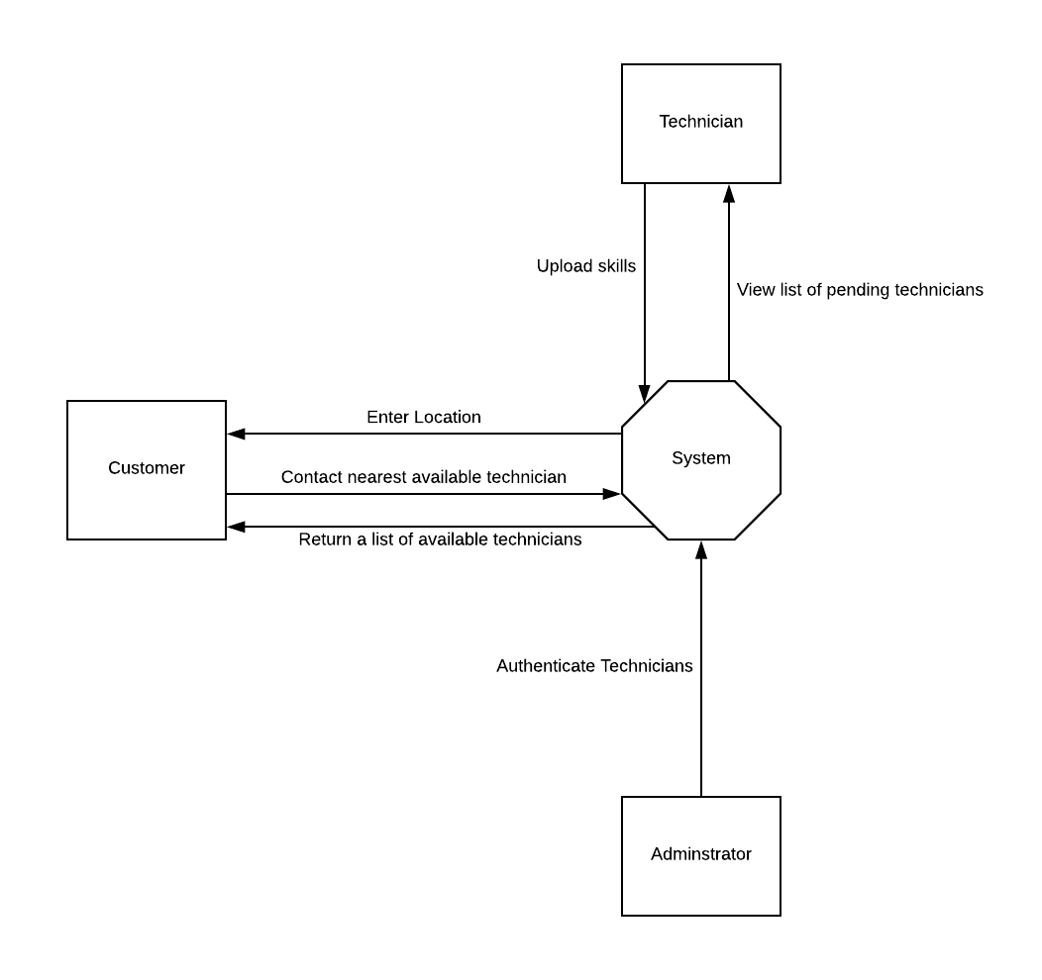

Figure 2.5 Conceptual Framework

# Methodology

## Introduction

This chapter highlights the methodology used in development of the techniefind system. The requirements of the system such as functional and non-functional requirements have also been explained in order to understand the development of the system. What the techniefind system aimed to deliver and the tools and techniques that enabled the delivery are discussed in detail in this chapter.

## System Development Methodology

The techniefind system has been developed using modified waterfall methodology. The modified waterfall methodology provided a structured approach to develop application projects. Waterfall model is a SDLC approach that assumes the various phases of a project can be completed sequentially – one phase leads into the next phase. It also ensures that the development process is efficiently managed. Due to its structured technique, the developers put equal emphasis on all modules to come up with a project that is of high quality to the consumers.

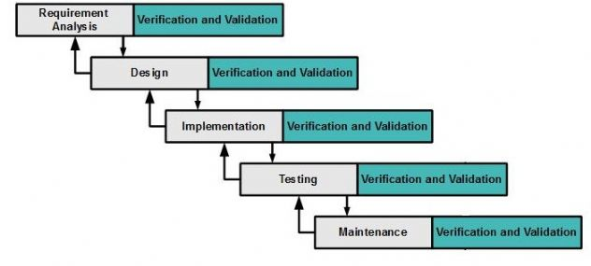

Figure 3.1 Modified Waterfall Methodology

### Requirements Analysis

System requirements of the techniefind system are identified. These include user requirements, which such as customers being able to contact and schedule an appointment with a computer technician, functional requirements, such as users can register and log in in to the system, Non-functional requirements, such as security and portability.

### Design

A description of the recommended solution is converted to logical then physical system specifications. In Logical design, all functional features of the system chosen for development in analysis are described independently of any computer platform. Physicaldesigns, the logical specifications of the system from logical design have been transformed into the technology-specific details from which all programming and system construction are accomplished.

### Implementation

The techniefind system and its database have been implemented using HTML, MySQL, CSS and PHP.

### Testing

The implemented application was tested. This was done so as to ascertain whether the user requirements were met, whether our expectations were met and the presence of bugs in our code. Users are able to test the application to see available technicians and even message the technicians via the application. They then give suggestions on the features they want improved or added to the application.

### Deployment

In this phase the application was released to the market after ascertaining that it was correctly working through the testing phase.

### Maintenance

In this phase more features were added to the system, current features were revised and debugging of the system was done to improve its efficiency in solving the problem.

## Functional requirements

This section covers what the software does so that the user can accomplish a specified task. It also dictates how the system responds to inputs from users and the capabilities and functions that are included in the system. The system is a web-based application that requires that the user have a mobile phone or computer that has access to the internet. Users need to login first before they can use the services offered by the application. The system allows computer technicians to upload their details so that they can be easily located by customers. The administrator then authenticate the technicians before they are visible to other users in the platform. Users are also able to check and contact computer technicians that have required skills and are within their proximity. Users can also rate computer technicians based on the services that were given by the computer technicians. Users can post questions and give answers relating to computers and computer repair in the blog section of the application. Administrator can check for irrelevant questions and answers in the blog section and delete them.

## Non-functional requirements

### Interoperability

The web application is designed in such a way that it can work in integration with different operating systems. The system also functions in various environments such as mobile phones and laptops. The system is therefore available to all the users.

### Portability

The web-based application is made in such a way that it works in various environments such as desktops, mobile and tablets. This helps the users to be able to access the system whenever convenient for them.

### Security

The system has a central administrator who can update content that is in the application. Content in the website is only available to users that are registered and logged in to the system to uniquely identify each client.

## Tools and Techniques to be applied

These are the tools and methods were used to develop the system. They include the programming and mark-up languages used in preparing the system into a functional web-based application.

### HTML

HTML is a markup language that provides a means to create structured documents and is widely used to write web pages. It was used in the techniefind system to create the web pages. It has also been used to embed images and other interactive forms (such as the login, registration and messaging forms) onto the web application.

### CSS

It is designed to enable the separation of presentation and content including layout, color and fonts. This separation helps in improving content accessibility and enables multiple web pages to share the same formatting. It is used alongside HTML. It has been used to enhance some features, such as the user interface and the web pages, in the techniefind system.

### PHP

This is a server-side scripting language used for web development. PHP code can be embedded onto HTML code. It has been used to connect the application to a database.

### MySQL

This has been used to create a database which is connected to the system through PHP.

## Deliverables

This defines what the system was expected to offer its users.

### Customers

They are able to view, contact and schedule appointments with computer technicians available in the system. They are also able to rate computer technicians.

### Computer Technicians

The system allows computer technicians to upload their details alongside their specifications to the system. They are then visible to other users in the system.

### Administrator

The system has got one central administrator. The administrator is able to view system reports, authenticate and delete users in the system.

# System Analysis and Design

## Introduction

This chapter covers the analysis and design of the techniefind system. It explains in details what the system does and it includes the use of system models and diagrams that explain how the system works.

## Analysis

In this phase, the analyst gathered all the system requirements and environmental considerations. The requirements were then analyzed in order to come up with an overview of the system architecture and functionality. The analyst also identified the overall direction that the project took through the creation of the project strategy documents.

## Design

In this phase, the system requirements and logical description of the entities, relationships, and attributes of the data that were documented during the Requirements Analysis phase were further refined and allocated into system and database design specifications that were organized in a way suitable for implementation within the constraints of a physical environment (e.g., computer, database, facilities).

### Use Case Diagram

A USD is a graphic depiction of the interactions among the elements of a system. A **use case** is a methodology used in system analysis to identify, clarify, and organize system requirements.

The techniefind system allows the customer to register into the system. The customer can then log in to the system after registration. The administrator also registers all the computer technicians with all their details and qualifications and also establishes agreement. After the customers log in, they input their details then select the technician of their best choice since they are able to view all technicians registered, they then contact and find the technician within their proximity whom they visit so as to get the computer services needed. The customer then pays for the service after being sure that his/her computer is well repaired. The payment can be made via cash or through Mpesa. The administrator views the transactions being made as he receives payment. Before the customer logs out, he/she is allowed to rate the technician according to how the service was carried out.

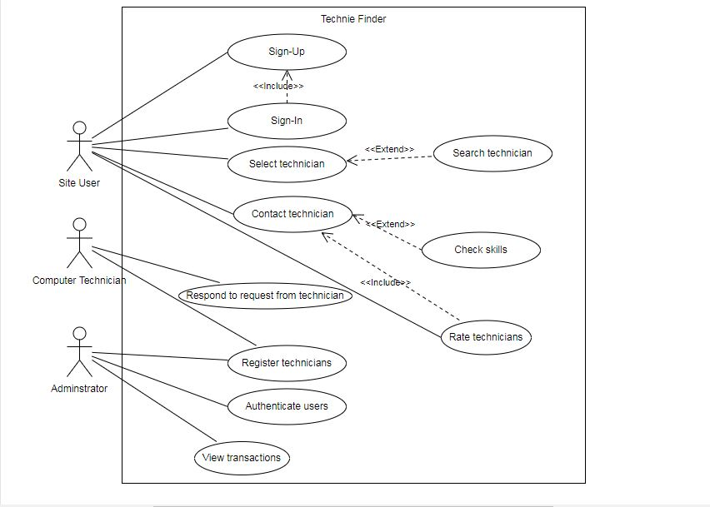

Figure 4.1 Use Case Diagram

### System Sequence Diagram

Figure 4.2, illustrates the visual model of the techniefind system, its components, and their interactions. With supporting documentations, it captures all the essential information of a system’s design. The customer logs in to the system and once they are granted access, they are able to view the list of technicians available. The list of the computer technicians is uploaded by the administrator. The customer selects the technician of his/her best choice then contacts and visits the technician’s office for computers services. Payment is done when the customer is satisfied with the technician’s work.

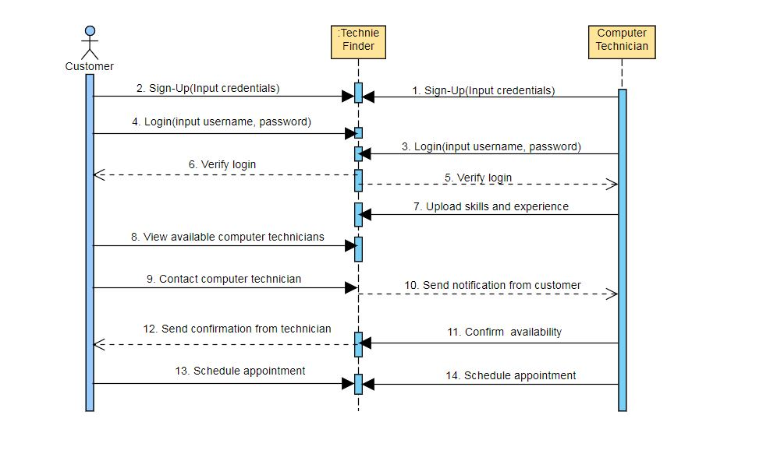

Figure 4.2 System Sequence Diagram

### Dataflow Diagram

Figure 4.3, shows a Context Level DFD for the techniefind system. Context level DFD’s demonstrates the interactions between the process and external entities. The system enables the customers to log in, put their details then the system sends request to the selected computer technician. The technician sends a confirmation note to the system if he/she is available at the moment to handle the problem then the system sends a notification to the customers for them to contact the technician for the services. The administrator registers more technicians who can be viewed by the customers.

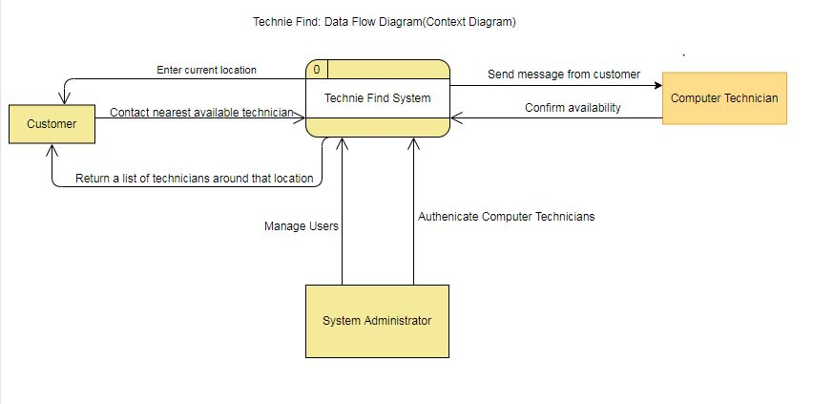

Figure 4.3 Context Level DFD

### Level 0 DFD Diagram

Figure 4.4, shows a Level 0 DFD Diagram.

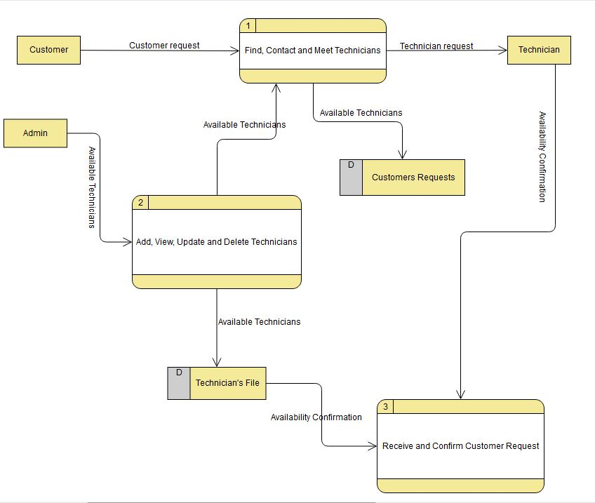

Figure 4.4 Level 0 DFD Diagram

### Database Schema

Figure 4.5, shows the structure of the database schema described in a formal language supported by the DBMS. The structure represents the logical view of the entire database. It defines how the data is organized and how the relations among them are associated.

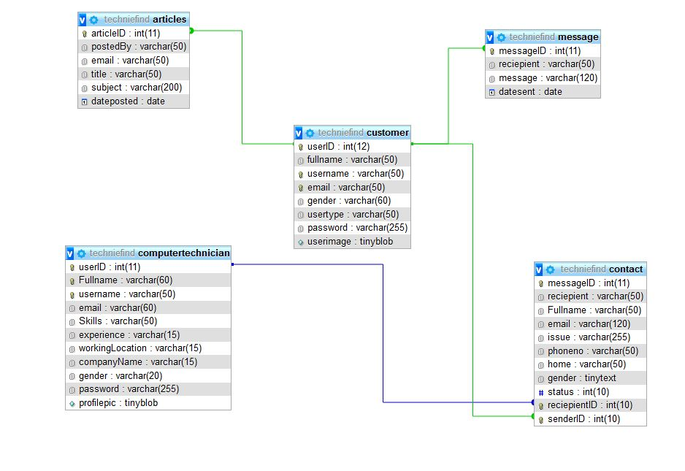

Figure 4.5 Database Schema

References

Career Technical Institute. (2016). *10-important-skills-for-a-computer-hardware-field-technician-to-possess: Career Technical Institute*. Retrieved from Career Technical Institute Web site: https://careertechnical.edu/10-important-skills-for-a-computer-hardware-field-technician-to-possess/

careertechnical. (2017). *10 important skills for a computer hardware technician to posses*. Retrieved from careertechnical: www.careertechnical.edu

Chron Computers. (2017, July 15). *https://work.chron.com/computer-technician-do-8293.html: Chron Computers*. Retrieved from Chron Computers: https://work.chron.com/computer-technician-do-8293.html

Computer Hope. (2018, November 12). *https://www.computerhope.com/basic.htm: Computer Hope*. Retrieved from Computer Hope Web Site: https://www.computerhope.com/basic.htm

Dominguez, A. (2018, February 12). *computer-maintenance*. Retrieved from https://ehorus.com: https://ehorus.com/computer-maintenance/

Fieldengeneer. (2019). *computer repair technician*. Retrieved from fieldengeneer: www.fieldengineer.com/computer repair technician

Learn.org. (2003, August). *https://learn.org/articles/Computer_Technician_Salary_and_Career_FAQs.html: Learn.org*. Retrieved from Learn.org Web site: https://learn.org/articles/Computer_Technician_Salary_and_Career_FAQs.html

TechCrunch. (2015). *10tips computer repai maintenance*. Retrieved from 247techies: https://www.247techies.com/technical-support/10tips-computer-repair-maintenance.php

The Tech Mentor. (2015, January). *https://www.thetechmentor.com/posts/9-tips-help-you-become-computer-technician/: The Tech Mentor*. Retrieved from The Tech Mater Web site: https://www.thetechmentor.com/posts/9-tips-help-you-become-computer-technician/

Appendix: Gantt Chart

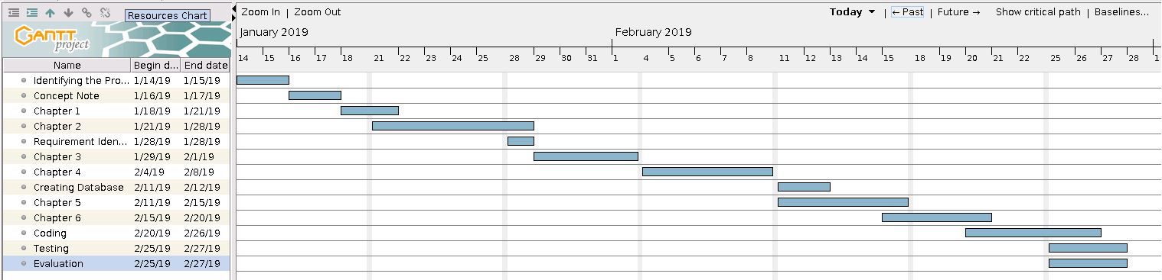

Figure 4.6 Gantt Chart